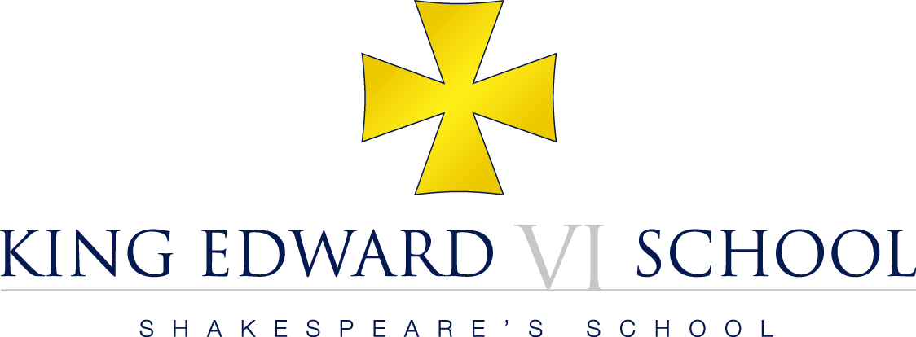

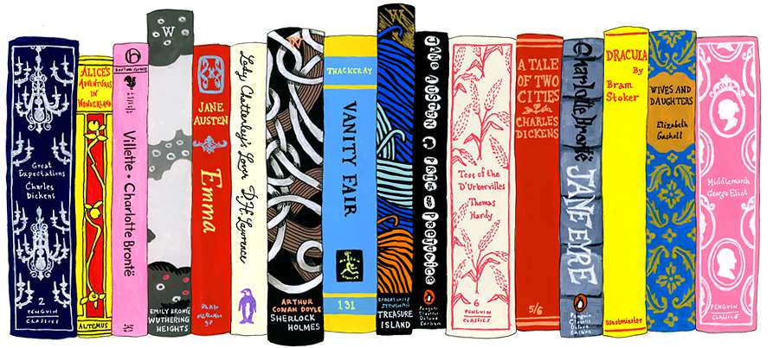

**Introduction to**

**English Literature at A Level**

*“The best moments in reading are when you come across something - a thought, a feeling, a way of looking at things - which you had thought special and particular to you. And now, here it is, set down by someone else, a person you have never met, someone even who is long dead. And it is as if a hand has come out, and taken yours.”*

 [Alan Bennett](http://www.goodreads.com/author/show/11781.Alan_Bennett), [*The History Boys*](http://www.goodreads.com/work/quotes/1120783)

We are delighted that you have chosen to study for the OCR A Level in English Literature. The course will equip you with a base of transferable skills and knowledge suitable for further study in Humanities and Arts subjects whilst stimulating independent thought and encouraging a love of reading.

**The English Department**

Mr Abbey Head of English

Miss Barton

Mrs Cyphus

Mrs Freer

*Mrs Hutton

*Mr Mills

* Year 12 teachers

**Preparation for the course**

* You should aim to have **read at least four texts from at least two sections** from the Sixth Form reading list by the beginning of next term.
* You should also visit the theatre and see at least one film not in English.
* You should begin to look at the reviews of books, plays, films and television programmes in broadsheet newspapers.
* You should become a regular browser in bookshops and in your local library, looking for books that might interest you.
* Listen to some of the many radio programmes and podcasts available.
* If you have not already joined your local library, then do so. Libraries are an excellent resource and you are able to order books on-line from other libraries for a minimal fee.

**Recording your thoughts**

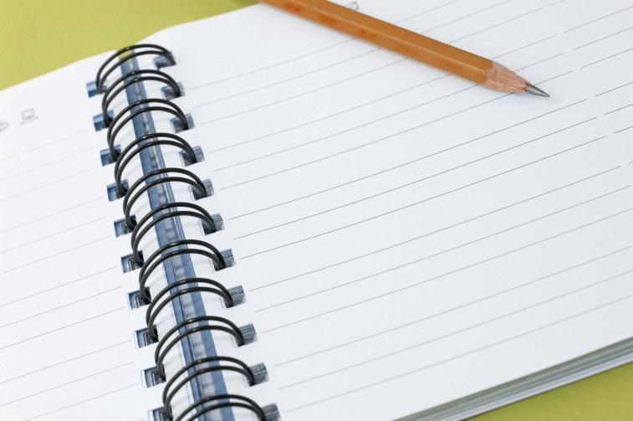

We would also like you to **keep a note-book** on everything you read and see, recording your reaction to them. These books will be collected and assessed by your teachers at the beginning of next term. They will also provide an excellent basis for class discussion.

**Sixth Form Reading List**

This is not in any sense an exclusive list, nor a list of the ‘best’ books; rather it is a list of books that should begin your involvement with the ideas and imagination of advanced level reading, whilst still being ‘accessible’.

**English Fiction:**

* Any novel by: Charles Dickens or

Jane Austen or

Thomas Hardy or

George Eliot.

* *Heart of Darkness* by Joseph Conrad
* *Nineteen Eighty-Four* by George Orwell
* *Atonement* by Ian McEwan
* *The Remains of the Day* by Kazuo Ishiguro
* *The Bloody Chamber* by Angela Carter
* *Behind the Scenes at the Museum* by Kate Atkinson
* *Wolf Hall* by Hilary Mantel

**Poetry:**

* *The Whitsun Weddings / High Windows* by Philip Larkin
* Poetry by Simon Armitage
* Poetry by Carol Ann Duffy
* Poetry by Tony Harrison

**Drama:**

* *The Importance of Being Earnest* by Oscar Wilde
* *Death of a Salesman / The Crucible* by Arthur Miller
* *A Man for All Seasons* by Robert Bolt
* *The Glass Menagerie* by Tennessee Williams
* *Pygmalion* by George Bernard Shaw
* *Dancing at Lughnasa* by Brian Friel
* *Glengarry Glen Ross* by David Mamet

**American Fiction:**

* *The Catcher in the Rye* by J D Salinger
* *Slaughterhouse Five* by Kurt Vonnegut
* *Beloved* by Toni Morrison
* *All the Pretty Horses* by Cormac McCarthy
* *The Handmaid’s Tale* by Margaret Atwood
* *The Things They Carried* by Tim O’Brien

**European Literature:**

* *The Prince* by Niccolo Machiavelli
* *Candide* by Voltaire
* Short Stories by Anton Chekhov
* *Metamorphosis and other stories* by Franz Kafka
* *The Outsider* by Albert Camus
* *Madame Bovary* by Gustave Flaubert
* *The Count of Monte Cristo* by Alexandre Dumas

**Teacher Recommendations:**

*English Literature: A Very Short Introduction* Jonathan Bate

*The Genius of Shakespeare* Jonathan Bate

*How Novels Work* John Mullan

*The Ode Less Travelled* Stephen Fry

*The Art of Fiction* David Lodge

*An Introduction to Literature, Criticism and Theory* Andrew Bennett & Nicholas Royle

*The Poetry Handbook* John Lennard

**Essential Reference:**

* A ‘good’ dictionary and thesaurus :

*Concise Oxford Dictionary*

*Concise Oxford Thesaurus*

* A dictionary of literary terms:

*Penguin Dictionary of Literary Terms & Literary Theory* J A Cuddon

Or

*The Oxford Dictionary of Literary Terms*  Chris Baldick

*The Literature Student’s Survival Kit* Ian Littlewood

**Radio**

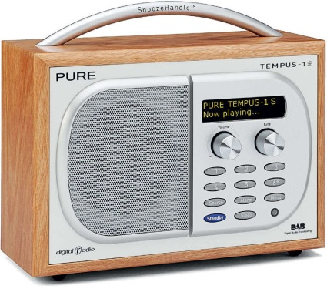

**BBC Radio 4**

*Open Book*

Mariella Frostrup with the best new fiction and non-fiction, talking to authors and publishers and unearthing lost classics.

*A Good Read*

Harriett Gilbert talks to two guests about their favourite books.

*In Our Time*

Melvyn Bragg and his guests discuss the history of ideas as it applies to culture – from literature and the visual arts to artistic movements and their origins.

*Front Row Weekly*

Live magazine programme on the worlds of arts, literature, film, media and music with John Wilson.

*Poetry Please*

Roger McGough presents a weekly selection of favourite poetry requested by listeners.

**BBC Radio 3**

*The Verb*

The Verb, words and performance with poet Ian McMillan: language at its most creative, interviews, discussions, performance, new writing, audio-cartoons, music and poetry.

**Podcasts**

The BBC website holds a wealth of podcasts. Here’s a selection:

[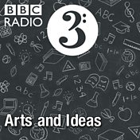](http://www.bbc.co.uk/programmes/p02nrvk3/episodes/downloads)

In-depth interviews, reviews and debates with artists, scientists and public figures.

I [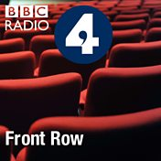](http://www.bbc.co.uk/programmes/b006qsq5/episodes/downloads)

Live magazine programme on the worlds of arts, literature, film, media and music.

[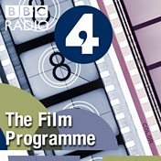](http://www.bbc.co.uk/programmes/b006r5jt/episodes/downloads)

The latest releases, the hottest stars and the leading directors, plus news and insights.

[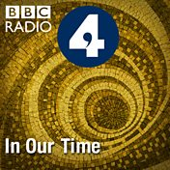](http://www.bbc.co.uk/programmes/b006qykl/episodes/downloads)

Melvyn Bragg and guests discuss the history of ideas

[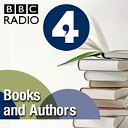](http://www.bbc.co.uk/programmes/p02nrsfl/episodes/downloads)

Featuring Open Book and A Good Read. With Mariella Frostrup and Harriett Gilbert

[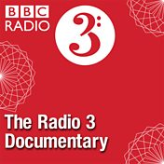](http://www.bbc.co.uk/programmes/p02nrscw/episodes/downloads)

Exploring different aspects of history, science, philosophy and the arts.

[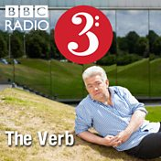](http://www.bbc.co.uk/programmes/b006tnsf/episodes/downloads)

Radio 3's cabaret of the word, featuring the best poetry, new writing and performance.

[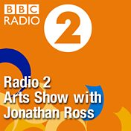](http://www.bbc.co.uk/programmes/p02nrw7k/episodes/downloads)

Looking at the latest books, films, plays and exhibitions.

[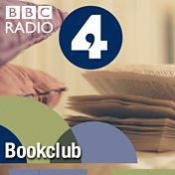](http://www.bbc.co.uk/programmes/b006s5sf/episodes/downloads)

Led by James Naughtie, readers talk to acclaimed authors about their best-known novels.

[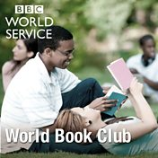](http://www.bbc.co.uk/programmes/p003jhsk/episodes/downloads)

World Book Club invites the globe's great authors to discuss their best known novel.

[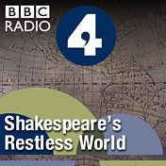](http://www.bbc.co.uk/programmes/b017gm45/episodes/downloads)

Neil MacGregor uncovers the stories twenty objects tell us about Shakespeare's world.