**Henry III and the Painted Chamber**

***The king’s council or "Parliament" meets in the king’s bedroom!!!??***

The king's council met regularly during the reign of Henry III but Henry fought with the nobles. They criticised the way he spent money and handled justice, and called for more reforms. In 1259, Henry's response was to call the council, or "Parliament", to his lavishly decorated bedroom.

The end of the Barons War

* The war with the barons did not end when King John died. Many nobles still supported French Prince Louis's claim to the throne. Battles continued for nearly 10 years into King Henry III's reign.
* Meetings of the king's council helped to settle disputes with the nobles. From 1236, the council was referred to as "Parliament" – meaning "to speak". Its powers were limited, it didn't represent ordinary people and Parliament met when the king called it, not the other way round. But at least the king could be talked to.

A room for a meeting

* There was still no fixed meeting place for Parliament to meet. The king moved between his different palaces through the year, so it was sometimes easier to meet his council in other places in England.
* But Henry III loved Westminster and employed the best artists and architects to turn it into the finest royal palace in Europe. It became the place to discuss matters of justice and grievances with the king – such as the money he was spending.
* 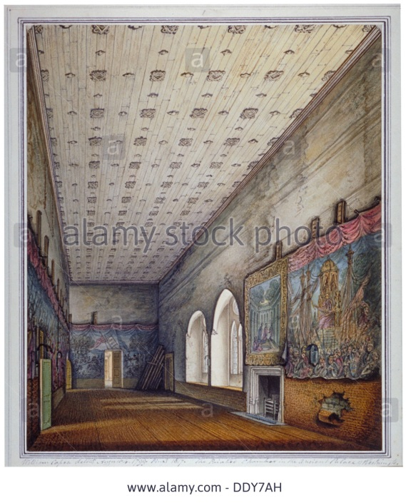Henry fought expensive wars in Wales and France, and raised new taxes to pay for them. He also lavished money on Westminster. By 1245 some £7,000 – about £3.5 million today – had been spent on improvements to the palace. Much of that was on Henry's new bedroom, known by 1243 as the "camera depicta" or "Painted Chamber".

What was the Painted Chamber like?

The large room – 24 metres long, 8 metres wide and 9 metres high – wasn't just for sleeping in. The king could meet with important people here and impress them with his power. The chamber was destroyed by the great fire of 1834, but parts of it survive. With sketches and accounts from the time, and comparison with Westminster Abbey – built at the same time and by the same artists – we can imagine what the Painted Chamber must have been like.

It would have been brightly painted. Henry's bed was in his favourite colours of green and gold. His bath was carved in the shape of a peacock, covered in pearls, gold and silver.

The pictures on the walls and windows had important meanings. Pictures of Edward the Confessor linked Henry to the last English King before the Norman conquest, and a man who had been made a saint by the Church. There were pictures of great military leaders, and good and bad kings and prophets. One painting showed, "the king who was rescued by his dogs from his seditious subjects".

This might have impressed the council when Henry called them there in 1259, reminding them of their oaths to the king. It might also have made them more angry about how the king was spending money.

But the Painted Chamber wasn't big enough for the meeting. They proceeded to the Queen's Chamber to discuss the matter.