**1259 – The Father of Parliaments**

Simon de Montfort led a rebellion against Henry III – and briefly captured him. Simon then called a Parliament to decide the new constitution. This was the first Parliament to which representatives from counties and towns were summoned to give advice. For the first time, it was not just the great barons who were being consulted, but representatives of a much wider section of the community.

Simon de Montfort

Henry III had a difficult relationship with his brother-in-law, Simon de Montfort. Henry was horrified by Simon's ruthless behaviour as Governor of a region of France. Simon didn't think much of Henry as a soldier.

Henry's plots annoy the barons

In 1254, Simon helped Henry get out of a deal he'd made with the Pope to usurp the King of Sicily. The English barons were appalled at the money and soldiers Henry had promised the Pope. They were fed up with Henry spending money wildly and making deals with foreigners. Most of all, they hated that he ignored them – Parliament met, but the king took little notice.

After a famine ravaged England, the barons demanded reforms to the way the king handled foreigners, justice and money. Simon took the reformers' side against Henry.

Kings stick together

At first it looked like Henry would win – the Pope declared that the demand for reform was unconstitutional. But in 1263 Simon led another attempt to make Henry accept reforms. Historians argue about whether he was motivated more by ideals or ambition. But Simon had a silver tongue, was a brilliant soldier and had good diplomatic connections. It looked like he might win.

Henry agreed that he and Simon would put their arguments to the French king, Louis IX. They would both agree to whatever decision Louis made. Not surprisingly, Louis sided with his fellow king. He later said he would rather have worked behind a plough than agreed to Simon's "restrictions".

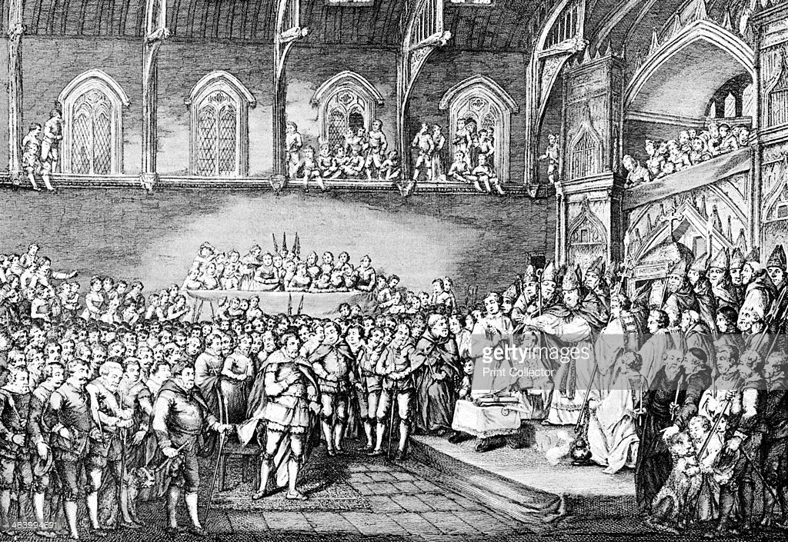A new kind of decision-making

Simon could not accept the judgement, and the barons went to war with Henry. Simon proved to be the better soldier, and at the Battle of Lewes in 1264, Henry was captured.

Simon issued writs in the king's name, calling a Parliament to discuss what to do next. But this Parliament would not be like those that had gone before. "From each county four prudent and law-worthy knights" were chosen by election. But also many towns were asked to send representatives as well.

Simon's victory didn't last long – he was killed in a battle the next year. But his elected Parliament was the first of its kind, and the father of all those to follow.