**Social and Economic development in Henry VII’s reign**

Rural society and enclosure

In 1300, the population in England was 6 million but by 1450 it was at 2 million. This decrease was a result of the 1348 Black Death which killed 1/3 of the population, the Hundred Years War and the War of the Roses.

By 1480, the population began to rise but fluctuated due to bad harvests and smaller plague outbreaks.

Before the Black Death, there were two types of peasants: freemen or serfs. They were bound to their feudal lord and made up the majority of the population.

After the Black Death, there were fewer peasants so landowners were forced to pay them more. This expense meant landowners were forced to lease or sell some land which made it available to a wider cross-section of society.

As a result, the elite group expanded to become not only the nobles (under the King) but a new social category known as the gentry (under the nobles).

The decline of economic power of the landowners meant that serfdom came to an end and they were free to travel looking for the best-paid work.

Some peasants were able to buy their own small areas of land and became known as Yeoman farmers.

Freedom of where to work and who to work for was the most significant change in the 15th Century.

During the Middle Ages, land was farmed using the open-field system: 3 fields surrounded each village and were divided into strips then shared among villagers. It also included a stretch of common land where animals could graze.

However, by the late 15th Century, the open-field system was put under threat by Enclosure which was the fencing off of lands with the abolition of rights over it.

*Advantages*

* Farmers could practice selective breeding so only the best animals were bred to strengthen the blood line.
* Farmers could develop their own techniques.

*Disadvantages*

* Led to the eviction of families who could not prove that they had legal rights over the land.
* Common land was lost so poor families could not collect firewood or graze their animals on it.

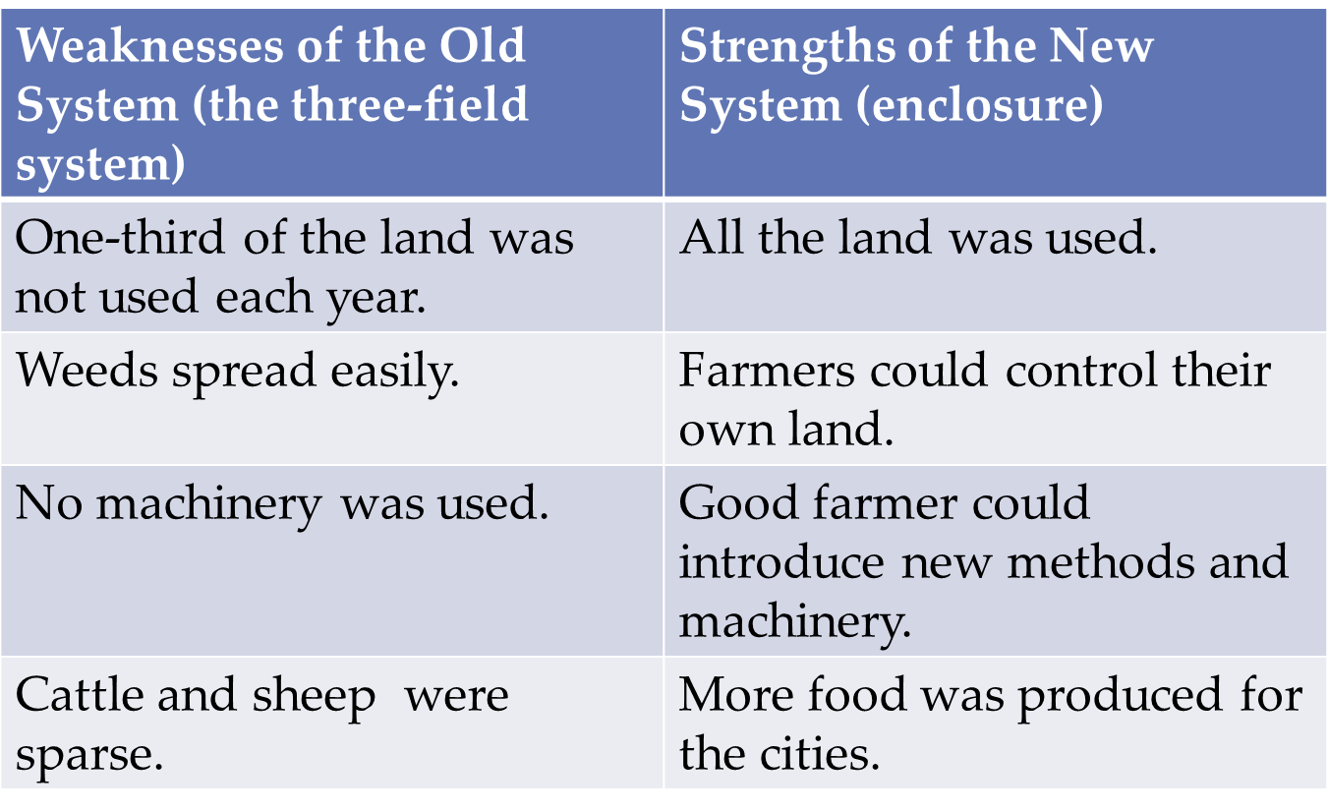

However, historians don’t believe that enclosure was as serious as contemporaries thought because:

* It had been practised for centuries
* It was the only viable option as many farmers lacked the workforce to farm their lands.
* Enclosure was said to take up just 3% of land in the Midlands (where Enclosure was thought to be concentrated)
* Most enclosed land had the permission of landowner and tenant.

Despite this, in some cases, enclosure did contribute to vagabondage and depopulation but contemporaries may have confused this with engrossment (where two or more farms combined to make one economic unit).

Henry’s government failed to distinguish between economic problems caused by enclosure and engrossment.

In 1489, an Act was passed against Enclosure following fears it was causing depopulation in the Isle of Wight which would decrease the defence of the realm.

Another Act attempted to prevent depopulation by forbidding the destruction of houses attached to 20 or more acres of land. However, this was never put into place as the responsibility for its enforcement was down to the landowners, who were the ones to benefit.

While the Acts did display confusion about the problem, it did show that Henry’s government were prepared to do something.

Urban Society: Towns and Merchants

In the late Middle Ages, 5% of the population lived in towns. 300,000 lived in them in 1300 which decreased to 100,000 in 1450. By the 1490s, numbers began to increase again.

There were 700 towns in 1485, with most having a population of under 1000. However, provincial towns such as Bristol or Norwich had populations of 10,000.

London’s population expanded during Henry’s reign and by the end of Henry VIII’s reign in 1487, the population had more than doubled from 50,000 to 120,000.

Towns were the centre of trade in a largely rural environment: they turned raw materials of the countryside into goods for sale and a place to exchange ideas in markets and fairs.

Anyone in any trade belonged to guilds who promoted their interests: they protected wages, hours of work and fixed prices to prevent rivalry between guilds.

By 1500, London had 66 guilds while York had 47.

Wealthier members of guilds became burgesses (could be artisans or tradesmen) who controlled the government of towns.

By the 15th Century, some guilds had become more powerful than others and the most powerful received charters from the King. The most powerful were Merchant Taylors (cloth) and Merchant Staplers (raw wool export).

*Merchant Adventurers*

However, these were swallowed up by Merchant Adventurers who were not tied to any trade but represented a wide cross-section of the Merchant community. They were formed during the 15th Century when the merchants from the most important towns came together to form trading companies.

Merchant Adventurers in London were the most important group and by 1500, Merchant Adventurers were based firmly there.

An increasing proportion of the finished cloth was exported from London through the Merchant Adventurers. This reinforced London’s commercial dominance within the country and established a commercial axis with Antwerp. According to the economic historian, Arnold Coleman, Antwerp was the commercial metropolis of Europe and its main money market. From Antwerp, English cloth was transported all over Europe.

In 1505, Henry granted them a charter allowing them to appoint a governor with 24 assistants to run the organisation.

Merchants were important because they encouraged and promoted trade which contributed to the nation’s finances; for example by 1509, Henry received £40,000 per annum from custom duties. This encouraged Henry to patronise (support) the Merchants and in times of peace he loaned 7 of his navy ships to them.

In return for his patronage, Henry expected the Merchants to support his foreign policy even if it meant them losing trade or ending contact with foreign traders. The king increasingly used their expertise in negotiating trade treaties such as the Intercursus Magnus and Intercursus Malus.

Successful traders invested in land and joined the gentry. They were distinguished through their wearing the sword and bearing the coat of arms.

*Hanseatic League*

They were a group of free cities originating in the thirteenth century who came together to form a commercial union hoping to control trade in the Baltic Sea. The league dominated commercial activity in northern Europe from the thirteenth to fifteenth century.

The Merchant Adventurers were unable to achieve complete domination of trade because they couldn’t overcome trading privileges from the Hanseatic League.

Henry couldn’t control their activity.

The League had been reasserted by treaty in 1474 and again in 1504. Henry may have agreed to reassert this treaty because he needed their support against the Earl of Suffolk (Yorkist claimant to the throne). However, this sacrifice of English commercial interests was “out of proportion to the feeble threat” posed by the de la Poles, as stated by Jack Lander.

Industry

Production of cloth from wool became the country’s main industry and accounted for 90% of exports.

In the earlier part of the fifteenth century, the bulk of exports were raw wool. It was shipped mainly from east-coast ports like Boston, Lynn and Yarmouth. It was then exported by Merchants of the Staple through Calais.

By the beginning of Henry’s reign the export of raw wool had halved and was overtaken by woollen cloth, exports of which increased by 60%.

Apart from woollen cloth, England had virtually no manufactured goods to export so the country was dependant on industry abroad and was backwards by European standards in the commodity of linen, silk, leather and glass. For example, Germany and Bohemia were superior in mining and metallurgy (scientific study of metals) whilst the Spanish, Portuguese and Dutch were superior in shipbuilding.

The dramatic increase of the export in cloth at the expense of wool had no impact on agriculture but did on trade and employment. The expansion of cloth trade was helped by the increase in population creating more labour.

Wool making mostly took place at home: children carded (untangled the fibres), women span it, and men wove the fabric ready for fulling (cleaning) and dyeing.

A cloth merchant was responsible for organising and financing; he was responsible for all stages of the process.

The different stages resulted in an economic and social hierarchy within the woollen industry. Cloth merchants contracted work to peasants to meet increasing demand for cotton and wool.

This finished cloth also resulted in the development of weaving:

* Done as a domestic process
* Fulling (cleansing of cloth to eliminate oils, dirt and other impurities, making it thicker in the process).
* Dyeing as commercial enterprise.

Consequently, there was rural employment to supplement agrarian incomes from the industry.

The increase in exports and the increase in the export of cloth to German states of the Hanseatic League increased by 5x from the beginning to the end of the 15th Century. However, England were still unsophisticated compared to the highly capitalised Flemish cloth industry.

The main districts that woollen cloth was manufactured in were East Anglia, the West Riding of Yorkshire and the West Country.

In some areas, such as Wiltshire, communities were solely dependent on the cloth trade (they did not farm, for example) so when there was a slump in trade they had to beg for survival.

Unemployment was a relatively new experience in the 16th Century; Kings had not had to deal with this before.

Other industry

There was very little heavy industry but any was located outside of town where water and raw materials were readily available.

The coal industry exported little but by Henry’s reign, output of coal began to accelerate; in 1508/9, 20% of Newcastle’s exports were in coal. This was because it was cheaper to transport coal by water than to bring in wood from other areas where timber was scarce. Coal also became an important source of fuel for the poor, especially in London. There was also a small export trade to Germany and the Netherlands.

Iron making was sporadic at the start of Henry’s reign but Henry had a small role in the development of the industry when he sponsored the building of a blast furnace in Kent as part of making armaments for the Scottish war in 1496.

Tin and lead were important at home and abroad. Mines in Devon and Cornwall were famous for their quality products and by the 16th Century, their goods dominated European markets.

There was also said to be an increase in the building industry due to the construction of homes for the gentry.

However, England were still very much behind because it provided only casual labour for a fraction of the population. It fluctuated with changes in population, season and natural disasters. Therefore, England was backwards in continental standards; in 1500, England couldn’t be described as an industrial country.

There was little development in coinage since the reign of Edward III but Henry introduced new coinage with gold and silver designs for political and economic reasons. He put into circulation the new shilling piece which was the first ever coin to have a true portrait of the King. It was in circulation until 1990.

Trade laws and treaties

Henry was clearly interested in maximising customs revenue yet it was equally clear that he was prepared to sacrifice revenue and trade in the interests of securing the dynasty. He was also happy for Parliament to legislate in favour of sectional interests (the interests of a particular group within a community or country).

The biggest issue concerning trade was the embargo of 1493 with the Netherlands. It had been imposed as a result of Margaret of Burgundy’s support for Perkin Warbeck. It meant that instead of trading directly with the Netherlands, Merchants had to trade through Calais which invited retaliation from the Netherlands. The embargo ended with the Intercursus Magnus though the terms of the treaty were still debated two years later. The terms seemed to be that:

* English merchants could export to any part of the Duke of Burgundy’s land apart from Flanders.
* Merchants would be granted swift and fair justice with effective arrangements for the resolution of disputes.

Philip of Burgundy confirmed this in 1499 and provided a solid basis for trading relations from then on.

The Intercursus Malus was extorted from Philip as a result of his weakness in 1506. It never became fully operative and by the following year, trading relations had been restored on the basis of the Intercursus Magnus.

In 1503, Henry appeared to panic again when the Earl of Suffolk was taken seriously again around Burgundy. Therefore, he attempted to re-impose the embargo. He was fortunate to negotiate the Intercursus Malus in 1506, despite its full terms never being imposed.

Several trade treaties were concluded but these were of little importance and showed that foreign policy and dynastic interests were of greater priority than the interests of English merchants.

Trading restrictions were removed in 1486 which had existed since Edward IV’s reign. They were re-imposed in the following year due to Henry’s support for Brittany but were largely removed again by the Treaty of Etaples in 1492. Although this was not primarily a trade treaty, it did try to encourage Anglo-French commercial relations. Most of the remaining trading restrictions were removed in 1497.

Weaknesses in trading policy were proven when the attempt to make a significant breakthrough in Mediterranean trade proved to be a dismal failure. Additionally, the Hanseatic League limited the development of English trade in the Baltic.

Henry also passed the Navigation Acts of 1485 and 1489 which were made to encourage English shipping; only English ships could carry certain products to and from English ports. This was designed to increase taxation from shipbuilding, create more profit as well as ship building facilities. However, these legislations had limited usefulness as foreign vessels continued to transport a large proportion of English exports.