**The first look at a contemporary piece of art:**

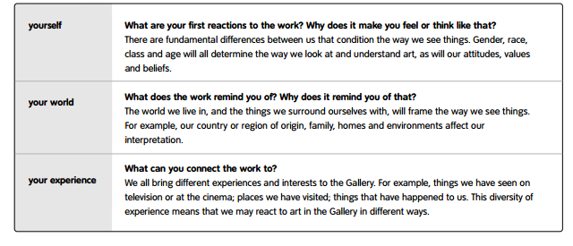

**Now look at the title of the work:**

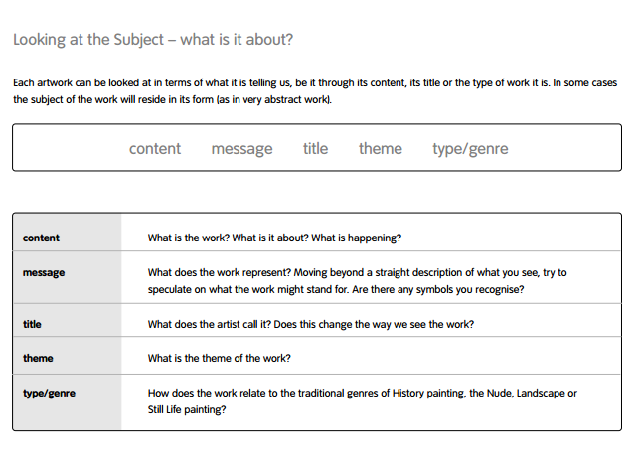

**Analyse the piece in greater depth:**

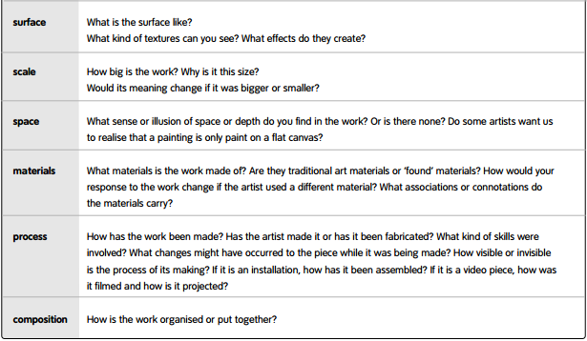

**Exploring and understanding the context of the work:**

