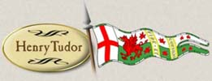  Number of soldiers: 5,000  Allegiance/motivation: Lancastrian (offensive)  Battle position: At the base of Ambion Hill, just north of some very marshy ground  Quality of troops: 2,000 experienced French soldiers, Welsh troops led by Welsh nobles such as Rhys ap Thomas and Sir Walter Herbert  Focus in battle: Killing Richard (winning the crown)  Tactics: Form a tight-knot around Henry to defend him  Extra information:  - Stanley had not prevented Henry’s march to Bosworth from Wales.  - A secret meeting with Stanley has taken place in Atherstone, the night before the battle. This has settled Henry’s nerves.  - The loyal Earl of Oxford led Henry’s vanguard (front line troops). |   Number of soldiers: 3,000  Allegiance/motivation: Uncertain (should be Yorkist, but had previously supported Lancastrians)  Battle position: Ordered by Richard to the flank (side) of his army, to the east of Stanley)  Quality of troops: Highly motivated Yorkist troops (Northumberland resented this)  Focus in battle: Defeating Henry, checking any treasonous move by Stanley’s forces  Tactics: Wait for orders from Richard, then decide whether to comply  Extra information:  - Northumberland had deliberately been slow to recruit his troops in support of Richard because he resented the support the king had in Yorkshire.  - After Stanley had attacked Richard’s army, word was sent to Northumberland to attack him. Northumberland did not, either choosing not to, or being unable due to the marshy terrain.
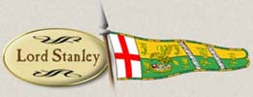  Number of soldiers: 4,000  Allegiance/motivation: Unknown (connections with both sides)  Battle position: Closer to Richard’s army, but not in line with his formation  Quality of troops: Experienced and loyal to Stanley and his decisions  Focus in battle: Getting the best for himself out of the battle  Tactics: Sit tight, wait till Stanley knows who will win  Extra information:  - Stanley’s reaction to his son’s kidnapping by Richard was apparently, “I have other sons”. | 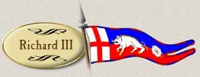  Number of soldiers: 8,000  Allegiance/motivation: Yorkist (defensive)  Battle position: Ambion Hill (Richard has taken the higher ground)  Quality of troops: Could rely on the experience and loyalty of many of the soldiers recruited (exc. Stanley’s), but could not trust his captains  Focus in battle: Killing Henry (defending his crown), reaffirming control over England’s nobles (e.g. Stanley)  Tactics: Red mist – put Henry in a vulnerable position and kill him  Extra information:  - Richard has taken Stanley’s son hostage as a guarantee that he will support him.  - The loyal Earl of Norfolk (John Howard) led Richard’s vanguard (front line troops). He is killed by the Earl of Oxford’s vanguard at the beginning of the battle.

