**Source One:**

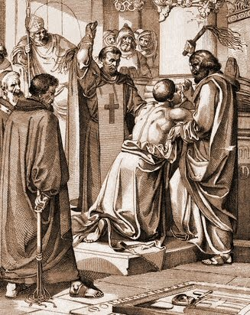

**Source Two: The relationship between Henry II and Thomas Becket**

Becket became very important in England at the start of Henry's reign when Henry asked Archbishop Theobald of Canterbury at the time to recommend a candidate for the office of Chancellor, a very powerful position in England.

In 1162 (eight years before Becket’s murder), Henry II, king of England, appointed Thomas Becket, as Archbishop of Canterbury. This was the most important religious position in England. No-one was surprised by Henry’s choice as both he and Thomas were very good friends. They enjoyed hunting, playing jokes and socialising together. Becket was known to be a lover of wine and a good horse rider. Henry II loved to ride as well but his personality was troubled by his fearsome temper. He tried to keep his temper under control by working very hard as it distracted him from things that might spark off his temper.

Sometimes Becket would help Henry out a lot by taking on those aspects of kingship which Henry found annoying or boring, and would often attend important meetings in place of Henry. It was clear that the king liked and trusted Becket very much.

**Source Three: The fall out between Henry II and Thomas Becket**

In 1164, the first sign of a split between Henry and Thomas occurred.

Henry felt that he should have all the power, while Becket believed that the church should have all the power. This made them both very angry.

Henry had always been worried that the church had more power than he did and thought that Becket would be understanding towards his worries. He wasn’t! The role of archbishop changed Becket. He became very strict in his religious beliefs.

He wore a shirt made of itchy horsehair and asked servants to whip him regularly to show his dedication to God. He also believed very much that God and the church should have more power than Henry.

Henry passed a law which stated that any person found guilty in a [church](http://www.historylearningsite.co.uk/medieval_church.htm) court would be punished by a royal court. Becket refused to agree to this, and knowing of Henry’s temper, he fled abroad for his own safety.

**Source Four: The Murder of Thomas Becket**

It took six years before Becket felt safe enough to return to England. However, Henry and Becket quickly fell out again when Becket asked the pope to excommunicate the Archbishop of York who had taken sides with the king. This was a very serious request and a very serious punishment for someone who could claim that he was only being loyal to the king.

Henry was furious when he found out what Becket had done. Henry is said to have shouted out "**will no-one rid me of this troublesome priest** ?" Four knights heard what Henry had shouted and took it to mean that the king wanted Becket dead. They rode to Canterbury to carry out the deed. The knights were Reginald FitzUrse, William de Tracey, Hugh de Morville and Richard le Breton. On December 29th 1170 they killed Becket in Canterbury Cathedral. After killing him, one of the knights said "Let us away. He will rise no more."The nights reached [Canterbury](http://www.historic-uk.com/HistoryMagazine/DestinationsUK/Canterbury/) Cathedral on December 29th, where they found Becket before the High Altar, as he had gone there to hear Vespers. One of the knights approached him, and struck Becket on the shoulder with the flat of his sword. It seems that the knights did not at first intend to kill Becket, but as he stood firm after the first blow, the four attacked and butchered him.It is recorded that they cracked open his skull spilling his brains onto the cathedral floor!Henry was horrified when he heard the news as he believed that it was his words that had been the cause of Becket’s death. As an act of penitence he donned sackcloth and ashes, and starved himself for three days.