What is the Relationship between Sexual Selection and Human Reproductive Behaviour?

**Definition**

Sexual selection describes the of traits not intrinsically

to an individual's survival (traits explained by 'natural ______ ‘) rather traits which have emerged as a way to mates and consequently

who also reproduce successfully.   
  
Traits which can be explained by selection are traits which are either attractive to of the opposite sex [inter-sexual selection], or are beneficial in competition with other members of one's own (normally males) [intra-sexual selection].

BENEFICIAL EMERGENCE GAIN GENDER

MEMBERS OFFSPRING SELECTION SEXUAL

*Stretch and challenge:*

* *Give 2 examples of BEHAVIOURS that benefit a person who is in competition with other people of the same sex to gain a person GAIN reproductive mates*

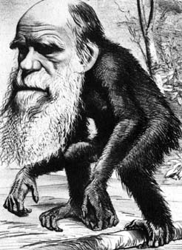

**Evolutionary Psychology**

* It explains behaviour in terms of its function and adaptiveness
* In other words, the extent to which the behaviour enhances the survival and reproduction of the individual’s genes

**Natural Selection**

* is the gradual process by which nature selects the forms most fit to survive and reproduce in a given environment
* In other words, the individuals with characteristics that are most suited to the environment are more likely to survive and reproduce
* The genes that allowed the individuals to be successful are passed onto the offspring in the next generation. We have evolved adaptive behaviours that ensure our survival

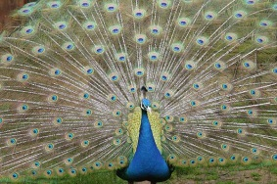

**Sexual selection (Darwin 1874)**

* It seems that some individuals possess characteristics which do not immediately appear to be beneficial to their survival
* Sexual Selection argues that if a characteristic increases the chances of reproduction then the characteristic will be adaptive because the animal will have more offspring
* Sexual Selection is the selection of characteristics that increase mating success.

Explain WHY a peacock’s tail is of an example of sexual selection.

___________________________________________________________________________________________________________________________________________________________________________________________________________________________

Explain why hairlessness could be explained by:

Natural selection ___________________________________________________________ _________________________________________________________________________

Sexual Selection (according to Pagel and Bodmer) ________________________________ _________________________________________________________________________

*[](http://www.google.co.uk/url?sa=i&rct=j&q=hairy+men+and+women&source=images&cd=&cad=rja&docid=v8iqVyZ52vvoHM&tbnid=9b0De6KEwASVRM:&ved=0CAUQjRw&url=http://conanvault.ign.com/View.php?view=Editorials.Detail&id=91&ei=J3cYUaPnIaWx0AXsmYGoBw&bvm=bv.42080656,d.d2k&psig=AFQjCNHqgPYiEML1ybXy2cEaNvt-KR6irg&ust=1360644203002347)*

*Stretch and challenge: Give another example of human behaviour that does not immediately appear to be beneficial to the person’s survival, but does increase their chance of reproduction.*

Natural Selection = ‘survival of the fittest’

Sexual Selection = ‘survival of the sexiest’

**The nature of sexual selection**

Sexual selection is the process by which characteristics are selected because they attract the opposite sex. These genes are passed on to offspring. Sexual selection can take place via two methods; intrasexual selection (mate competition) or intersexual selection (mate choice).

**Intrasexual selection (mate competition)**

* One sex competes with other same sex members for access to opposite sex. When successful they are able to mate and pass on their genes resulting in the desirable traits to be passed onto the next generation enabling them to compete.

**Intersexual selection (mate choice)**

* This refers to the specific trait that is desirable in a sex (i.e. in males) being passed on to future generations. For example if being muscular attracts the most females men will strive to be the most muscular. The preferences of one sex, therefore, determine the areas in which the other sex must compete. These ‘sexy’ traits will be passed on to offspring. According to the evolutionary explanation as humans we are genetically pre-programmed to attend to displays of indicators such as good looks and wealth.
* Evolutionary psychologists’ would suggest that men have evolved to be responsive to females who are young and attractive, since these are physical cues to a women’s reproductive value. Women on the other hand are sensitive to cues from a male that he has the resources necessary for her survival and the survival of potential offspring.

|  |  |  |  |
| --- | --- | --- | --- |
|  | **Explanation** | **Example #1** | **Example #2** |
| **Intra-sexual selection** |  |  |  |
| **Inter-sexual selection** |  |  |  |

**Mate Choice**

Mate choice plays a key role in reproductive behaviour

* Our mate preferences formed in the ‘environment of evolutionary adaptiveness’ (EEA)
* These built-in preferences are important because the genetic quality of your mate will be responsible for half the genetic quality of your offspring.
* A high-quality choice of mate is likely to lead to your genes being passed on

**[](http://www.google.co.uk/url?sa=i&rct=j&q=attractive+women&source=images&cd=&cad=rja&docid=JOfK0T28SYmbAM&tbnid=icOAbrSdPpiCqM:&ved=0CAUQjRw&url=http://www.kelleher-international.com/blog/three-paths-to-dating-hotter-women/&ei=PYYYUfuVIInY0QWDo4HwBQ&bvm=bv.42080656,d.d2k&psig=AFQjCNHTVusQexWi5HEVuaCBmhnFnqorBA&ust=1360648096696472)Evolutionary basis of physical attraction**

* **Cunningham (1986)** investigated what men found attractive in women. He did this by varying photographs of female’s faces including their eyes, nose and mouth. Results (on a 6 point scale) revealed that men were most attracted to women with ‘childlike’ features (neotenous) such as large eyes, small noses and small chins. Some features associated with maturity were found to be attractive also such as prominent cheekbones, dilated pupils and wide smiles.
* **Grammar & Thornhill (1994)** has shown that females are attracted to males with masculine characteristics
  + Large jaw
  + Prominent cheekbones

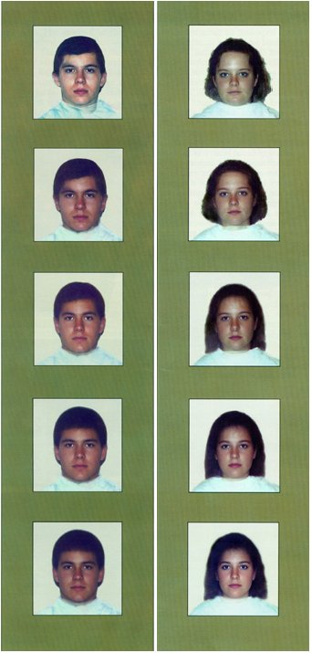These features arise as a result of testosterone, which is also a handicap because it suppresses the immune system. So only ‘healthy’ individuals can afford to produce these traits- advertising a strong immune system

* **Langlois et al (2000)** conducted a meta-analysis of 919 studies and found considerable agreement within cultures as to what was attractive and what was not attractive. Some agreement on these factors was also found between different cultures. Langlois et al also reported the finding that by the time a child is around 26 months old they prefer attractive faces.
* In another study**, Longlois & Roggman (1990)** took photos of faces and *morphed* them together to produce composite images (made up of 4, 8, 16, or 32 images)

**[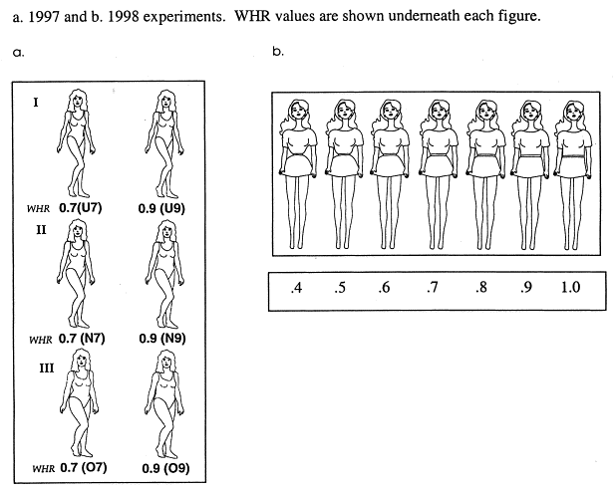](http://www.google.co.uk/url?sa=i&rct=j&q=waist+hip+ratio&source=images&cd=&cad=rja&docid=HJ8yTMKotopb8M&tbnid=3jGWz6OX_wYVbM:&ved=0CAUQjRw&url=http://www.sciencedirect.com/science/article/pii/S0191886900000398&ei=-oMYUbS_B4aT0QXe6YGgCw&bvm=bv.42080656,d.d2k&psig=AFQjCNHxcTDnfrrZP6Eww93ke2C9ATCvBA&ust=1360647536917597)**

* **Singh (1993)** found that across cultures there is a preference for a female waist-hip ratio (WHR) of 0.7 (typical hour glass shape). This preference seems to exist across culture irrespective of cultural differences for curvier or slimmer women. The ideal WHR for men is around 0.85 to 0.9 which results in a tapering figure from wide shoulders down to narrow hips.
* [](http://www.google.co.uk/url?sa=i&rct=j&q=long+legs+man&source=images&cd=&cad=rja&docid=uh-rkcK1kKNCmM&tbnid=XpbaDgoGyYRGGM:&ved=0CAUQjRw&url=http://lankymen.proboards.com/index.cgi?board=pics&action=print&thread=378&ei=oYQYUeDEN_Ds0gW5tICYCw&bvm=bv.42080656,d.d2k&psig=AFQjCNHw2vyr-gGJbnH7P5DG5HS_Gl4VFw&ust=1360647698346785)**Pawlowski (2008)** found that long legs are attractive to both sexes (study in Poland and GB). 218 males and females ranked the attractiveness of seven pictures where leg length had been digitally altered. In both sexes it was the photos that had 5% longer legs that were ranked as the most attractive.

|  |  |  |  |
| --- | --- | --- | --- |
| **Feature** | **Study** | **Explanation** | **Evaluation / IDA** |
|  |  |  |  |
|  |  |  |  |
|  |  |  |  |
|  |  |  |  |

[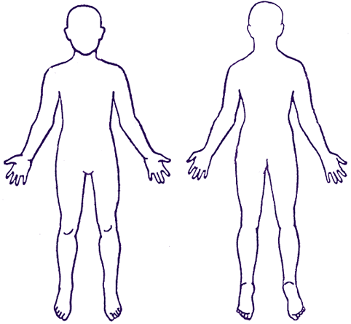](http://www.google.co.uk/url?sa=i&source=images&cd=&cad=rja&docid=RegEgTPXuUjK9M&tbnid=q9nd2pwEqqhBrM:&ved=0CAgQjRwwAA&url=http://growingupboys.info/Answers/20071204.html&ei=rogYUeDzB8PO0QXvmoDIAw&psig=AFQjCNHpUpuq8Mdjc1DtXCnCDopXMWi5Yg&ust=1360648750180027)

**Human mate preferences**

Buss (1989) explored what males and females looked for in a marriage partner using over 10,000 people from 37 different cultures. The sample accounted for a wide diversity of ethnic, religious and political and economic groups. The main findings are shown in the table below.

Table summarising findings of Buss (1989)

|  |  |  |
| --- | --- | --- |
|  | Research findings | Evolutionary advantage |
| Human female mating preferences  **Females were looking for males**: | * Who could financially provide * Who were tall, strong and healthy * Who were older than themselves * Who had symmetry of face and body | Men with greater resources are better mates because access to resources can improve female reproductive success.  Typically, physically strong males would have been better hunter/gatherers and therefore successful providers for their families.  Older men typically have greater resources therefore increasing reproductive success.  Symmetry is associated with health, so healthy offspring are more likely and there is less genetic predisposition to illness. |
| Human male mating preferences  **Males were looking for women**: | * Who were younger than themselves * Who were healthy and physically symmetrical * With a good waist-to-hip ratio | Female fertility declines with age, therefore younger females are more likely to be fertile.  Symmetry is associated with good genes and health.  Improved chances of child bearing with ideal high waist-to-hip ratio. Too high a ratio can result in problems conceiving. |

[](http://www.google.co.uk/url?sa=i&rct=j&q=buss+psychology&source=images&cd=&cad=rja&docid=BYq9qmY9sy1sMM&tbnid=SlzoPBIOJp-X8M:&ved=0CAUQjRw&url=http://www.thepsychfiles.com/2009/06/episode-98-evolutionary-psychology-an-interview-with-dr-david-buss/&ei=7ZkYUe37H6bB0QWk5YHgCw&bvm=bv.42080656,d.d2k&psig=AFQjCNE9Jw9JDSt0OmLs2Sp_-2NIyaKmoA&ust=1360653160181860)**Evaluation of Buss**

* Validity – the study indicates preferences rather than being a true reflection of real life. For example other people such as our friends and families can influence our choice of partner.
* Sampling – Buss was criticised for misrepresenting rural and less educated individuals and the sampling methods to gain participants varied across cultures.
* Support from other research – Buss (1989) studied actual marriages in 29 different cultures and found that men do choose younger women and that a man who divorced and remarried tended to choose a younger woman.

**Highlight, annotate and summarise Buss’ study (in blue text).**

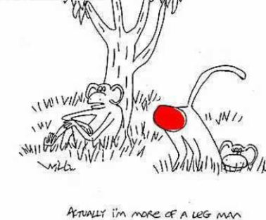**Buss, D (1989)**

**Sex Differences in Human Mate Preferences**

**Aims and context**

In the 1870’s Charles Darwin suggested that mate selection was a matter of evolution because it determined which members of a species got to reproduce and pass on their characteristics to future generations. Evolutionary psychologists are interested in how behaviour like mate selection might be affected by instincts designed to maximise the chances of reproducing and passing on genes.

**Trivers (1972)** proposes that one factor that affects mate selection is **parental investment.** In humans, females invest more time and energy in reproduction than men. Men can invest just a few minutes to impregnate a woman who then carries the child through pregnancy, and takes the majority of the responsibility of child rearing into adulthood.

The fact that women invest more in reproduction means that they will be fussier in their mate choice. It also means that women‘s selection of men should be influenced by their ability to contribute to childrearing - this theory suggests that women will favour ambitious, hard-working and rich men who are most likely to be able to look after them and their children.

Other factors that affect mate choice are **fertility and reproductive value**. These primarily **affect males’ choice** of females because for men, access to fertile females is the major factor affecting their chances of reproducing. For males, reproduction is limited by access to reproductivity. **Reproductive value** ismeasured in expected future reproduction while **Fertility** is described as the current ability to reproduce.

In humans, reproductive value peaks in mid teens while fertility peaks in mid twenties and both decline from then on with age **(Thornhill and Thornhill 1983)** Younger females would have higher reproductive value, while the older female would have higher fertility. Both reproductive value and fertility differ across cultures depending on cultural norms, contraception and mortality rates, but in all cultures these factors are strongly **age dependant. (Williams 1975)**

If males in our evolutionary past sought short-term mating partners, these partners would have been in their twenties, but if males in our evolutionary past sought long-term mating partners, these partners would have been in their teens. Evolutionary scientists differ in their opinions to which of these are most likely. **Symons (1979)** argues that males have been attracted to females who have highest reproductive value, while **Williams(1975)** suggests acompromise preference between fertility and reproductive value occurs due to the existence of long term bonds and the possibility of divorce.

Features of physical appearance associated with youth – smooth skin, good muscle tone, lustrous hair and behavioural indicators of youth such as high energy levels have been described as having the strongest link to reproductive capacity. Female reproductive success is not so closely related to obtaining fertile mates. Male fertility is less age-graded from puberty than female fertility. Physical appearance should be less central to female mate selection.

Fertility in females peaks in late teens or early twenties and obviously the younger the woman, the longer she is likely to remain fertile. This approach predicts that men will favour younger women. This approach also suggest that facial attractiveness in women will be important to men as facial appearance gives clues to age, and therefore gives clues to fertility and reproductive value.

Evolutionary psychologists are also interested in how behaviour varies across cultures. In general, the more something can be applied to a range of cultures, the more likely it is to be a result of evolution. Buss' research aimed to investigate favoured mate characteristics of human males and females. The purpose of this research was to **investigate the characteristics in potential mates across cultures**. Cross-cultural data is important as it helps to test hypotheses that speculate about species-typical or sex-typical preferences. It not only gives information about the current direction of sexual selection, but may also reflect the selection pressures that were evident in ancestors.

**Procedures**

This was a survey of mate preferences in a number of cultures (cross cultural). A questionnaire was used to gather information.

37 samples were taken from 33 countries, located on six continents and five islands which created a total number of 10,047 participants. The samples varied in size from 55 in Iran to 1,491 in USA (mainland) and all apart from the Iranian sample exceeded 100 participants. The mean sample size was 272 participants. The age of participants in the sample groups ranged from 16.96 years in New Zealand to 28.71 in West Germany. The mean age of the overall sample was 23.05 years. In countries where more than one ethnic group was present resulted in more than one sample (i.e. Canada a sample of French and English speakers was used)

Sampling techniques varied across the different countries:

* In Estonia, the sample consisted of couples applying for a marriage licence and high school students;
* In Venezuela, the sample consisted of every fifth household in a series of neighbourhoods that varied in socio-economic class;
* In South Africa, the Zulu sample consisted of a rural population, some of which had the questions read aloud to them;
* In West Germany, the sample was selected through newspaper advertisements;
* In New Zealand the sample consisted of high school students taken from 3 schools.

Occasionally, questionnaires needed to be amended to reflect the cultural differences of the various cultures. In Nigeria, polygyny is practiced, so questions had to be added to reflect the possibility of multiple wives while few couples marry in Sweden (they live together)

The Questionnaire consisted of two measuring instruments. The first instrument was in three sections:

1. Biographical data such as age, sex, religion, marital status, number of brother and sisters.

2 Information on the age at which respondent preferred to marry; preferred age difference between self and spouse; whom the respondent preferred to be older; and how many children were desired.

3. A four point rating scale from 3 (indispensable) to 0 (irrelevant/unimportant) where participants had to rate 18 characteristics, amongst which were the target variables:

* Good financial prospects
* Good looks
* Chastity
* Ambition and industriousness

The second instrument consisted of 13 characteristics. Participants were asked to rank them on their desirability in someone they might want to marry. Rank '1' was given to the most desirable characteristic, '13' to the 13th most desirable characteristic in a potential mate. Interspersed among the 13 characteristics were the target variables:

* Good earning capacity
* Physically attractive

Instructions were given to translators that when translating from English into the native language they must make all the terms 'sex neutral' rather than use terminology that might be linked to a specific sex. (i.e. beautiful / handsome)

The research data was collected by **native residents** of each country and mailed to the US for analysis. Research collaborators were unaware of the central hypotheses of the investigation.

**Findings and conclusions**

***"Good financial prospects”*** – there was considerable variation in how much this mate characteristic is valued. It was rated quite highly in Indonesia, Nigeria and Zambia but was quite low in South African Zulu, Netherlands and Great Britain. In general, Western European samples valued earning capacity less than South American, North American, Asian, and African samples, although there were variations amongst samples within continents.

In 36 of the 37 samples, females valued "good financial prospects" in a mate more highly than males. The Spanish sample was the only exception to this. The sample did show a difference between males and females but it was not significant.

**"*Ambition and industriousness"*** – Both sexes in Nigerian, Zulu, Chinese, Taiwanese, Estonian, and Palestinian, Columbian and Venezuelan samples placed a high value on this mate characteristic. This characteristic was not rated low in any sample; however samples in Netherlands, Great Britain, West Germany and Finland expressed the least amount of preference.

In 34 of the 37 samples, **females** expressed a higher valuation for "ambition and industriousness" in a mate than did males. Three samples (Columbian, Spanish and South African Zulu) *showed the opposite sex difference* (males rating "ambition and industriousness" more highly than females); however it was only statistically significant in the South African Zulu sample. The research collaborator for the Zulu sample suggested that this may be because arduous physical tasks, such as building the house, are considered to be women's work. Males in this culture usually commute from rural to urban centres to work.

*"****Age differences****"* – in all 37 samples, both males and females preferred the male to be the older partner in the relationship. The mean ideal age for marriage for males was 27.49 years, compared to 25.39 years for females. Females preferred a larger age difference between males and females of 3.42 years, compared with males' preference of 2.66 years.

In cultures where polygyny was substantial, (Nigeria and Zambia) males' preference for being older was the largest, 6.45 years and 7.38 years. This may be because males tend to be older when they acquire wives in polygynous systems compared to monogamous mating systems.

*"****Good looks****" –* All of the 37 samples showed that males rated "good looks" in their mate more than females did. "Good looks" were particularly important to males in the Bulgarian, Palestinian, Nigerian and Zambian samples.

*"****Chastity****"* - cultures varied tremendously in the value placed on this characteristic. Samples from China, India, Indonesia, Iran, Taiwan and Israel (Palestinian) attached a high value to chastity in a potential mate. Chastity was viewed as 'irrelevant or unimportant' in samples from Sweden, Norway, Finland, Netherlands, West Germany and France. Ireland differed from other western European samples by placing a moderate emphasis on chastity.

Buss concluded that sex differences involving mate preferences for earning potential, relative youth and physical attractiveness were strongly confirmed across cultures. Predictions about sex differences in ambition/industriousness were supported across 29 of the samples, but completely reversed amongst the Zulu sample. Finally, the chastity prediction received the least support, with only 23 of the 37 samples showing significant sex differences.

**Methodology**

**Strengths**

* This was the first study of its kind, sometimes called a **seminal study.** These studies are usually small scale as the intention is to raise questions that will inspire further research.
* The scale of the study is impressive. 10,000 in 33 countries. This suggests that Buss was very thorough including a number of different **cultures.** Geographic, cultural, political, ethnic, religious, racial and economic groups are all represented in this study which makes it a diverse study. Where more than one culture was represented in any given country, Buss used more than one sample to reflect this.
* Buss used two separate measures to gather data about mate preference –using a single questionnaire can be difficult as it hard to know what might affect people’s answers. Using two different questionnaires reduces the chances of this
* Questionnaire is the most direct method of findings out about mate preferences. Local cultural factors like arranged marriage can affect mate selection as well as mate preference so answers to questions are more valid about mate preference.

**Weaknesses**

* Self-elected and opportunity samples were used in this study and as a result, Buss’ sampling procedures werenot **representative** of the population.In some countries, samples were advertised in newspapers, while in others, high school students were used.
* In some countries the sample was very **small**. i.e. only 28 men and 27 women from Iran. Although the results are very consistent across cultures we cannot be sure that this would have occurred if the sample had been more representative.
* Translation issues could have an effect on the results. In non-English speaking countries, questionnaires were translated into the native language and then the responses translated back into English.

**Evaluation of Alternative Findings**

Evolutionary psychology has grown into an exciting and dynamic field of research. Evidence has continued to mount from a range of sources that mate choice is influenced by instincts to maximise successful reproduction and child rearing. Mate preferences and mate selection remain an important area of research.

**Pillsworth, Hasleton and Buss (2004)** studied whether sexual desire in general and for long term partners in particular increases when women are ovulating. A sample of 202 female university students were questioned about how sexy they felt that day, both in relation to their partner and to other attractive men, and where they were in their menstrual cycle. It emerged that sexual desire was peaked around ovulation in women with partners but not others. In addition, among the women with partners, women expressed more desire towards their partner relative to other men when ovulating. In addition, there is evidence that men rate women as more attractive when they are ovulating **(Roberts *et al* 2004)**

Additional evidence supports the idea that there are universal sex differences in mating preference. One important hypotheses has been that men, with their low parental investment, seek sex with a range of women, while women are choosier about whom they have sex seeking sex with fewer men.

**Schmitt (2003)** tested this in a cross cultural study of 16,288 people from 53 countries. In every culture there was a significant difference on each of several measures between women and men’s preferences for variety in mates. In every case, men desired a larger number of mates.

Evolutionary psychology faces a number of on-going controversies. **Bergstrom and Leslie (2000)** challenged much of the existing research into mate preference and selection because studies generally look at men or women or both, in isolation. Asking people about their mate preference in principle is quite different to the reality, which is quite different to assessing how they behave in real situations where their potential partners are exhibiting attractive or unattractive behaviour. It may not be a valid measure of how we select mates. There have also been more serious challenges to the whole principle of evolutionary psychology.

In direct opposition to the notion of instinctive sexual behaviour, social constructionists place their emphasis on the role of culture in affecting our social behaviour. The debate over culture versus evolution has been particularly bitter over the issue of rape.

Evolutionary psychologists believe that one of the instincts guiding our behaviour is to reproduce and pass on our genes. **Thornhill and Palmer (2000)** suggest that rape has evolved as a mechanism for sexually unsuccessful men to pass on their genes. In support, evolutionary psychologists can draw on examples of similar behaviours in other species. A number of species, for example, mallards use forced sex as a reproductive strategy. **Rose and Rose (2000)** have challenged this perspective proposing instead that rape is actually a *cultural phenomenon*. They go on to suggest that the evolutionary perspective contributes to the social acceptability of rape by suggesting that it is inevitable and in some ways beneficial to the species.

Instead of instinct, social constructivists emphasise how cultural practices benefit those with social power at the expense of those with less power. As most rape is carried out by men against women, a social constructionist view is that rape is a way for men to uphold their **dominant social position** over women.

[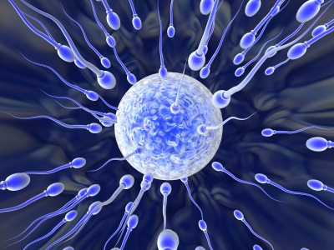](http://www.google.co.uk/url?sa=i&rct=j&q=eggs+and+sperm&source=images&cd=&cad=rja&docid=EYP6l7s-XEUNbM&tbnid=y1nbP3uQ0Kq6XM:&ved=0CAUQjRw&url=http://blog.f1000.com/2011/12/16/how-egg-greets-sperm/&ei=YJYYUZr9EKGs0QWQuIGwDw&bvm=bv.42080656,d.d2k&psig=AFQjCNHQYUGGGwrTv-eswPGrmuqyg3Bv3Q&ust=1360652247117286)**Short-term mating preferences**

There appear to be differences between males and females motivation for short term relationships or causal sex. The logic of sexual selection suggests that the more females a male manages to impregnate, the greater his reproductive success.

However the implications are greater for the woman as mating with a poor quality male would lead to poor quality offspring.

Clark & Hatfield (1989) conducted a study to investigate the differences in reproductive behaviour between men and women.

Attractive male and female experimenters approached total strangers on a university campus and said ‘Hi, I’ve been noticing you around campus and I find you very attractive’ and then asked them a series of questions

1. Would you go on a date with me?
2. Would you go back to my apartment?
3. Would you have sex with me?

None of the female students who were approached agreed to sex, although 75% of the males did! 69% of the men agreed to go back to the experimenter’s apartment. These sex differences (supported in subsequent research) provide strong evidence that men have evolved psychological mechanisms to ensure short-term mating success.

Men appear to lower their standards in the context of short term mating success (Buss & Schmitt, 1993) and then show a marked decrease in attraction following sex-an evolved adaptation to bring about a hasty departure which prevents them spending too long with one woman.

Explain how Clark and Hatfield’s study proves that “*Sperm are cheap and eggs are expensive*” ________________________________________________________________ ___________________________________________________________________________________________________________________________________________________________________________________________________________________________

**Evaluation of Clark & Hatfield**

* This study has been replicated in subsequent studies and so provides compelling evidence that men evolved psychological mechanisms to ensure success in short-term mating. These include
  + A desire for sexual variety
  + The tendency to let little time elapse before seeking sexual intercourse
  + A willingness to consent to sex with strangers.
* Ethical issues – Participants’ were deceived and could not give full informed consent

IDA: Explain why studying students on a university campus limits external validity. (social mobility, ability to meet new people, etc.) ________________________________________ ___________________________________________________________________________________________________________________________________________________________________________________________________________________________

IDA: Explain why propositioning strangers may lack internal validity. (social desirability bias, experimenter effects, etc.) ____________________________________________________ ___________________________________________________________________________________________________________________________________________________________________________________________________________________________

*Stretch and challenge: How could Clark and Hatfield’s study be adapted for homosexual couples?*

[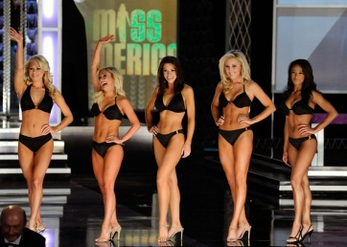](http://www.google.co.uk/url?sa=i&rct=j&q=signs+of+fertility+in+women&source=images&cd=&cad=rja&docid=KZcSjqy75cNzYM&tbnid=3YA17l8tdrPA8M:&ved=0CAUQjRw&url=http://therealrevo.com/blog/?p=81551&ei=X5wYUYScEcqJ0AWVnYGgDA&bvm=bv.42080656,d.d2k&psig=AFQjCNGBkYaiBH8yhgzALljUcqEisSp82Q&ust=1360653767263940)**Long-term mating preferences**

Sexual selection favours high levels of selectiveness in both sexes as both sexes have to invest long term in their offspring.

Poor long-term mate choice could result in wasted time and resources. As women have an obligatory biological investment in their children, they would be expected to be very particular about their choice of mate. They would be attracted to males who

* are able to invest and provide,
* are able to physically protect her and her children
* and show promise as a good parent (Buss, 2003).

However, people do not give away their resources indiscriminately, therefore males would be most attracted to females who display signals of fertility, an indication of their reproductive value.

[](http://www.google.co.uk/url?sa=i&rct=j&q=music+and+attraction&source=images&cd=&cad=rja&docid=Sl9mL8AR2F81PM&tbnid=rZ7CykbuZTRNjM:&ved=0CAUQjRw&url=http://www.tumblr.com/tagged/music%20taste&ei=VJ0YUbzdAaHE0QWU7IHICQ&bvm=bv.42080656,d.d2k&psig=AFQjCNHIBjgfTvgY6FdW3rHPZcZWMNwOtw&ust=1360654031425189)The signals of fertility that men may notice in women are ____________________________ __________________________________________________________________________________________________________________________________________________________________________________________________________________________________________________

**Male Strategies**

Courtship rituals (due to intrasexual selection)

* 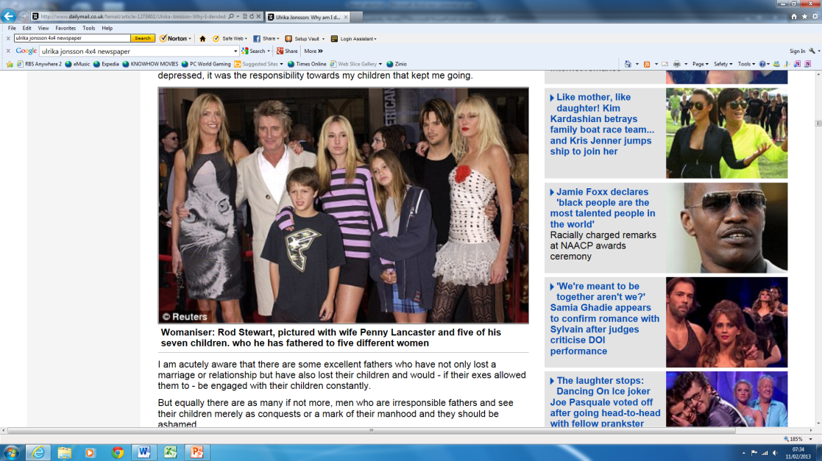Miller sees human culture as being shaped by evolution. Think about the reasons for art, humour, music? Could it be all about attracting sexual partners?

Size

* Men evolved to be bigger than females demonstrating strength for success in competition against other males

Jealousy

* May have developed to help reduce chance of cuckoldry (wasting resources on other’s children)

Promiscuity

* [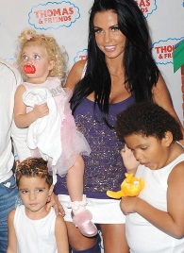](http://www.google.co.uk/url?sa=i&rct=j&q=katie+price+and+children&source=images&cd=&cad=rja&docid=IAelrjT-Faml_M&tbnid=HG8HJsQd0UQPEM:&ved=0CAUQjRw&url=http://thepricey.co.uk/katie-prices-love-life-rollercoaster-the-sun/&ei=ZJ8YUc-6Aq7a0QXF0IDICA&bvm=bv.42080656,d.d2k&psig=AFQjCNH-q0QZ2PWTAI4TChKvgnWKzKAFGg&ust=1360654557947565)Males tend to be willing to mate with someone outside of their partner

This is also good for the female to have multiple fathers for her children! Greiling and Buss (2000) suggest that she could profit in a number of ways:

* + Mate switching – to leave a poor quality relationship
  + Producing more genetically diverse offspring.

[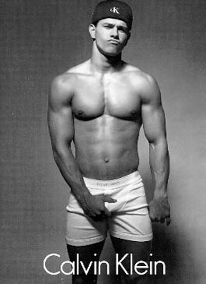](http://www.google.co.uk/url?sa=i&rct=j&q=bad+boys+celebrities&source=images&cd=&cad=rja&docid=oSkTrezKjj7RcM&tbnid=C47vVx8D7ocUXM:&ved=0CAUQjRw&url=http://www.ibeatyou.com/blog/2010/03/22/10-celebrities-most-likely-to-have-a-napoleon-complex/&ei=aKAYUeuyKYyo0AXOkoDgDg&bvm=bv.42080656,d.d2k&psig=AFQjCNFTTbzImceruxeGrxuOTkNqLynKWQ&ust=1360654807004675)**Female Strategies**

Sexy sons hypothesis

* Females choose attractive males so that they will produce equally attractive sons

Handicap hypothesis

* Zahavi (1975) believes women may favour men with handicaps because they have been able to survive despite difficulty so must have strong genes (bad boys?)

Courtship

* Female preference for long courtship (i.e. dating) requires males to invest time and effort making them less likely to leave.

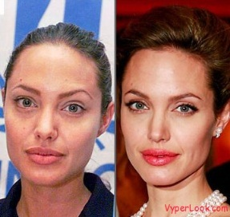Evaluation

* Evidence of males and females using strategies to maximise reproductive potential
  + Females often use deception:
    - 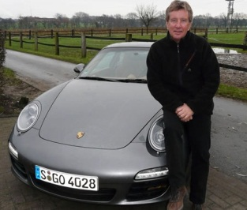to alter their physical appearance
    - to appear younger
  + Males use deceit to exaggerate their resource potential
* Research Buss (1989) studied 10,000 people (37 cultures, 6 continents) found:
* Women of all cultures preferred men with resources
* Men universally placed more emphasis on physical attraction
* Men of all cultures preferred partner younger than them
* Difficulty in in identifying and separating the effects of sexual selection from natural selection so research is hard to do
* There are other explanations for differences in sexual behaviour of males and females – especially gender role socialisation
* Evolutionary theory has problems explaining homosexuality – it assumes relationships are about producing children
* Most research has focussed on preferences rather than real-life choice – this affects its VALIDITY. However Buss (1989) studied real marriages and found many of these predictions are confirmed. Men do choose younger women etc.

IDA

Evolutionary theory can be accused of being **reductionist** in trying to explain reproductive behaviour in terms of gene survival and ignoring social, cultural and moral influences on our reproductive behaviour.

Evolutionary theory is also highly **deterministic**, which is dangerous as we forget that humans have the ability to think about their actions. Richard Dawkins believes we can override biology with freewill, e.g. evolutionary theory predicted that men who cannot attract a mate would resort to rape. While this does happen, the majority of single men would not entertain this idea.

BLT

Much of the evidence for evolutionary theory is based on presumed knowledge about past human environments leading to speculations about which behaviours may have been adaptive. As such evolutionary theory is very **difficult to test** experimentally.

Evolutionary theory of sexual selection is reductionist BECAUSE ___________________ ______________________________________________________________________ This LEADS to ____________________________________________________________________ _________________________________________________________________________________ THEREFORE _____________________________________________________________________ _________________________________________________________________________________

Evolutionary theory of sexual selection is deterministic BECAUSE ____________________________ _________________________________________________________________________________ This LEADS to ____________________________________________________________________ _________________________________________________________________________________ THEREFORE _____________________________________________________________________ _________________________________________________________________________________

Evolutionary theory of sexual selection is very difficult to test BECAUSE _______________________ _________________________________________________________________________________ This LEADS to ____________________________________________________________________ _________________________________________________________________________________ THEREFORE _____________________________________________________________________ _________________________________________________________________________________