What is a laboratory experiment?  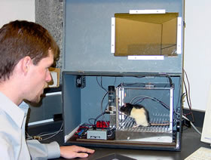 | Advantages:  Think about: control, extraneous variables, ethics, replicability, ecological validity.
Disadvantages:

Think about: control, extraneous variables, ethics, replicability, ecological validity.
What is a field experiment?  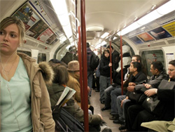 | Advantages:  Think about: control, extraneous variables, ethics, replicability, ecological validity.
Disadvantages:

Think about: control, extraneous variables, ethics, replicability, ecological validity.
What is a natural experiment?   | Advantages:  Think about: control, extraneous variables, ethics, replicability, ecological validity.
Disadvantages:

Think about: control, extraneous variables, ethics, replicability, ecological validity.
Describe the ‘independent measures’ experimental design.  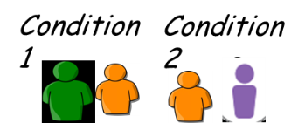 |  | When would it be used? What are the advantages/disadvantages?  Think about: Numbers of participants needed, order effects, individual differences, difficulties of matching.
Describe the ‘repeated measures’ experimental design.  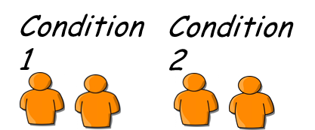 |  | When would it be used? What are the advantages/disadvantages?  Think about: Numbers of participants needed, order effects, individual differences, difficulties of matching.
Describe the ‘matched pairs’ experimental design.  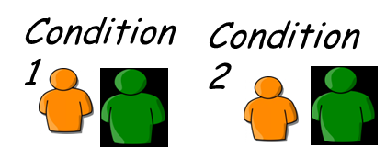 |  | When would it be used? What are the advantages/disadvantages?  Think about: Numbers of participants needed, order effects, individual differences, difficulties of matching.

What are the advantages of a questionnaire vs. an interview? | Think about: time, expense, depth of information, honesty.
What are the advantages of an interview vs. a questionnaire? | Think about: time, expense, depth of information, honesty.

What is a case study? | Advantages and disadvantages?

