1066 | 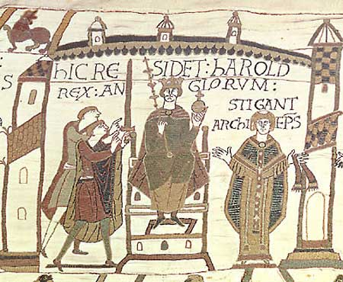 | 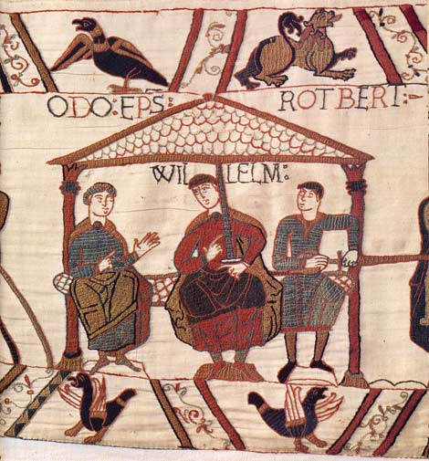
May | Harold guards south coast against attack by exiled brother Tostig. | William prepares his invasion fleet.
Aug |  | William’s invasion fleet ready to set sail.
Sept 8 | Supplies run out for Harold’s army. Harold sends army home for a while. | William waiting for a favourable wind to carry his fleet to England.
Sept 18-20 | Harald Hardrada lands on Yorkshire coast with over 500 ships. Harold gathers his army and marches north to fight Hardrada.
Sept 25 | Harold defeats Hardrada at Stamford Bridge.
Sept 27-29 |  | William’s fleet set sail after a change in the wind direction. The fleet lands at Pevensey, occupy Hastings and prepares for battle.
Oct 2 | Harold marches south again – covering 50 miles a day. But leaves his archers in the north.
Oct 6 | Harold arrives in London and gathers together a new army, mostly footsoldiers.
Oct 11-13 | Harold marches almost 60 miles to Hastings.
Oct 13 | Harold reaches Hastings with 7000 exhausted men.
Oct 14 | The battle of Hastings

Harold vs William – Who will win?
The run up to the battle

