Observing an aggressive model creates memories of the behaviour which are stored as schemas. E.g video games provide us with a script of how violent acts should be played out. This process is automatic.  Situational cues then trigger these aggressive schema in real life. | Cognitive priming | 
Frequent viewing of aggressive behaviour in the media reduces the sensitivity of the observer to aggression in the real world AND provides positive reinforcement for aggression. For example, computer games desensitise players to the effects of aggression (they become habituated to aggression, and have a lesser emotional response to it in the real world.) Less empathy is felt for victims and aggression becomes acceptable. | Desensitization  What is the impact on our nervous system? | 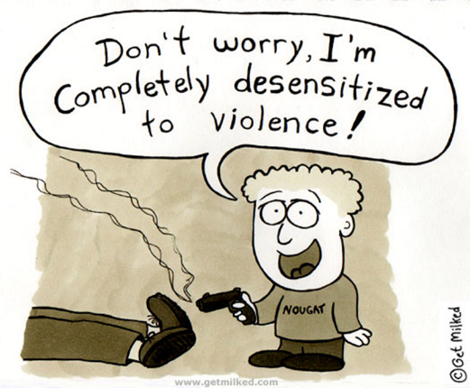 | Bushman (2009) – Ppts who had been playing violent video games for 20 mins took longer to help someone they witnessed be injured in a fight (confederates), than controls who had not been playing violent games. Suggests they were _______, as the injury did not affect them emotionally.  Christopher Earls conducted a lab experiment into desensitisation
This can occur through media sources, especially computer games, as people are anonymous (reduces responsibility for aggression), experience solipsistic introjection (becoming merged with a character in the media) and have reduced legal consequences for actions.  Can lead to uncharacteristic acts of aggression in real life, especially directly after engaging with the game/media.  Aggressive behaviour is normalised and effects of violence is seen as justified. Most video games see violence being rewarded and consequences ignored. | Disinhibition |  | Bandura et al. (1975) – reduced responsibility led to increased aggressive behaviour. Ppts were more likely to shock others to higher level in an experiment they believed to be on the effects of punishment on group decision making skills.

