1. Would the following situations produce random samples? If not, why not?
   1. Mark is conducting a survey for a magazine. He stops people at random on a Saturday morning at his local shopping centre.
   2. Granny Taylor’s National Lottery Numbers.
2. There are 10 competitors in an athletics event. Their names are:

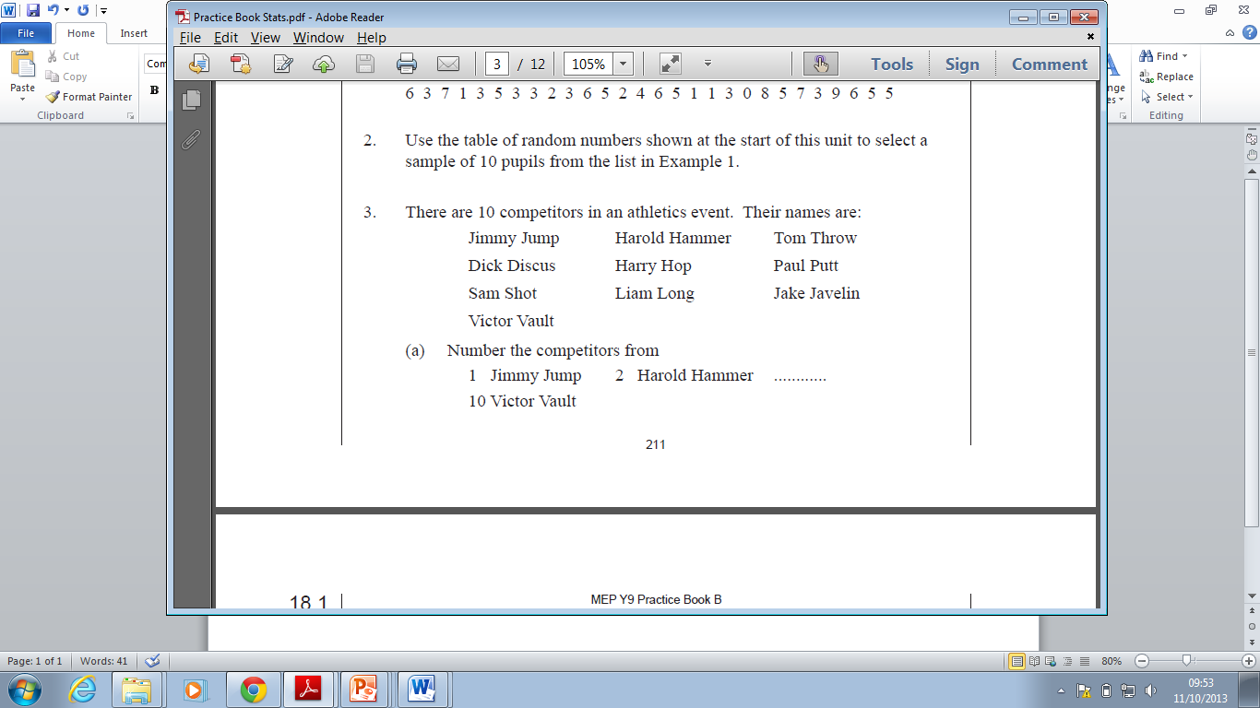

* 1. Number the competitors from
  2. 1. Jimmy Jump,
  3. 2. Harold Hammer…
  4. 10. Victor Vault
  5. Use the following list of random digits to select a random sample of 3 of the competitors for drug testing.

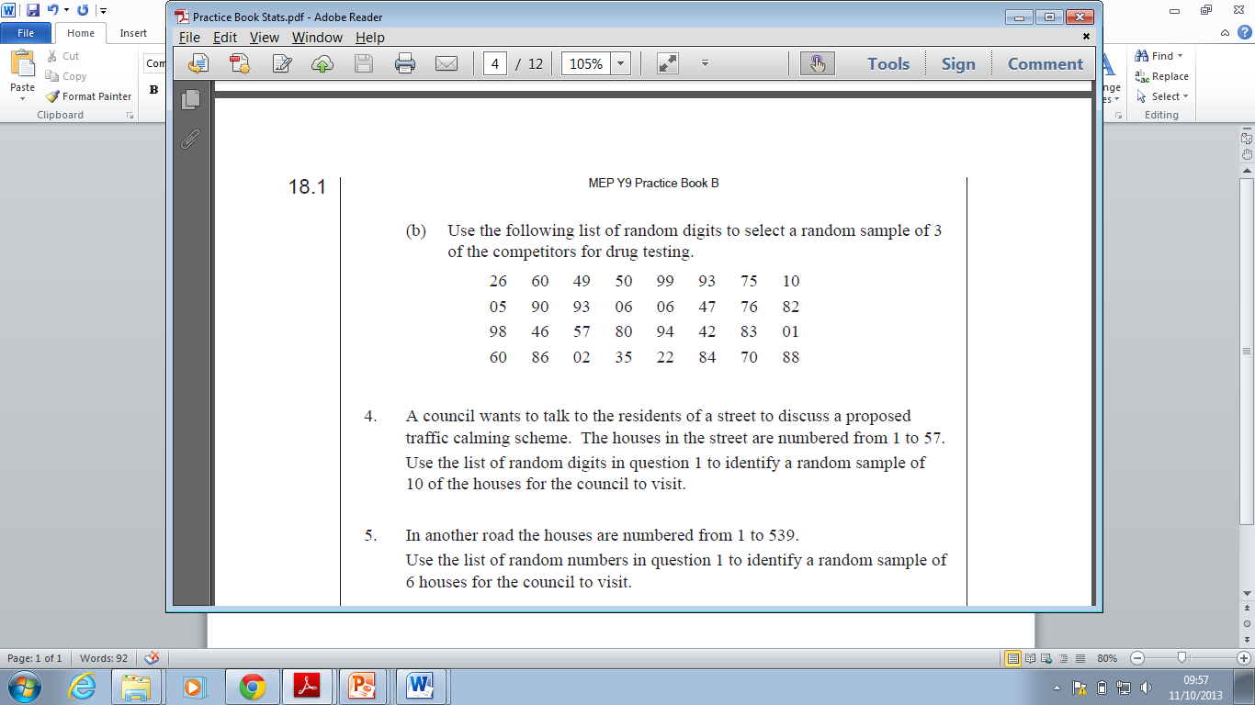

1. A council wants to talk to the residents of a street to discuss a proposed street party. The houses in the street are numbered from 1 to 57. Use the list below to identify a random sample of 10 to visit.

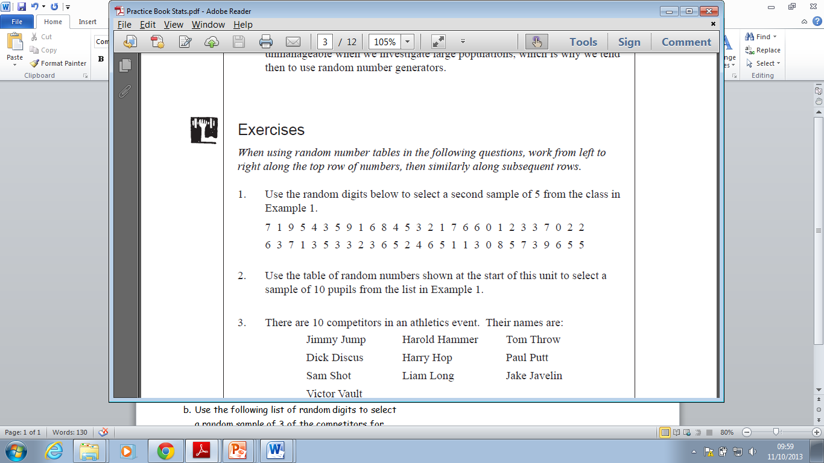

1. In another road, the houses are numbered from 1 to 539. Use the list of random numbers above to identify a random sample of six houses for the council to visit.

Extension Question



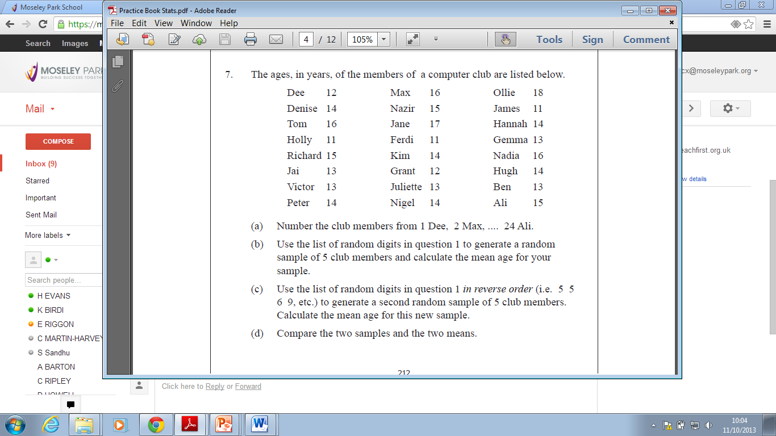

Extension Question



