**Punishment: Death by Beheading**

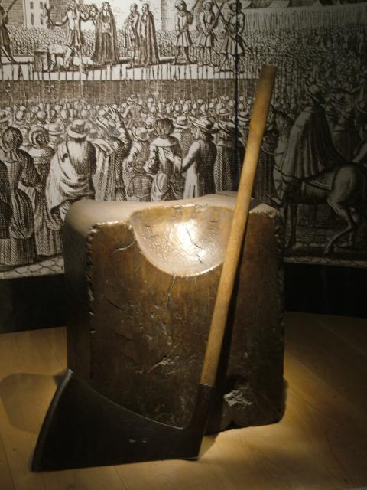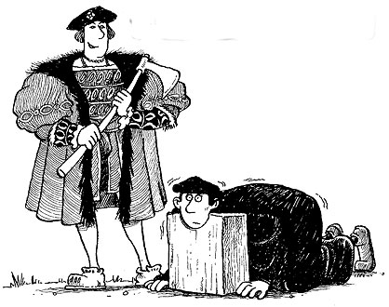The punishment of death by the axe was the most common form of execution and it was a terrifying prospect. The Tudor executioners often took several blows before the head was finally severed. The punishment of beheading was held in public and witnessed by many people. Following the execution by beheading the severed head was held up by the hair by the executioner. This tradition was not just to show the crowd the head, but also to show the head of the victim the crowd and to its own body. Consciousness remains for at least eight seconds after beheading, until the lack of oxygen causes unconsciousness and mercifully death. The heads of Tudor traitors were placed on stakes and displayed in public places such as on the ramparts of castles or such prominent spots like London Bridge.

Common crimes resulting in beheading:

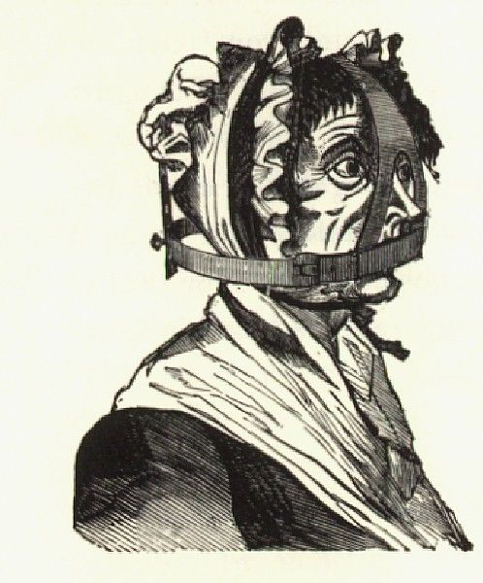**Punishment: Scold’s Bridle**

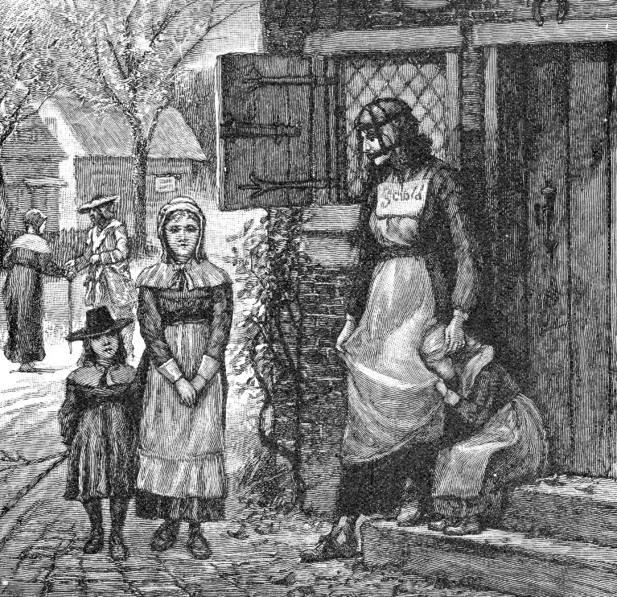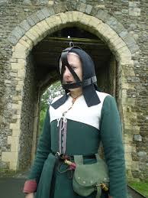A **scold's bridle**, sometimes called a **branks**, was an instrument of punishment used primarily on women, as a form of torture and public humiliation. The device was an iron muzzle in an iron framework that enclosed the head. An iron rod (curb plate) about 2 inches long and 1 inch broad, projected into the mouth and pressed down on top of the tongue. The curb-plate was frequently studded with spikes, so that if the offender moved her tongue, it inflicted pain and made speaking impossible. A **scold** was a species of public nuisance—a troublesome and angry woman who broke the public peace by regularly arguing and quarrelling with her neighbours. A shrew was seen to be repeatedly aggressive, nagging and violent in their demeanour with a ‘vicious bite’.

**Who was punished?** Wives who were seen as [witches](http://en.wikipedia.org/wiki/Witch), [shrews](http://en.wikipedia.org/wiki/Shrew_(archetype)) and [scolds](http://en.wikipedia.org/wiki/Scold), were forced to wear the branks/ scold’s bridle, locked onto their head.

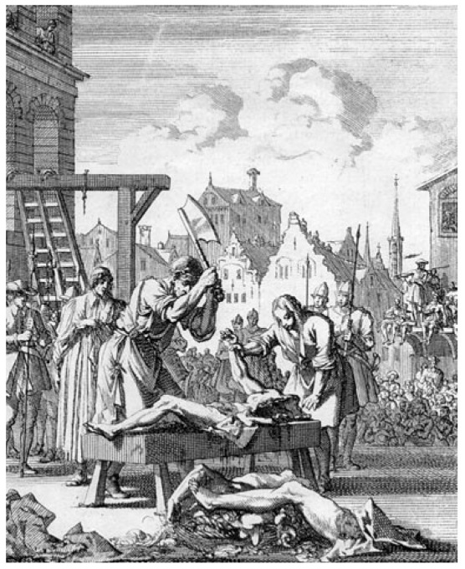**Punishment: Hanged, Drawn and Quartered**

Convicts were fastened to a [hurdle](http://en.wikipedia.org/wiki/Hurdle), or wooden panel/plank, and drawn by horse (dragged along behind the horse), to the place of execution, where they were [hanged](http://en.wikipedia.org/wiki/Hanged) (almost to the point of death), [emasculated](http://en.wikipedia.org/wiki/Emasculation) (private parts cut off, [dis-embowelled](http://en.wikipedia.org/wiki/Disembowelment), [beheaded](http://en.wikipedia.org/wiki/Decapitation) and [quartered](http://en.wikipedia.org/wiki/Dismemberment) (chopped into four pieces). Their remains were often displayed in prominent (important easily viewed) places across the country, such as [London Bridge](http://en.wikipedia.org/wiki/London_Bridge).

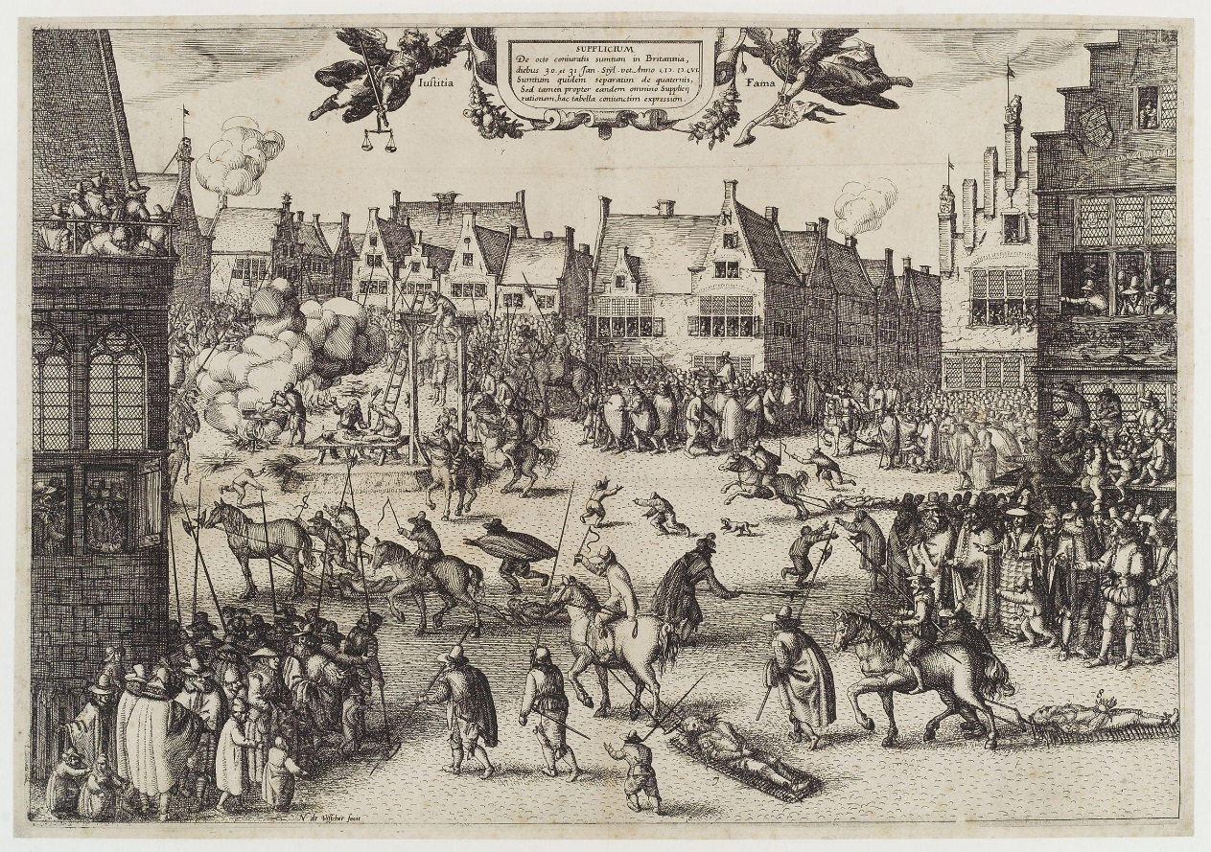Only men suffered this punishment, for example Guy Fawkes. For reasons of [public decency](http://en.wikipedia.org/wiki/Modesty), women convicted of high treason were instead [burned at the stake](http://en.wikipedia.org/wiki/Burning_of_women_in_England). People suffered this extreme act of punishment for crimes such as high treason as the severity of the sentence was [measured against the seriousness of the crime](http://en.wikipedia.org/wiki/Retributive_justice). As an attack on the monarch's authority, high treason was considered an unforgivable, disgraceful act demanding this most extreme form of punishment.

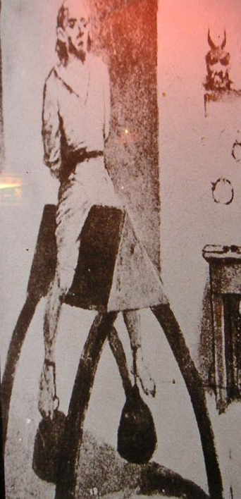**Torture: Spanish Donkey**

It was a [sharply angled wooden device](http://www.tripadvisor.com/LocationPhotoDirectLink-g188590-d244492-i32583779-Museum_of_Medieval_Torture_Instruments-Amsterdam_North_Holland_Province.html) of triangular shape, pointing upward, mounted on a horse-leg like support poles. The naked victim was then made to sit on the [main board](http://www.occasionalhell.com/infdevice/detail.php?recordID=Spanish%20Donkey) as if riding a horse, and various weights were attached to his or her feet, to increase the agony and prevent the victim from falling off.

According to historical sources, the wedge occasionally sliced entirely through the victim as a result of too much weight being attached to his or her feet.

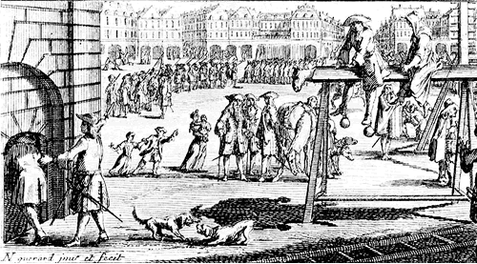More weights were applied until the prisoner confessed.

A torture first used in Spain, the idea was to destroy a victim’s genitals!

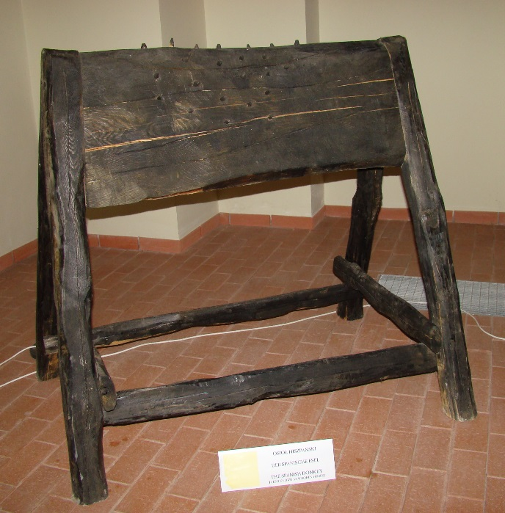Used for many crimes to get the victim to confess. Carried out both publicly and privately.

**Torture: The Press**

A prisoner would lay under strong wooden or metal boards whilst heavy stones were placed upon them. If a prisoner failed to own up to their crime, another heavy rock would b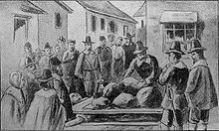e placed upon them.

One press operator once boasted that he knew a prisoner would not hold out for much longer, ‘When he heard his chest crack’.

"Pressing to death" might take several days, and not necessarily with a continued increase in the load.

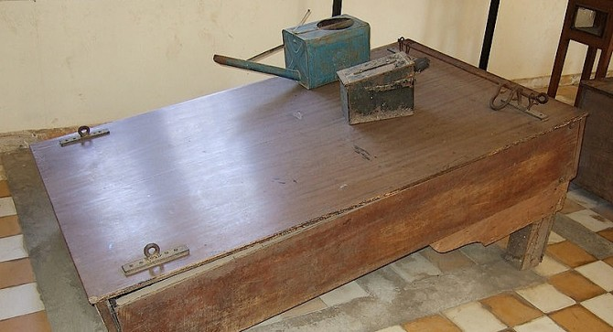

**Torture: The Rack**

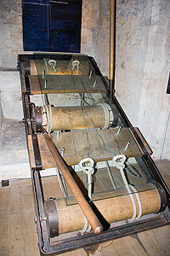The rack is a [torture](http://en.wikipedia.org/wiki/Torture) device consisting of a rectangular, usually wooden frame, slightly raised from the ground, with a roller at one or both ends. The victim's ankles are fastened to one roller and the wrists are chained to the other. As the interrogation progresses, a handle and [ratchet](http://en.wikipedia.org/wiki/Ratchet_(device)) attached to the top roller are used to very gradually stepwise increase the tension on the chains, inducing excruciating pain.

One gruesome aspect of being stretched too far on the rack is the loud popping noises made by snapping [cartilage](http://en.wikipedia.org/wiki/Cartilage), [ligaments](http://en.wikipedia.org/wiki/Ligament) or [bones](http://en.wikipedia.org/wiki/Bone). One powerful method for putting pressure upon prisoners was to force them to watch someone else being subjected to the rack.

There was only one rack in the whole of England which was kept in the Tower of London. One famous Tudor rack torturer boasted that his victims were usually a foot longer when he finished with them.

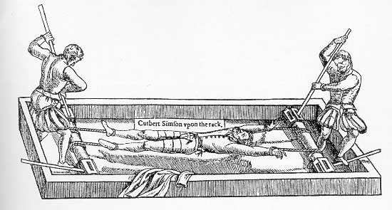

**Torture: The Judas Cradle**

The victim would presumably be placed in the waist harness above the [pyramid](http://en.wikipedia.org/wiki/Pyramid)-shaped seat, with their legs spread apart the points, then very slowly lowered by ropes. The subject is tortured by intense pressure, eventually succumbing to tears in muscle tissue that could turn septic and kill from infection, or simply being stabbed.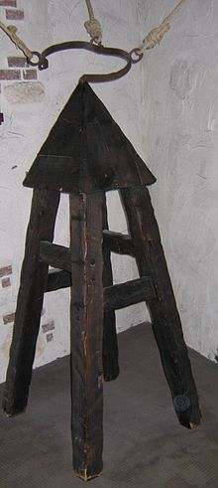

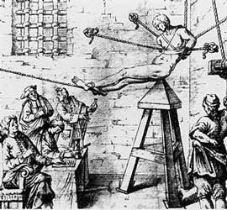Visitors to the Tower of London are usually told about this torture device and it usually gets the biggest gasps!

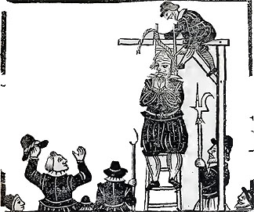**Why were punishments so harsh?**

Tudor England and Tudor Crime and Punishment. Crimes committed in the 15th and 16th century were met with violent and cruel punishments. Many of the punishments and executions of the Tudor period were witnessed by many hundreds of people. The poor Tudors treated such events as exciting days out. It was common practise for royalty and nobility to be subjected to this most public form of punishment or execution for their crimes. The execution of the tragic Queen Anne Boleyn was restricted to the members of the Tudor court and the nobles of the land, including close members of her family, but her execution was still witnessed by several hundred spectators.

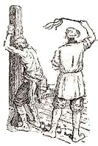There were no police during the Tudor times. However, laws were harsh and wrongdoing was severely punished. In Tudor times the punishments were very, very cruel. People believed if a criminal’s punishment was severe and painful enough, the act would not be repeated and others would deter from crime as well.

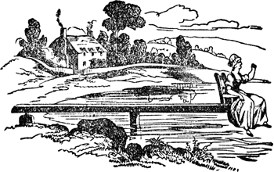

**Punishment: The Stocks**

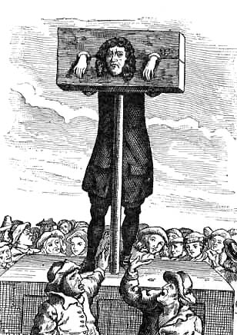 A form of [physical punishment](http://en.wikipedia.org/wiki/Physical_punishment) involving [public humiliation](http://en.wikipedia.org/wiki/Public_humiliation). The stocks and pillory partially immobilized its victims and they were often exposed in a public place such as the site of a market to the scorn of those who passed by. The stocks are similar to the [pillory](http://en.wikipedia.org/wiki/Pillory) and the [pranger](http://en.wikipedia.org/wiki/Pranger), as each consists of large, hinged, wooden boards; the difference, however, is that when a person is placed in the stocks, their feet are locked in place, and sometimes as well their hands or head, or these may be chained.

With stocks, boards are placed around the legs and the wrists in some cases, whereas in the pillory they are placed around the arms and neck and fixed to a pole, and the victim stands. However, the terms can be confused, and many people refer to the pillory as **the stocks**.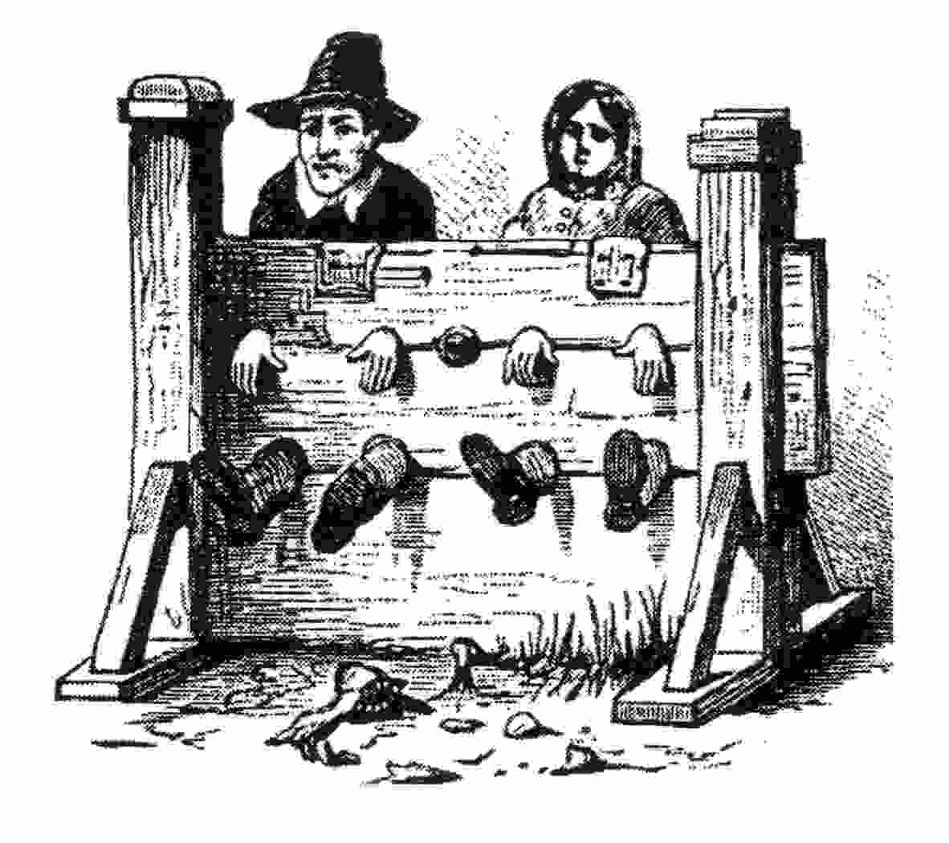Since stocks served an outdoor public form of punishment its victims were

subjected to the daily and nightly weather. As a consequence it was not uncommon for people kept in stocks over several days to die from [heat exhaustion](http://en.wikipedia.org/wiki/Heat_exhaustion) or[hypothermia](http://en.wikipedia.org/wiki/Hypothermia).