**Cognitive Psychology - Memory**

Cognitive Psychology is a branch of Psychology that is concerned with higher mental processes such as perception, language, problem solving and memory to name a few.  
Memory is central to our ability to function and also to all of our cognitive processes.

**The Multi-Store Model** (Atkinson & Shiffrin, 1968)

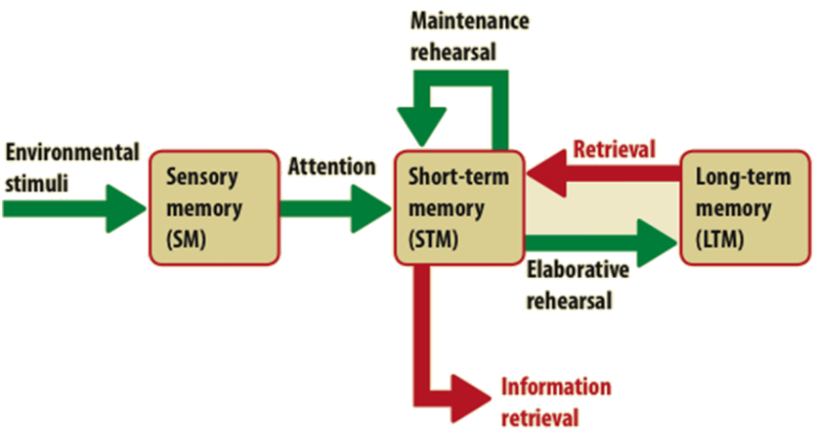

**Key Features**3 different types of memoryModel describes these as “memory stores”SM, STM, AND LTMAny stimulus you come across has been in one or more of these stores – in this sequence!Each store retains a different amount of info, in a different way, and for a different length of time.

* “DURATION”: how long this store can retain info for
* “CAPACITY”: how much info this store can retain
* “ENCODING”: the form in which the memory is retained

For us to remember a piece of info well, we need to:

* + Pay **attention** to it
    - This moves it from SM to the STM
  + **Rehearse** it
    - *Maintenance rehearsal* keeps it in our STM
    - *Elaborative rehearsal* can move it to our LTM

**Sensory Memory (SM)**

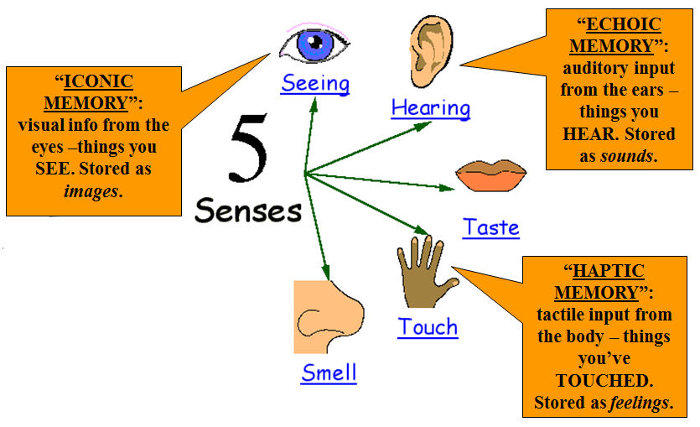External stimuli form the external environment entering our memory system is first registered in the sensory store.

This is a very brief, but large capacity, storage system that holds information for only a fraction of a second in whatever form it was received e.g. visual, sound etc. *Sperling* (1960) found that the SM holds at least 9 items of information, but only for a brief period of time.

The majority of stimuli being received by the sensory store is lost, as we cannot possibly pay attention to every piece of incoming information. Processing is mostly unconscious and can only be deduced from experiments.

**What is sensory memory for?**Baddeley (1988) suggests that it is there to give continuity to our visual environment. If you watch a television programme it appears as a continuous programme whereas in reality it is made up of a series of still, fixed images that are played in quick succession. Our sensory store holds onto each screen until the next one is presented giving the impression of continuity.

Another suggestion is that sensory memory is used to filter the larger amount of information being presented to the memory system to avoid overload.

**Short Term Memory (STM)**

Atkinson and Shiffrin (1968) see STM as a temporary storehouse for information passed from sensory memory en route to long term memory. Information in STM has to be rehearsed in order to be passed on to LTM.

***Encoding*:** Conrad (1964) Visually presented students with letters one at a time  
Found that: letters which are acoustically similar (rhyming) are harder to recall from STM than those which are acoustically dissimilar (non-rhyming)

This suggests that STM mainly encodes things acoustically (as sounds), even though the items were presented visually.

***Capacity:*** Miller (1956) found that the STM can hold ‘the magic number seven, plus or minus two’  
On average, the capacity of STM is between 5 and 9 items of information.

***Extending Capacity:*** Miller (1956) also found that the capacity of STM could be considerably increased by combining/organising separate ‘bits’ of information, e.g. letters or digits, into larger chunks.  
Chunking involves making the info more meaningful, through organising it in line with existing knowledge from your LTM - in this case, of abbreviations for qualifications.

*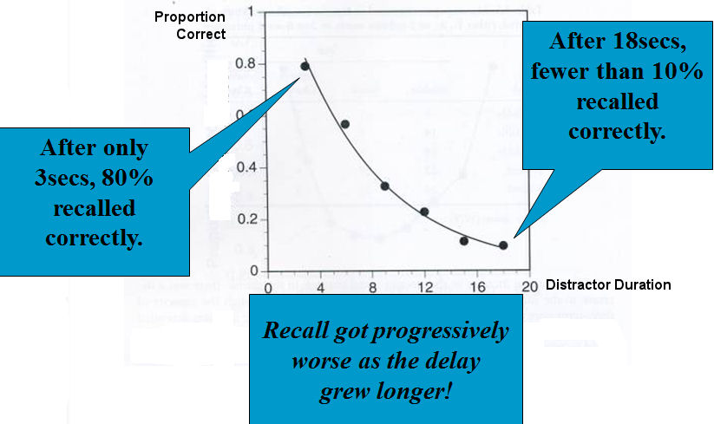****Duration:*** The duration for which STM can retain info is temporary.  
Not much research interest into this aspect, but some findings suggest only a few seconds before it fades/decays (unless we rehearse it).

*Peterson & Peterson (1959)*

What? - Students recalled combinations of 3 letters (trigrams), after longer and longer intervals. During the intervals, students were prevented from rehearsing by a counting task.

Found? - Capacity is 3 – 5 seconds without rehearsal.

Critical evaluation? - Limited sample size,  
Not representative – students minds are active, Lacks ecological validity.

**The Long Term Memory (LTM)**

LTM is a store that can ‘remember’ for a period of time lasting from minutes to a life-time. It has a huge capacity and seems to be able to store memories in a number of forms.

***Encoding:*** Although both visual and acoustic encoding are used in the LTM, (think of experiences such as the ‘tip of the tongue phenomenon’ and ‘déjà vu’), the evidence suggests that semantic coding is most important.

Baddeley (1966): What? - Presented lists of 10 short words one at a time. Some lists were semantically similar, others not. Participants tested immediately, and then after 20 min delay.  
Found? - After 20 mins, participants did poorly on the semantically similar words.  
Concluded? - This suggests that we encode LTMs according to what they mean – so we get similar-meaning things confused! Encoding in LTM is “semantic” – meaning-based.

***Capacity:*** Although it is not possible to quantify the exact capacity of LTM, it is safe to say that it is basically unlimited.  
***Duration:*** Bahrick et al (1975) refer to the LTM as a ‘permastore’. Their research looked at VLTM (very long term memory). They tested US graduates by showing them classmate photos years after graduation.  
Found? - 90% accuracy for remembering faces and names 34yrs after graduation. However, declined after 48yrs, particularly for faces, suggesting that age diminishes LTM.

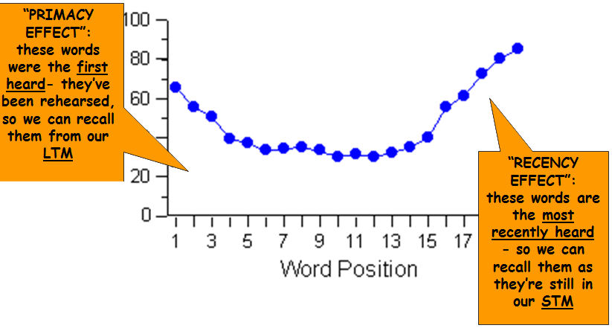Glanzer & Cunitz (1966) What? - Read out list of words to participants, and asked them to recall as many as possible.  
Found? – Participants recalled more from start and end of word list.  
Conclusions? - Supports the idea of there being a separate STM and LTM, because…  
The “serial position effect”

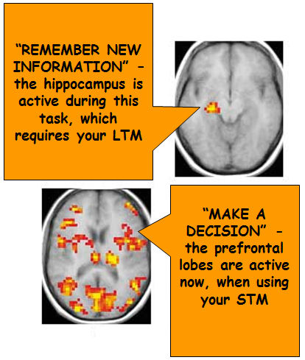Case Study Evidence:Most people with memory problems have either impairment of their STM or LTM, not usually both. This suggests that they are different systems.

There are several cases of patients who have suffered brain damage to their hippocampus and have memory deficits: e.g. H.M. and Clive Wearing.  
Their memory loss tends to be selective, as one store (STM or LTM), can function relatively normally, whilst the other is impaired. This supports the idea of separate stores for different types of memory

Brain Scanning Research:MRI scans show which parts of the brain are being used when certain tasks are carried out. MRI research shows different areas (stores) of memory, being used for STM and LTM memory task. These findings back up the existence of different stores for different memories.

|  |  |  |  |
| --- | --- | --- | --- |
|  | **Encoding** | **Capacity** | **Duration** |
| **Short Term Memory** | Acoustic | Magic Number 7 + or – 2 **(Miller)** | 15 Seconds  **(Peterson & Peterson)** |
| **Long Term Memory** | Semantically (**Baddeley)** | Unlimited | Unlimited **(Bahrick)** |

**Key Features**

* This model describes the structural features of memory rather than the processes
* It is an information processing approach
* Memory is seen as a flow of information through the system
* Information passes through the system in a fixed sequence and is linear
* Each store has its own characteristics in terms of encoding, capacity and duration.
* Information first enters the sensory store and if no attention is paid to it then it decays, if attention is paid to it then it passes to the short term store
* Memory traces in STM are fragile and can be lost through displacement (pushed out by other incoming information ) or decay if not rehearsed
* Rehearsed material is passed to LTM where it can stay for a lifetime – loss of information from this store is a result of retrieval failure of interference
* Coding in STM is thought to be acoustic and in LTM semantic
* Rehearsal is the key element to information being passed to LTM
* It is a structural model
* STM and LTM are unitary stores
* Information passes through each store in a linear way

**Strengths**

* There is experimental evidence that there is a distinction between STM and LTM e.g. the serial reproduction curve and brain scan evidence.
* There is case study evidence for the existence of separate stores e.g. HM and Clive Wearing.
* The multi store model was very influential and started a great deal of research into memory.

**Weaknesses**

* The model is too simplistic and inflexible e.g. in order to understand incoming information we rely on information and knowledge stored in LTM and therefore require a backward flow of information that this model doesn’t allow.
* Focuses on the structure of memory rather than explaining it.
* Cannot explain flashbulb memories or why we remember things we haven’t rehearsed.
* Rehearsal is too simple a process to account for the transfer of information from STM to LTM.
* Other studies e.g. Craik and Lockhart suggest that we remember things better if we process them at a deeper level.
* Doesn’t distinguish between different types of memory.