**Homework:**

1. Carefully read the story below.
2. Use the boxes to divide the story into different sections.
3. To fill in the boxes you need to use key words, people and place names from the story. You can also research additional details online.

At the start of 1066 Harold Godwinson was selected to be the new King of England. This made two men very unhappy, William of Normandy and Harald Hardraada. Both these men thought that they should be the new king of England.

Harold Godwinson knew his action would make him enemies and that they would invade England at some point. Therefore Harold Godwinson gathered together the largest army that England had ever seen. All through the summer of 1066 he kept his men and fleet of ships along the south coast of England waiting for William and his Norman army to come.

Harold Godwinson had to wait a very long time for William’s invasion because the wind was not blowing in the right direction so William could not sail across the English Channel. The Normans prepared very carefully for the battle. They brought with them from France a mixture of well-equipped infantry soldiers, archers and cavalry.

Suddenly Harold Godwinson heard bad news. Harald Hardraada, King of Norway had landed with a Viking army in the north of England. Even worse, Tostig (Harold Godwins half brother) had joined Hardraada in this attempt to take over England. Harold had to forget about William and go north to fight Hardraada.

Harold Godwinson marched his army north to Stamford Bridge where he fought and beat Harald Hardraada. This is the Battle of Stamford Bridge. More bad news reached Harold Godwinson. William of Normandy had landed in the south of England. Harold decided to march his exhausted men down to meet William. Many soldiers were left behind because they couldn’t keep up.

In the meantime William had found time to gather food and build a camp which was secure. The two leaders and their armies met at Hastings, the normally well prepared King Harold was not as ready as William. This would cost him a great deal.

**Before the battle - the English were not ready**

6) William arrives on the south coast.

5) The march South

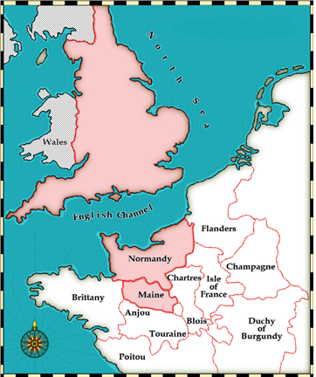

3) Harald Hardraada ………….

4) The Battle of Stamford Bridge.

2)

1. King Harold had been made King of………….. He gathered together……….

**After the Battle of Stamford Bridge:** Read through this source and explain what happened in your own words.

[**Anglo-Saxon Chronicle**](http://spartacus-educational.com/MEDchronicleAS.htm)**, D Version, entry for 1066.**

The Norwegians who survived took flight; and the English attacked them fiercely as they pursued them until some got to the ships. Some were drowned, and some burned, and some destroyed in various ways so that few survived and the English remained in command of the field. The king gave quarter to Olaf, son of the Norse king and all those who survived on the ships, and they went up to our king and swore oaths that they would always keep peace and friendship with this country; and the king let them go home with twenty-four ships.

**Your explanation:**

………………………………………………………………………………………………………………

………………………………………………………………………………………………………………

………………………………………………………………………………………………………………

………………………………………………………………………………………………………………

………………………………………………………………………………………………………………

………………………………………………………………………………………………………………

………………………………………………………………………………………………………………

………………………………………………………………………………………………………………

………………………………………………………………………………………………………………

………………………………………………………………………………………………………………

………………………………………………………………………………………………………………

………………………………………………………………………………………………………………