King Henry III – 1216-1272 | King Edward II – 1307 - 1327
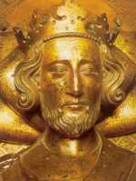 | 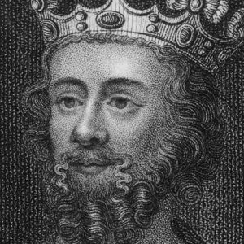
He lost wars in France.  Henry took an army to France three times to try to win back the land his father, John, had lost. Each time he failed. | He lost the war with Scotland.  In 1314 the English were defeated by the Scottish army at the battle if Bannockburn. People said Edward was a coward because he ran away from the battlefield.
He wasted money and demanded high taxes.  In 1258, Henry tried to have his second son, Edmund, crowned King of Sicily. Large sums of money were sent to the pope who controlled Sicily and decided who be king there. The attempt failed. | He caused people to suffer.  During 1315 and 1316 there were many storms in England. The harvest was ruined and people starved. Many people said it was the king’s fault. God was punishing the people for his bad behaviour.
He chose his favourites as advisors.  Henry ignored the advice of his English Barons. Instead he preferred the advice of the friends and relatives of his French wife. He gave them important jobs. The English barons were very angry. | He chose his favourites as advisors.  Edward chose first Piers Gaveston and then Hugh le Despenser as advisers. He took their advice, whether it was good or bad, on everything and rewarded them with lands and wealth. Gaveston treated the other barons as if he was a second king. These favourites were hated by everyone.
He treated people unfairly.  Henry was mean. For example, the people of London gave him a gift of a hundred pounds. But because he regularly received gifts from them, he had come to expect it. He was heard commenting, ‘I am not saying thank you to the people of London for not paying me what they owe’  Extension  Using the extra sources, can you compare King John to Henry III and Edward II?  Was he worse, better than or about the same as the others?  You also have an extra column on purpose of the source – instead of just saying if it is reliable or not, think about the providence of the source:  Who was it written for? Why was it written?  Does this affect the interpretation? | He treated his wife badly.  Edward often insulted his wife, Isabella, in public. In the end she led a rebellion against him.

