

Year 7 History
Revision Booklet

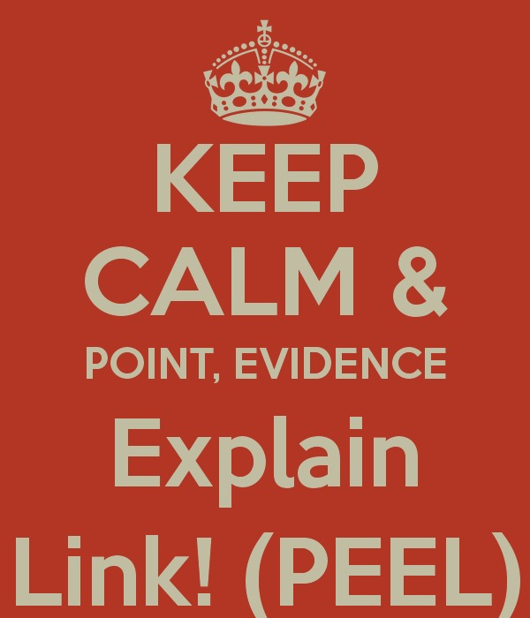

Name: ___________________________________
Class: ___________

REMEMBER

- Revise for a short periods of time – such as 25-35 minutes at a time.
- Write down the main points you need to remember.
- Persuade someone to test you, or set yourself a test.
- Reward yourself at the end of your revision sessions – play some football or have a quick game – but time this as well (you don’t want to get carried away!)
- After your break, settle down to another short period of revision.

The Exam
Your exam will be split into three sections:
- Factual recall
- A source question, which starts with: “Using the sources and your own knowledge…” so do just that. If you only use information from the source or your own knowledge, you will only get half marks!
- A longer essay worth 10 marks similar to questions we have answered in class ISTs.

Observe the sources and read the questions carefully. Make sure you understand what they are asking before you attempt the question!

How to structure your answers:

- Write a balanced answer.
- Use the structure “On the one hand…. On the other hand…,. I conclude that….. “
- By using this structure, and referring to all the sources and your own knowledge, you will write a balanced answer, which includes facts and your opinions based on what you know.
- Remember to consider the provenance (the origin) of sources:
- WHAT does the source tell us?
- WHEN was it produced? At the time? Years after? Centuries after?
- WHO wrote it?
- What is their Point of View?
- WHY was it produced?

Essay writing
- Read the essay title carefully.
- Your essay should contain:
- Point – where you describe the different events or make an observation from a source.
- Evidence – where you give your own knowledge or evidence from the source.
- Explanation – where you analyse the causes and/or consequences of these events
- Link - keep referring back to the question so that your answer is relevant.

Timings and what to do in the exam room

Keep Calm and Be Positive. Go into the exam determined to impress and adopt a really positive attitude.

DON’T PANIC: if you think you don’t know what to do, keep calm, breathe deeply and think about what you know and how you could use this. Keep an eye on the clock so you can plan your time.
Topic One: 1066 and the succession crisis

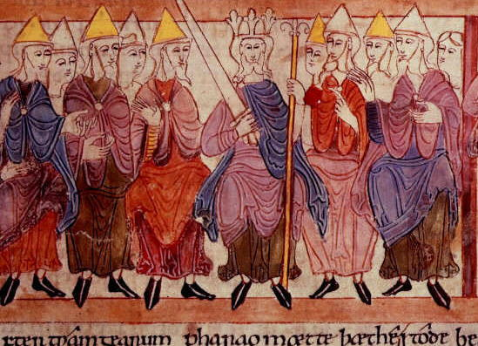
At the start of 1066, England was led by King Edward who was respected and loved by his people. Such was his saint-like lifestyle, that he was known as Edward the Confessor. Edward was a very religious man and he ordered the building of the first Westminster Abbey. However, when he died in January 1066, he left no heir to the throne.

The most powerful nobleman was Harold Godwinson and he was Earl of Wessex. He was not a blood relative of the king but he was heavily supported by other noblemen in the Witan (a council of England's most powerful nobles). He had been the leader of Edward the Confessor's army and he was experienced in government. It was said (by Harold) that Edward named Harold as his successor on his deathbed and that the most important noblemen in the country had agreed to his choice when they met as the King's Council - the Witan.

On January 7th 1066, just two days after Edward's death, Harold was crowned king by Archbishop Stigant. This was the time when a comet was seen over England - now known as Halley's Comet - and many believed that it was a sign of bad luck for England. When William heard of what Harold had done, it is said that he flew into a terrible rage of anger. Harold defended what he had done by claiming that William had forced him to make the promise and therefore it was done by blackmail and was not valid. William promised to take what he believed was his - the throne of England - by force.

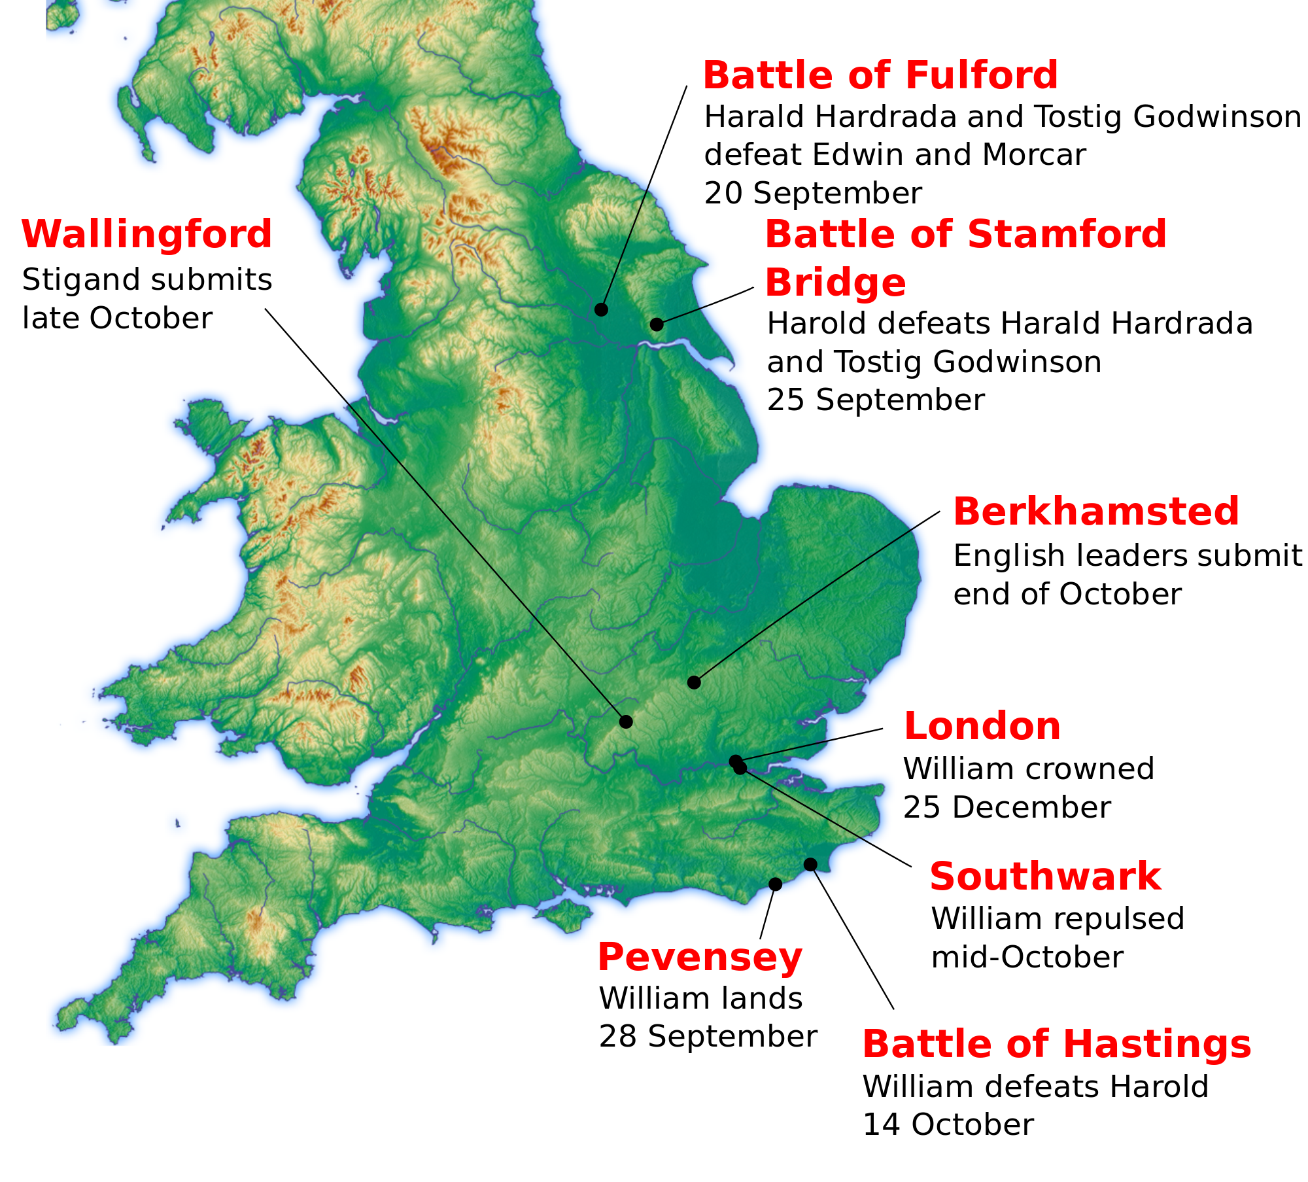
Regardless of who claimed what, William decided that he would have to fight for what he regarded as his - the throne of England. He ordered his knights to gather at Saint Valery on the Norman coast in preparation for a sea crossing.

Throughout July and August, Harold had expected William to attempt an invasion and Harold put his troops near to the Isle of Wight - where he felt William would land. However, some of Harold's army got tired of waiting and because they could not be fed, they went home. It was also the harvest season and many of Harold's men had farming commitments. At the start of September, Harold received news that Tostig and Harold Hardraada had landed with an army in the north of England. He marched north with his army to fight Hardraada.
The English army met the Norwegian army at the Battle of Stamford Bridge on 25th September. The battle was bloody and violent. The River Derwent, which flows near to the field where the battle was fought, was said to have turned red with the amount of blood that went into it. The mouth of the river as it enters the North Sea was said to have been blood red. Hadrada needed 300 ships to bring his army over to the north of England. Only 30 ships were needed to take the surviving Norwegians back. Harold had a major victory and Tostig, his untrustworthy brother, was killed along with Harold Hadrada. On 28t September, Harold heard the news that William had landed at Pevensey Bay in Sussex.

Here are the main events of the Battle of Hastings:
- Harold's brother, Gyrth, offered to lead the army against William, pointing out that as king he should not risk the chance of being killed. Harold rejected the advice and after five days Harold decided to head for the south coast without his northern troops.
- When Harold realised he was unable to take William by surprise he positioned himself at Senlac Hill near Hastings. Harold selected a spot that was protected on each flank by marshy land. At his rear was a group of trees. The English Housecarls provided a shield wall at the front of Harold's army. They carried large battleaxes and were considered to be the toughest fighters in Europe.
- The Fyrd were placed behind the Housecarls. The leaders of the Fyrd, the thegns had swords and javelins but the rest of the men were inexperienced fighters and carried weapons such as iron-studded clubs, scythes, slings, reaping-hooks and hay-forks.
- Historians have estimated that William had 5,000 infantry and 3,000 knights while Harold had about 2,500 Housecarls and over 6,000 members of the Fyrd.

Stage 1: At nine in the morning the Norman archers walked up the hill and when they were about a 100 yards away from Harold's army they fired their first batch of arrows. Using their shields, the Housecarls were able to block most of this attack. The Norman infantry then charged up the hill.
Stage 2: The English held firm and the Normans were forced to retreat. Members of the Fyrd broke ranks and chased after the Bretons. William ordered his cavalry to attack the English who had left their positions on Senlac Hill. English losses were heavy and very few managed to return to their place at the top of the hill.
Stage 3: At about twelve, noon, there was a break in the fighting for an hour. This gave both sides a chance to remove the dead and wounded from the battlefield. William, who had originally planned to use his cavalry when the English retreated, decided to change his tactics. At about one in the afternoon he ordered his archers forward. This time he told them to fire higher in the air. The change of direction of the arrows caught the English by surprise. The arrow attack was immediately followed by a cavalry charge. Casualties on both sides were heavy. Those killed included Harold's two brothers, Gyrth and Leofwine. However, the English line held and the Normans were eventually forced to retreat. The Fyrd, this time chased the Flemings down the hill. William of Normandy ordered his knights to turn and attack the men who had left the line. Once again the English suffered many casualties.
Stage 4: William decided to take another rest. He had lost a quarter of his cavalry. Many horses had been killed and the ones left alive were exhausted. William decided that the knights should dismount and attack on foot. This time all the Normans went into battle together. The archers fired their arrows and at the same time the knights and infantry charged up the hill.
Stage 5: It was now four in the afternoon. Heavy English casualties from previous attacks meant that the front line was shorter. The Normans could now attack from the side. The few Housecarls that were left were forced to form a small circle round the English standard. The Normans attacked again and this time they broke through the shield wall and Harold and most of his Housecarls were killed.
You will also need to know:
- Why was the battle fought?
- Why was William victorious?

Complete this chart:
William’s Skill | Harold’s Mistakes
Preparation | Luck and Other Reasons

REVISION QUESTION 1: Why was William victorious at the Battle of Hastings?
(10 marks)

William’s (I) control of England

There is a lot of debate about how King Harold died. One of the most popular sources for the events of the Battle of Hastings is the Bayeux Tapestry. Some people think that the tapestry shows King Harold with an arrow in his eye. Other people think that King Harold is actually the soldier whose leg is being cut off by a Norman knight.
Part of the difficulty is that the tapestry was made on the orders of Bishop Odo of Bayeux. Bishop Odo was the half-brother of William the Conqueror and would probably support the Norman side. The tapestry was also made about 1077, several years after the Battle of Hastings and some details could have been forgotten. Accounts of the battle which state that Harold Godwinson was killed by an arrow in his eye are produced after the Bayeux Tapestry, whereas accounts of Harold’s death that were produced before the Bayeux Tapestry do not mention him being hit by an arrow.
Once William had won the Battle of Hastings, he had to make sure that the English would obey him. One of the first things he did after becoming king, was to send his army north to put down any rebellions. His soldiers destroyed land and set fire to people’s houses. William wanted to teach the English a lesson that anyone who rebelled against him would die. If the English were afraid of him, they wouldn’t rebel against him.
The Harrying of the North refers to the brutal slaughter and pillaging of Northumbria in 1069-1070 by the army of William the Conqueror. This is thought to have been devastating to the extent that 100,000 people starved to death. The presence of the last Wessex claimant, Edgar Atheling had encouraged Anglo-Danish rebellions that broke the Norman hold in the North of England.
In particular, the Harrying of the North was a response to the strong resistance to Norman rule shown by the Northumbrian people. It was sparked by the murder of William’s newly-appointed earl, Robert de Comines, in 1069. Following the Harrying of the North, many of the key positions formerly held by the Anglo-Saxon nobles were given to Normans.
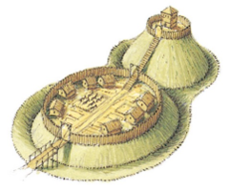
Another way in which William tried to make sure the English obeyed him was by building castles. Castles demonstrated that William and his followers were in charge and they also helped protect them against attacks from the English. The first types of castles were Motte and Bailey castles. These took between 7 and 14 days to build and they were made of wood. They were built wherever the Normans wanted them, even if it involved pulling down houses.
However these wooden castles had were easy to burn and also the wood kept having to be replaced because it rotted. So the Normans started to replace the Motte and Bailey castles with stone castles. Stone castles took longer to build and were more expensive, but they were also much stronger and offered greater protection from attack.
Although all the land in England belonged to the king, it was impossible for William to control England by himself. He needed landowners that he could help him protect the country from invasion, keep the English under control and collect taxes. He also needed to reward his followers who had fought at the Battle of Hastings.
William used the Feudal System to help him keep control of England. The word ‘feudal’ is Latin for ‘land’. Under this system, William still owned the land but he could ‘lend’ large areas of land to his followers (Barons) in return for their loyalty. The Barons could show their loyalty to William by paying homage and promising to provide him with knights to fight in his army.
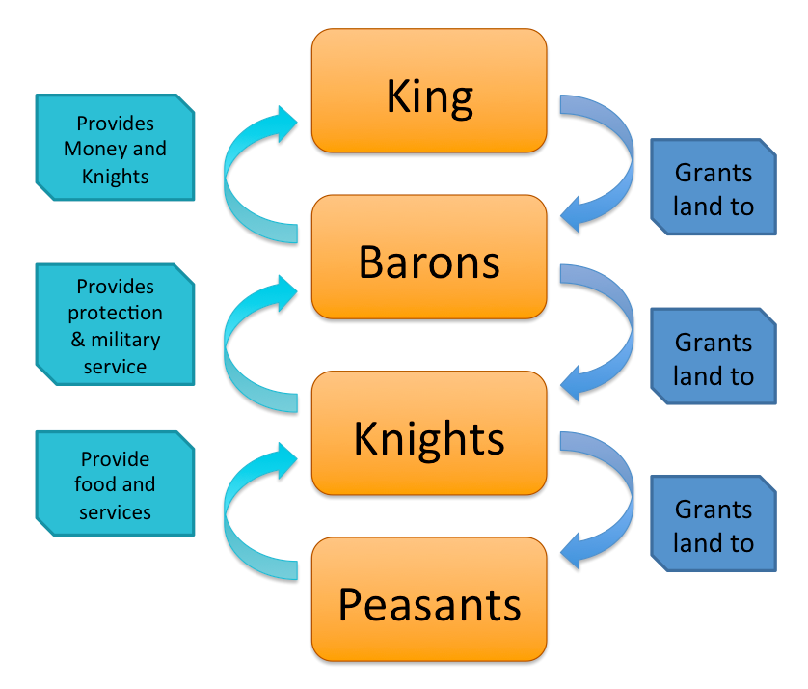
Like William, the Barons would also distribute some of their land to their followers (knights). In return for this land, these knights would promise to serve in the army for 40 days a year. Finally the knights would grant land to the villeins (peasants who were tied to the land) who would pay for the land by working for the knights.
William also needed to know how much England was worth. So in 1085 he sent officials all over England to interview villages and find out how much they owned. Soldiers went with the officials and threatened to kill anyone who lied. The results of these surveys were sent to Winchester and copied out in Latin into two books.

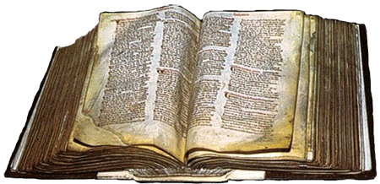
Originally the book was called the Winchester Book, but later it became known as the Domesday Book after ‘doomsday’ (the day of judgement) because people were not able to argue with what the book said. The Domesday Book was very important for King William, now he knew how much England could afford to pay in taxes, how many men he could get for his army and he could settle any arguments about who owned which bit of land.
Life in Medieval England was very different to today. Most people lived in small villages for their entire lives and farmed the land. If there was a bad harvest they could easily starve. Most land was farmed using an Open-Field System. The fields were divided into strips and each person had strips scattered across all fields. Each field would grow a different crop and the crops rotated each year so that the soil was not farmed too intensively. Every year, one field was left fallow (empty) to allow the soil to recover.
Some people lived in towns. There were not very many towns in Medieval England. When William became king in 1066, there were only ten towns in the whole country. Most towns had less than 2,000 people living in them. They were usually busy and smelly places – there was no sewerage system so most waste was left in the streets. Towns often grew near to a castle or a monastery (a monastery was a large building where monks lived and spent their lives praying and caring for others). This was because a castle could give the town protection if needed and being near a monastery meant that lots of people would visit town when they visited the monastery. Towns usually had a market once or twice a week and shops so people could come and buy what they needed or sell items that they had made.
It is very hard to find out about the lives of medieval peasants. Most lords didn’t think they were important enough to make records about them and usually villeins couldn’t read and write. In addition to this, their belongings and houses were usually of poor quality and would not have survived. Rich people in Medieval England had a much more comfortable life. They did not have to work all the time like the villeins and they were able to spend more time hunting and enjoying themselves.

REVISION QUESTION 2: How was William able to maintain control after his succession in 1066?
(10 marks)

Henry II and Thomas Becket

For people in England, there was always the real problem- do you obey the king or the pope? In fact, this was rarely a problem as both kings and popes tended to act together as both wanted to remain powerful. On two occasions they fell out - one involved the Archbishop of Canterbury, Thomas Becket, and the other Henry
VIII.

In 1162, Henry II, king of England, appointed Thomas Becket, as Archbishop of Canterbury. This was the most important religious position in England. No one was surprised by Henry’s choice as both he and Thomas were very good friends. They enjoyed hunting, playing jokes and socialising together. Becket was known to be a lover of wine and a good horse rider. Henry II loved to ride as well but his personality was troubled by his fearsome temper. He tried to keep his temper under control by working very hard as it distracted him from things that might spark his temper.

Henry II also controlled a lot of France at this time. William the Conqueror had been his great-grandfather and he had inherited his French territories as a result of this. When Henry was in France sorting out problems there, he left Becket in charge of England - such was his trust in him. Becket became Henry’s chancellor - the most important position in England after the king. When the Archbishop of Canterbury died in 1162, Henry saw the chance to give his close friend even more power by appointing him Archbishop of Canterbury - the most important church position in England. Why would Henry do this?

In Henry’s reign, the Church had its own courts and any member of the Church could decide to be tried in a Church court rather than a royal court. Church courts usually gave out easier punishments to churchmen who had done wrong. Henry believed that this undermined his authority. As king, he was concerned that England was becoming too lawless - there was too much crime. He believed that Church courts did not set a good example as they were too soft on offenders. For example, a royal court would blind or cut off the hand of a thief; a Church court might send a thief on a pilgrimage.

Henry hoped that by appointing his good friend Becket, he might have more of a say in how the Church punished offenders. He hoped that Becket would do as he wished and toughen up the sentences passed out by Church courts. Becket did not want the job. As chancellor, he was as powerful as he wished to be. He also had an excellent relationship with Henry, and he did not want to spoil this. In fact, on being offered the post, Becket wrote to Henry that "our friendship will turn to hate." However, Henry persuaded Becket and he agreed in 1162 to the appointment. His letter was indeed to become prophetic.

The post of Archbishop changed Becket. He dropped his luxurious lifestyle; he ate bread and drank water, he had a luxury bed but preferred to sleep on the floor; he wore the rich clothes of an archbishop, but underneath the fine tunics he wore a horse hair shirt - very itchy and unpleasant to wear. He gave his expensive food to the poor.

In 1164, the first sign of a split between Henry and Thomas occurred. The Constitutions of Clarendon represent an attempt by Henry II to exert state control over the Church in England. During the turmoil of the Civil War the church had extended its sphere of influence, and Henry was doing his best to reverse that trend. Constitutions were composed of 16 articles, which laid out the extent of papal influence in the realm and the degree to which church members were subservient to the crown and English legal custom. The majority of the Constitution was simply a restatement of English custom and practice, but severe controversy erupted over two clauses which made "criminous clerks" (i.e. clerics accused of a crime) answerable to the legal authority of crown courts rather than ecclesiastical courts, and prevented appeals to the church in Rome without royal permission.
The church leaders in England, including Archbishop of Canterbury Thomas a Becket, reluctantly agreed to the provisions. When Pope Alexander condemned the agreement, Becket reversed his field and also condemned the Constitutions.
This led to bitter conflict between Becket and Henry and knowing of Henry’s temper, he fled abroad for his own safety. It took six years before Becket felt safe enough to return to England. However, they quickly fell out again when Becket asked the pope to excommunicate the Archbishop of York who had taken sides with the king. This was a very serious request and a very serious punishment for someone who could claim that he was only being loyal to the king.
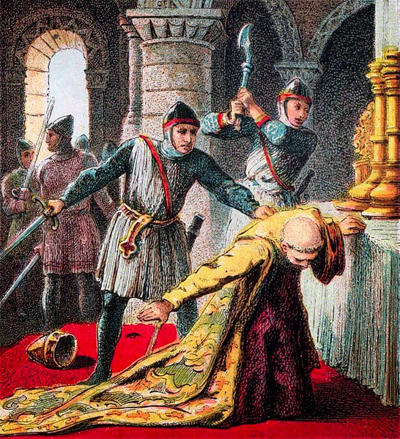
Henry was furious when he found out what Becket had done. He is said to have shouted out "will no-one rid me of this turbulent priest?" Four knights heard what Henry had shouted and took it to mean that the king wanted Becket dead. They rode to Canterbury to carry out the deed. The knights were Reginald FitzUrse, William de Tracey, Hugh de Morville and Richard le Breton. On December 29th 1170 they killed Becket in Canterbury Cathedral. After killing him, one of the knights said "Let us away. He will rise no more." Becket’s body was still on the cathedral floor when people from Canterbury came in and tore off pieces of his clothes and then dipped these pieces in his blood. They believed that they would bring them luck and keep evil away.

The burial of Becket
Where Becket died quickly became a place of pilgrimage. The pope quickly made him a saint. Henry II asked the pope for forgiveness and he walked bare foot to Canterbury to pray at the spot where Becket was killed. Monks whipped him while he prayed. People left valuables at the spot of his death. It became a shrine to him and people claimed that a visit to the shrine left them free of illness and disease. No one dared to touch the valuables there until Henry VIII shut down the monasteries and churches and took away any valuables he wanted. It took 21 carts to remove the valuables from Becket’s shrine at Canterbury Cathedral.

Complete this chart:
Explain why the two men argued: | Explain who you believe won the argument:

REVISION QUESTION 3: Did Thomas Becket want to die a Martyr?
(10 marks)
King John

King John was born in 1167 and died in 1216. Like William I, King John is one of the more controversial monarchs of Medieval England and is most associated with the signing of the Magna Carta in 1215.
John was born on Christmas Eve, the youngest son of Henry II and his wife Eleanor of Aquitaine. As a child,
John tended to be overshadowed by is older brother Richard. Like his father, John developed a reputation for violent rages, which lead to him foaming at the mouth. Henry left no land to John when he died so John was given the nickname John Lackland. In 1189, all of Henry's territory went to his oldest son, Richard I, better known as Richard the Lionheart.

In 1191, Richard left England to embark on the Third Crusade. He left John in charge of the country. John's reputation as a leader had been severely dented as far back as 1185 when Henry II sent him to Ireland to rule. John proved to be a disaster and within six months he was sent home. In 1192, Richard was imprisoned by Duke Leopold of Austria as he returned from the Crusades. John tried to seize the crown from his brother but failed. In 1194, when Richard finally returned to England, John was forgiven by his brother.

In 1199, Richard was killed in France and John became the king of England. His reign started in an unfortunate way. In 1202, John's nephew, Arthur of Brittany, was murdered. Many in Brittany believed that
John was responsible for his murder and they rebelled against John. In 1204, John's army was defeated in
Brittany and John had no choice but to retreat. His military standing among the nobles fell and he was given a new nickname - John Softsword. The defeat in north France was a major blow for John and a costly one. To pay for the defeat, John increased taxes which was not popular with anybody other than John and his treasurers.

John also succeeded in falling out with the pope in 1207. John quarreled with the pope over who should be Archbishop of Canterbury. The pope excommunicated John and put England under a Church law that stated that no christening or marriage would be legal until the time the pope said that they would be. Church law said that only christened people could get to Heaven while children born out of marriage were doomed to
Hell. This placed people in England under a terrible strain and they blamed one person for this - John.
In 1213, John had to give in and surrender the spiritual well being of the whole country to the pope. However, the pope never fully trusted John and in 1214, the pope proclaimed that anybody who tried to overthrow John would be legally entitled to do so. In the same year, John lost another battle to the French at Bouvines. This defeat resulted in England losing all her possessions in France. This was too much for the powerful barons in
England. In 1214, they rebelled.

John was forced to sign the Magna Carta at Runnymede in 1215. This guaranteed the people of England rights that the king could not go back on. In 1216, John tried to go back on the Magna Carta but this only provoked the barons into declaring war on him. By 1216, John was ill. During the war, he suffered from dysentery. He also lost all of his treasure when he tried to take a shortcut across a stretch of water in the
Wash, Lincolnshire. As the tide rose faster than he expected, his baggage train was engulfed. Just a few days later, John died and was succeeded by Henry III.

Despite the obvious failings of John, there is still some evidence that he was not as bad as some have tried to make him out to be since his death. It certainly was not uncommon for kings to have their names tarnished when they were not alive to defend themselves!
Magna Carta

The Magna Carta was signed in June 1215 between the barons of Medieval England and King John. 'Magna Carta' is Latin and means "Great Charter". The Magna Carta was one of the most important documents of Medieval England. It was signed (by royal seal) between the feudal barons and King John at Runnymede near Windsor Castle.
The document was a series of written promises between the king and his subjects that he, the king, would govern England and deal with its people according to the customs of feudal law. Magna Carta was an attempt by the barons to stop a king - in this case John - abusing his power with the people of England suffering.
Why would a king - who was meant to be all-powerful in his own country - agree to the demands of the barons who were meant to be below him in authority?

England had for some years owned land in France. The barons had provided the king with both money and men to defend this territory. Traditionally, the king had always consulted the barons before raising taxes (as they had to collect it) and demanding more men for military service (as they had to provide the men). This was all part of the Feudal System.

So long as English kings were militarily successful abroad, relations with the barons were good. But John was not very successful in his military campaigns abroad. His constant demands for more money and men angered the barons. By 1204, John had lost his land in northern France. In response to this, John introduced high taxes without asking the barons. This was against feudal law and accepted custom.
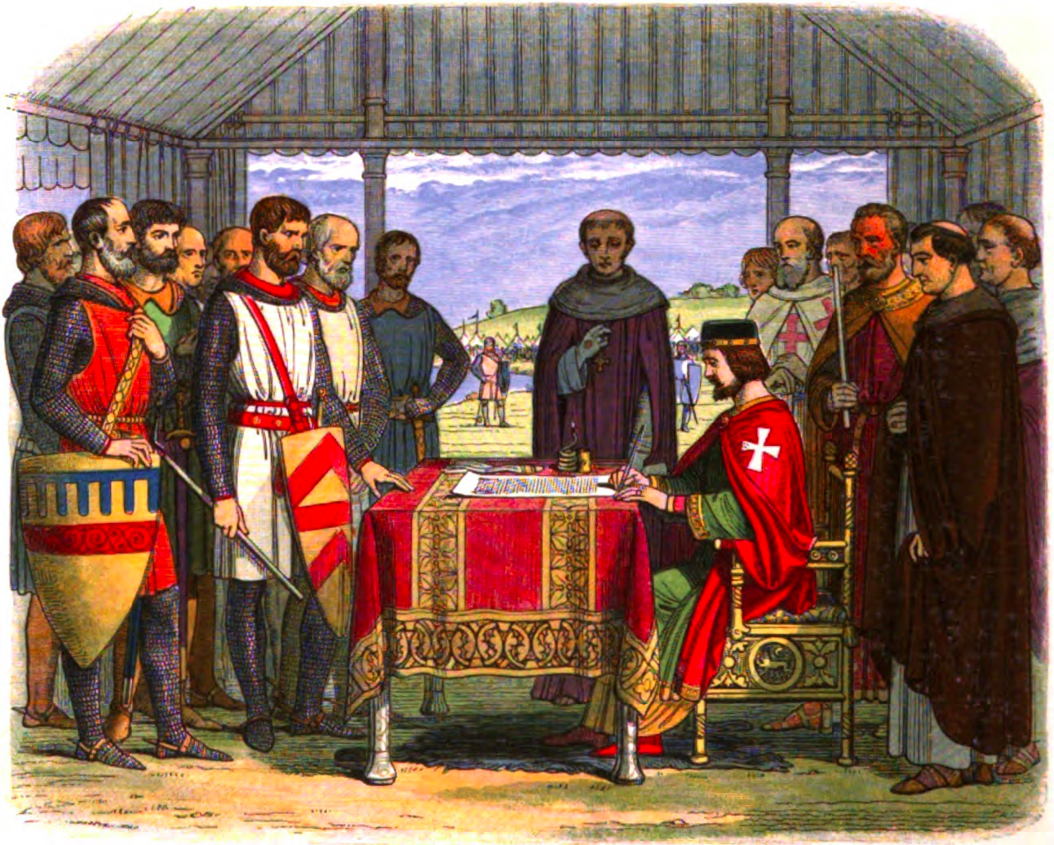
John made mistakes in other areas as well. He angered the Roman Catholic Church. The pope, vexed by John's behaviour, banned all church services in England in 1207. Religion, and the fear of Hell, were very important to the people including the barons. The Catholic Church taught the people that they could only gain entrance to Heaven if the Catholic Church believed that they were good enough to get there. How could they show their goodness and love of God if the churches were shut? Even worse for John was the fact that the pope excommunicated him in 1209. This meant that John could never get to Heaven until the pope withdrew the excommunication. Faced with this, John climbed down and accepted the power of the Catholic Church, giving them many privileges in 1214.

1214 was a disastrous year for John for another reason. Once again, he suffered military defeat in an attempt to get back his territory in northern France. He returned to London demanding more money from taxes. This time the barons were not willing to listen. They rebelled against his power. The barons captured London. However, they did not defeat John entirely and by the Spring of 1215, both sides were willing to discuss matters. The result was the Magna Carta.
REVISION QUESTION 4: Was King John an evil ruler or just unlucky?
(10 marks)
The Black Death

You will need to know:
- What was the Black Death?
- How the Black Death was caught and spread
- What people believed caused the Black Death
- How people tried to prevent and cure it
- The consequences of the Black Death: how it affected England

What was the Black Death and how was it caught?
The Black Death was a combination of two diseases: the bubonic and the pneumonic plague. This led to death by septicemia – blood poisoning.

Bubonic plague was a bacterium, which lives in the gut of a black rat. A flea would bite the rat and ingest the bacterium. This would multiply in the flea until its digestive system became blocked. This would cause it to become hungry so it would to another animal to feed – a human. The flea would bite the human but would vomit and excrete into the bite. The human would scratch the bite and so rub the bacterium into their body. Large black swellings – or buboes – would cover the body and become hot with infection. The patient would have a fever, headache and feel nauseous. Within 7 to 10 days the nervous system had shut down and the patient would die. You had a 30% (1 in 3) chance of survival.

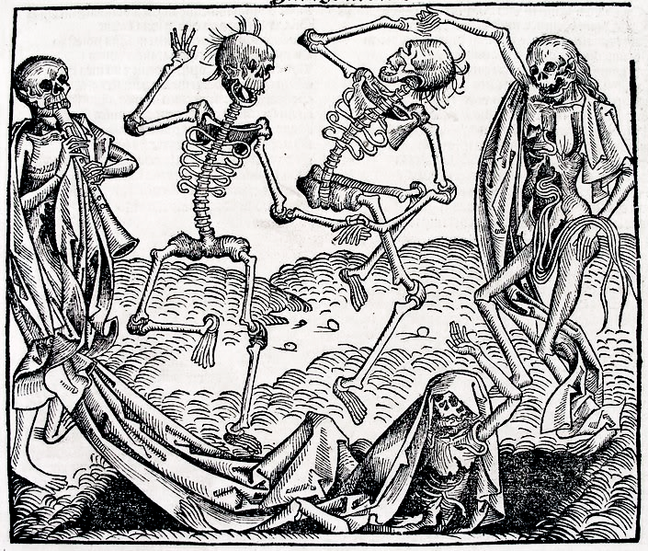
Pneumonic Plague was an airborne virus, which would be inhaled and would attack the lungs. The patient would have a fever and would cough up blood and pus – spreading the virus as they did so. Death came within 3 very painful days and the survival rate was less than 1% (1 in 100).

The disease originated in China and spread through trade routes with the East. The Black Death entered England in Melcombe, Dorset in June 1348. It had arrived in grain ships from France. The disease spread very quickly. As people did not know what caused the disease, they did nothing to contain it. People lived happily amongst rats and fleas and their houses were built of materials which rats loved – straw, wood and mud. Without knowing, people would spread the disease and share their homes with plague victims. Travellers and traders would spread the disease around the country.

What did people believe caused the plague?
As people had little or no actual medical or biological knowledge, they did not know what actually caused the plague. Some ideas were:
- The alignment of the planets in the sky
- Miasma – bad air and its smell
- Volcanoes
- Jews poisoning the water
- A punishment from God for mankind’s sins
- Touching victims or their clothing
- Spread by looking at a plague victim
How did people try and cure and prevent the disease?
Remember, nobody knew what caused the plague at the time so the remedies are not based on any medical knowledge.
- Towns and cities would quarantine themselves and stop people leaving or entering
- Victims’ clothes were burned
- People prayed for forgiveness and some people – flagellants – whipped themselves so as not to receive God’s punishment
- Church bell were rung to circulate fresh air
- Jews were rounded up, particularly in Germany, and killed
- Peculiar cures were created using sweet smelling produce e.g. marigolds and lilies
- Laws were passed to keep the streets clean
- Patients were ‘bled’ by cuts or leeches

What were the effects of the Black Death?
The effects were devastating and wide-ranging and can be divided into roughly three sections: social, economic and religious.

Social: one third to one half of the population was simply killed. Families were devastated and whole villages were killed which led to their desertion. People could not cope with the large numbers of dead bodies and many were slung into mass graves.
Economic: many workers were killed and there was a labour shortage, which led to a subsequent famine as there were hardly any workers to gather in the harvest. With food scarce, there was great inflation and, in some instances, produce rose 400% in price. In light of this, surviving peasants demanded higher wages for their work. If their lord refused, they would find another lord who was prepared to pay. This started the breakdown of the feudal system and the surviving peasants found themselves cash-rich and with more freedom. However, lords and government were keen to put them “back into place”. Rents were raised and in 1351 the government issued the Statute of Labourers, which put wages back to pre-plague levels and forced everybody back to their original lands in fear of being fined or imprisoned. With fewer workers, new ideas about farming were introduced and landlords started rearing sheep as this required fewer workers; England’s future wool trade is based on this.
REVISION QUESTION 5: How did the Black Death change life in England?
(10 marks)
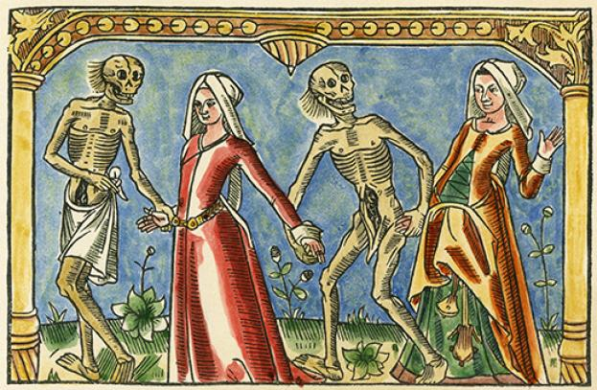
Religious: The Church was one of the worst hit sectors. They lost huge numbers of clergy as they had such great exposure to plague victims; three Archbishops of Canterbury also died. Due to this shortage of clergy, untrained people had to take services and confession – even women, which was unheard of at the time. As these clergy were untrained, English became the language of the church, rather than Latin. Colleges – e.g. Winchester – were founded to re-educate clergy. People’s beliefs changed: some still saw this as a punishment from God and the plague strengthened their faith; others questioned their belief in God. As you can see, there were short term and long term consequences, one of which was…

The Peasants Revolt – 1381

You will need to know:
- What were the causes of the Peasants Revolt?
- What were the main events of the Peasants’ Revolt, both before and in London?
- The meetings between Wat Tyler and Richard II
- The consequences of the revolt
- A consideration of who won in the short term and the long term

What were the causes of the Peasants’ Revolt?
- The Black Death: survivors of the Black Death experienced greater freedom and wealth than they had ever had. In 1351, this was taken away by the Statute of Labourers, which angered peasants.
- The Church: Resentment was growing with the church as people had to spend 2 day a week working on church lands, for which they received no pay. Preachers like John Ball were preaching radical ideas like equality – “When Adam delved (dug) and Eve span, who then was the gentleman?”
- War with France: The Hundred Years War had been fought since 1337. After a good start, England had suffered defeats and had experienced raids on the English coast: people feared for the future.
- The Poll Tax: to fund this war, the government raised the poll tax. This tax was collected three times and, even though efforts were made for the wealthy to pay more, everybody over the age of 14 had to pay the same, which was considered unfair. Also, the tax rose 300% in the three times it was collected.
- Government: the king at the time – Richard II – was a young king of only 14 years old. People resented his advisors who, they believed, were leading king astray and guiding him unwisely.

What were the main events of the Peasants’ Revolt?
The revolt started in May 1381 when tax collectors arrived at the Essex village of Fobbing. They were attacked and thrown out of the village. When they returned with troops, they were also attacked. Word started to spread and villagers started joining together.
In June 1381, peasants from Kent, who were now lead by Wat Tyler, captured Canterbury and burned tax records. They were hoping to capture Simon of Sudbury, the Archbishop of Canterbury, as he was the man who created the Poll Tax. Simon was in London so the rebel appointed a simple monk as their new Archbishop. Also in Kent, John Ball was freed from Maidstone prison. The peasants marched on London to meet with Essex rebel and seek a meeting with the king to air their grievances. As they marched, they attacked manor houses and destroyed any records of tax payments and labour services. By 12th June, about 60000 peasants were camped outside London.

Richard decided to meet with the rebels so, on the 13th June, he was rowed out of London along the Thames to meet the peasants at Rotherhithe. He took with him Simon of Sudbury and Robert Hales – his treasurer. As soon as the peasants saw that the king had brought these men, they started shouting “traitor, traitor!” and throwing missiles. Richard retreated.
Richard took refuge in the Tower of London but, that night, the citizens of London allowed the peasants into the city. They went on the rampage; freeing prisoners, burning palaces and attacking lawyers.
The next day, Richard arranged to meet the rebels at Mile End. He met with Wat Tyler and listened to his demands. Tyler wanted:
- An end to serfdom
- The abolition of all labour services
- Death to all traitors (king’s advisors)
- Pardons for all rebels taking part
Richard agreed to all of these except death to traitors, as he said only courts had the power to sentence men to death. Richard had 30 clerks waiting to draw up charters of freedom so the peasants could take them away. However, some peasants were unhappy about the decision not to punish traitors so, that night, they took matters into their own hands and attacked and killed Robert Hales and Simon of Sudbury; they cut off their heads and displayed them on Tower Hill. That night in London saw riots and more killings. Many peasants had gone home but others remained and wanted more from the king. On the 15th June, Richard arranged another meeting with the rebels. This was held at Smithfield – a site chosen by the mayor of London, William Walworth, to get the peasants out of the city.
The king and Tyler greeted each other civilly and Tyler made his new demands:
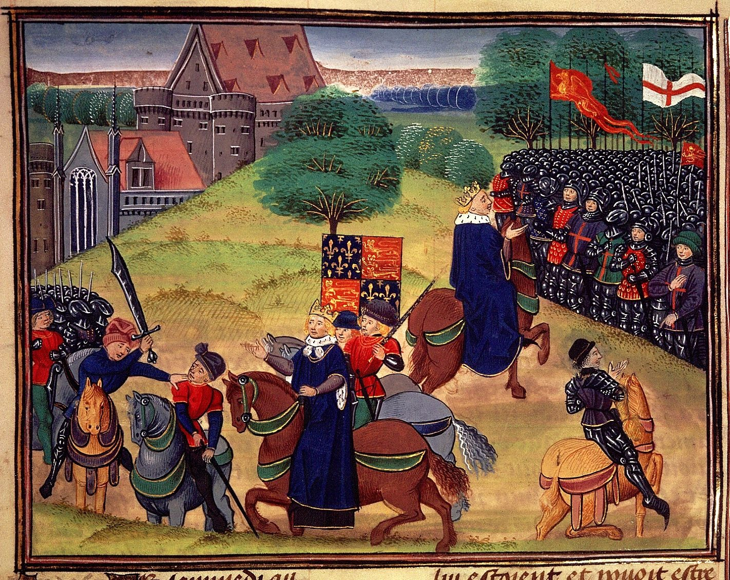
- Lords’ estates to be reduced in size
- Church lands to be divided up amongst the peasants
At this point, the kings’ party could take no more. Tyler is rumored to have spat some drink on the ground and one of Richard’s men said he was no more than a common thief. Walworth tried to arrest Tyler so Tyler drew his dagger and tried to stab Walworth. However, he was wearing armour which deflected the blow. Walworth retaliated by slicing Tyler through the neck. Tyler fell and was surrounded by Richard’s men who completed the killing, out of view of the peasants. As the peasants realised what had happened they prepared to fight. Bravely, Richard rode out to the peasants and tells the he will be their “captain”. The peasants believed him and returned home. Richard was not as good as his word….

What were the consequences of the Peasants’ Revolt?
Richard broke all of his promises and his vengeance was swift and brutal:
- Remaining rebels in London were captured and killed
- Citizens of London were forced to swear an oath of loyalty
- Tyler’s head was cut off and displayed on London Bridge
- Troops moved through the countryside, putting down rebellions and executing rebels
- Rebel leaders, including John Ball, were hanged
- Peasants fined or imprisoned
REVISION QUESTION 6: ‘The Peasants’ Revolt was a total failure.’ How far do you agree with this statement?
(10 marks)
Who ‘won’ the Peasants’ Revolt?
It seems as if Richard did. Peasants were forced back to their old way of life and remained in servitude. Richard became increasingly powerful and his enemies were imprisoned. However, in the long term, it can be argued that he peasants won: the poll tax was never collected again, parliament never again tried to control wages, within 100 years the feudal system had disintegrated and peasants achieved their freedom. Richard was finally disposed and murdered and Henry IV became the new king.

