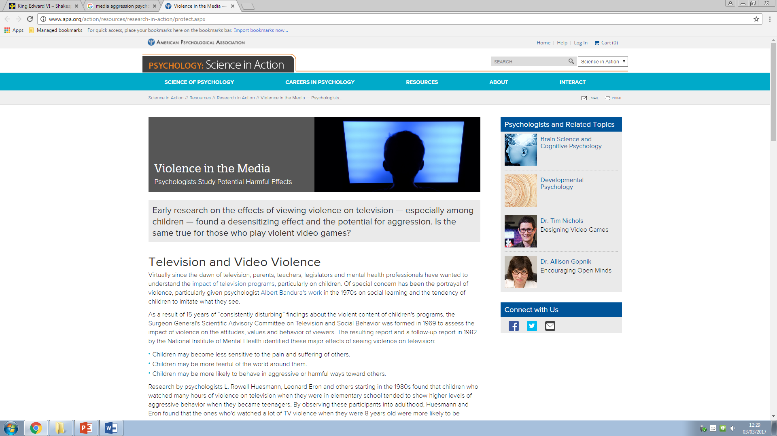

Television and Video Violence

Virtually since the dawn of television, parents, teachers, legislators and mental health professionals have wanted to understand the [impact of television programs](http://www.apa.org/topics/kids-media/index.aspx), particularly on children. Of special concern has been the portrayal of violence, particularly given psychologist [Albert Bandura's work](http://www.apa.org/research/action/nonviolent.aspx) in the 1970s on social learning and the tendency of children to imitate what they see.

As a result of 15 years of “consistently disturbing” findings about the violent content of children's programs, the Surgeon General's Scientific Advisory Committee on Television and Social Behavior was formed in 1969 to assess the impact of violence on the attitudes, values and behaviour of viewers. The resulting report and a follow-up report in 1982 by the National Institute of Mental Health identified these major effects of seeing violence on television:

* Children may become less sensitive to the pain and suffering of others.
* Children may be more fearful of the world around them.
* Children may be more likely to behave in aggressive or harmful ways toward others.

Research by psychologists L. Rowell Huesmann, Leonard Eron and others starting in the 1980s found that children who watched many hours of violence on television when they were in elementary school tended to show higher levels of aggressive behaviour when they became teenagers. By observing these participants into adulthood, Huesmann and Eron found that the ones who'd watched a lot of TV violence when they were 8 years old were more likely to be arrested and prosecuted for criminal acts as adults.

Interestingly, being aggressive as a child did not predict watching more violent TV as a teenager, suggesting that TV watching could be a cause rather than a consequence of aggressive behaviour. However, later research by psychologists Douglas Gentile and Brad Bushman, among others, suggested that exposure to media violence is just one of several factors that can contribute to aggressive behaviour. Other research has found that exposure to media violence can desensitize people to violence in the real world and that, for some people, watching violence in the media becomes enjoyable and does not result in the anxious arousal that would be expected from seeing such imagery.

Video Game Violence

The advent of video games raised new questions about the potential impact of media violence, since the video game player is an active participant rather than merely a viewer. Ninety-seven percent of adolescents age 12-17 play video games — on a computer, on consoles such as the Wii, Playstation and Xbox, or on portable devices such as smartphones and tablets. A Pew Research Center survey in 2008 found that half of all teens reported playing a video game “yesterday,” and those who played every day typically did so for an hour or more.

Many of the most popular video games, such as “Call of Duty” and “Grand Theft Auto,” are violent; however, as video game technology is relatively new, there are fewer empirical studies of video game violence than other forms of media violence. Still, several meta-analytic reviews have reported negative effects of exposure to violence in video games.

A 2010 review by psychologist Craig A. Anderson and others concluded that “the evidence strongly suggests that exposure to violent video games is a causal risk factor for increased aggressive behaviour, aggressive cognition, and aggressive affect and for decreased empathy and prosocial behaviour.” Anderson’s earlier research showed that playing violent video games can increase a person's aggressive thoughts, feelings and behaviour both in laboratory settings and in daily life. "One major conclusion from this and other research on violent entertainment media is that content matters," says Anderson.

Other researchers, including psychologist Christopher J. Ferguson, have [challenged the position](http://www.apa.org/pubs/highlights/peeps/issue-32.aspx) that video game violence harms children. While his own 2009 meta–analytic review reported results similar to Anderson’s, Ferguson contends that laboratory results have not translated into real world, meaningful effects. He also claims that much of the [research into video game violence](http://www.apa.org/monitor/2010/12/virtual-violence.aspx) has failed to control for other variables such as mental health and family life, which may have impacted the results. His work has found that children who are already at risk may be more likely to choose to play violent video games. According to Ferguson, these other risk factors, as opposed to the games, cause aggressive and violent behaviour.

The American Psychological Association launched an analysis in 2013 of peer-reviewed research on the impact of media violence and is reviewing its policy statements in the area.