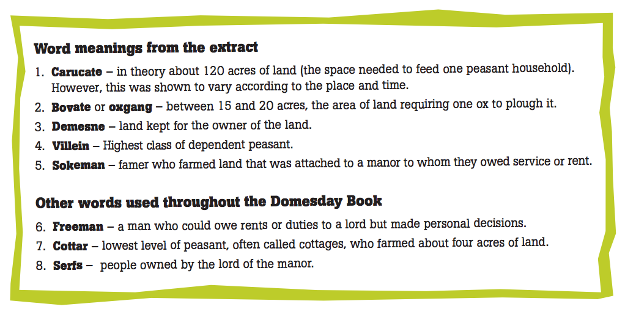

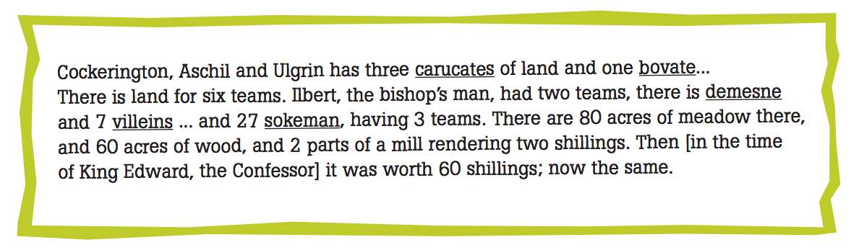

Translation:

____________________________________________________________________________________________________________________________________________________________________________________________________________________________________________________________________________________________________________________________________________________________________________________________________________________________________________________________________________________________________________________