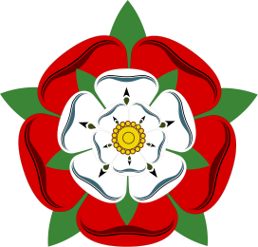

**What are the differences between England in the 1500s and today?**

**Today**

**1500s**

**Population**

**Size of towns**

**Houses and Furniture**

**Meals**

**Industries**

**Jobs**

**The Countryside**