PSYA3 - Formation of relationships
Reward/Need Satisfaction Theory | Similarity Theory
Outline (AO1)   | Outline (AO1)  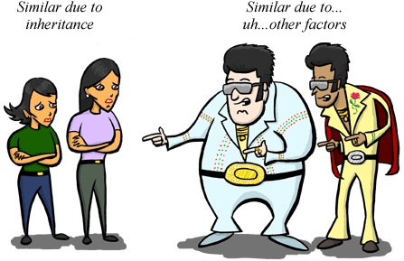
Evaluate (AO2) | Evaluate (AO2)

