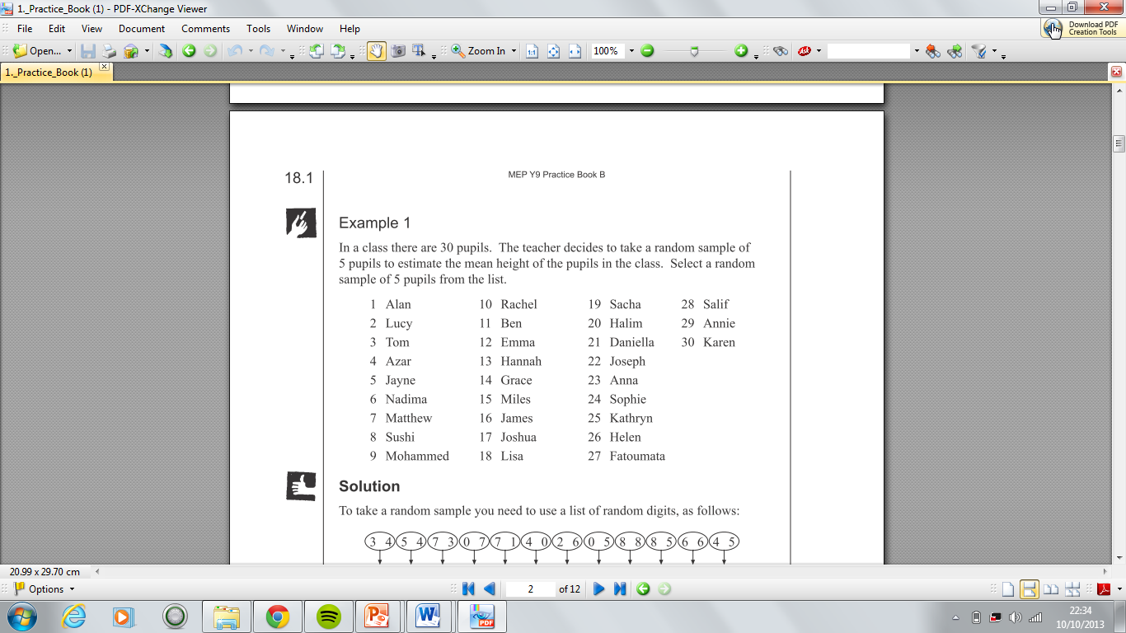

In a class there are 30 pupils. The teacher decides to take a random sample of 5 pupils to estimate the mean height of the pupils in the class. Select a random sample of 5 pupils from the list.

We can now use a random number table like:

3 4 5 4 7 3 0 7 7 1 4 0 2 6 0 5 8 8 8

5 6 6 4 5 5 7 6 0 2 7 8 2 7 6 1 5

The 5 students would be:





In a class there are 30 pupils. The teacher decides to take a random sample of 5 pupils to estimate the mean height of the pupils in the class. Select a random sample of 5 pupils from the list.

We can now use a random number table like:

3 4 5 4 7 3 0 7 7 1 4 0 2 6 0 5 8 8 8

5 6 6 4 5 5 7 6 0 2 7 8 2 7 6 1 5

The 5 students would be:

The 5 students would be:

We can now use a random number table like:

3 4 5 4 7 3 0 7 7 1 4 0 2 6 0 5 8 8 8

5 6 6 4 5 5 7 6 0 2 7 8 2 7 6 1 5

In a class there are 30 pupils. The teacher decides to take a random sample of 5 pupils to estimate the mean height of the pupils in the class. Select a random sample of 5 pupils from the list.