Stratified Sampling – Red and Amber
The rule for stratified sampling is:
$$Sample size × \frac{Stratum Size}{Total Population}$$
Stratum is the group you are sampling from. (For example, female)
Question 1  The table shows the number of girls in four different schools.  Jenny wants to use a stratified sample of exactly 80 girls by school.  Complete the calculations shown to find how many girls from each school Jenny should use. | 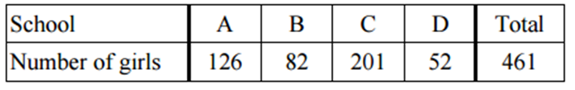  School A: $80 × \frac{126}{461}$  School B: $80 × \frac{82}{461}$  School C: $80 × \frac{201}{461}$  School D: $80 × \frac{52}{461}$
Question 2  The table shows the number of boys in four different schools.  Adam wants to use a stratified sample of exactly 40 boys.  Complete the calculations to find how many boys Adam should use. | 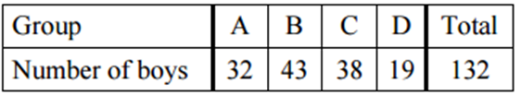  School A: $40 × \frac{32}{132}$  School B: $40 × \frac{43}{132}$  School C: $40 × \frac{38}{132}$  School D:
Question 3  The table shows the number of competitors in a competition by age group.  The organisers want to conduct a survey and use a stratified sample of 50 people.  Calculate how many people from each age group they need to sample. | 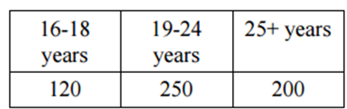
Question 4  This table shows the gender of students studying three languages at college.  - Calculate the total number of students at the college studying languages.  Jamie wants to conduct a survey at the college. He wants to take a sample of 50 students stratified by gender and by language studied.  - Complete the calculations to find the size of each sample group. | 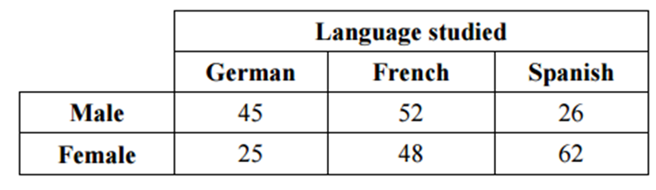  Male studying German: $50 × \frac{45}{???}$  Male studying French: $50 × \frac{52}{???}$  Male studying Spanish: $50 × \frac{26}{???}$  Female studying German: $50 × \frac{25}{???}$  Female studying French: $50 × \frac{18}{???}$  Female studying Spanish: $50 × \frac{62}{???}$
Question 5  A golf club is conducting a survey of its members.  They want to take a sample of 90 stratified by both age and by gender.  Calculate the size of each sample group.  (Hint: There will be 8 groups) | 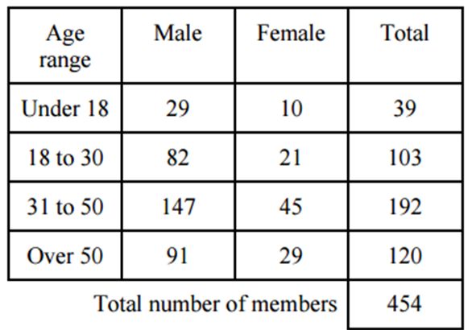
Question 6  The table shows the number of students studying a two year college course.  Laura wants to sample 70 students, stratified by year group and gender.  Calculate the size of each sample group. | 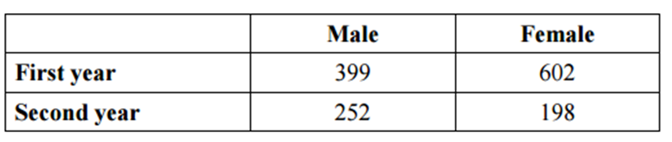  Hint: There are 4 groups that will be sampled.
Stratified Sampling – Red and Amber
The rule for stratified sampling is:
$$Sample size × \frac{Stratum Size}{Total Population}$$
Stratum is the group you are sampling from. (For example, female)
Question 1

School A – 80 x (126/461) = 22

School B – 80 x (82/461) = 14

School C – 80 x (201/461) = 35

School D – 80 x (52/461) = 9
Question 2

School A – 40 x (32/132) = 10

School B – 40 x (43/132) = 13

School C – 40 x (38/132) = 11 (Actually rounds to 12, but should be rounded down to keep the sample size correct)

School D – 40 x (19/132) = 6
Question 3

16 – 18 = 50 x (120/570) = 10
(Actually rounds to 11, but should be rounded down to keep the sample size correct)

19 – 24 = 50 x (250/570) = 22

25+ = 50 x (200/570) = 18

Question 4

Male German = 50 x (45/258) = 9

Male French = 50 x(52/258) = 10

Male Spanish = 50 x (26/258) = 5

Female German = 50 x (25/258) = 5

Female French = 50 x (48/258) = 9

Female Spanish = 50 x (62/258) = 12

Question 5

Male under 18 = 90 x (29/454) = 6

Male 18 to 30 = 90 x (82/454) = 16

Male 31 to 50 = 90 x (147/454) = 29

Male over 50 = 90 x (91/454) = 18

Female under 18 = 90 x (10/454) = 2

Female 18 to 30 = 90 x (21/454) = 4

Female 31 to 50 = 90 x (45/454) = 9

Female over 50 = 90 x (29/454) = 6

Question 6

Male first year = 70 x (399/1451) = 19

Male second year = 70 x (252/1451) = 12

Female first year = 70 x (602/1451) = 29

Female second year = 70 x (198/1451) = 10

