Homework for Learning Assessment Booklet



Year 7 History Homework and Assessment Planner

- This planner is designed to help you to understand when your homework should be done and the standard to which we expect you to adhere. Exemplars are provided in this document to help you. History is about enjoyment in learning – and we hope you find this year a suitably rewarding experience.

- Six assessments will be produced during the year. Each assessment will be given a curriculum level and grade.

- Assessments will range from model design and building to formal assessments at the end of the year, from presentations to written answer skills.

- When your work is marked you will be given a mark or grade with comments or suggestions on how you can improve further. Any errors will be circled or underlined and in the margin, or above the error, one of the following will explain what kind of mistake you have made:
Sp spelling error – write the correct sentence out three times
Gr grammar error – write the sentence out correctly
P punctuation error – write the sentence out correctly
? incomprehensible
// new paragraph needed

- We expect feedback from you every half term – this is your chance to look at what you have accomplished and take the next step with your studies. Remember – you should always know what level you are working at and how you can improve.


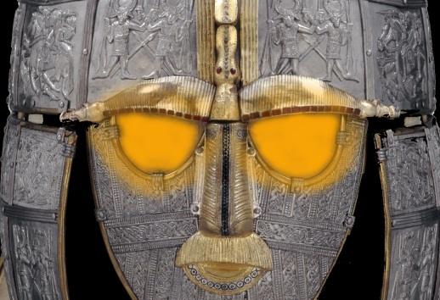
Homework for Learning Assessment Booklet

Assessment Tracker 2013
Name:
Challenge Grade:
TERM | Michaelmas |  |  |  |  |  | Lent |  |  |  |  |  |  |  | Summer
 | Grade +/=/- |  |  |  |  |  | Grade +/=/- |  |  |  |  |  |  |  | Grade +/=/-
Grade
My History Timeline | Why did William Win? Essay | Spy Report | Domesday Book Statistics Exercise | Castle Models | How does a King take control? | What makes a good King? | Why is the King being whipped? Newspaper Article | King John – An Evil King | Personal Profile – King John | Magna Carta – KES version | Medieval Towns – Health and Hygiene | How did disease spread? Medical Review | What were the causes of the Black Death | How was the plague prevented? | Why did Henry dissolve the Monasteries? | Mid Tudor Crisis. The problem of religion | What problems did Elizabeth face? | Why did the Spanish Armada fail? | Gunpowder, Treason and Plot | The English Civil War – Success and Failure
To get a Level Three you must:
◊ Show a developing sense of chronology (order of events)
◊ Develop a realisation that the past can be divided into periods of time
◊ See some similarities and differences between different time periods
◊ Know some basic facts
◊ Begin to understand why things changed and what happened because of the changes

Attainment Targets for History

To get a Level Seven you must:
◊ Make links between your factual knowledge and understanding of Britain and the wider world
◊ Work independently to evaluate sources critically and form appropriate conclusions
◊ Explain how and why historians have different opinions of the same event/period
◊ Select and use relevant information to produce well structured work
◊ Analyse (study closely) features of periods of time and societies
◊ Analyse the causes and consequences of change

To get a Level Six you must:
◊ Use the facts you know about Britain and the wider world to describe past societies
◊ Make links between different periods of history
◊ Investigate and explain the reasons for, and results of, change
◊ Begin to analyse (study closely) why historians interpret events differently
◊ Show you can evaluate sources to reach a conclusion
◊ Select relevant information to produce structured (well organised) work

To get a Level Five you must:
◊ Show a good factual knowledge and understanding of Britain and the wider world
◊ Be able to describe past periods and societies and make links between them
◊ Describe, knowledgably, the causes and consequences of changes
◊ See that historians may see the same event in different ways
◊ Begin to evaluate sources (historical information) by yourself
◊ Select relevant information and organise your work well

To get a Level Eight you must:
◊ Use your factual knowledge of Britain and the wider world to analyse relationships between events, people and changes
◊ Use a wider historical awareness to expain causes and consequences of change
◊ Analyse and evaluate historical interpretations
◊ Use sources critically and reach substantial conclusions on your own
◊ Select and use relevant information to produce structured and well planned work

To get a Level Four you must:
◊ Have some factual knowledge and understanding of Britain and the wider world
◊ Be able to describe what past societies and people were like
◊ Know some reasons for things changing and begin to understand the results of change
◊ Be able to combine information from different sources
◊ Produce work that is well structured (organised sensibly) and uses key dates and historical terms

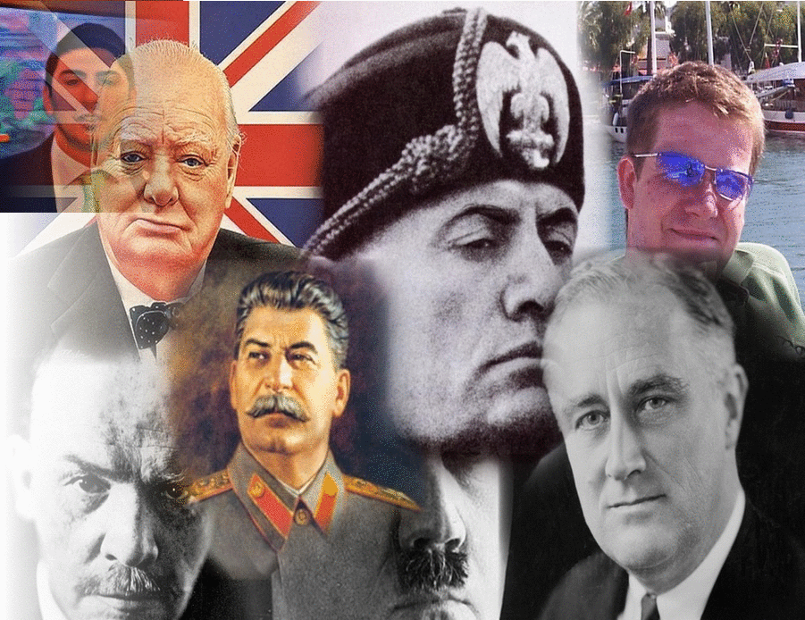
Homework for Learning Assessment Booklet

Contents – IST’s

LA 1: Why did William win?
Michaelmas

LA 2: Create a model of a medieval castle

LA 3: Murder Investigation – Thomas Becket
Lent

LA 4: Write your own Magna Carta for the school

LA 5: The Black Death – what impacts did this have?
Trinity

LA 6: Exams

KEY

Learning objective

Research

Writing frame

Links & resources

Assessment criteria

Extension task

1
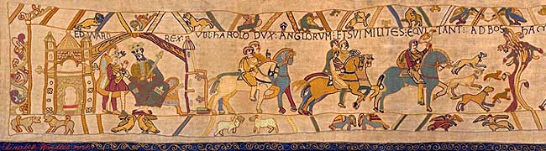
Learning Assessment
Why did William win?

Homework for Learning Assessment Booklet

Type of activity: Independent enquiry / local study
Form of assessment: Teacher assessed

Learning objective

You will be taught about the reasons behind the Norman Conquest and the role of William. You will be given the opportunity to research and investigate evidence of his achievements. This might be remapping the battle of Hastings, extracts from contemporary sources which relate to Harold Godwinsson, Harald Hardrada or William, or personal research. You will then write up your research in the form of a structured piece of extended writing, illustrated where appropriate with maps, photos and diagrams.

Suggested topics to investigate

The Bayeux Tapestry – a pictorial history

Vikings and Anglo-Saxons – etymology of place-names

Law and order – Anglo Saxon style

Links with France

Religion and power
Links and resources
Battlefield Britain DVD on Hastings
1066 game Channel 4.com

Assessment criteria

You are being assessed on your ability to research and collect appropriate evidence, produce a structured piece of extended writing and present your findings in a clear and professional way. Your teacher will show you examples of work for you to assess in order to get a clearer example of our expectations.

Writing frame

You will be provided with both source material and a writing frame by your teacher.

Extension task

Imagine you are a war correspondent reporting on William’s invasion of England in 1066. Write a report (or make a short film) describing the events as they happen. Watch a news report on the BBC News to give you an idea of how to structure your ideas.

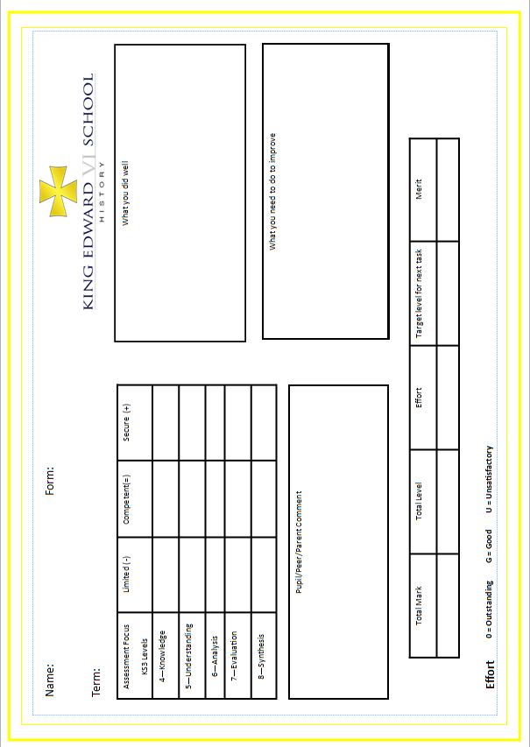
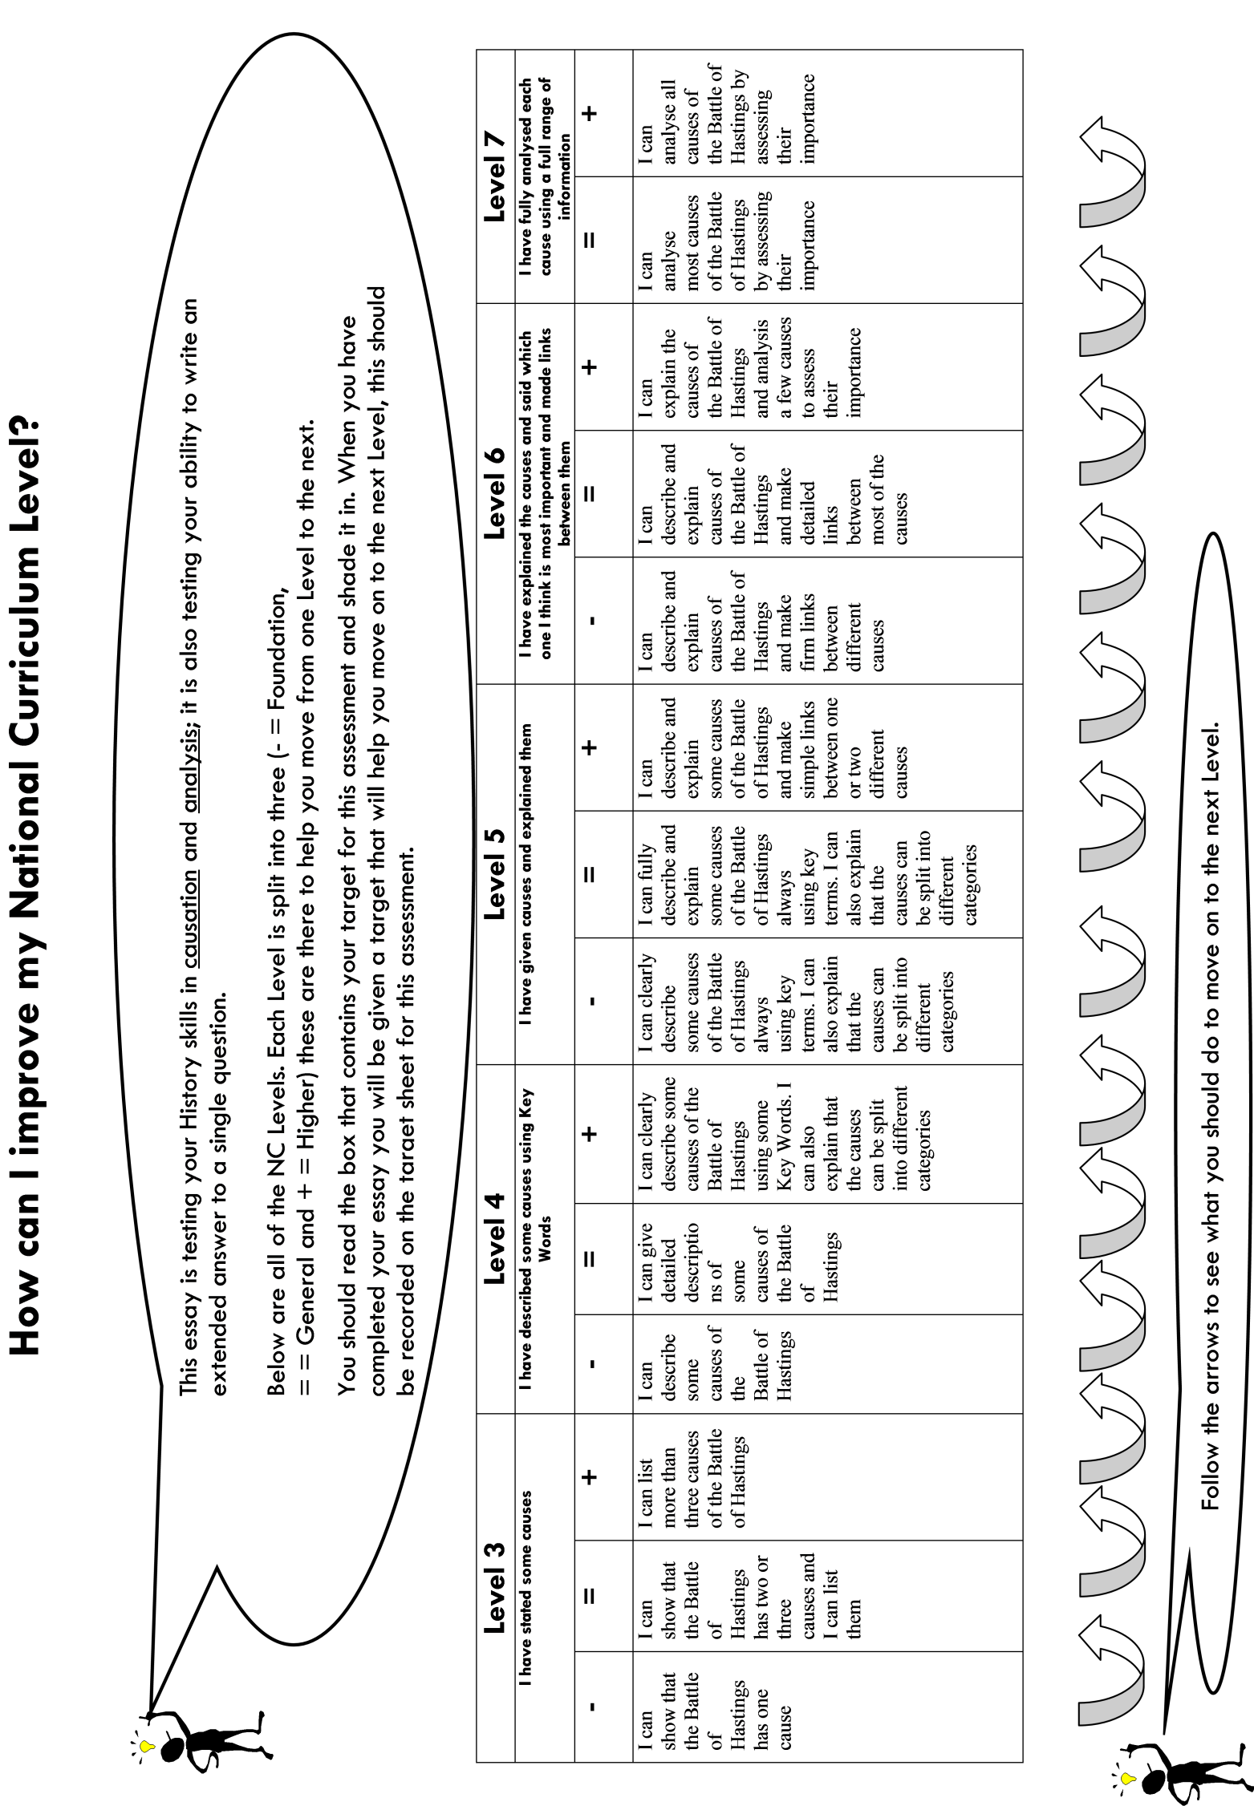
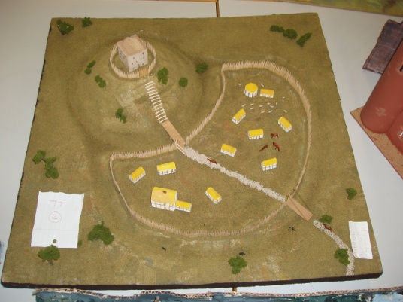
Homework for Learning Assessment Booklet

2
Learning Assessment
Castle Models

Type of activity: Independent modelling/history around us
Form of assessment: Peer assessed and teacher moderated

Learning objective

You will learn about the reasons behind the growth of castles, the feudal system and how the use of castles has changed over time. You will investigate through changes in architecture the changing political regime in England and also develop your cross-curricular skills in art and design.

Suggested topics to investigate

Kenilworth Castle – a local field trip

History of castle building – see History DVD

Power and politics – Magna Carta, Simon de Montfort and the growth of Parliament

Links and resources
Kenilworth powerpoint
Castles DVD
Castle game on History resources on the network.
Contrasts and Connections p.84

Assessment criteria

You are being assessed on your ability to research and create a model of a castle showing changes over time or a castle at one particular point in time. Your teacher will show you examples of work for you to assess in order to get a clearer example of our expectations.

Writing frame

You will be provided with an assessment writing frame to assess your castles.

Extension task
Write a Spy Report for the castle at York. You are a spy for the Normans in 1068. You plan to take over the castle. Looking at the defences carefully, what strategy would give you the best chance of success?

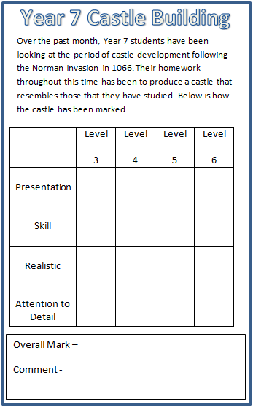
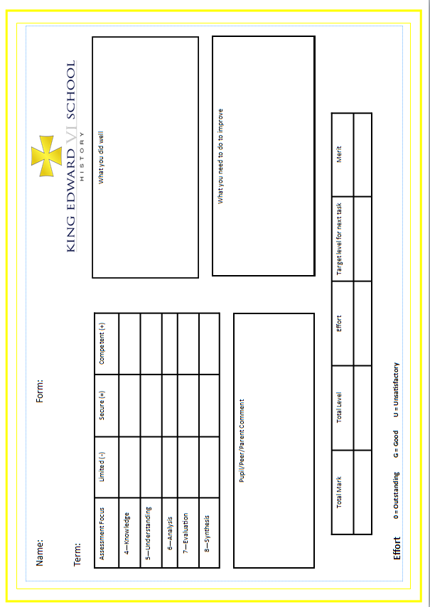
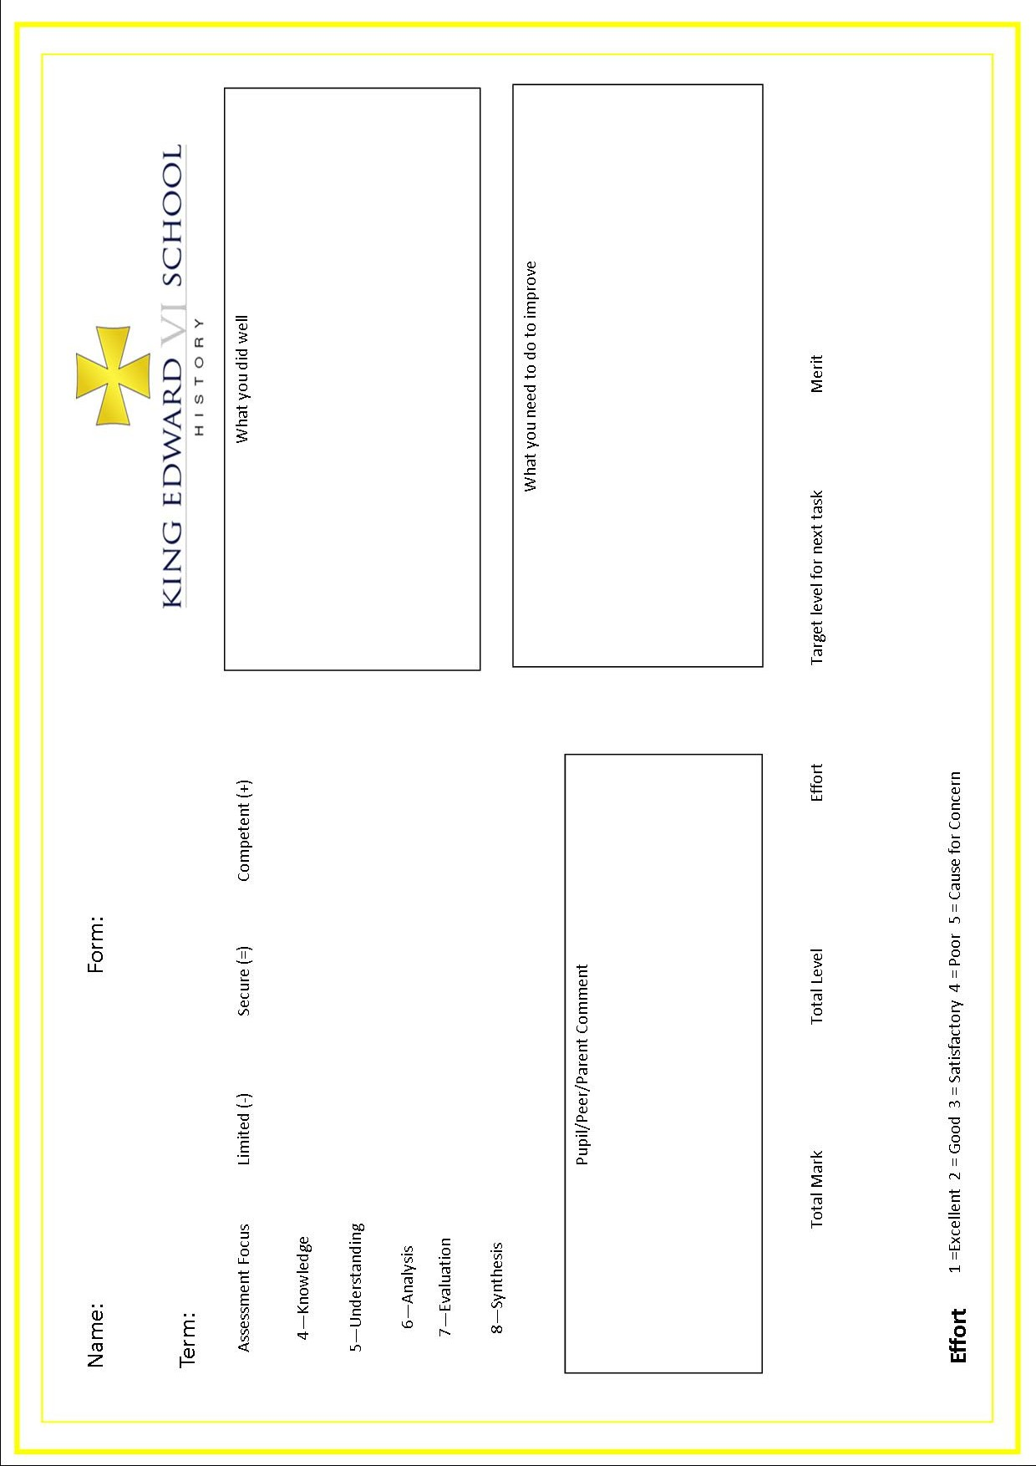
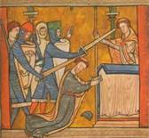
Homework for Learning Assessment Booklet

3
Learning Assessment
Thomas Becket

Type of activity: IT source based news article
Form of assessment: Teacher moderated

Learning objective

You will learn about the reasons behind the struggle for power between the king and his over mighty subjects in the form of this epic clash of Church and State. Like Shakespeare’s doomed lovers, you will learn how Becket and Henry II found themselves in a web of conflicting loyalties, a Gordian knot only the martyrdom of Becket would break.

Suggested topics to investigate

Monks and nuns – a monastic life – see History file and ICT resources on Moodle.

Power and politics – the clash between temporal and spiritual power – the role of crusades from 1095.

Links and resources

Terry Jones – Medieval Lives (The Monk)
The Church – Michael Wood
Animated Thomas Becket – DVD 1.
Medieval menus – a taster session of monastic life – see recipe on Moodle.

Assessment criteria

You are being assessed on your ability to use information from your textbook, own research and resources provided to write a front page newspaper article on the death of Thomas Becket. You will be expected to provide an argument as to why he died and who now holds the upper hand in the battle for supremacy between King and Church. Your teacher will show you examples of work for you to assess in order to get a clearer example of our expectations.

Writing frame

You will be provided with a writing frame for the newspaper. You do not have to use it and in fact we prefer you not to. However it provides an idea of the minimum length you need.

Extension task
Write a brief role play script titled ‘The Trial of Thomas Becket’. If Becket had been tried in a court rather than butchered on the cathedral steps, what would the verdict have been?
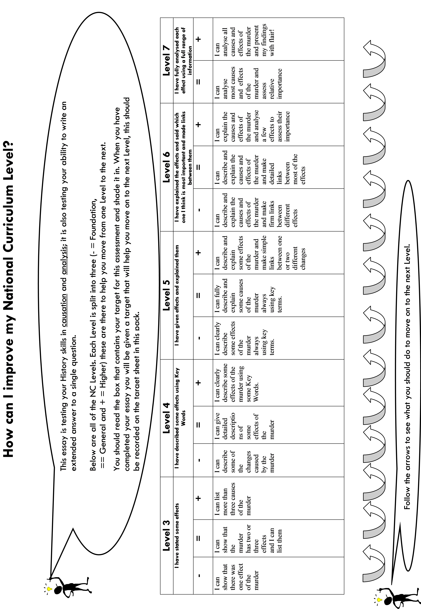

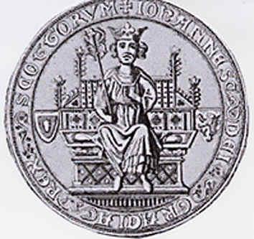
4
Homework for Learning Assessment Booklet

Learning Assessment
Magna Carta

Type of activity: Independent research activity/ literacy exercise
Form of assessment: Teacher moderated

Learning objective

You will learn about the reasons behind the growth of castles, the feudal system and how the use of castles has changed over time. You will investigate through changes in architecture the changing political regime in England and also develop your cross-curricular skills in art and design.

Suggested topics to investigate

Simon de Montfort and the beginnings of Parliament

Richard Coeur de Lion versus John Lackland – what qualities made for a ‘good’ Plantagenet king?

Links and resources

King John and Magna Carta – History DVD

Castle game on Your Magna Carta exemplars.
Contrasts and Connections p.136

Assessment criteria

You are being assessed on your ability to research and create a artistic reproduction of the Magna Carta using similar language and representing the views of the school barons. Your teacher will show you examples of work for you to assess in order to get a clearer example of our expectations.

Writing frame

You will be provided with a template giving details of the excesses of the tyrannical King Carr. Only YOU can stop his evil plans!

Extension task
Medieval documents like the Magna Carta need to look the part. With an ADULT present singe the paper for your Magna Carta or use tea to stain it. Add ribbon and a wax seal for the finished effect.

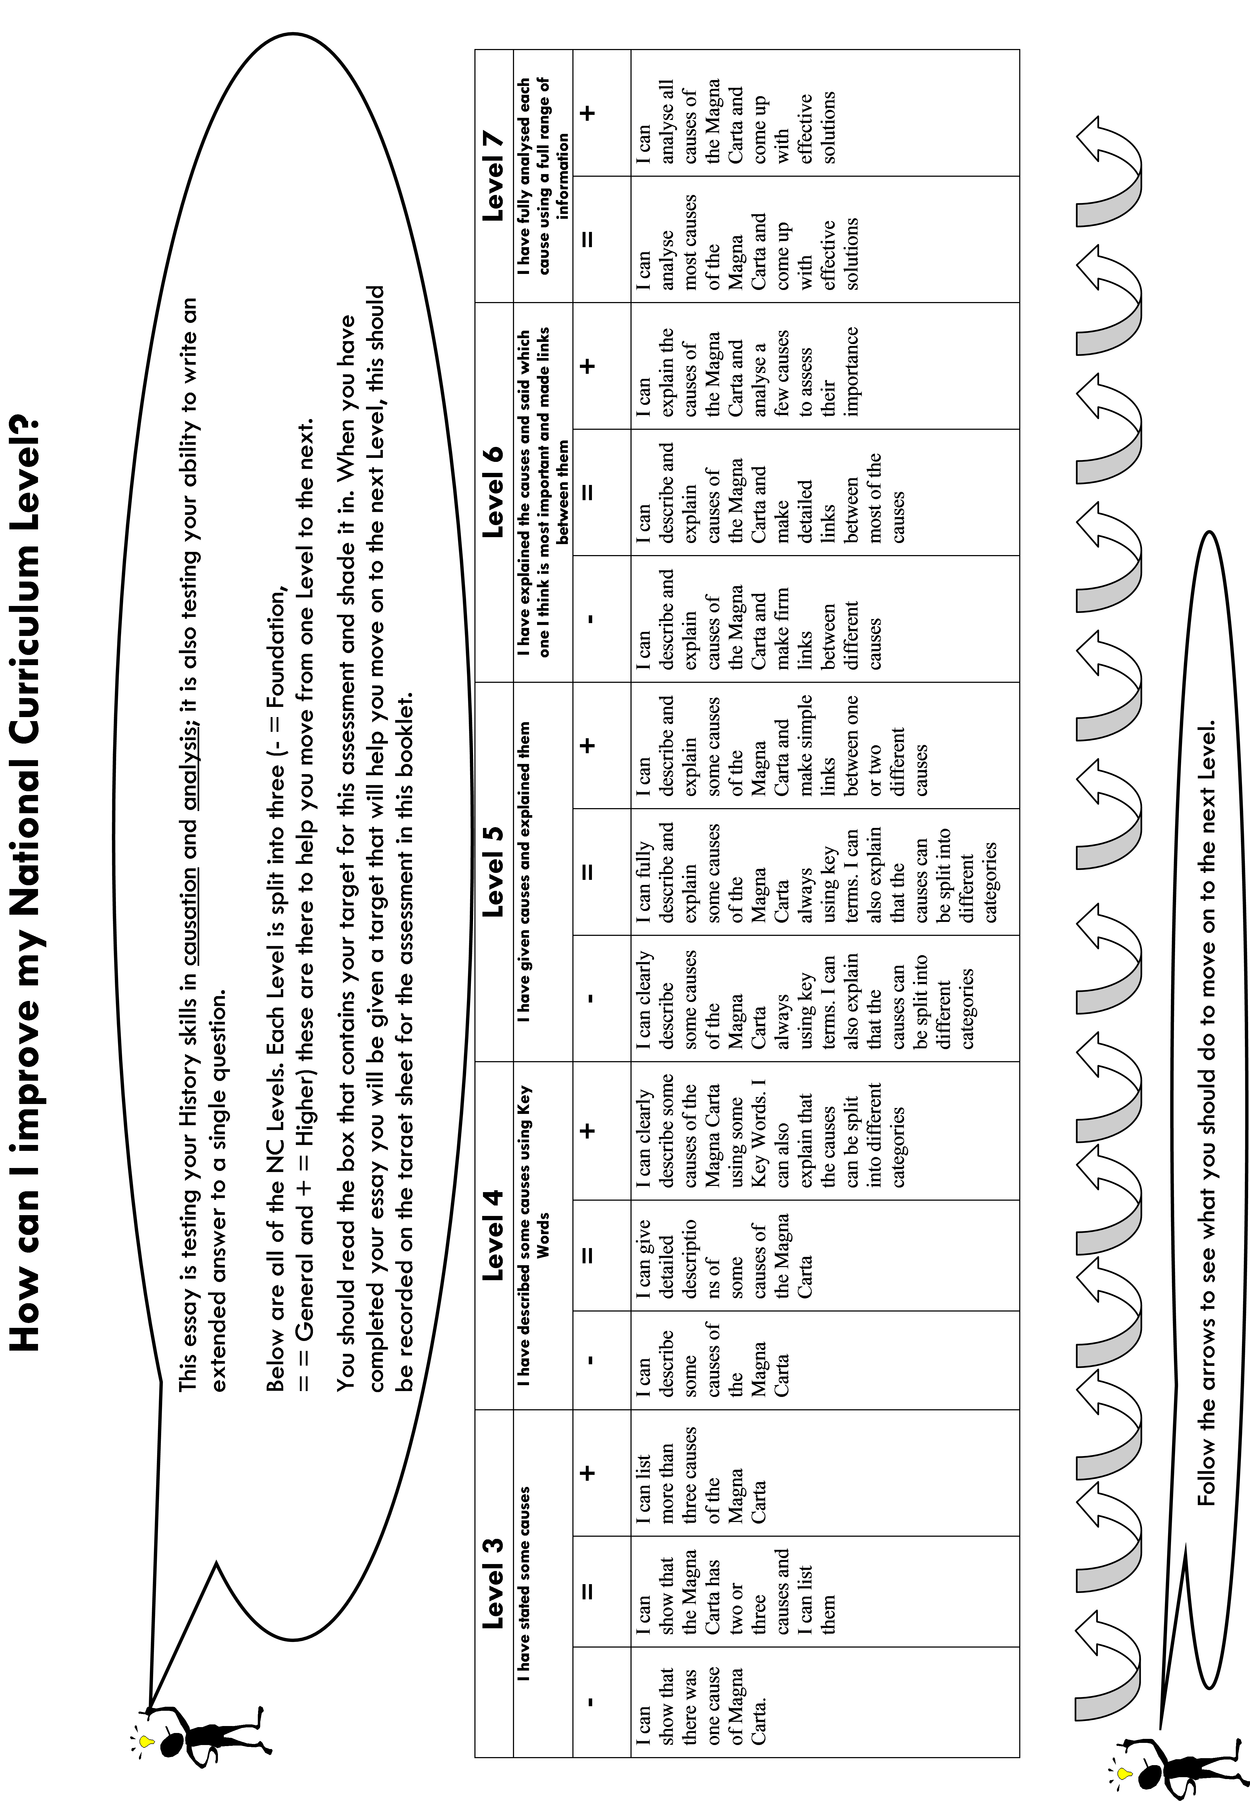

5
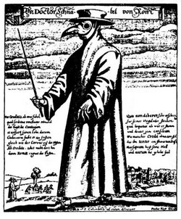
Homework for Learning Assessment Booklet

Learning Assessment
The Black Death

Type of activity: Open book essay assessment
Form of assessment: Teacher moderated

Learning objective

You will learn about the reasons behind the changes taking place in England in the period 1300-1500 and the specific changes and impacts upon society caused by the Black Death. You will learn how society felt about the plague, stories of courage and heroism in the face of adversity in the village of Eyam, and also how some changes made by the Black Death were positive in the long run.

Suggested topics to investigate

The medieval village and village life.

The medieval town and town life.

Medieval Medicine and the Four Humors.

Links and resources
Medicine through Time textbooks
The Peasant – Terry Jones – Medieval Lives DVD
Contrasts and Connections

Assessment criteria

You are being assessed on your ability to research and write an essay on the subject of the changes caused by the Black Death in England from 1348. Specific examples and detail will be credited and you will need to reach a balanced and supported judgement. Your teacher will show you examples of work for you to assess in order to get a clearer example of our expectations.

Writing frame

You will be provided with source material and a writing frame if you wish to use it. These are not prescriptive and indeed the best answers are usually from those who go beyond the demands of the writing frame.

Extension task
Draw up a poster in the style of Leonardo Da Vinci’s Vitruvian Man to show how medieval people felt the body worked.
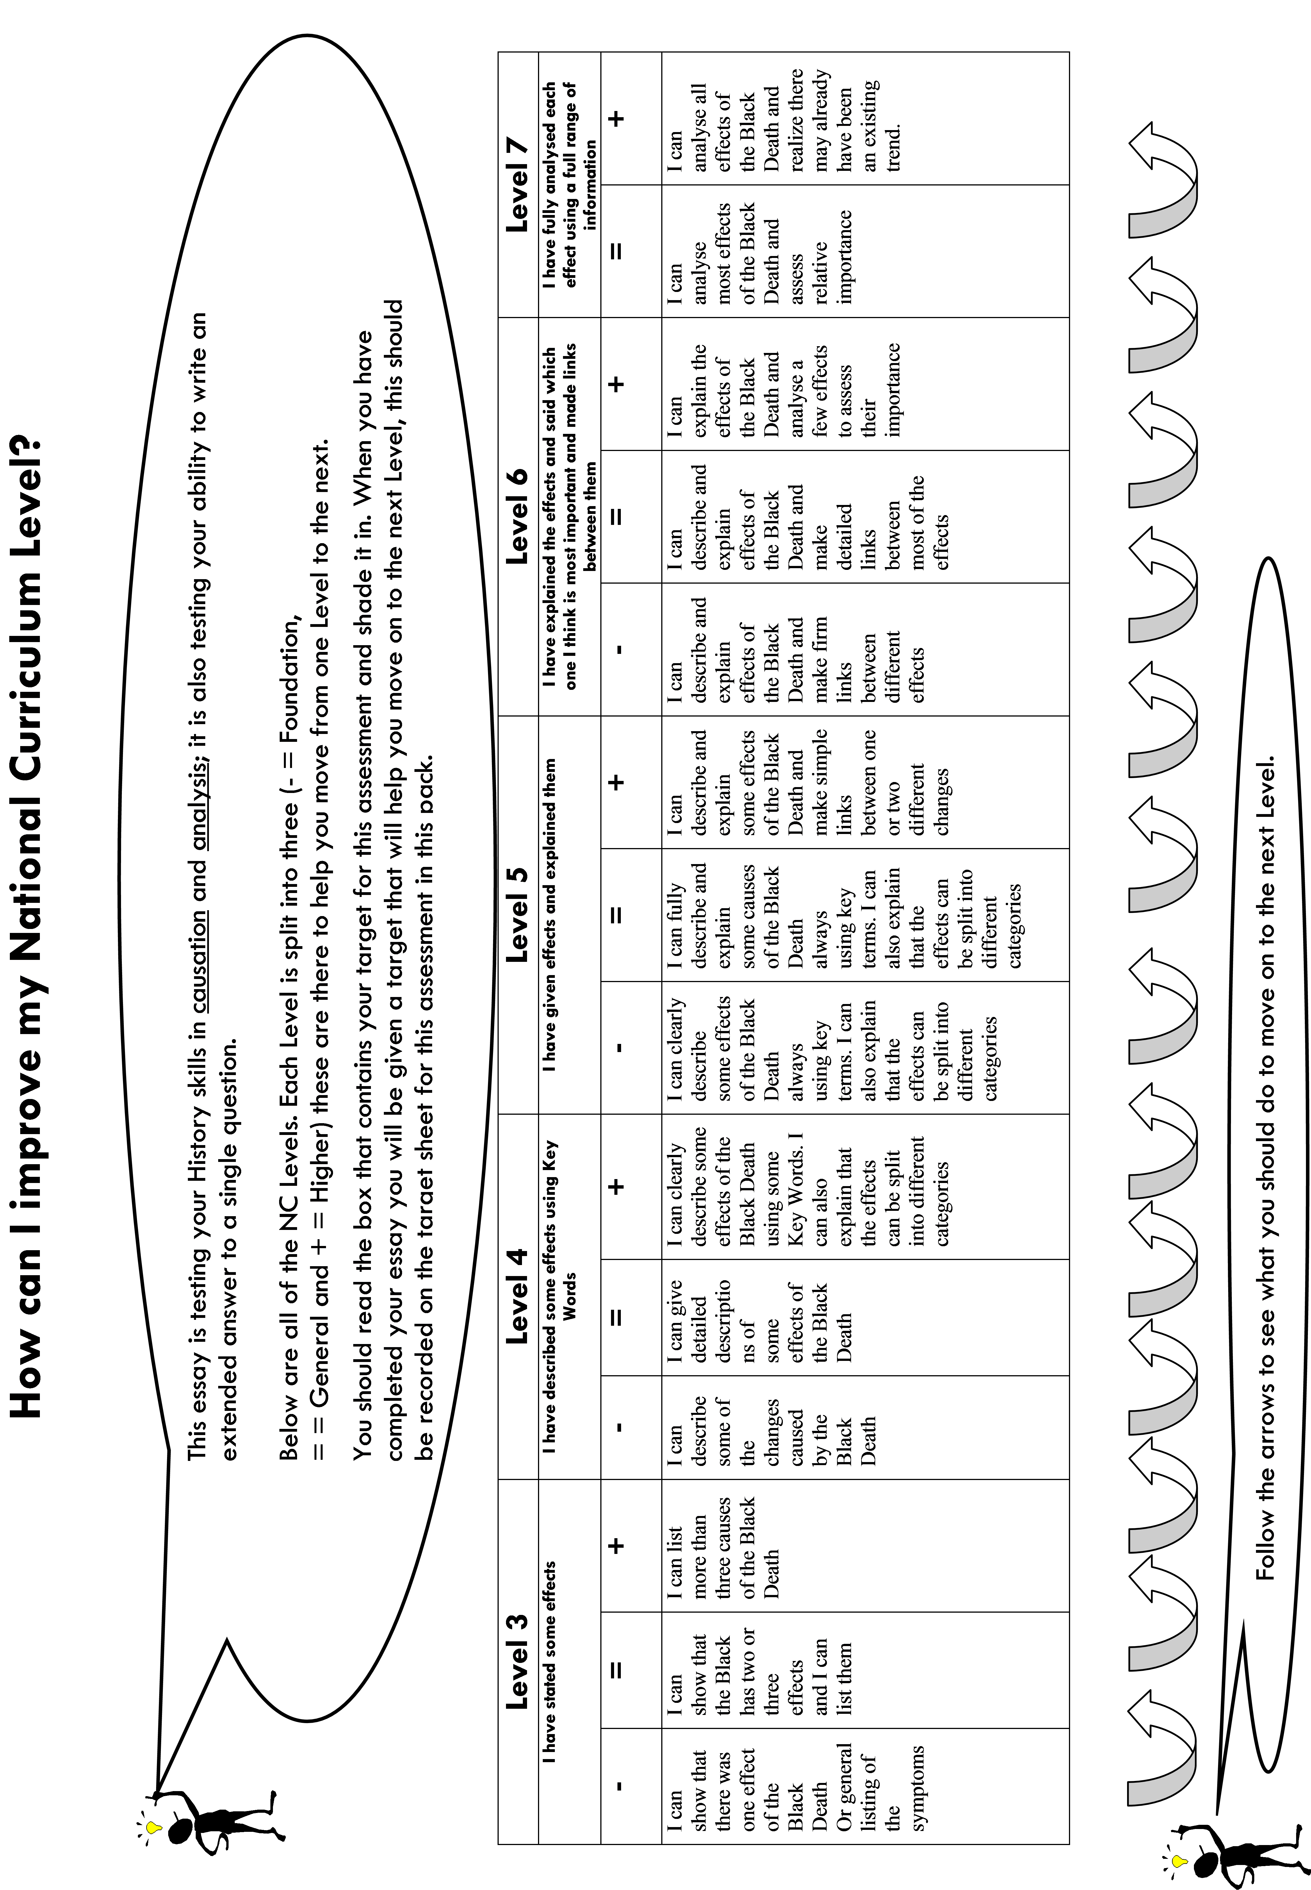

6

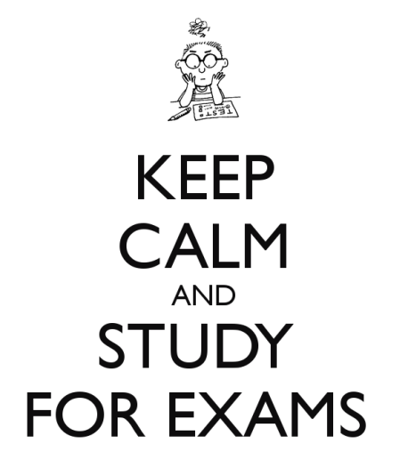
Homework for Learning Assessment Booklet

Summer Exams

Type of activity: End of year assessment
Form of assessment: Teacher moderated

Learning objective

You will learn about how to answer effectively in a pressure situation; how to make best use of time; how to balance your arguments; make key judgements; extract information and build towards reasoned conclusions.

Suggested topics to investigate

Effective revision – key methods

Mnemonics

Why do we need SpaG?

Links and resources
Revision methods powerpoint
Revision topics list
Contrasts and Connections textbook

Assessment criteria

You are being assessed on your ability to write a series of answers in a relatively short period of time. This will place you under pressure. It is your ability to work effectively under pressure to make judgements of a high calibre that is being assessed.

