The relationship between socioeconomic status and health and the different policy solutions

EPQ

# Ciara Farrelly

# Introduction

There is much evidence to suggest that lower socio-economic groups have a greater risk of health problems such as obesity and heart disease. This needs to be addressed. Not only does this reduce the quality of life of a large proportion of society, these health inequalities have an adverse effect on the economy. In England, health inequalities lead to productivity losses to industry of between £31 to 33 billion each year and the cost of treating illness and disease arising from health inequalities has been estimated at £5.5 billion per year[1]. It is imperative that policies are focused on improving the health of the population for both economic and social reasons. Since lower socio-economic groups have greater risk of health problems, policies should be aimed at these groups. This involves understanding why there is a link between lower socio-economic groups and poorer health in order to ensure policies are effective.

Although commonly socio-economic groups in the UK are divided into six social grades: A, B, C1, C2, D and E, much research regarding health inequalities focuses on income type. This is because it is easier to measure and can be easily compared between countries. Therefore, the information presented is in accordance with income group, which is measured in deciles (poorest 10th to the richest 10th). This has limitations as average income changes each year, meaning the range of income will vary in each decile every year. This makes it hard to compare deciles from different years. This presents limitations to the data, as they cannot be easily compared from different periods of time. However, measuring socio-economic groups in terms of income does show clear trends that are relative. Income groupings also correspond with the six social grades commonly used, as people in groups D and E are likely to be in the bottom two deciles of income group. Therefore, measuring socio-economic status in terms of income does not present too great a limitation.

# The link between socio-economic status and health

Obesity in lower income groups

A considerable percentage of those who are obese are from lower income groups. This can be shown in Figure 1[2]. This data shows that in the two lowest income deciles 16.2% of women are obese, compared to 9.0% in the two highest income deciles. Interestingly, the same trend cannot be seen for men. Further research suggests that 30% of women and 25% of men who are classified as the most deprived in society are obese. These numbers drop to 19% and 22% obesity rates for the least deprived.[3] This shows a difference of 8% in women, but only a 3% difference in men.

People on low incomes may feel that they have no control over their own lives, leading to a poor psychological state. This may result in these people not having the incentives to stay healthy, which may result in obesity. Toynbee (2004)[4] highlighted this in her article “Inequality is fattening”, deeming fat to be a class issue. Toynbee suggests “people will only get thinner when they are included in things that are worth staying thin for. Offer self-esteem, respect, jobs or some social status and the pounds would start to fall away”. This suggests that obesity in lower social classes is primarily due to low self-image and a lack of incentive to maintain a normal weight. Although this source is based on opinions, data regarding the relationship between income group and food choices can support this view. James et al (1997)[5] suggests that the bottom two income groups consume more full fat milk, meat products, fats, sugar and preservatives and consume fewer fresh fruit and vegetables than higher income groups. A similar result is apparent in a 2013 report published by the UK Government (Public Health England) as shown in Figure 2. This shows that in the highest income quintile 34.5% of adults eat five or more portions of fruit and vegetables a day compared with 19.5% of adults in the lowest quintile. As a result, the lower socio-economic groups are not consuming enough protective nutrients. These sources can be assumed to be accurate as they come from recognised, respected bodies: the UK Government and the British Medical Journal. However it must also be recognised that this may not be due to psychological state: it may be due to financial reasons. People on low incomes must be efficient in their purchases, leading to a consumption of high-energy foods that satisfy and are much cheaper per unit of energy than foods rich in protective nutrients.

It must be considered that other factors other than income may mean that these low socio-economic groups have a higher risk of obesity. Dr. Costa-i-Font[6], a Senior Research Fellow in Health Economics at LSE Health found that roughly 70 per cent of inequalities in obesity are explained by differences in education rather than low income alone. As Maglione (2007) [7] states, those who are uneducated will have less knowledge of the positive effects of healthy eating and exercise. Education on the importance of physical activity, as well as food choices, is crucial. Although there is little evidence to suggest there is a significant relationship between low income and physical activity, education undoubtedly embeds the importance of physical activity in young people. Interventions to promote physical activity must be done at a developmentally important time when young adults are embedded within a learning environment. Whilst low income may result in a poorer quality of education due to poorer performing schools in deprived areas, a lack of education in turn may reduce income in later life. Therefore, it can be concluded that a lack of education may be the most crucial factor explaining the link between obesity and low income, as education both influences food and exercise habits and results in a greater income in later life.

Heart disease in lower income groups

Coronary heart disease has become progressively more common in lower socio-economic groups[8]. M.G Marmot et al (1978) shows that from 1931 to 1961, in each age group, the mortality from heart disease for men in the lowest two classes was higher than that for men in the highest two classes. The report, published in the British Medical Journal, suggests that this link can be explained by their diet. There was a relative decline in sugar intake in the upper-income groups and a decline in potentially harmful food such as cheese, butter and milk. This source may be assumed to be accurate, as it is published in the British Medical Journal as a research document. Therefore, it is unlikely to contain bias.

However, there are other factors that increase heart disease in low socio-economic groups. Another report published in the same year (1978) in the Journal of Epidemiology and Community Health[9] suggested the main reason for the link between socio-economic status and heart disease is smoking. Cigarette smoking increases the risk of heart disease as it increases blood pressure and increases the tendency for blood to clot. The report measured 17530 civil servants working in London with little difference in body mass index. After seven and a half years of follow-up, the results showed that men in the lowest grade (messengers) had 3.6 times the CHD mortality of men in the highest employment grade (administrators). In these groups, the proportion of current cigarette smokers was more than twice as high in the ‘other’, lower grade (60.9%) as it was in ‘administrators’ (28.8). However, this study acknowledged that smoking was not the only factor, as cholesterol and blood pressure also play a huge role in the risk of heart disease. It must also be considered that this report did not, like the majority of sources used, measure socio-economic status in terms of income. However, as there is a strong link between income and the grades of unemployment, the relationship would be similar if measured in terms of income rather than employment grade.

In order to understand the link between socio-economic status and heart disease, it must be understood why lower socio-economic groups have a higher tendency to smoke and feel stressed. The other major factor, obesity, is discussed above. Marsh and McKay (1994)[10] explain that smoking is increasingly concentrated among low-income groups in the UK as they may turn to tobacco as a coping device; just as they may turn to food (Toynbee (2004)). Furthermore, working class attitudes to smoking may thus reflect a cultural acceptance socially. Chamberlain and O’Neill (1998) showed that working class respondents were more likely to see health in functional terms, especially the ability to work, whereas respondents from higher classes tended to see health in holistic terms and as a sense of all round wellbeing. This suggests that lower classes do not see the extent of the dangers of smoking, whilst higher classes may. The higher tendency to smoke in lower classes directly increases the risks of heart disease in these groups.

Life expectancy in lower income groups

Life expectancy may be measured through Healthy Life Expectancy that combines longevity with health status. This gives a clearer indication of the relationship between socioeconomics status and health. In a statistical bulletin published by the ONS (2014)[11], a report revealed that males in the most deprived areas of the United Kingdom have a healthy life expectancy of 9.2 years shorter and females 6.8 years shorter (when measured by the range) than those in the least deprived areas. There are many varying models to explain why there is a correlation between socio-economic groups and healthy life expectancy. The behavioural model suggests that individuals may exercise health damaging or health promoting behaviour including diet, drugs and alcohol consumption. As a result, this model may explain reasons for obesity and heart disease. However, long-term studies have found that differences in health behaviour explain only one-third of social class differences in mortality.

Alternatively, the materialist model suggests that poverty exposes people to greater health hazards, for example poor housing, air pollution, insufficient or unhealthy food, which may be out of a person’s control and can reduce their life expectancy. These factors are more likely to be present where there is low income. A third model: the psychosocial model expresses that the effects of social inequality may cause stress, which can bring about biological changes that increase the risk of heart disease. Poverty can result in both stress and isolation. Arguably, the psychosocial model is not as influential as the behavioural and materialist models. This is because all people may experience stress; it is not restricted to people of lower socio-economic status. Finally, the life-course model argues that health reflects the patterns of all advantages and disadvantages experienced by a person over the course of their life. Disadvantages or advantages at birth and during early childhood are likely to extend into adulthood. All four models provide factors that equally contribute to the varying life expectancies in different socio-economic groups[12].

# Policies to be implemented

Although only three factors have been explored: obesity, risk of heart disease and life expectancy, it is clear that there is a link between socio-economic status and quality of health. Once the reasons for poorer health in low socio-economic groups have been understood; it is imperative that policies are implemented. In order to reduce the risks of poor health exposed to people in lower socio-economic groups, policies must either aim to either improve the health of the lower classes or decrease the inequality gap. Policies aiming to improve the health of the lower classes will reduce the problems of poor health but this will not tackle the cause. The only way to address the root of the problem is to reduce the inequality gap between socio-economic groups. The cause of the problem is only getting worse, as income inequality in the UK is rising. From the period of 1979 to 2008/09, income inequality rose in the 30-year period to its highest level with a Gini Coefficient of 0.35. Therefore, although it is important that the health of lower classes must be improved, the root of the problem must also be addressed.

# Improving the health of lower social classes

Provision of Information

It may be suggested that poor health is self-inflicted through poor lifestyle choices (the behavioural model). This may be due to imperfect information. This is a type of market failure and results in people making irrational choices. Therefore, the government may have to intervene through the provision of information, for example through displaying nutritional information. In the United Kingdom, it is the law that food manufacturers follow the EU rules for nutritional labelling[13]. This includes declaring the energy values in both kilojoules and kilocalories and the amount of fat, saturates, carbohydrates, sugars, proteins and salt in grams. However, although this is legally stated, this does not guarantee that consumers will use this information. It must be explored further how best to provide information to consumers in order to change their behaviours.

Grunet, Wills and Fernandez-Celemin (2010)[14] attempted to get a realistic estimate of the level of usage of nutritional information on food labels and to provide evidence on the extent to which UK consumers are able to understand and apply information about the nutritional label format. Their results concluded that 27% of respondents looked at the nutritional information on the package before making a selection in a shop. However, the percentage of respondents coming up with correct health inferences when asked was in the range of 70%-90%. This suggests that people are able to infer health information given on packages, yet only 27% actually look at this information. This presents a problem, as there is still no proof that these 27% of people will make a change in lifestyle choice, even though they have observed the nutritional information. Therefore, it is clear that nutritional information will only be effective when embedded in a broader nutrition policy that uses multiple instruments to increase interest in healthy eating, including a reduction in the trade off between trade and health. However, this source does present some limitations as this sample is constrained by choice of retail chains, cities and product categories. Furthermore, this sampled 2160 in-store observations, of which the majority were women. This corresponds to the fact that women still have the main responsibility for shopping in UK households. Therefore, it may be concluded that this data is not representative of the UK population as the sample is limited and not representative of all sexes and age groups.

Clearly, it is not enough to provide the information; measures must be taken to increase the incentive to use this information. A new system was given the green light in June 2013[15] to provide colour coded, front of package information that can be easily seen through red, amber and green colour coding. This may overcome the problem of only 27% of people looking at nutritional labels. Whilst aesthetic elements may be effective, the knowledge of the importance of healthy eating and nutritional information must be established from an early age. Current measures taken include[16] the 5 A DAY programme which aims to increase access to and consumption of fruit and vegetables and the Food in Schools programme which promotes a whole-school approach and encourages greater access to healthier choices within schools. By tackling the younger generation by increasing their knowledge of the effects of healthy eating, this sets good standards for the future.

A popular form of information provision is through the Internet as it is easy to access. For example, information about the guidelines of exercise is published by the National Health Service[17] in Britain. This states that adults ages 19-64 should try to do at least 150 minutes of moderate aerobic activity (including walking) and strength exercises on two or more days a week that work all major muscles. This is published online and is available to all. Information on the dangers of smoking are also published online by the National Health Service, including their page ‘Smokefree’, which allows people to sign up for regular, encouraging, informative emails. However, it must be considered that not all people access the Internet every day. According to a survey by the ONS[18] in 2014, 76% of adults accessed the Internet every day and fixed broadband Internet connections were used by 91% of households. Although this is a great proportion of the population, the percentage that this does not account for is likely to be the lower socio-economic groups, as they cannot afford to access the Internet. In addition, although this information is available, there is no incentive for many people to search these statistics on the Internet.

Therefore, whilst measures may be taken to increase information provision, there is no certainty that this information will be accessed and influence people’s behaviour. Instead, people may be encouraged to be physically active through community events through mass media campaigns and decision prompts to help inspire people, for example using the stairs instead of an elevator. This may be more effective, as although information is provided, lower classes do not have the incentive in every day life to research such information. Simple strategies such as posters in the workplace, mass media campaigns and tackling the next generation through the provision of health information in schools may be more effective.

Fiscal Measures

The behaviour of low socio-economic groups may be altered through taxing unhealthy foods and subsidising health food in order to create a financial incentive for consumers to avoid unhealthy options.. Taxation is likely to target lower socio-economic groups, as these are likely to be the most elastic consumers. This is because these are the groups who are most likely to try to reduce the amount they spend. Lower socio-economic groups tend to purchase high processed, energy-dense foods because they are consistently cheaper, in terms of energy content for a given price, than more nutrient rich foods. The tax revenue that is collected through an increase in tax on unhealthy foods may be re-injected back into the economy to take further measures regarding health inequalities.

In order to effectively implement fiscal measures, it is important to observe to what extent a price change must be implemented in order affect consumption. In a study carried out by the World Health Organisation (2006), it was found that to influence consumption and improve health considerably, taxation and subsidies must be large. Santarossa & Mainland [19]and Gustavsen[20] proposed taxes that raised the price of unhealthy foods by about 25%, Nordström & Thunström’s[21] healthy grain subsidy was 50%, and Marshall[22] and Mytton[23] et al both considered a VAT rate of 17.5%. This is because small changes in price will not be sufficient enough to be noticed and behaviours changed. These studies examined by the World Health Organisation on food consumption all found that a subsidy, tax or change to a tax altered consumption in the expected direction. It is important to look at a range of sources suggesting different percentage of taxation, as there is no evidence that one specific percentage is most effective. The World Health Organisation (WHO) studied all five suggestions for taxation; therefore this suggests the sources are accurate as the WHO is a respected, international organisation. Nevertheless, a greater range of evidence and suggestions for price changes to different foods must be tried and tested to observe how they affect consumption.

Behavioural Economics

Behavioural economists devise “nudges” and “shoves” that steer individuals toward choices that are more in sync with their best interest. This is because individuals may have bounded rationality where they make irrational choices[24]. Individuals may suffer from “hyperbolic discounting”, leading them to exhibit time inconsistency about discounting future tradeoffs between the present self and the future self. It is clear that there is a great demand for solutions to improve health as evidenced by the market for diet books, health foods, weight loss centres and exercise facilities in the UK. Therefore, it is clear that individuals in lower socio-economic groups want to change their health, but they jeopardise their future for instant pleasure in the present, whether it be indulging in unhealthy snacks or procrastinating on exercise.

Information provision, as examined previously, may act as a behavioural economics approach, such as displaying calorie information in fast food restaurants at the till. This gives people the incentive to change their behaviour at the present. In a Stanford study[25] carried out in the United States, it was suggested that calorie posting at Starbucks led to a 6% reduction in calories per transaction, from 247 to 232 average calories per transaction. For those customers that averaged more than 250 calories per transaction, calories per transaction fell by 26%. Fast food restaurants such as McDonalds and KFC attract lower socio-economic groups due to their energy dense, cheap foods. Therefore, this approach of displaying nutritional information at the counter of fast food restaurants may have a huge impact on low socioeconomic groups. Supermarkets are also adopting similar behavioural economics measures in order to ‘nudge’ customers away from unhealthy choices. For example, Tesco has eliminated sweets and chocolates being sold at checkouts in order to encourage customers to make healthier choices[26]. By keeping unhealthy options such as sweets and chocolate out of eye level reach, customers are less likely to purchase these goods. This encourages people to alter their behaviour in the present.

Behavioural economics can also be used to promote exercise. Gym-Pact, a behavioural economics gym plan, is an iPhone app where there are money incentives to achieve health goals week after week. This gives a financial incentive to exercise. According to their website[27], this has encouraged a 92% success rate with 6.2 million fruit and vegetables eaten and 11.8 million total workouts. This may encourage lower socio-economic groups to change their habits, as the financial incentive for them will be high on a limited income. However, they may not be prepared to take risks financially and may not be willing to make a financial pact. Not only does Gym-Pact have a high success rate due to financial rewards, much of its success is due to the fact that it is in the form of a smartphone app. Smartphones have become a new addiction with Deloitte[28] estimating that 76% of adults now own smartphones in the UK and 53% of these checking their phones within 5 minutes of walking. Therefore, health and fitness applications on smartphones may be the key to breaking unhealthy lifestyle choices. However, it must be considered that of the 24% of adults that do not have smartphones, a large percentage of these will be of lower socio-economic groups. Therefore, these measures to encourage healthy lifestyles through technology may not be effective at targeting low-income groups. It must be noted that taxation and nutritional information provision are also behavioural economics approaches, as they attempt to use human psychology to affect economic choices.

# Decreasing the inequality gap

Fiscal Measures

In order to reduce health inequalities, inequality itself must be reduced. Fiscal policy may take the form of taxation or government spending and can be used to redistribute income. Taxation in the UK is mildly progressive[29]. Income tax rates in the UK are charged at three rates: the basic rate (below £31,875), the higher rate (at £150,000) and the additional rate (over £150,000) at 20%, 40% and 45% respectively. According to the OECD[30] in 2014, the gap between the rich and the poor is now at its highest level in 30 years. Therefore, it is clear that the tax system should be made more progressive, with the rich in higher socio-economic groups paying a larger percentage of their income as tax. Direct taxes will have a greater effect than indirect taxes in reducing inequality, because they directly take account of the ability of households or individuals to pay. However, making income taxation more progressive may decrease the incentive to work. This is because the rich will have a greater percentage of their income taken whilst the poor will receive more money from the State.

The other component of fiscal policy is government spending. This is financed through taxation. According to the IMF[31], social spending (social protection, education, and health) is the primary instrument used to achieve redistributive goals in most countries. One way to reduce inequality is to have a large welfare state. Benefits to the poor may decrease the inequality gap, as the unemployed have a form of income. These can make a considerable impact on final income, especially for the poorest. The National Health Service, launched in 1948, is one of the most important benefits in kind to lower socio-economic groups. Funding for the NHS comes directly from taxation and is available for free at the point of use for any UK resident. This undoubtedly reduces health inequalities in the UK, as lower socio-economic groups do not have to pay for their healthcare. Therefore, this service does reduce the problem of health inequalities between different social classes in the UK and is based on the ideal that good healthcare should be available to all, regardless of wealth[32]. The National Healthcare Service deals with all problems arising from lower socio-economic status, such as obesity and heart disease.

The impact of tax and expenditure policies on redistribution should be evaluated jointly. For example, where the efficiency cost of redistribution through taxes is relatively large, this suggests that these taxes should focus on raising revenue to finance other redistributive instruments. For instance, an increase in regressive taxes can still be the best approach to supporting redistribution if the public expenditures they finance are highly progressive. Taxation has many challenges in implementing. Although it may seem obvious to address inequality by progressive taxation, in principle, assessments of the incidence of fiscal policies should incorporate information on consumers’ and producers’ behavioural responses to taxes and transfers and their impact on market incomes. In particular, there is a need to identify fiscal instruments that achieve distributional objectives at a minimum cost to economic efficiency.

For example, taxing higher socio-economic groups may not be the most efficient as it may have a long-term detrimental affect on the economy as they fuel the economy.

Reducing Unemployment of lower income groups

Unemployment is a cause of inequality as it prevents lower socio-economic groups from earning a higher income. Jobless workers and their families find themselves in financial crisis, resorting to borrowing to add to their debt burden. This mountain of debt pushes the unemployed more towards the debt trap, thus widening the income gap and adding to the problem of inequality[33]. Unemployment not only increases inequality, it also leads to a range of social costs including poverty that may result in helplessness, despair, isolation and mental illness. When people are in this position they are less likely to look after their health and get into habits such as overeating, smoking, drug use and alcohol. Therefore, reducing unemployment may increase the health of lower socio-economic groups as well as decreasing the inequality gap.

Frictional unemployment affects lower socio-economic groups due to the immobility of labour. Workers on low income are likely to have less education than high income earners. Therefore, they are more likely to experience occupational immobility of labour as they may lack sufficient education and skills to switch jobs easily.. Lower socio-economic groups may also experience geographical immobility of labour (a cause of frictional unemployment), as they cannot afford to travel or move to an area where there is high employment opportunities. Geographical immobility of labour may be solved by increasing transport to increase the number of commuters or reforming the housing market to improve supply including reducing the price of rented properties. However, introducing rent caps will reduce the supply of rentals, as people simply will not put their property up for rental when prices are low. Reducing immobility of labour is expensive, however it may be the most effective way to reduce unemployment of lower socio-economic groups, as it gives them a greater opportunity to obtain a higher income. Occupational immobility of labour is also cause of structural unemployment, where there is a mismatch of skills in the economy. To reduce occupational immobility of labour and structural unemployment, the government might invest in increased education and training programmes for lower socio-economic groups.

Another type of unemployment that is likely to affect lower socio-economic groups is real-wage unemployment. This is where wages are above the equilibrium level of unemployment, causing supply to be greater than demand. When the minimum wage is higher than what employers are willing to pay, they simply will hire fewer workers. Further to this, by setting a minimum wage, people in low socio-economic groups may be prepared to work for lower than the minimum wage rather than being unemployed. Studies support this observation. Published by the Institute of Economic Affairs[34] it is stated that minimum wage undermines employment for the least productive whilst raising wages for others. This is supported by Ahn et al.’s (2011)[35] research that shows that, as the minimum wage increases, there is a shift in employment towards teenagers in families with highly educated heads and away from poorer groups. Therefore, increasing the minimum wage will not reduce unemployment. This may in fact lead to greater unemployment, and therefore a greater risk of poor health.

# Conclusion

As many studies conclude, lower socio-economic status results in a greater risk of poor health. However, this research only looks into three different factors: obesity, the risk of heart disease and life expectancy. There are many other factors that are important to overall health that have not been explored, including mental health. Mental health is a huge problem in the United Kingdom with a quarter of the population experiencing some kind of mental health problem in the course of a year, with the most common being mixed anxiety and depression[36]. However, it is difficult to find precise information on the link between mental health and socio-economic status, as the causes are widespread. However, it can be concluded that poor physical health and mental health are closely related. Therefore, it is highly suggested that more research needs to be conducted on the link between socio-economic status and mental health as it affects such a large proportion of the population. Another limitation presented in conducting research between health and socio-economic status is that there are many other factors influencing health inequalities other than income such as age, sex, ethnicity and location. For example, it is suggested that poor health in low socio-economic groups is not due to low income but a lack of education. Therefore, it may be hard to distinguish whether income itself is the main factor contributing to poor health in low socio-economic groups.

Once the link between socio-economic status and higher risk of health problems is understood, this information can be used to implement policies. However, whilst policies aiming to tackle the reasons for poor health in low socio-economic groups are effective, income inequality itself must be addressed. Income inequality is the root cause of the problem; therefore this must be tackled through fiscal policy and a reduction in frictional and geographical immobility of labour. Reducing the inequality gap and policies to improve health must not be looked at in isolation; they must be implemented in conjunction with one another.

Throughout my project, I consulted a wide range of sources which I have tried to ensure are accurate and unbiased. This included selecting information from trusted, international organisations such as the World Health Organisation, the IMF and the UK Government. However, there is a possibility of bias as their purpose is likely to be in favour of policies to reduce income inequality by highlighting the adverse affects it has. However, I have also looked at a range of research reports that are not biased and study health inequalities and policies objectively. Although the research may be limited by sample size and period of time, for example Grunet, Wills and Fernandez-Celemin (2010)’s[37] research on nutritional information usage in the UK, these studies provide real life models of human behaviour. I also used a range of news articles in my research such as Toynbee (2004)[38]. These may not be as useful, as they are likely to be biased and heavily opinionated. However, these have been used these in my research to understand how the media is presenting the problem of poorer health in low socio-economic groups. I used news articles in conjunction with further research and studies in order to justify opinions presented.

# References

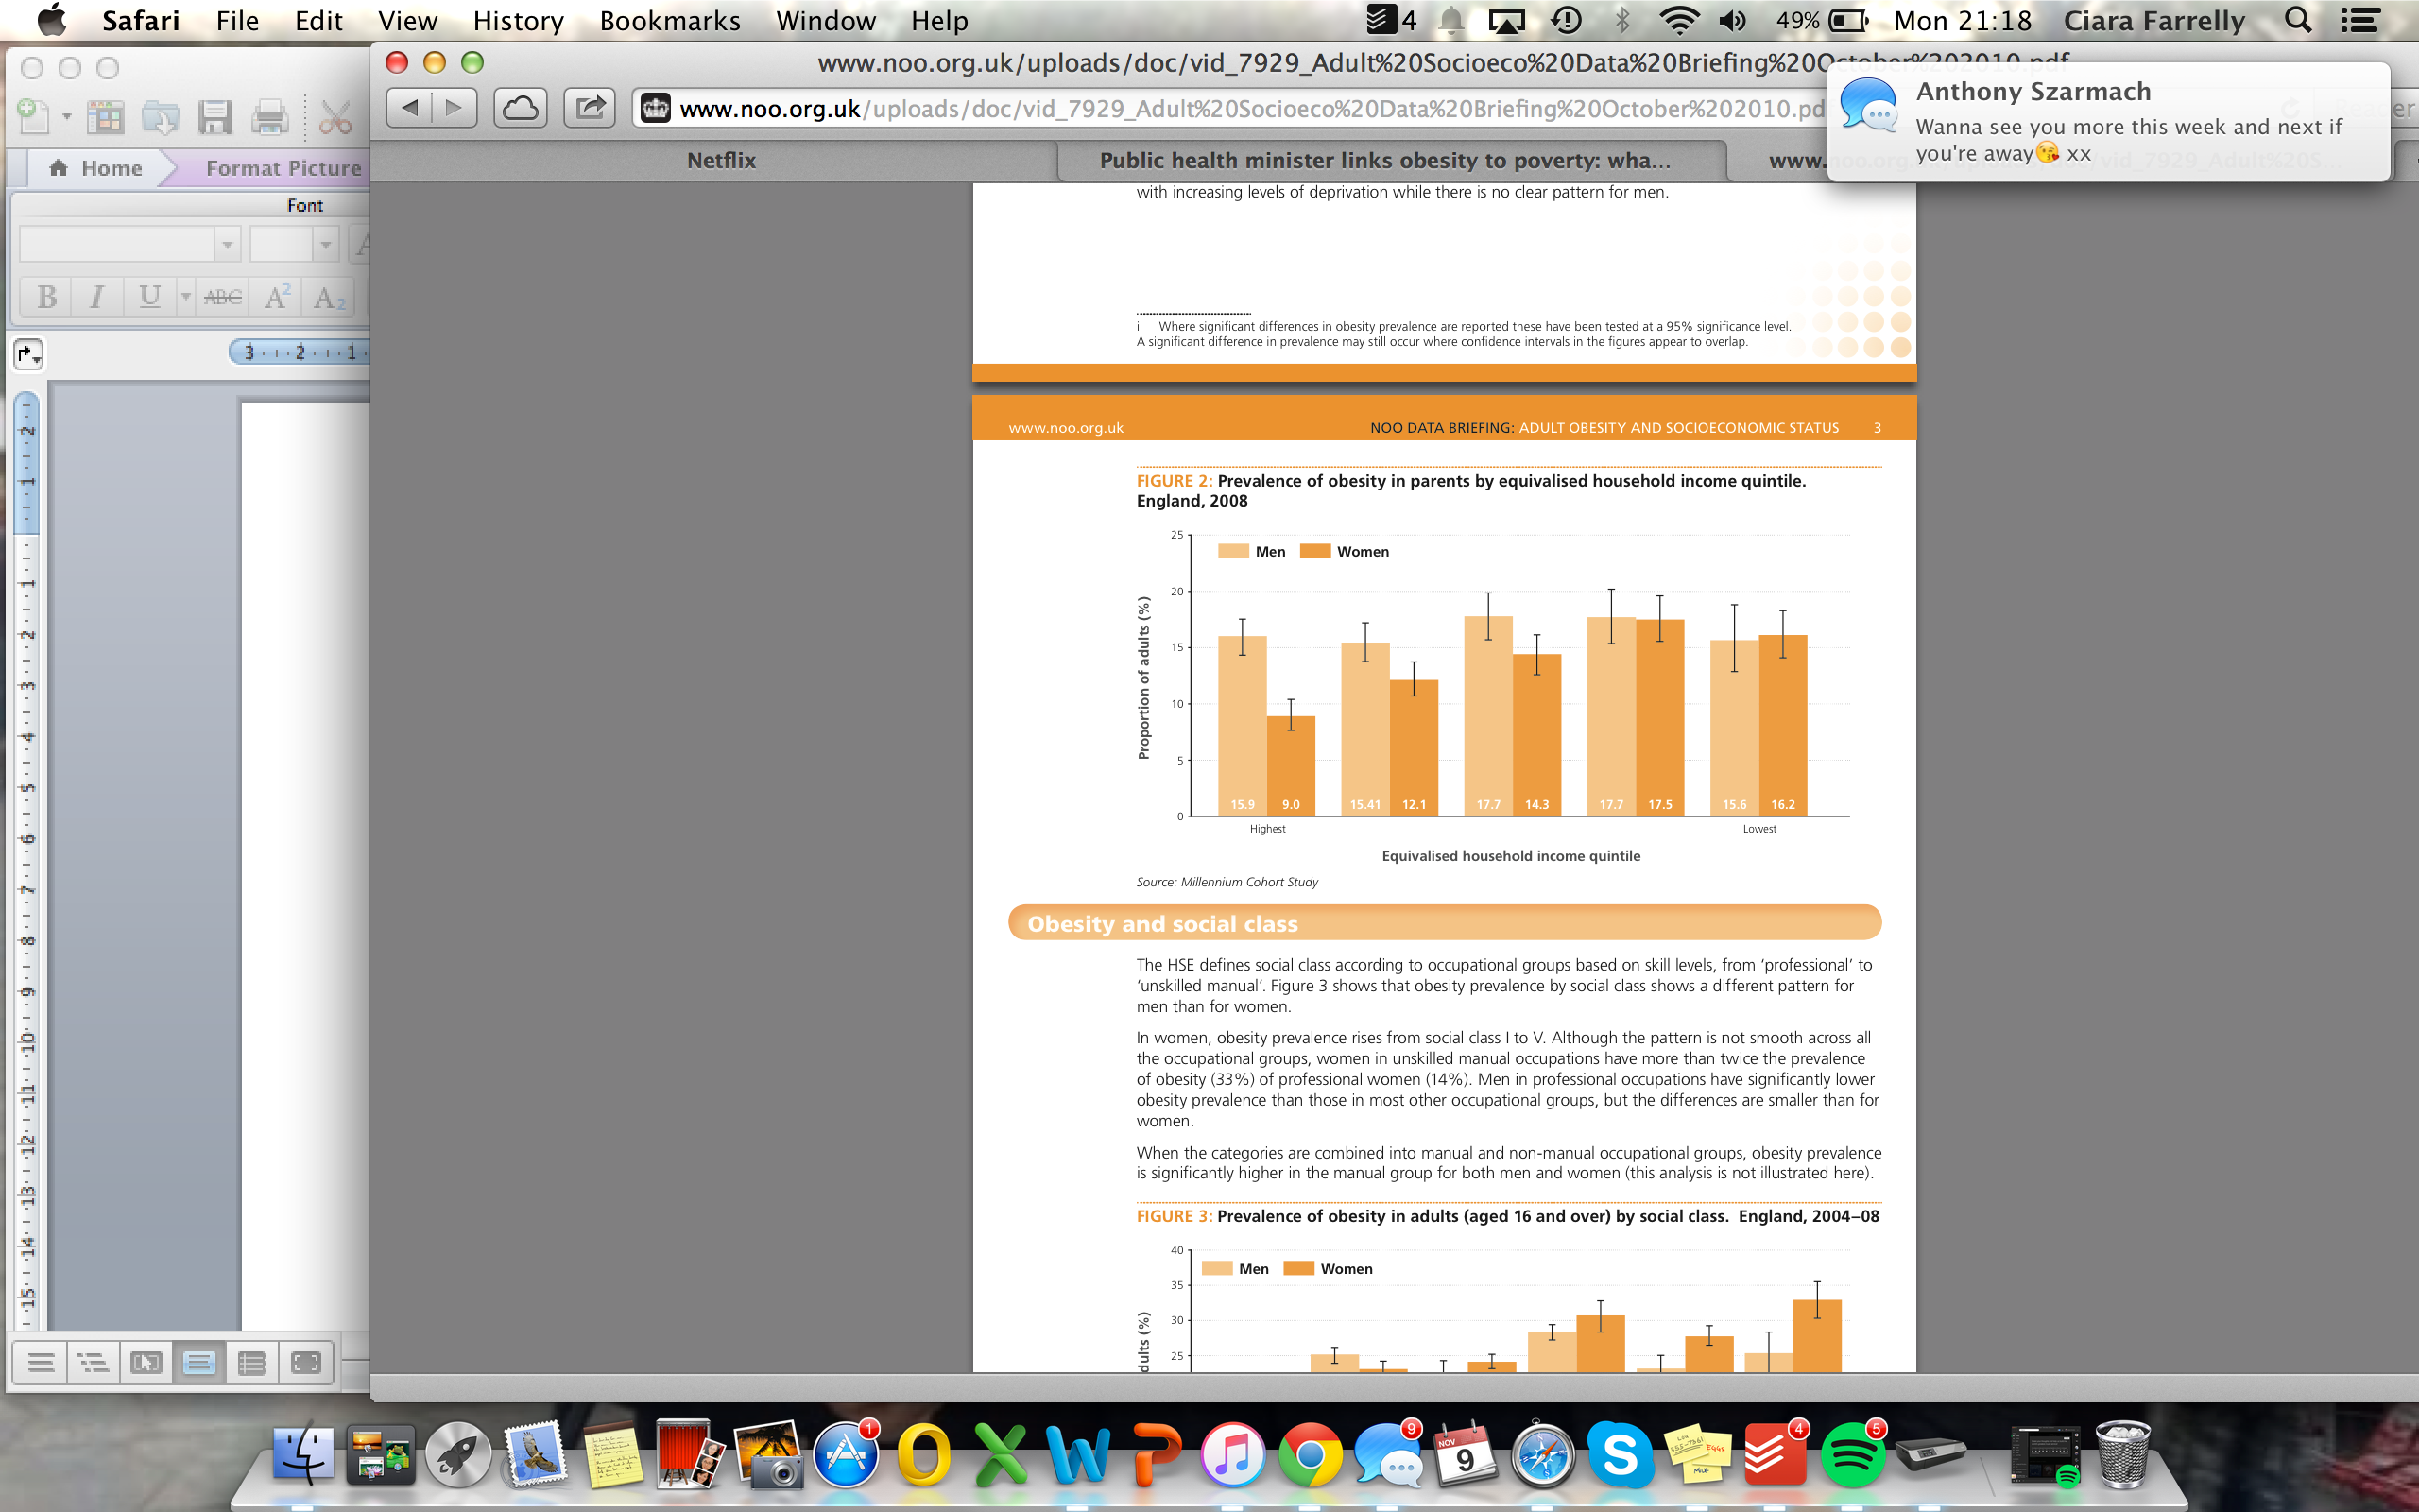

**Figure 1: Prevalence of obesity in parents by equivilised household income quintile, England, 2008**

<http://www.noo.org.uk/uploads/doc/vid_7929_Adult%20Socioeco%20Data%20Briefing%20October%202010.pdf>

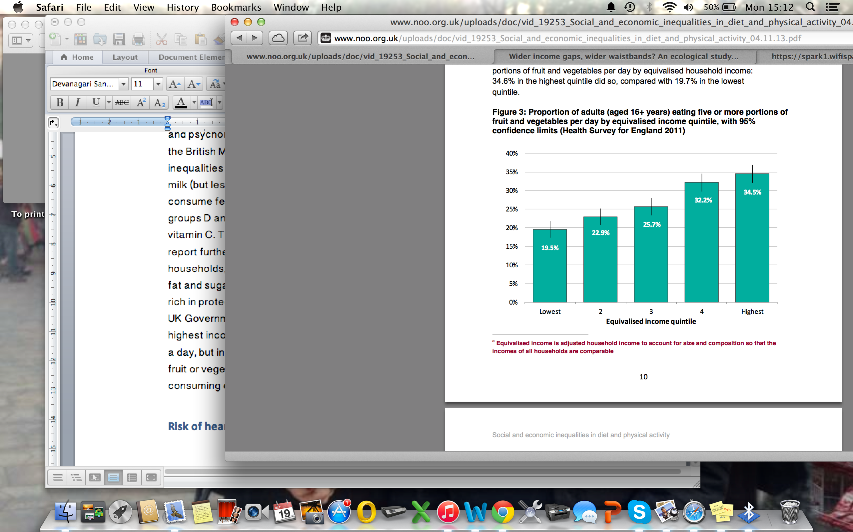

**Figure 2: Proportion of adults (aged 15+ years) eating five or more portions of fruit and vegetables per day by equivalised income quintile**

http://www.noo.org.uk/uploads/doc/vid_19253_Social_and_economic_inequalities_in_diet_and_physical_activity_04.11.13.pdf

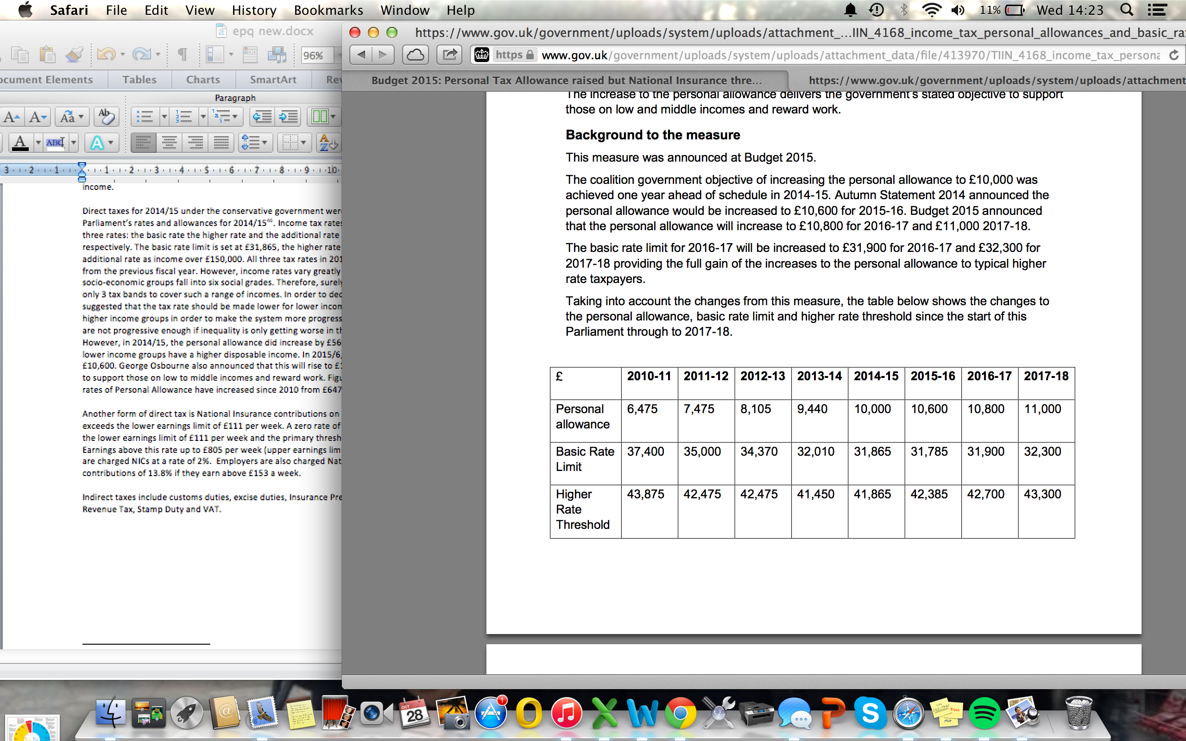

**Figure 3: Income tax: personal allowance and basic rate limit for 2016-17 and 2017-18**

HM Revenue and Customs

# Bibliography

National Institute for Health Care and Excellence (NICE) “Health Inequalities and Population Health (2012)

Public Health England “ Social and Economic inequalities in diet and physical activity”

Chalabi M and Burn-Murdoch J “Public health minister links obesity to poverty: what does the data show?” (2013) The Guardian

P. Toynbee “Inequality is fattening”, *Guardian* (2015)

James WP, Nelson M, Raphe A, Leather S “Socioeconomic Determinants of Health. The contribution of nutrition to inequalities in health” BMJ (1997) 314.7093 1545-1549

London School of Economics “Why are poorer people in western societies more likely to be obese?” (2012) Available at: <http://www.lse.ac.uk/researchAndExpertise/researchHighlights/Health/obesity.aspx>

Maglione JL “Psychosocial correlates of physical activity in low income college students” (2007)

M.G Marmot, A.M Adelstein, N. Robinson and G.A. Rose “Changing social class distribution of heart disease” British Medical Journal (1978)

M.G Marmot, G. Rose, M. Shipley and PJ Hamilton, “Employment grade and coronary heart disease in British civil servants” Journal of Epidemiology and Community Health (1978)

Alan Marsh and Stephen McKay, Poor Smokers. Policy Studies Institute, London, 1994

Office of National Statistics “Inequality in Healthy Life Expectancy at Birth by National Deciles of Area Deprivation: England, 2009-11” (2014)

Garrod J “Health Inequalities” Sociology review

UK Government: “Food labelling and packaging” <https://www.gov.uk/food-labelling-and-packaging/overview>

Grunert K.G, Wills J.M, Fernandez-Celemin L (2010) “Nutritional knowledge, and use and understanding of nutritional information on food labels among consumers in the UK”

UK Government “Final design of consistent nutritional labelling system given green light” (2013) available at: *<https://www.gov.uk/government/news/final-design-of-consistent-nutritional-labelling-system-given-green-light>*

Faculty of Public Health: “Tackling overweight and obesity”

National Health Service: “Physical guidelines for adults (19-64 years)

ONS “Internet Access - Households and Individuals” (2014)

Santarossa JM, Mainland DD. Employing an environmental taxation mechanism to reduce fat intake. In: Chern WS, Rickertson K, eds. *Health, nutrition and food demand*. Oxford: CABI Publishing; 2003. pp. 223-45

Gustavsen G. Public policies and the demand for carbonated soft drinks: a censored quantile regression approach. In: The future of rural Europe in the global agric-food system: Proceedings of the: *XIth Congress of the EAAE (European Association of Agricultural Economists); Copenhagen, 24–27 August* *2005*

Nordström J, Thunström L. *The impact of tax reforms designed to encourage a healthier grain consumption.* Umeå: Umeå University; 2007.

Marshall T. Exploring a fiscal food policy: the case of diet and ischaemic heart disease. *BMJ* 2000; 320: 301-5 doi: [10.1136/bmj.320.7230.301](http://dx.doi.org/10.1136/bmj.320.7230.301) pmid: [10650031](http://www.ncbi.nlm.nih.gov/sites/entrez?cmd=Retrieve&db=PubMed&list_uids=10650031&dopt=Abstract)

Mytton O, Gray A, Rayner M, Rutter H. Could targeted food taxes improve health? *J Epidemiol Community Health* 2007; 61: 689-94 doi: [10.1136/jech.2006.047746](http://dx.doi.org/10.1136/jech.2006.047746) pmid: [17630367](http://www.ncbi.nlm.nih.gov/sites/entrez?cmd=Retrieve&db=PubMed&list_uids=17630367&dopt=Abstract).

Marlow LM, Abdukadirov S “Can Behavioural Economics Combat Obesity?” (2012)

Bollinger B, Leslie P and Sorensen A “Calorie Posting in Chain Restaurants” *American Economic Journal: Economic Policy*. February 2011, Vol. 3, Issue 1, Pages 91-128

BBC News: “Tesco to end checkout sweets in ‘healthy choice’ move

[www.gym-pact.com](http://www.gym-pact.com)

Deloitte “Mobile Consumer 2015: The UK cut. Game of Phones” 2015 available at [http://www.deloitte.co.uk/mobileuk/#feature](http://www.deloitte.co.uk/mobileuk/%23feature)

UK Parliament “Direct taxes: rates and allowances 2014/15” – April 2014

OECD (2014), "Focus on Inequality and Growth - December 2014

IMF “Fiscal Policy and Income Inequality” (2014)

“About the National Health Service (NHS) in England <http://www.nhs.uk/NHSEngland/thenhs/about/Pages/overview.aspx>

Economy Watch “Unemployment and Inequality” (2010) <http://www.economywatch.com/unemployment/in-equality.html>

Ahn et al “The Distributional Impacts of Minimum Wage Increases When Both Labor Supply and Labor Demand Are Endogenous” (2011)

Mental Health Foundation “Mental Health Statistics” <http://www.mentalhealth.org.uk/help-information/mental-health-statistics/>

Grunert K.G, Wills J.M, Fernandez-Celemin L (2010) “Nutritional knowledge, and use and understanding of nutritional information on food labels among consumers in the UK”

1. National Institute for Health Care and Excellence (NICE) “Health Inequalities and Population Health (2012)
2. Public Health England “ Social and Economic inequalities in diet and physical activity”
3. Chalabi M and Burn-Murdoch J “Public health minister links obesity to poverty: what does the data show?” (2013) The Guardian
4. P. Toynbee “Inequality is fattening”, Guardian (2015)
5. James WP, Nelson M, Raphe A, Leather S “Socioeconomic Determinants of Health. The contribution of nutrition to inequalities in health” BMJ (1997) 314.7093 1545-1549
6. London School of Economics “Why are poorer people in western societies more likely to be obese?” (2012) Available at: http://www.lse.ac.uk/researchAndExpertise/researchHighlights/Health/obesity.aspx
7. Maglione JL “Psychosocial correlates of physical activity in low income college students” (2007)
8. M.G Marmot, A.M Adelstein, N. Robinson and G.A. Rose “Changing social class distribution of heart disease” British Medical Journal (1978)
9. M.G Marmot, G. Rose, M. Shipley and PJ Hamilton, “Employment grade and coronary heart disease in British civil servants” Journal of Epidemiology and Community Health (1978)
10. Alan Marsh and Stephen McKay, Poor Smokers. Policy Studies Institute, London, 1994
11. Office of National Statistics “Inequality in Healthy Life Expectancy at Birth by National Deciles of Area Deprivation: England, 2009-11” (2014)
12. Garrod J “Health Inequalities” Sociology review
13. UK Government: “Food labelling and packaging” https://www.gov.uk/food-labelling-and-packaging/overview
14. Grunert K.G, Wills J.M, Fernandez-Celemin L (2010) “Nutritional knowledge, and use and understanding of nutritional information on food labels among consumers in the UK”
15. UK Government “Final design of consistent nutritional labelling system given green light” (2013) available at: https://www.gov.uk/government/news/final-design-of-consistent-nutritional-labelling-system-given-green-light
16. Faculty of Public Health: “Tackling overweight and obesity”
17. National Health Service: “Physical guidelines for adults (19-64 years)
18. ONS “Internet Access - Households and Individuals” (2014)
19. Santarossa JM, Mainland DD. Employing an environmental taxation mechanism to reduce fat intake. In: Chern WS, Rickertson K, eds. Health, nutrition and food demand. Oxford: CABI Publishing; 2003. pp. 223-45.
20. Gustavsen G. Public policies and the demand for carbonated soft drinks: a censored quantile regression approach. In: The future of rural Europe in the global agric-food system: Proceedings of the: XIth Congress of the EAAE (European Association of Agricultural Economists); Copenhagen, 24–27 August 2005
21. Nordström J, Thunström L. The impact of tax reforms designed to encourage a healthier grain consumption. Umeå: Umeå University; 2007.
22. Marshall T. Exploring a fiscal food policy: the case of diet and ischaemic heart disease. BMJ 2000; 320: 301-5 doi: [10.1136/bmj.320.7230.301](http://dx.doi.org/10.1136/bmj.320.7230.301) pmid: [10650031](http://www.ncbi.nlm.nih.gov/sites/entrez?cmd=Retrieve&db=PubMed&list_uids=10650031&dopt=Abstract)
23. Mytton O, Gray A, Rayner M, Rutter H. Could targeted food taxes improve health? J Epidemiol Community Health 2007; 61: 689-94 doi: [10.1136/jech.2006.047746](http://dx.doi.org/10.1136/jech.2006.047746) pmid: [17630367](http://www.ncbi.nlm.nih.gov/sites/entrez?cmd=Retrieve&db=PubMed&list_uids=17630367&dopt=Abstract).
24. Marlow LM, Abdukadirov S “Can Behavioural Economics Combat Obesity?” (2012)
25. Bollinger B, Leslie P and Sorensen A “Calorie Posting in Chain Restaurants” American Economic Journal: Economic Policy. February 2011, Vol. 3, Issue 1, Pages 91-128
26. BBC News: “Tesco to end checkout sweets in ‘healthy choice’ move
27. [www.gym-pact.com](http://www.gym-pact.com)
28. Deloitte “Mobile Consumer 2015: The UK cut. Game of Phones” 2015 available at http://www.deloitte.co.uk/mobileuk/#feature
29. UK Parliament “Direct taxes: rates and allowances 2014/15” – April 2014
30. OECD (2014), "Focus on Inequality and Growth - December 2014
31. IMF “Fiscal Policy and Income Inequality” (2014)
32. “About the National Health Service (NHS) in England http://www.nhs.uk/NHSEngland/thenhs/about/Pages/overview.aspx
33. Economy Watch “Unemployment and Inequality” (2010) http://www.economywatch.com/unemployment/in-equality.html
34. Siebert W.S “Unemployment and the Minimum Wage” (2013)
35. Ahn et al “The Distributional Impacts of Minimum Wage Increases When Both Labor Supply and Labor Demand Are Endogenous” (2011)
36. Mental Health Foundation “Mental Health Statistics” http://www.mentalhealth.org.uk/help-information/mental-health-statistics/
37. Grunert K.G, Wills J.M, Fernandez-Celemin L (2010) “Nutritional knowledge, and use and understanding of nutritional information on food labels among consumers in the UK”
38. P. Toynbee “Inequality is fattening”, Guardian (2015)