Sourcework on Mary Tudor

# Mary Tudor and the Protestant Persecution

Carefully read **all** of the sources below and answer the questions which follow.

SOURCE A An extract from a letter written to Philip II of Spain by Simon Renard, the Spanish Ambassador who lived in London. Philip was preparing to visit England to marry Mary.

*A certain Rogers was burned publicly yesterday. Some of the onlookers wept, others prayed to God to give him strength to bear the pain, others threatened the bishops... Although it may seem necessary to apply harsh punishment, during your visit you must support a more gentle policy otherwise I predict your people may rise up in revolt. Your Majesty must also remember that Princess Elizabeth has her supporters and that there are Englishmen who do not love foreigners.*

SOURCE B The social origins of the Protestants burned by Mary (figures taken from John Foxe’s *Book of Martyrs)*

*26 priests including 5 bishops*

*8 members of the gentry*

*113 labourers and servants*

*91 craftsmen*

*26 wives*

*20 widows*

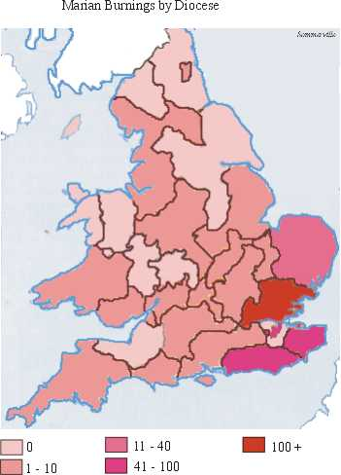SOURCE C A map showing where the burning of Protestants took place.

SOURCE D An extract from John Foxe’s *Book of Martyrs* about the burning of bishops Latimer and Ridley. Foxe was a devout Protestant and fled England to escape persecution.

*Dr Ridley, entering the place first, looked towards heaven. Then, seeing Mr Latimer, with a cheerful look he ran and embraced him, saying “Be of good heart, brother, for God will either ease the fury of the flame, or else strengthen us to endure it.”*

*Dr Ridley then went to the stake and prayed with great fervour while Mr Latimer followed him. Dr Ridley gave presents to those people standing near; many of the people were weeping. Then the blacksmith took a chain of iron and placed it around both their waists and knocked in the staple.*

SOURCE E Religious persecution under the Tudors

**Monarch Length of Reign Heretics burned**

Henry VII 24 years 10

Henry VIII 38 81

Edward VI 6 2

Mary 5 284

Elizabeth 45 5

**QUESTIONS**

1. Read Source A

Why did Simon Renard think that the burning of Protestants was a dangerous policy to follow?

1. Study Sources B and C

What do these two sources tell us about the persecution of Protestants during Mary’s reign?

1. Read Source D

How useful is this source to historians who want to find out about the persecution of Protestants during Mary’s reign?

1. Does Mary Tudor deserve to be known as ‘Bloody Mary’?

**Fully explain your answer using all of the sources and your own knowledge.**