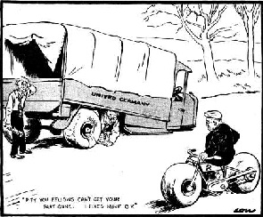
The Berlin Blockade, 1948-1949
Airlift Facts
• The blockade lasted 318 days (11 months).
• In the winter of 1948–49 Berliners lived on dried potatoes, powdered eggs and cans of meat. They had four hours of electricity a day.
• The airlift was codenamed 'operation Vittles'; the first flight was on 26 June 1948.
• The Soviet authorities offered to provide West Berlin with essential supplies - this offer was rejected.
• 275,000 flights carried in 1½ million tons of supplies. A plane landed every 3 mins.
• On 16 April 1949, 1400 flights brought in 13,000 tons of supplies in one day – Berlin only needed 6,000 tons a day to survive.
• Some pilots dropped chocolate and sweets.
• The airlift continued until 30 September 1949, in order to build up a reserve of supplies.
• The USA stationed B-29 bombers (which could carry an atomic bomb) in Britain.
• The American airmen were regarded as heroes
Source C
On 23 June the Soviet authorities suspended all traffic into Berlin because of alleged technical difficulties… They also stopped barge traffic on similar grounds. Shortly before midnight, the Soviet authorities issued orders to… disrupt electric power from Soviet power plants to the Western sectors. Shortage of coal was given as a reason for this measure.
US Government report, June 1948.
Germany had become a real headache for the Western Allies. After the destruction of the war, their zones were in economic chaos. Stalin feared a recovering Germany and wanted to keep it crippled. But it was clear to the Allies that Germany could not feed its people if it was not allowed to rebuild its industries. Although they themselves were wary of rebuilding Germany too quickly, Britain, France and the USA combined their zones in 1946 to form one zone (which would become Western Germany in 1949). In 1948 they reformed the currency and within months there were signs that Germany was recovering.
Stalin felt that the USA’s attitude was provocative. He could do nothing about the western zones, but de felt he could show his authority on Berlin. It was in the Soviet zone and was linked to the West by roads, railways and canals. In June 1948, Stalin blocked all these supply lines, cutting off the population of West Berlin from Western help. Stalin believed that this would force the Allies out of Berlin, making it entirely dependent on the USSR.
It was a clever plan. However, the Americans were not prepared to give up. They saw West Berlin as a test case. If they gave in to Stalin on this issue, West Germany would be next. Truman wanted Berlin to be a symbol of freedom behind the Iron Curtain.
The only way into Berlin was by air. So in June 1948 the Allies decided to air-lift supplies. Everyone feared the Soviets would shoot them down, which would have been an act of war. People waited as the planes flew over Soviet territory, but nothing happened. For the next ten months West Berlin was supplied by airplanes bringing everything from food and clothing to oil and building materials. By May 1949 it was clear that the blockade would not make the Western Allies give up Berlin, so Stalin reopened communications.
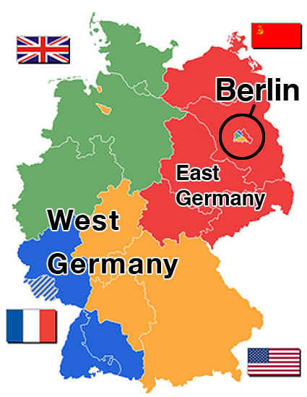
Source A Germany in 1948
Source B British cartoon of October 1946 shows British foreign minister and the American one trying to get the lorry of a 'united Germany' going, while Soviet foreign minister Molotov sits smugly on his motorbike, having stolen the wheels - 'Pity you fellows can't get your part going. I fixed mine OK', he is saying.

