What were the results of the Blockade?

a. Cold War got worse It almost started an all-out war.
b. East and West Germany Germany split up. In May 1949, America, Britain and France united their zones into the Federal Republic of Germany (West Germany). In October 1949, Stalin set up the German Democratic Republic (East Germany) .
c. NATO and the Warsaw Pact In 1949, the western Allies set up NATO (North Atlantic Treaty Organisation) as a defensive alliance against Russia. NATO countries surrounded USSR; in 1955, the Soviet Union set up the Warsaw Pact – an alliance of Communist states.
d. Arms Race After Berlin, the USA and the USSR realised that they were in a competition for world domination. They began to build up their armies and weapons.
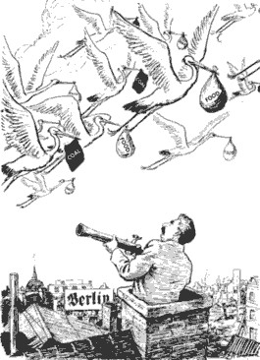
Source D
This cartoon of 14 July 1948 by EH Shepard for the British magazine Punch shows Stalin watching as storks fly coal and food into Berlin.

Source E
The crisis was planned in Washington behind a smokescreen of anti-Soviet propaganda... The self-blockade of the Western powers hit the West Berlin population with harshness. The people were freezing and starving. In the Spring of 1949 the USA was forced to yield
From a Russian history book.
Source F
We demonstrated to the people of Europe that we would act resolutely, when their freedom was threatened. Politically it brought the people of Western Europe closer to us.
President Truman, speaking in 1949.

Source G
Neither side gained anything. The USSR had not gained control of Berlin. The West had no guarantees that land communications would not be cut again. Above all confrontation made both sides even more stubborn.
Historian Jack Watson writing in 1984.
Activities
- Think of as many reasons as you can why, in the period 1945-49, Germany was often at the centre of the Cold War.
- Read source C. What reasons did the USSR give for cutting off West Berlin?
- Working as a whole class, draw a spider diagram to show all the reasons why the Berlin blockade failed.
- What were the results of the Berlin Blockade.
- Choose one source, B or D to label it and write a report.
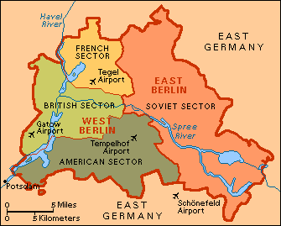
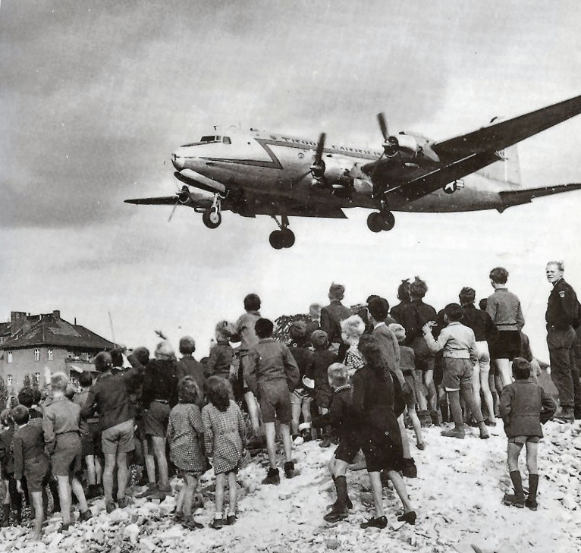
Source H
Berliners watch a C-54 Skymaster land at Tempelhof Airport, 1948
Source I

