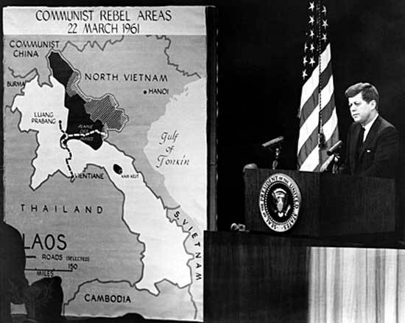**JFK & Vietnam 1961-1963**

1. **Task: Bullet point specifically the increase of aid and support that the JFK administration sent to Vietnam.**
2. **Copy down the statements and then explain whether you agree with them or not.**
3. Before 1961 JFK favoured democracy in Vietnam.
4. The Democrat JFK had a tougher view on Communism than Republican president Eisenhower in the 1950s.
5. JFK managed his advisors poorly.
6. JFK’s concerns over Laos, Vietnam and Cambodia were dominated by concerns over his own image: he did not wish to appear weak on Communism.
7. The Battle of Ap Bac (Jan 1963) highlighted fundamental problems with winning the war in Vietnam.
8. JFK’s advisers gave similar advice over the Vietnam situation.
9. Diem manipulated the USA in their dealings with him.
10. If Diem had been eliminated before JFK came to power the USA would have been successful in South Vietnam.
11. JFK’s policy in Vietnam was a continuation of Eisenhower’s.
12. **Task**

**Create a 5 minute presentation to argue one of the following points:**

* JFK’s policy was essentially to escalate the war in Vietnam.
* JFK planned to pull out of Vietnam as soon as possible.
* JFK’s policy on Vietnam was confused, he had no defined long term aim.