**The 1973 Yom Kippur War**

**Direction: Use the documents and your own knowledge to complete the chart and questions. Make note of significant quotes and who said them.**

|  |  |  |
| --- | --- | --- |
|  | **The Arabs** | **The Israelis** |
| **Position of the Sinai** |  |  |
| **Strategy and Attitudes** |  |  |
| **End Result** |  |  |

1. **How did the Yom Kippur War contribute to the tensions between Arab countries and Israel?**
2. **How did the war strengthen Israel’s position?**
3. **What impact did this conflict have on the Cold War?**

**The 1973 Yom Kippur War**

**Source A (Sadat and Dayan)**

War broke out again between Arab and Israelis in October 1973. The conflict took place at the time of the Jewish festival of Yom Kippur. This took the Israeli government and people by surprise.

**Why did the Yom Kippur War take place?**

In the aftermath of the 1967 there was little progress towards a peaceful solution of the dispute between Israel and the Arab world. In 1969, the Egyptian army was ordered to use their artillery against Israeli forces close to the Suez Canal. The Israelis returned fire and there were regular artillery duels across the Canal. Israeli escalated the conflict by mounting air raids deep into Egyptian territory. This was known as the War of Attrition. It finally ended in August 1970 when both sides agreed to a cease fire. Shortly afterwards Nasser died and a new president, Anwar el-Sadat, came to power. Sadat was willing to negotiate with the Israelis.

**Sadat offers peace**

Sadat was ready to make peace. He wanted Israel out of the Sinai and he wanted to reopen the Suez Canal. The closure of the Canal was a great blow to the Egyptian government because it lost its tolls and taxes from the shipping. In February 1971 Sadat made a speech making it clear that he was ready to make permanent peace with Israel in return for and Israeli withdrawal from the Sinai. However, the Israeli government did not trust Sadat and was not ready for any compromise with Egypt. Moshe Dayan, the minister of defence, felt that Israel would remain strong if it held on to the land conquered in 1967. He repeatedly said, “Israel has no foreign policy, only a defence policy.” This meant that Israel did not need to negotiate deals with neighbouring countries as long as it had good borders and good armed forced. Dayan’s views were shared by many ordinary Israelis.

**Sadat opts for war**

Sadat gradually came to believe that only by a display of military power could the Israelis be forces to the conference table. Sadat built up the arms forces in Egypt with the help of massive aid from the Soviet Union. The Egyptian arms was equipped with new surface-to-air missiles, which made Sadat confident that there would be no repeat of the devastating Israeli air attacks of 1967. Sadat’s view that there was a need for a war to end the stalemate was reinforced by a speech made by Dayan in April 1973. The Israeli defence minister said that the government now regarded the Suez canal as part of the permanent border of Israel.

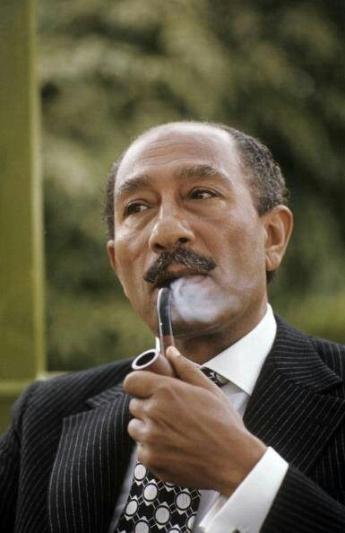 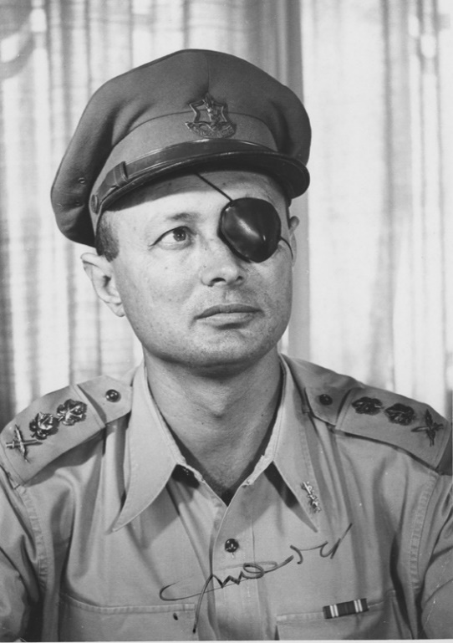

Anwar el-Sadat. Why did he decide to attack Israel? Moshe Dayan. He was not interested in Sadat’s offer of a peace deal.

**Source B**

An article from a leading Israeli newspaper, Ma’ariv, on 13 July 1973, gives some sense of the complacency of many Israelis before the Yom Kippur War.

Our present-day defence lines give us a decisive advantage in the Arab-Israeli balance of strength. There is no need to mobilize our forces every time we hear Arab threats, or when the enemy concentrates his forces along the cease-fire lines. Before the Six-Day War, any movement of Egyptian forces into Sinai would compel Israel to mobilise reserves on a large scale. Today, there is no need for such mobilisation as long as Israel’s defence line extends along the Suez Canal. The Arabs have little capacity for coordinating their military and political action. To this day they have not been able to make oil an effective political factor in their struggle with Israel. Renewal of hostilities is always a possibility, but Israel’s military strength is sufficient to prevent the other side from gaining any military objective.

**Source C**

The Israel general, Ariel Sharon, speaking in September 1973:

There is no target between Baghdad [in Iraq] and Khartoum [in Sudan] including Libya, that our army us unable to capture. With our present boundaries we have no security problems.

**Attack at Yom Kippur**

The war began on 6 October 1973. This day was a religious holiday in Israel, known as Yom Kippur. Simultaneously, Egyptian and Syrian forces launched a surprise attack on Israel. On the Suez Canal only about 400 Israeli troops and 30 tanks were in place. The Israeli soldiers were not full-time professionals; they were reservists from Jerusalem serving their annual duty. The Egyptians launched a massive artillery attack on the Israeli positions near the Suez Canal. A few minutes later 8,000 Egyptian infantry soldiers attacked the Israeli defences. The Israelis were soon overrun. Israeli aircraft were shot down in large numbers by Egyptians using accurate Soviet missiles.

There was a similar Israeli collapse on the Syrian front. As in the Suez Canal area, the Israelis were completely unprepared and lacked the resources to stop the invasion. In the north the Israeli forces were greatly outnumbered. A total of 1,100 Syrian tanks faced only 157 Israeli tanks. The Syrian forces were soon within the Israeli borders.

**The turning of the tide**

In the first three days, the Israelis lost 50 aircraft and hundreds of tanks. After the initial shock they began a successful counterattack. By the 10th October, the Syrians had been driven out of the territory occupied in the first days of the war. A day later, the Israelis entered Syria itself. The Israeli position on the Golan Heights was re-established. The defeat of the Syrians enabled the Israelis to devote their resources to the Egyptian front. On the 14th October an enormous battle took place in the Sinai desert. The Israelis won the battle decisively – Egypt lost over 260 tanks, while the Israelis lost only 10 tanks. The Israelis then moved on and crossed the Canal on the 19th October. Soon the Egyptian Third Army was surrounded. The American government put intense pressure on Israel, however, and the Israelis reluctantly agreed to a cease fire on the 26th October 1973. The war was over.

**The aftermath of the war**

The Yom Kippur was another victory for the Israelis but the fact that they had been taken by surprise and had so much damage inflicted on them in the first part of the war had destroyed their reputation for invincibility. There had also been a change in world opinion between 1967 and 1973. At the time of the Six Day War much of the word was on the side of Israel. By 1973 there was much more sympathy for the Arab position.

During the war, the rich Arab oil-producing countries placed a ban on supplying countries which helped Israel. After the war they also dramatically increased the price of oil. This encouraged many Western countries, particularly the USA, to look for solutions to the political problems in the Middle East.

**Source D**

Reich, B. *A brief history of Israel, Second Edition* (New York, 2005) pp. 100-101

The 1973 Yom Kippur war wrought substantial change in Israel. The war stunned a population that had believed that the Arabs would not dare attack. Also, Israel had lionized its military. In the popular view, the IDF’s capability for combat reached near legendary levels. Its intelligence services were regarded as mong the finest in the world. At the same time, Arab military capabilities had been underestimated, and senior Israeli decision makers had talked about the absence of war in the Middle East for the next 10 to 15 years.

Map of Israeli-held territories after the Yom Kippur War

