Year 7 Castles IST (2)

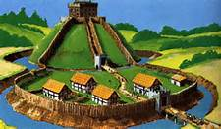

This IST asks you to Create a Model of a Medieval Castle

Your challenge is to build a model of a medieval castle. It can be a wooden motte and bailey castle, a more advanced stone-built concentric castle or a castle that shows changes over time. You can also choose to show specific methods of attack or defence of a castle.

You can build your castle out of any materials other than lego or mecano – edible castles may not last long. You have to be able to bring it into school - do not make it too big and think about how you are going to transport it. You will need to store it in your locker before your lesson, so it should not be made larger than you can store.

You will be assessed on:

* Historical accuracy
* Attention to detail
* The care and craftsmanship you have put into your work.
* You will have a chance to peer assess each other’s castles but the History Dept. will choose the overall winner - one per form and one for the Year.

Time spent thinking and planning will be very important, we will be discussing castles in the lessons after half term so don’t get too ahead of yourself.

Please ensure your castle is clearly named.

