What does Guild Chapel tell us about the importance of religion in medieval society?
Starter
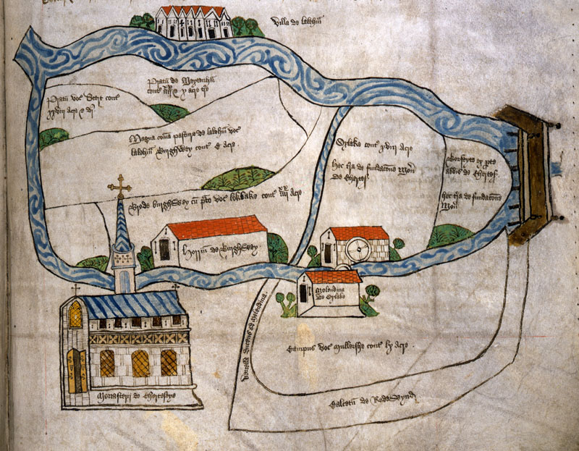
This image is of __________________________________________________________________________
The biggest building on the map is ___________________________________________________
This tells us that religion in the medieval period ___________________________________
______________________________________________________________________________________________
______________________________________________________________________________________________
______________________________________________________________________________________________

- The Church played a far _________ role in Medieval England than the Church does today.
- The Church ___________everybody’s life.
- All medieval people – be they ________ or _____ people – believed that God, Heaven and Hell all existed.
- From the earliest ages, the people were taught that the only way they could get to ________was if the Roman Catholic Church let them.
- Therefore people would do anything to ______the church
- Everybody would have been _________of Hell and the people would have been told of the sheer horrors awaiting for them in Hell in the ________ services they attended.

