***PLAGUE DIARY***

[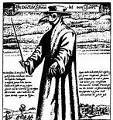](http://www.bing.com/images/search?q=black+death&FORM=HDRSC2&adlt=strict#view=detail&id=38FDDF9B03BE8324CFFCD086198A414F8C1C966C&selectedIndex=66)***You are a Goldsmith living in London during the Great Plague of 1666. Write three diary entries to cover the following events:***

***2nd June 1665*** *– The Plague*

*begins to spread through the city.*

***10th August 1665*** *– Your son dies of*

*the plague.*

***1st September 1665*** *– Celebrations for the*

*end of the plague.*

*Feel free to embellish your pages with illustrations!*