**BRITAIN: A DIMINISHED STATE?**

After the war Britain emerged weakened, on its knees and in need of generous economic support from the United States. It was also a time when Britain was beginning to diverge ideologically from its ally and its imperial past with the election of the new Labour government in July 1945. By no means was empire over, but this was the beginning of the period we call ‘End of Empire’. As you may know, the United States, as a former colony itself, was suspicious of Britain’s imperial power. You may think that growing scepticism towards empire in Britain would bring the two allies closer together. This was not so, as you will find in this booklet, the early years of the Cold War were a challenging time for Anglo-American relations. Britain did not shy away from involvement in the Cold War. As you will find in this booklet Britain was a key player in the Berlin blockade.

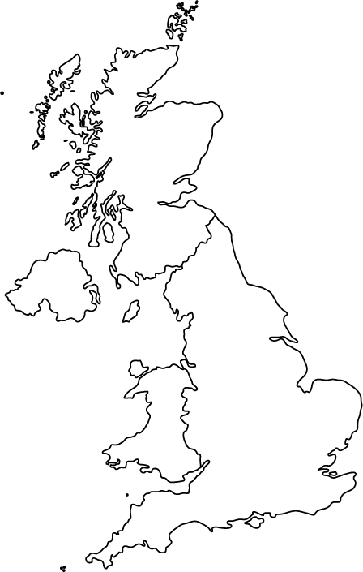

**HIGHLIGHTER HEADS:**

Your task is to highlight the correct head(s) to match the statements on the left

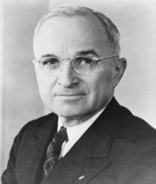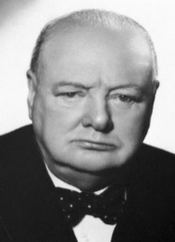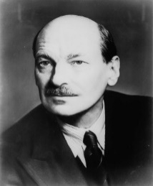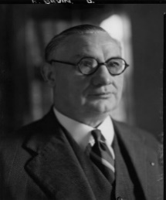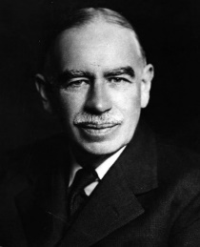

Promoted significant government intervention in the economy, underpinning the recovery strategies of the American government after the great depression

British PM that sought to build a ‘New Jerusalem’ in the United Kingdom in the post-war period through revolutions in welfare, housebuilding and healthcare

Considered a somewhat more Hawkish member of Labour’s cabinet who pushed Britain’s involvement in the Berlin blockade

Gave the famous ‘Iron Curtain’ speech warning of the threat posed to the world by the Eastern Bloc and the Soviet Union’s growing sphere of influence

Pressured by his advisors to terminate the Lend-Lease to the UK. Ultimately not held accountable by the British government

Economist sent to the United States by the British government to negotiate a $5 billion loan in place of the lend-lease

Keynes

Truman

Bevin

Attlee

Churchill

|  |  |  |
| --- | --- | --- |
| *Going by the title of the book – ‘Citizen Clem’ – how do you think the author views Clement Attlee?*  *The Chicago Tribune had a large Irish-American audience, why do you think we might term them “Anglo-phobes?”*  *In response to the American rebuke, Attlee’s government sent John Maynard Keynes to United States to negotiate a loan. His economic theory was very similar to the strategy used by FDR to recover from the Great Depression and the economic strategy of Attlee’s Labour government. Were the Americans really so different from the British?* | An extract from *‘Citizen Clem’* (Bew, 2017) detailing Anglo-American immediately after the war. On the left is some extra detail, as well as questions to think about. Use the extract to complete ‘Highlighter Heads’ and the task on the right.  (p.371)  In fact, Attlee’s victory had caused some consternation in certain sections of the American press. First were the predictable attacks from the Anglo-phobe newspapers such as the *Chicago Tribune* […] which was suspicious of British imperialism, no matter the government in charge.  […]  A number of influential voices in the US had already begun to question the need in peacetime, to maintain Lend-Lease to the UK. That this would now be used to prop up a socialist government stuck in the craw of those on the right of the political spectrum, in particular. One Republican congressman was quoted saying that ‘We must make sure that any American dollars loaned to England are used only for reconstruction and not to aid the leftist government in effecting its radical social and economic reforms.’ This was not helped by a number of boastful interventions by Harold Laski in the *New York Times*, where he talked of a ‘revolution by consent’, and lauded Britain’s conversion to socialism as an example to America.  The termination of Lend-Lease, within a week of the ending of the war in Asia, caused shock and consternation. The day before the announcement was made, *The Economist* warned about the effects of the scaremongering of the American right about British socialism, combined with a return of the American isolationist reflex.  (p.372)  For his own part, Truman later expressed regret about the way the ending of Lend-Lease had been handled. He was influenced by a caucus of advisers within the US State Department. ‘It was a great shock. The tap was turned off at a moment’s notice,’ Attlee recalled. All we had was what was in the pipe line and even that looked like being in jeopardy when the news first came. We had not had a chance to reorganise ourselves on a peacetime basis. The Americans, I suppose, didn’t realise what it meant.’ Nonetheless, he absolved Truman from personal blame. […] In the short term, the only response that was open to ministers was to seek to return to the US government with a request for a large loan. | *Clearly, Anglo-American relations were not a priority for the United States immediately after the war. In your view, was it the election of a socialist government or the British empire that was the main reason for the return of ‘the American isolationist reflex’? Use evidence from the extract to support your claim* |

**Adapted from a note to British PM Clement Atlee, in July 1948, in which Bevin presented his analysis of the situation in Germany:**

‘The mere fact of our continuing presence has so far prevented and shall continue to hinder the setting up in Berlin of a Soviet-controlled German government. To retreat from Berlin, the last democratic island in the Soviet sphere, would immensely increase Soviet prestige, win over the doubtful masses in Germany to their side and depress our friends in each of the free countries in Europe. We must however be clear in our minds that to stay in Berlin is a means to an end rather than an end in itself.’

**Clement Attlee on Building the 'New Jerusalem', prior to the 1951 general election, when Labour would lose power despite winning the popular vote**

"Let us go forward into this fight in the spirit of William Blake: "I will not cease from mental strife/Nor shall my sword sleep in my hand/Till we have built Jerusalem/In England's green and pleasant land".

**British Foreign Secretary Ernest Bevin on the Berlin airlift**

[…] no alternative between that and surrender, and none of us can accept surrender.

**Attlee addressing the US congress November 1945**

I think that some people over here imagine that the Socialists are out to destroy freedom, freedom of the individual, freedom of speech, freedom of religion, and the freedom of the Press. They are wrong; the Labour Party is in the tradition of freedom-loving movements which have always existed in our country, but freedom has to be striven for in every generation, and those who threaten it are not always the same. Sometimes the battle of freedom has had to be fought against kings, sometimes against religious tyranny, sometimes against the power of the owners of the land, sometimes against the overwhelming strength of the moneyed interests. We in the Labour Party declare that we are in line with those who fought for Magna Carta and habeas corpus, with the Pilgrim Fathers, and with the signatories of the Declaration of Independence.

**The sources on this page give some indication of the Britain’s post-war ambitions, as well as the constraints. In this domestic context how do you think Briton’s felt about potential intervention in the Berlin blockade?**

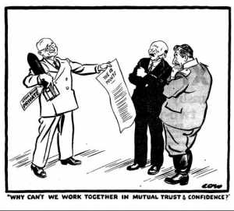

**British cartoon (1946) showing Truman negotiating with Attlee and Stalin while clutching the atomic bomb**

**Berlin – The Crisis Guided Viewing:**

Answer the questions below with appropriate justifications and note down key phrases in the space below.

1. Several thousand tonnes of food were imported into Berlin everyday by the allies; Make a snap judgement - How might this intervention been received by the British public at large?
2. Did you notice Bevin correct himself? Why might he have changed his mind and referred to the “western powers’ rather than the ‘allies’?
3. “The Danzig of tomorrow” – what does this ominous closing line mean and how might it influence British public opinion on involvement in Berlin?

**Key Phrases:**

**Is this source approving, disapproving or neutral on British involvement in Berlin? Circle the icon corresponding to your view below:**



**Berlin Ready for Winter Guided Viewing:**

Answer the questions below with appropriate justifications and note down key phrases in the space below.

1. “Beleaguered Berlin” – do you consider this phrasing to be sympathetic? Why?
2. Why was it necessary for the barber to take his business out into the street?
3. What did the narrator nickname Berlin at the end of the video? What can we infer from his phrasing?

**Key Phrases:**

**Is this source approving, disapproving or neutral on British involvement in Berlin? Circle the icon corresponding to your view below:**

