Why was NATO set up?
During the Berlin Blockade, war between the USA and the USSR seemed a real possibility. At the height of the crisis, the Western powers met in Washington and signed an agreement to work together. The new organisation they formed in April 1949 was known as NATO (North Atlantic Treaty Organisation).
Find out what countries were part of NATO in 1949

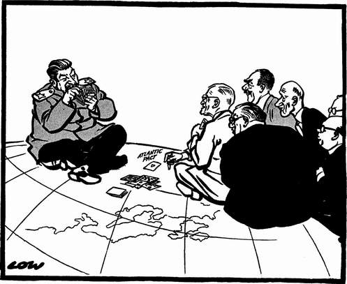
Source A A cartoon by David Low, 1949, entitled ‘You play, Joe’. Western leaders wait to see how Stalin will react to the formation of NATO.
A pattern for the Cold War
The Berlin Blockade set out a pattern for Cold War confrontations. On the one hand, two superpowers that their allies had shown how suspicious they were of each other; how they would obstruct each other in almost any way they could; how would they bombard each other with propaganda. On the other hand, each had shown that it was not willing to go to war with the other. The Berlin Blockade established a sort of tense balance between the superpowers that was to characterise much of the Cold War Period.

The rise of Khrushchev
Stalin was a hero to millions of people in the USSR. He had defeated Hitler and given the USSR an empire in Eastern Europe. He made the USSR a nuclear superpower. He died in 1953, and in 1955 Nikita Khruschev became the new leader of the USSR. He seemed very different from Stalin. He talked of peaceful co-existence with the West. He made plans to reduce expenditure on arms. He met with American, French and British representatives. He also said he wanted to improve the living standards of people living in the Communist world.
Khruschev even relaxed the control of the USSR. He released thousands of political prisoners. People believed he would give countries of Eastern Europe much greater independence to control their own affairs.

The Warsaw Pact
One aspect of Stalin’s policy did not change, however. His aim in Eastern Europe had always been to create a buffer against attack from the West. Khruschev continued his policy. In 1955 he created the Warsaw Pact. This was a military alliance similar to NATO. The members would defend each other if one was attacked. The Warsaw Pact included all the Communist countries of Eastern Europe except Yugoslavia, but it was dominated by the USSR.
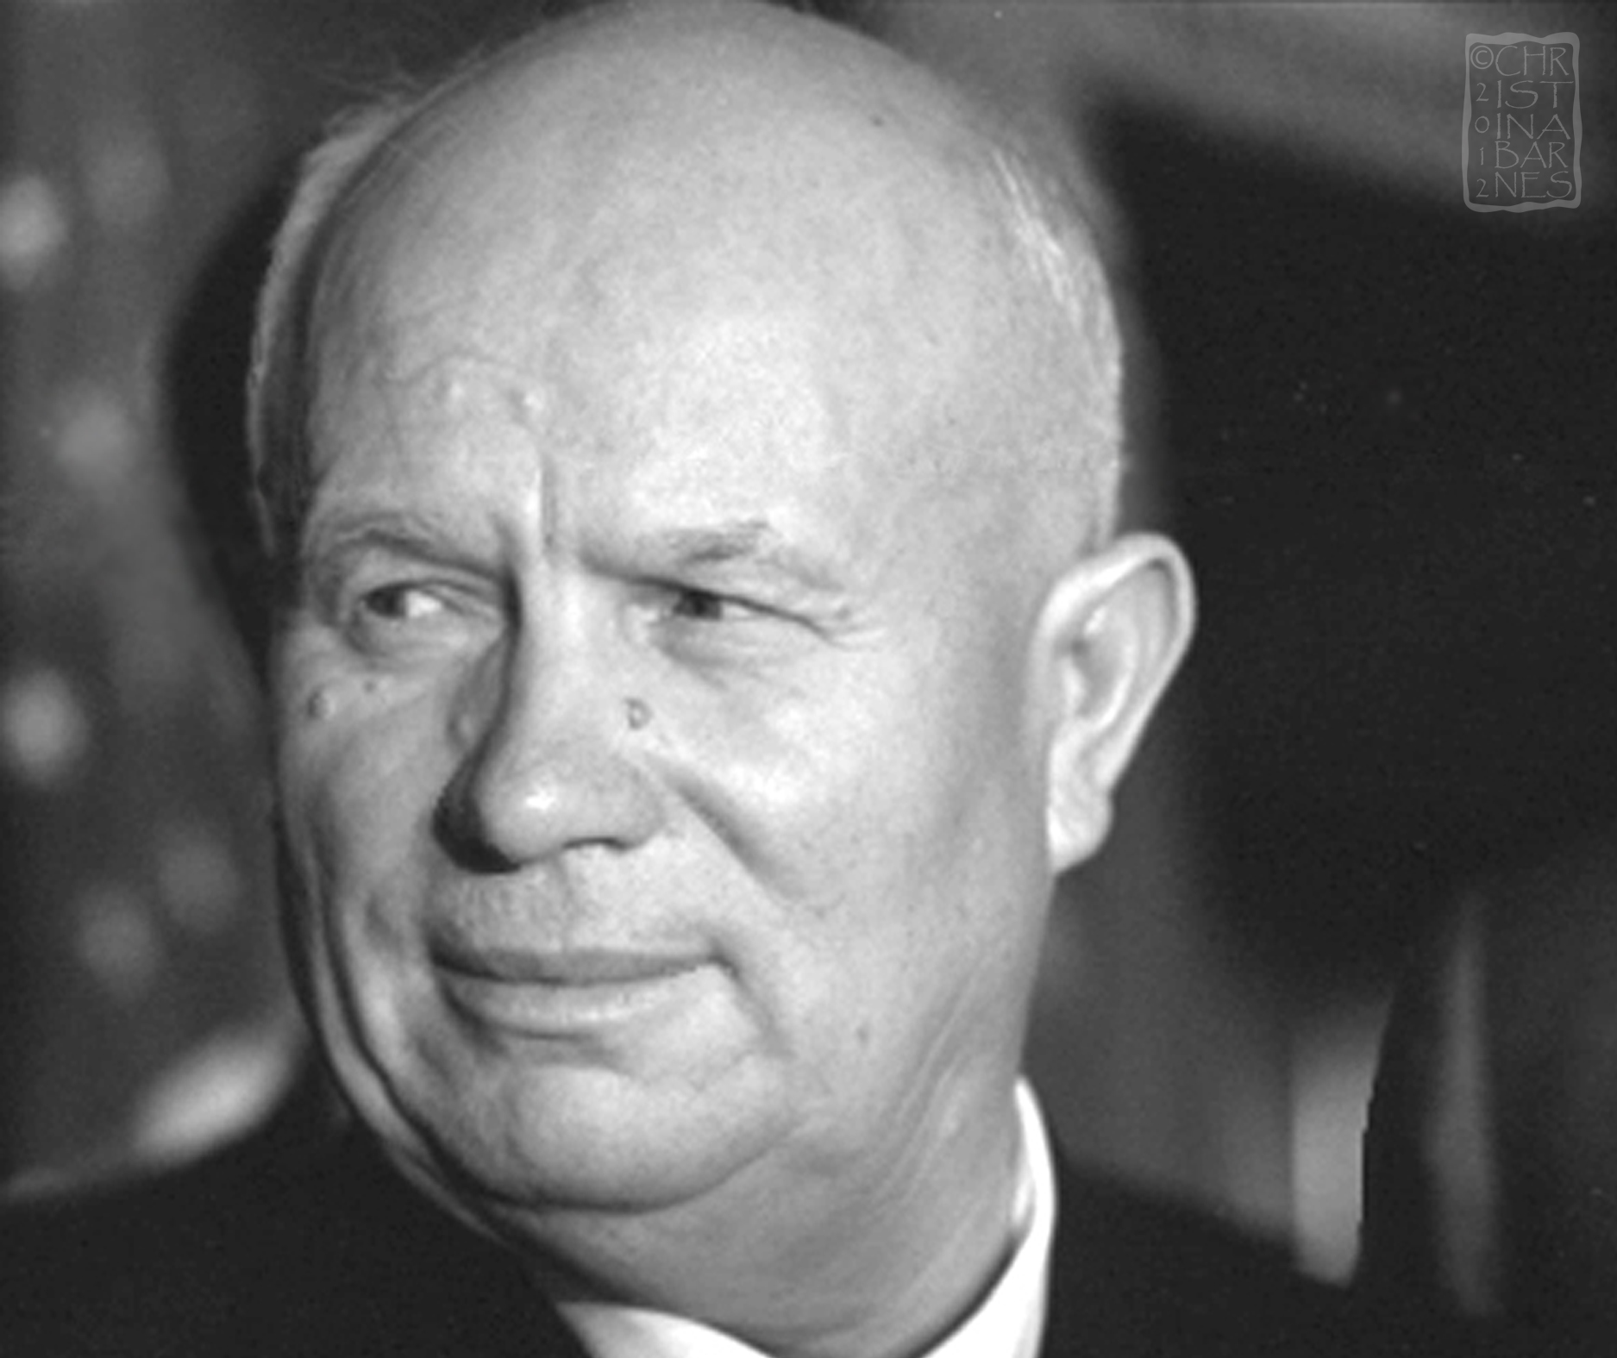
Nikita Khruschev ruled the USSR between
1955 and 1964.

Find out what countries were part of the Warsaw Pact in 1955

