Mathematics Student Wider Reading / Listening List
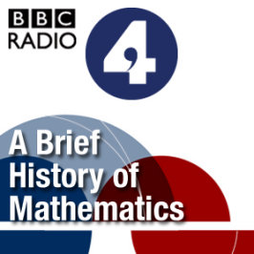 | The Infinite Monkey Cage - Award winning science/comedy chat with Brian Cox, Robin Ince and guests. Witty, irreverent look at the world according to science with physicist Brian Cox and comedian Robin Ince - Free Podcast | 
A Brief History of Mathematics - Professor Marcus du Sautoy argues that mathematics is the driving force behind modern science. Ten fifteen minute podcasts that reveal the personalities behind the calculations from Newton to the present day. How do these masters of abstraction find a role in the real world?
- Free Podcast
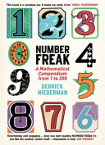 | Number Freak - Derrick Niederman has compiled a compendium of numbers from 1 to 200 and gives you information about the characteristics and qualities of each number.  (ISBN 978-0715637104) | 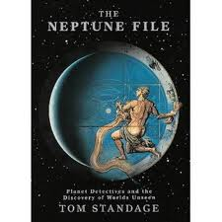
The Neptune File - Tom Standage tells the story of John Couch Adams and the quest to find the planet Neptune using mathematics to locate it's position.
(ISBN 0-71-399472-X).
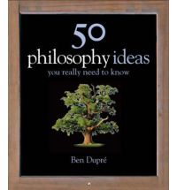 | 50 Mathematical Ideas - By exploring the subject through its 50 key insights from the simple (the number one) and the subtle (the invention of zero) to the sophisticated (proving Fermat's last theorem) this book shows how mathematics has changed the way we look at the world around us  ISBN: 978-1847241474 | 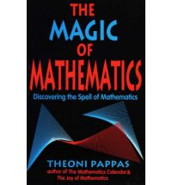
The Magic of Mathematics - explores the mathematics of nature, literature and art. This fascinating look at the surprising ways mathematics influences the everyday world takes an abstract universe and anchors it to the "real" worlds of science, history and the arts in an intriguing way.
ISBN: 9780933174993
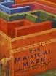 | The Magical Maze - is structured on the image of a maze representing the network of connected mathematical ideas that have proved so powerful and effective in the understanding of the natural world. It covers topics such as numbers, probablity, game theory, patterns and oscillators, as well as knots, computability, chaos and other topics chosen to communicate the intellectual excitement and beauty of mathematics as a subject.  ISBN: 978-0297819929 | 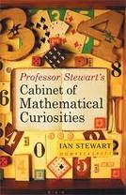
Cabinet of Mathematical Curiosities - There are some hidden gems of logic, geometry and probability – like how to extract a cherry from a cocktail glass (harder than you think), a pop up dodecahedron, the real reason why you can’t divide anything by zero and some tips for making money by proving the obvious. There are beguiling secrets about familiar names like Pythagoras or prime numbers, as well as anecdotes about great mathematicians.
ISBN: 978-1846680649
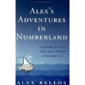 | Alex's Adventures in Numberland - Alex explains the surprising geometry of the 50p piece, and the strategy of how best to gamble it in a casino. He shines a light on the mathematical patterns in nature, and on the peculiar predictability of random behaviour by Alex Bellios.  ISBN: 978-0747597162 | 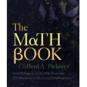
The Math Book - Its 250 short entries provide a veritable history of mathematics by focusing on its greatest theorems and the geniuses who discovered them by Clifford Pickover.
ISBN: 978-1402757969
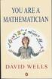 | You are a Mathematician - Beginning with the familiar, this book takes you on a journey from the Greek mathematicians to quantum theory by David Wells  ISBN: 0-14-017480-X | 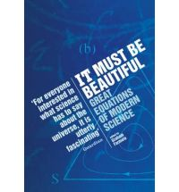
It must be beautiful - An exploration of some of the great equations of modern science presented for the non-mathematician by a range of experts
ISBN: 1-86207-555-7
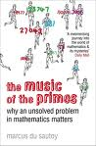 | The Music of the Primes - A look at Riemann's hypothesis and the relevance of a formula to generate primes by Marcus Du Sautoy  ISBN: 1-84115-580-2 | 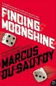
Finding Moonshine - A book full of insight into the nature of symmetry and the people who study it by Marcus Du Sautoy
ISBN: 978-0-00-721462-4
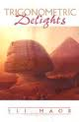 | Trigonometric Delights - an entertaining exploration of trigonometry through a blend of history, biography and mathematics by Eli Maor  ISBN: 0-691-09541-8 | 
Prisoners Dilemma - Explains game theory lucidly and brings to life the mathematician Von Neumann by William Poundstone
ISBN: 978-0-385-41580-4
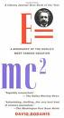 | e = mc² - A biography of the World's most famous equation by David Bodanis  ISBN: 0-333-78033-7 | 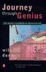
Journey through Genius - An exploration of some of the great theorems of mathematics by William Dunham
ISBN: 978-0-14-014739-1
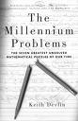 | The Millennium Problems - The 7 greatest unsolved mathematical problems of our time by Keith Devlin  ISBN: 1-86207-735-5 | 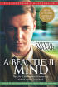
A Beautiful Mind - The Life of Mathematical Genius and Nobel Laureate John Nash by Sylvia Nasar
ISBN 0571212921
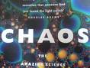 | CHAOS - The amazing Sciences of the unpredictable by James Gleick  ISBN: 0-7493-8606-1 | 
Fractal, Images of Chaos by Hans Lauwerier. A look at the use of fractals in computer art, modelling population growth and the movements of the planets in the solar system.
ISBN: 0-14-014411-0
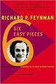 | Six Easy Pieces - The fundamentals of Physics explained by Richard Feynmann  ISBN: 978-0-14-027666-4 | 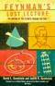
Feynman's Lost Lecture - The motion of the planets around the sun by David and Ruth Goodstein
ISBN: 0-09-973621-7
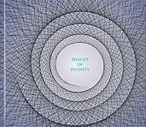 | Images of Infinity - A collection of images, writings and cartoons revolving around the ideas and paradoxes associated with the infinite and infinitesimal. Can a drawing of a hand drawing itself and the thing it is drawing ever be finished? by Tarquin Press.  ISBN: 0906212898 or 978-0906212899 | 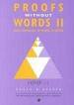
Proofs Without Words by Roger B. Nelson. A look at the use of pictures and diagrams that enable us to see why a particular mathematical statement is true. Visual clues to stimulate mathematical thought.
Book 1 - ISBN 0883857006
Book 2 - ISBN 0883857219
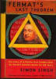 | Fermat’s Last Theorem by Simon Singh  ISBN: 1-84115-791-0 | 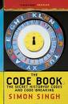
The Code Book by Simon Singh
ISBN 1-85702-889-9
The Cracking Code Book by Simon Singh
ISBN: 0-00-717604-X
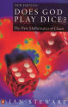 | Does God Play Dice? by Ian Stewart. An excellent introduction to Chaos. The title is a quotation from Einstein, who believed the answer was no! [KS5]  ISBN: 0-14-025602-4  Game, Set and Math by Ian Stewart.  ISBN 0140132376 | 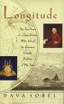
Longitude - The True Story of the solving of the Greatest Scientific Problem of the time by Dava Sobel
ISBN: 0-00-721422-7
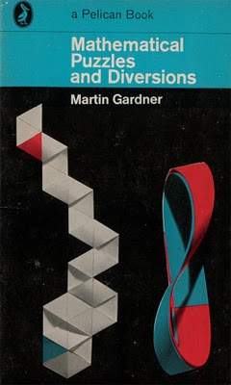 | Mathematical Puzzles and Diversions  More Mathematical Puzzles and Diversions  Mathematical Circus  The Unexpected Hanging  Fractal Music, Hypercards and More all by Martin Gardner | 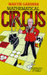
 | Flatland – a Romance of Many Dimensions by Edwin A Abbott.  A story of a square living in a two dimensional world and his encounter with a sphere.  Also available to read online:  http://www.geom.uiuc.edu/~banchoff/Flatland/ | 