Major Battles of ‘The Ionian War’
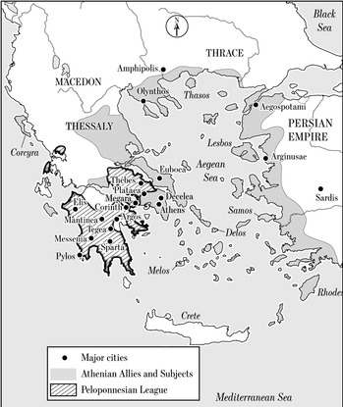
Battle of Aegispotami 405BC ^{Plutarch Alc 36, Lys 9-11}
Lysander returns as Aracus’ ‘Deputy’ and takes the fighting to the Hellespont (critical for Athens’ grain convoys). Spartans controlled Abydos + Lampsacus; Athenians had Sestos.
Decisive naval victory over Athenians under Conon, who escapes with 8 ships; Paralus also escapes.
170 Athenian ships captured; 3,000 killed, led by Philocles. ‘In the space of a single hour he had put an end to a war which … eclipsed any that had gone before.’ ^{Plutarch Lys 11.}
Battle of Notion 406BC
Alcibiades had left his helmsman Antiochus, who showed fatal initiative! 15 Athenian ships lost. Spartan victory under Lysander.
in command. Alcibiades’ fall from favour.
Battle of Cyzicus 410BC ^{Plutarch Alc 28}
Generals = Alcibiades, Thrasybulus, Theramenes.
Decisive Athenian victory over Spartans and Persians.
Mindarus killed; Pharnabazus defeated.
Alcibiades’ + 40 ships draws the Spartans out.
80 triremes lost
‘The ships are gone. Mindarus is dead. The men are starving. We don’t know what to do.’
Spartan offer of terms rejected

Capture of Byzantium by Alcibiades,^{Plutarch Alc 31}
who returns triumphant to Athens in 408.
Eleusinian procession through Attica. ^{Plutarch Alc 34}

Battle of Abydos 411BC November ^{Plutarch Alc 27}
Athenian victory over Spartans commanded by Mindarus. Alcibiades’ arrival with 18 ships secures the victory. Imprisoned in Sardis by Tiss, but escapes.
Battle of Arginusae ^{August} 406BC ^{Plutarch Alc 36, Lys}
Spartans lose 77/120 ships. Callicratidas killed. Athenians under Conon lose 25/155 ships.
6 of the 8 generals are executed on their return to Athens for failure to recover their dead (stormy seas).
Spartan offer of terms again rejected
under influence of Cleophon

412/11BC Alcibiades falls from Spartan favour and resides with the satrap Tissaphernes.
407BC Lysander appointed Nauarchos (1 yr); his friendship with Cyrus brings funding for the Peloponnesian fleet.
Persian Activities
Pharnabazus, Satrap of the Hellespont | Cyrus, son of Darius II | Tissaphernes, Satrap of Caria
410-407 Pays for rebuilding of Peloponnesian fleet after Cyzicus. ?Treaty of Boeotius between Sparta and Persia.  404 Lysander tells Pharnabazus to kill Alcibiades in Phrygia. | Friendship with Lysander.  Provides funding for the Peloponnesian fleet while Lysander was in office (407-6 and 405-4) and enables L. to increase daily pay of oarsmen.  4 instead of 3 obols/day. ^{Plutarh Lys 4}  ‘By this action he all but emptied the Athenian ships.’ | 3 ^{(2 drafts?)} Alliance^{(s)} with Sparta under Chalcideus ^{Thuc 8.18} (Alcibiades’ guidance).  Alcibiades at court of Tissaphernes after fall from Spartan favour 41, but  imprisoned in Sardis after  Unreliable in payments and deployment of Phoenician fleet (halts at Aspendos)

Battle of Cynossema 411BC
First Athenian victory after the Sicilian Expedition
Narrow victory under Thrasybulus + Thrasyllus.

Battle of Eretria 411BC September
Spartan victory; Athenians lose 22 ships;
Consternation in Athens leads to end of the 400 and the moderate 5,000 (admired by Thucydides)
Spartan Victories
Athenian Victories

