Qualitative data analysis – Task 1

Content analysis

Description – painting 1

Description – painting 2

Describe the 2 paintings presented below:

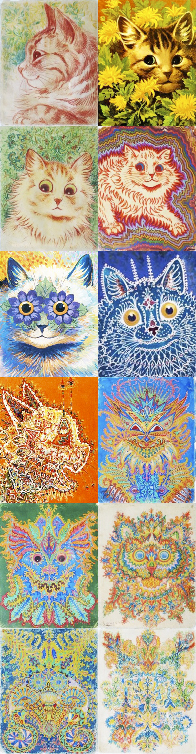

- Share your ideas with everyone else in the class and make a note of all the other descriptions of both paintings.
- Look at the descriptions and see if you can identify categories.
- Tally how many times each of the categories were mentioned.
- Is there a recurrent themes/ patterns?

Other descriptions: painting 1 | Other descriptions – painting 2

Main categories:

Conclusion:
Qualitative data analysis – Task 2
Below are the clinical characteristics for OCD, from the DSM-V, your task is to use them as a basis for codes/ categories to look for when analysing the extract from a therapy session, in order to determine whether or not the patient has OCD.
- The person suffers recurrent and persistent thoughts that are intrusive and distressing and cause more than usual anxiety
- The person is driven to perform repetitive behaviours which are unrealistic in terms of what they are trying to prevent
- The person recognises that these obsessions and compulsions are unreasonable and are a product of their own mind (this is what distinguishes OCD from schizophrenia).

- You need to break the clinical characteristics down into categories.
- Read the therapy session transcript over the page.
- Make a note in the right hand column every time a characteristic appears
- Decide if you think he has OCD.

Therapy session extract: | Using the clinical characteristics of OCD, identify any key themes from the therapy session below.
Th: How long have you had these thoughts?
H: Well it started when I was about fourteen.
They just came out of the blue
Thoughts like “There’s germs”
And my head would be filled with images…
Images of germs crawling all over my hands
And then I’d have to go and wash them.
At first I felt better but that soon stopped,
I suppose I’ve never felt like my hands were clean since.
It’s like I’m dirty and I contaminate everything I touch,
I hate it, but I can’t do anything about it,
The thoughts in my head and I just can’t get rid of it.
Th: Do you try and get rid of it?
H: Yeah. I say to myself “You know that’s nonsense Harry”
I just want rid of it so I push the damn thing away
But it keeps coming back – it’s stronger than me.
If that doesn’t work I try to resist it.
For example when I wake up I say to myself
I’m not going to wash my hands’ over ‘n’ over, but it does no good.
I just can’t stop it, even when my hands hurt and are really sore
I’m just not strong enough.
I’m useless and I’m driving Sue crazy.
To be honest I’m sick of it all and my life is falling apart.
I’ve lost my job, I might lose Sue and yet I can’t stop.
What’s worse is that I’ll end up giving someone a serious disease…
I know I will.
Th: So you feel clean afterwards?
H: Err…no not really except when it first started
But it is the only thing I can do.
Th: When you say not really what do you mean?
H: Well I’m really anxious before I wash, that’s why I do it.
And when I’m washing things are great!
I imagine the germs dying… disappearing down the sink
But it only feels good for about five or ten minutes
Cos then I think, “Did you get rid of them all?”
Once I’ve thought that I’m in trouble
Coz how can you be sure?
And the whole process starts all over again

