
GCSE Mathematics
Practice Tests: Set 3
Paper 2H (Calculator)
Time: 1 hour 30 minutes
You should have: Ruler graduated in centimetres and millimetres, protractor, pair of compasses, pen, HB pencil, eraser, calculator.

Instructions
- Use black ink or ball-point pen.
- Fill in the boxes at the top of this page with your name,
centre number and candidate number.
- Answer all questions.
- Answer the questions in the spaces provided
– there may be more space than you need.
- Calculators may be used.
- Diagrams are NOT accurately drawn, unless otherwise indicated.
- You must show all your working out.

Information
- The total mark for this paper is 80
- The marks for each question are shown in brackets
– use this as a guide as to how much time to spend on each question.

Advice
- Read each question carefully before you start to answer it.
- Keep an eye on the time.
- Try to answer every question.
- Check your answers if you have time at the end.

Answer ALL questions.
Write your answers in the spaces provided.
You must write down all the stages in your working.

1.

Work out the value of x.
Give your answer correct to 1 decimal place.

x = ................................
(Total 3 marks)
___________________________________________________________________________

2. On July 1st 2004, Jack invested £2000 at 5% per annum compound interest.
Work out the value of Jack’s investment on July 1st 2006

£ ..........................................
(Total 3 marks)
___________________________________________________________________________
3. The diagram shows part of the design of a stained glass window.
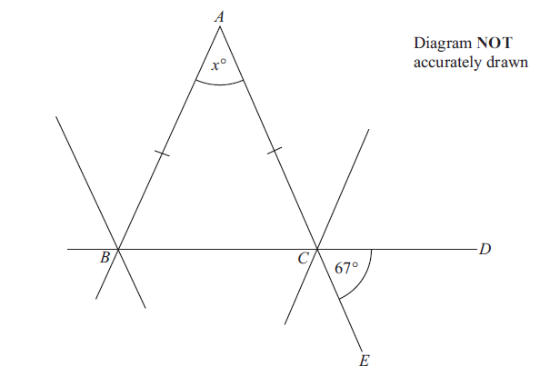

ABC is an isosceles triangle. BCD and ACE are straight lines. Angle DCE = 67°.

Work out the size of the angle marked x°. Give reasons for your answer.

(Total 4 marks)
___________________________________________________________________________
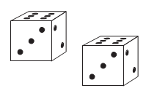
4. Naomi is playing a board game.
She must throw two fair dice.

She must get a 6 on each dice to start the game.

Work out the probability that she will not start the game on her first throw.

.........................................
(Total 3 mark)
___________________________________________________________________________
5. A company sells circular mirrors.
The price P pounds of a mirror is proportional to the square of its radius r cm.
A mirror with radius 20 cm has a price of £36
Find a formula for P in terms of r.

P = .........................................
(Total 3 marks)
___________________________________________________________________________

6. The width of a rectangle is a whole number of centimetres.
The length of the rectangle is 9 cm longer than its width.
The perimeter of the rectangle is less than 200 cm.
Find the greatest possible width of the rectangle.

......................................... cm
(Total 4 marks)
___________________________________________________________________________
7. The diagram shows Diana’s suitcase.
The suitcase is in the shape of a cuboid.

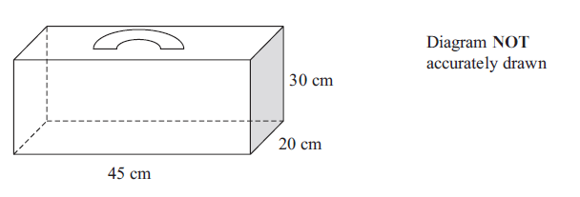
Diana has a walking stick that folds.
The folded walking stick has a length of 60 cm.

Diana wants to put the folded walking stick in the suitcase.
Will the folded walking stick fit in the suitcase?

(Total 4 marks)
___________________________________________________________________________
8. Draw the locus of all points which are equidistant from the lines AB and AC.

(Total 2 marks)
___________________________________________________________________________

9. In a sale normal prices are reduced by 20%.

A washing machine has a sale price of £464

By how much money is the normal price of the washing machine reduced?

£ ..............................................
(Total 3 marks)
___________________________________________________________________________
10. The surface area of Earth is 510 072 000 km².
The surface area of Jupiter is 6.21795 × 1010 km².

The surface area of Jupiter is greater than the surface area of Earth.
How many times greater?
Give your answer in standard form.

...........................................
(Total 3 marks)
___________________________________________________________________________

11. 25 students in class A did a science exam.
30 students in class B did the same science exam.

The mean mark for the 25 students in class A is 67.8.
The mean mark for all the 55 students is 72.0.

Work out the mean mark for the students in class B.

..............................................
(Total 3 marks)
___________________________________________________________________________
12.

Describe fully the single transformation that maps triangle A onto triangle B.

......................................................................................................................................................

......................................................................................................................................................

......................................................................................................................................................
(Total 3 marks)
___________________________________________________________________________

13. Fred has a solid brass model of an Egyptian pyramid.
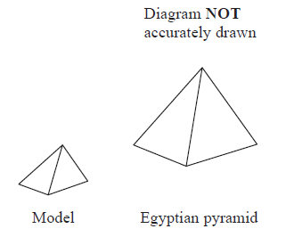
The model has a volume of 3000 cm3.
The density of the brass is 8.5 g/cm3.

(a) Calculate the mass of the model.
Give your answer in kg.

.............................................. kg
(2)

The model and the Egyptian pyramid are mathematically similar. The length of the base of the model is 25 cm.
The length of the base of the Egyptian pyramid is 225 m.

(b) Calculate the volume of the Egyptian pyramid.
Give your answer in m3.

.............................................. m3
(3)
(Total 5 marks)
___________________________________________________________________________
14. Here is a rectangular sheet of metal.
A square hole is cut out of the metal.

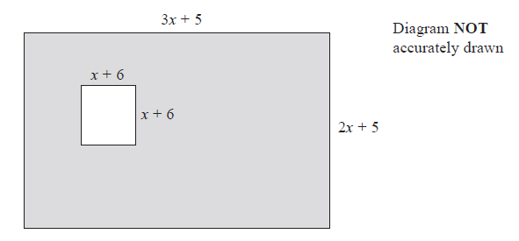
The length of the rectangle is 3x + 5
The width of the rectangle is 2x + 5
The square has sides of length x + 6
All measurements are in centimetres.
The perimeter of the square hole is $\frac{3}{5}$ of the perimeter of the rectangle.
Work out the length of a side of the square hole.

.......................................... cm
(Total 5 marks)
___________________________________________________________________________
15. (a) Expand and simplify (2x + 1)(x − 3)(x + 5)

.............................................
(3)

(b) Make r the subject of 5r + 1 = a(m + r)

..........................................
(3)
(Total 6 marks)
___________________________________________________________________________

16.

A, B and C are points on the circumference of a circle.
The straight line PAQ is a tangent to the circle.
Angle PAC = 56°
Angle ACB = 75°

Work out the size of the angle marked x.
Give reasons for each stage of your working.

(Total 3 marks)
___________________________________________________________________________
17.

There is a coastguard station at point A and at point B.
B is due East of A.
The distance from A to B is 12 km.

There is a rowing boat at point R.
R is on a bearing of 160° from A.
R is on a bearing of 220° from B.

There is a speedboat at point T.
T is 5 km due South of A.

Work out the shortest distance from T to R.
Give your answer correct to 1 decimal place.
You must show all your working.

..............................................km
(Total 5 marks)
___________________________________________________________________________
18. The diagram shows part of the curve with equation y = f(x).

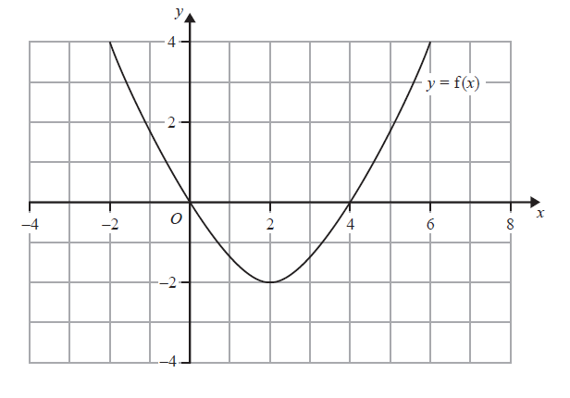
(a) (i) Write down the coordinates of the points where the graph of y = f(x – 2) crosses
the x-axis.

( ............................ , ............................ ) and ( ............................ , ............................ )

(ii) Write down the coordinates of the point where the graph of y = f(x – 2) crosses
the y-axis.

( ............................ , ............................ )
(2)

(b) On the diagram above, sketch the graph of y = f(x) + 2

(2)
(Total 4 marks)
___________________________________________________________________________
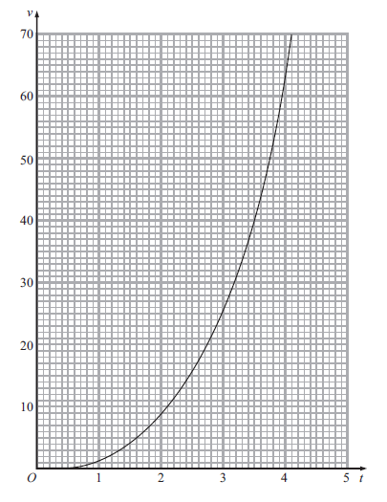
19. The graph shows the velocity, v metres per second, of a rocket at time t seconds.

(a) Find an estimate for the rate of change of the velocity of the rocket at t = 2

.............................................. m/s²
(3)
(b) Find an estimate for the distance travelled by the rocket in the first 4 seconds.
Use 4 strips of equal width

........................m
(3)
(Total 6 marks)
___________________________________________________________________________
20. Rhys has a beehive.
The number of bees in the beehive is decreasing.

Rhys counts the number of bees in the hive at the start of week 5 He counts the number of bees in the hive at the start of week 7

Here are his results.

week | number of bees
5 | 1200
7 | 900

Assuming that the population of bees is decreasing exponentially, how many bees were there at the start of week 2?
You must show your working.

.............................................. bees
(Total 5 marks)
___________________________________________________________________________
21. A trapezium ABCD has an area of 5√6 cm².

AB = 4 cm.
BC = √3 cm.
DC = k cm.

Calculate the value of k, giving your answer in the form a√b – c,
where a, b and c are positive integers.
Show each step in your working.

k = ................................
(Total 3 marks)
___________________________________________________________________________

TOTAL FOR PAPER IS 80 MARKS

BLANK PAGE

