
GCSE Mathematics
Practice Tests: Set 3
Paper 1H (Non-calculator)
Time: 1 hour 30 minutes
You should have: Ruler graduated in centimetres and millimetres, protractor, pair of compasses, pen, HB pencil, eraser, calculator.

Instructions
- Use black ink or ball-point pen.
- Fill in the boxes at the top of this page with your name,
centre number and candidate number.
- Answer all questions.
- Answer the questions in the spaces provided
– there may be more space than you need.
- Calculators may not be used.
- Diagrams are NOT accurately drawn, unless otherwise indicated.
- You must show all your working out.

Information
- The total mark for this paper is 80
- The marks for each question are shown in brackets
– use this as a guide as to how much time to spend on each question.

Advice
- Read each question carefully before you start to answer it.
- Keep an eye on the time.
- Try to answer every question.
- Check your answers if you have time at the end.

Answer ALL questions.
Write your answers in the spaces provided.
You must write down all the stages in your working.

1. The equation of a straight line is y = 4x + 7

(a) Write down the gradient of the line.

.....................................
(1)

(b) Write down the y-intercept of the line.

.....................................
(1)
(Total 2 mark)
___________________________________________________________________________

2. Work out $3\frac{1}{8}−1\frac{2}{3}$

..........................................
(Total 3 marks)
___________________________________________________________________________
3. Here are the ingredients needed to make 8 shortbread biscuits.

Shortbread biscuits
makes 8 biscuits
120 g butter
60 g caster sugar
180 g flour

Tariq is going to make some shortbread biscuits.
He has the following ingredients

330 g butter 200 g caster sugar 450 g flour

Work out the greatest number of shortbread biscuits that Tariq can make with his ingredients.
You must show all your working.

......................................... biscuits
(Total 3 marks)
___________________________________________________________________________

4. Railtickets and Cheaptrains are two websites selling train tickets.

Each of the websites adds a credit card charge and a booking fee to the ticket price.

Railtickets  Credit card charge: 2.25% of ticket price  Booking fee: 80 pence |  | Cheaptrains  Credit card charge: 1.5% of ticket price  Booking fee: £1.90

Nadia wants to buy a train ticket.
The ticket price is £60 on each website.
Nadia will pay by credit card.

Will it be cheaper for Nadia to buy the train ticket from Railtickets or from Cheaptrains?

(Total 4 marks)
___________________________________________________________________________
5. The table gives information about the lengths of the branches on a bush.

Length(Lcm) | Frequency
0 ≤ L <10 | 20
10 ≤ L < 20 | 12
20 ≤ L < 30 | 10
30 ≤ L < 40 | 8
40 ≤ L < 50 | 6
50 ≤ L < 60 | 0

(a) Draw a frequency polygon to show this information.

(2)

(b) Work out the total number of branches on the bush.

.....................................
(2)

(c) Write down the modal class interval.

.....................................
(1)
(Total 5 marks)
___________________________________________________________________________

6. Here are three circles A, B and C.

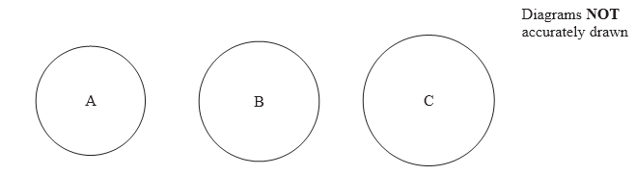
The area of circle A is 200 cm2.

The area of circle B is 10% larger than the area of circle A.
The area of circle C is 10% larger than the area of circle B.

How much larger is the area of circle C than the area of circle A?

(Total 4 marks)
___________________________________________________________________________

7. (a) Expand and simplify 2(x + 3y) + 4(x – y)

..............................................
(2)

(b) Factorise completely 8p – 12pq

..............................................
(2)
(Total 4 marks)
___________________________________________________________________________
8. The diagram shows a triangle.

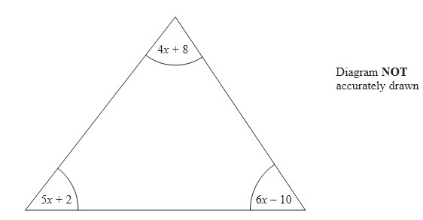

All the angles are measured in degrees.
Show that the triangle is isosceles.

(Total 5 marks)
___________________________________________________________________________
9. (a) Find the Highest Common Factor (HCF) of 30 and 42.

..............................................
(2)

(b) Find the Lowest Common Multiple (LCM) of 30 and 45.

..............................................
(2)
(Total 4 marks)
___________________________________________________________________________

10.

The diagram shows a solid prism made from metal.
The cross-section of the prism is a trapezium.

The parallel sides of the trapezium are 8 cm and 12 cm.
The height of the trapezium is 6 cm.
The length of the prism is 20 cm.

The density of the metal is 5 g/cm³.

Calculate the mass of the prism.
Give your answer in kilograms.

................................ kg
(Total 5 marks)
___________________________________________________________________________
11. (a) Write down the value of ${\text{25}}^{0}$

..............................................
(1)

(b) Write down the value of ${\text{49}}^{−\frac{1}{2}}$

..............................................
(1)

(c) Write as a power of 2 $\frac{4×8}{{\text{16}}^{3}}$

..............................................
(3)
(Total 5 marks)
___________________________________________________________________________
12. There are 9 counters in a box.

4 of the counters are red.
2 of the counters are blue.
3 of the counters are yellow.

Pavinder takes at random two counters from the box.

Work out the probability that he takes at least one yellow counter.

..........................................
(Total 4 marks)
___________________________________________________________________________
13. Simplify fully $\frac{2x^{2}−7x+3}{x^{2}−9}$

..........................................
(Total 3 marks)
___________________________________________________________________________

14. Work out (2 + √3)(2 – √3)
Give your answer in its simplest form.

..........................................
(Total 2 marks)
___________________________________________________________________________
15.

OAB is a triangle.
M is the midpoint of OA.
N is the midpoint of OB.
= m
= n

Show that AB is parallel to MN.

(Total 3 marks)
___________________________________________________________________________
16.

A, B, C and D are points on the circumference of a circle, centre O.

Angle AOC = y.

Find the size of angle ABC in terms of y.
Give a reason for each stage of your working.

(Total 4 marks)
___________________________________________________________________________
17. This is a sketch of the curve with the equation y = f(x).
The only minimum point of the curve is at P(3, –4).

(a) Write down the coordinates of the minimum point of the curve with the equation
y = f(x – 2).

(............ , ............)
(2)

(b) Write down the coordinates of the minimum point of the curve with the equation
y = f(x + 5) + 6

(............ , ............)
(2)
(Total 4 marks)
___________________________________________________________________________

18.
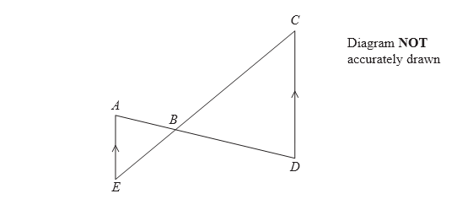

AE is parallel to CD.
ABD and EBC are straight lines.

Prove that triangle ABE is similar to triangle DBC.
Give reasons for each stage of your proof.

(Total 4 marks)
___________________________________________________________________________
19. The diagram shows a sketch of the curve $y=\text{sin}x°$for $0≤x≤\text{360}$
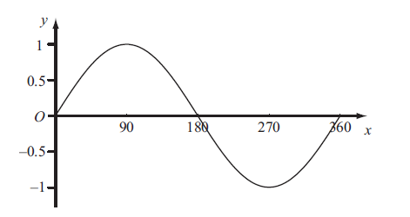

The exact value of $\text{sin}\text{60}\text{°=}\frac{\sqrt{3}}{2}$
(a) Write down the exact value of
- $\text{sin}\text{120}°$,
.............................
- $\text{sin}\text{240}°$.
.............................
(2)
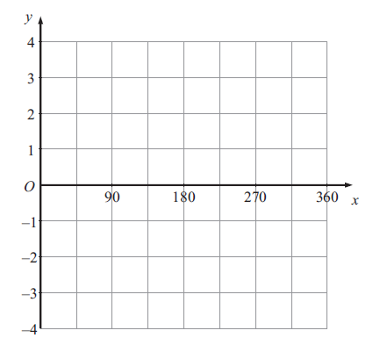
(b) On the grid below, sketch the graph of $y=\text{sin}2x°$ for $0≤x≤\text{360}$

(2)
(Total 4 marks)
___________________________________________________________________________
20. Prove algebraically that the difference between the squares of any two consecutive integers is equal to the sum of these two integers.

(Total 4 marks)
___________________________________________________________________________

21 Sketch the graph of f(x) = −x² − 3x + 5, showing the coordinates of the turning point and the coordinates of any intercepts with the coordinate axes.

(Total 4 mark)
___________________________________________________________________________

TOTAL FOR PAPER IS 80 MARKS

