Questions
Q1.
A particle P of mass 0.6 kg is released from rest and slides down a line of greatest slope of a rough plane. The plane is inclined at 30º to the horizontal. When P has moved 12 m, its speed is 4 m s⁻¹. Given that friction is the only non-gravitational resistive force acting on P, find
(a) the work done against friction as the speed of P increases from 0 m s⁻¹ to 4 m s⁻¹,
(4)
(b) the coefficient of friction between the particle and the plane.
(4)
(Total 8 marks)

Q2.
[The centre of mass of a uniform hollow cone of height h ish above the base on the line from the centre of the base to the vertex.]
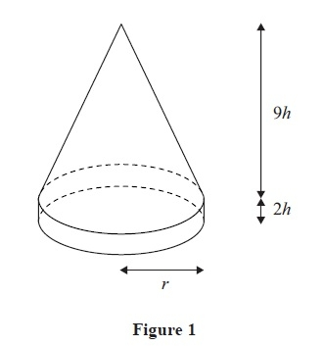
A marker for the route of a charity walk consists of a uniform hollow cone fixed on to a uniform solid cylindrical ring, as shown in Figure 1. The hollow cone has base radius r, height 9h and mass m. The solid cylindrical ring has outer radius r, height 2h and mass 3m. The marker stands with its base on a horizontal surface.
(a) Find, in terms of h, the distance of the centre of mass of the marker from the horizontal surface.
(5)
When the marker stands on a plane inclined at arctan to the horizontal it is on the point of toppling over. The coefficient of friction between the marker and the plane is large enough to be certain that the marker will not slip.
(b) Find h in terms of r.
(3)
(Total 8 marks)

Q3.
Two smooth uniform spheres S and T have equal radii. The mass of S is 0.3 kg and the mass of T is 0.6 kg. The spheres are moving on a smooth horizontal plane and collide obliquely. Immediately before the collision the velocity of S is u₁ m s⁻¹ and the velocity of T is u₂ m s⁻¹. The coefficient of restitution between the spheres is 0.5. Immediately after the collision the velocity of S is (−i + 2j ) m s⁻¹ and the velocity of T is (i + j) m s⁻¹. Given that when the spheres collide the line joining their centres is parallel to i ,
(a) find
(i) u₁ ,
(ii) u₂ .
(6)
After the collision, T goes on to collide with a smooth vertical wall which is parallel to j. Given that the coefficient of restitution between T and the wall is also 0.5, find
(b) the angle through which the direction of motion of T is deflected as a result of the collision with the wall,
(5)
(c) the loss in kinetic energy of T caused by the collision with the wall.
(3)
(Total 14 marks)

Q4.
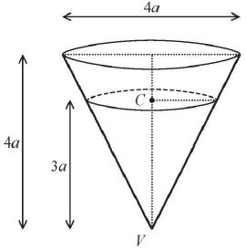
Figure 1
A hollow right circular cone, of base diameter 4a and height 4a is fixed with its axis vertical and vertex V downwards, as shown in Figure 1.
A particle of mass m moves in a horizontal circle with centre C on the rough inner surface of the cone with constant angular speed ω.
The height of C above V is 3a.
The coefficient of friction between the particle and the inner surface of the cone is
Find, in terms of a and g, the greatest possible value of ω.
(8)

(Total for question = 8 marks)

Q5.
A particle of mass 0.8 kg is attached to one end of a light elastic string of natural length 0.6 m. The other end of the string is attached to a fixed point A. The particle is released from rest at A and comes to instantaneous rest 1.1 m below A.
Find the modulus of elasticity of the string.
(4)

(Total 4 marks)

Q6.
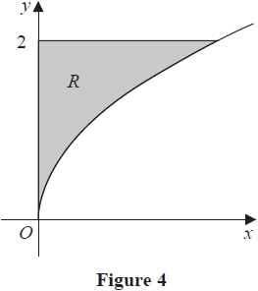
The region R, shown shaded in Figure 4, is bounded by part of the curve with equation y² = 2x,
the line with equation y = 2 and the y-axis. The unit of length on both axes is one centimetre.
A uniform solid, S, is formed by rotating R through 360° about the y-axis.
Given that the volume of S is π cm³,
(a) show that the centre of mass of S is cm from its plane face.
(4)
A uniform solid cylinder, C, has base radius 2 cm and height 4 cm. The cylinder C is
attached to S so that the plane face of S coincides with a plane face of C, to form the
paperweight P, shown in Figure 5. The density of the material used to make S is three
times the density of the material used to make C.
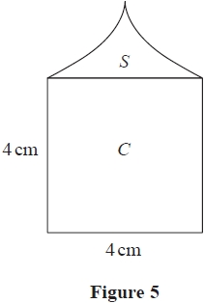
The plane face of P rests in equilibrium on a desk lid that is inclined at an angle θ° to
the horizontal. The lid is sufficiently rough to prevent P from slipping. Given that P is
on the point of toppling,
(b) find the value of θ.
(7)

(Total for question = 11 marks)

Q7.
A fixed smooth sphere has centre O and radius α. A particle P is placed on the surface of the sphere at the point A, where OA makes an angle a with the upward vertical through O. The particle is released from rest at A. When OP makes an angle θ to the upward vertical through O, P is on the surface of the sphere and the speed of P is ν.
Given that cosα =
(a) show that.
ν² = 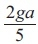 (3 − 5 cosθ)
(4)
(b) find the speed of P at the instant when it loses contact with the sphere.
(8)
(Total 12 marks)

Mark Scheme
Q1.
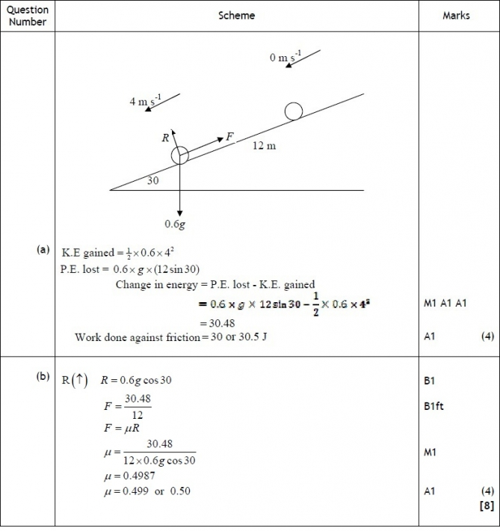

Q2.
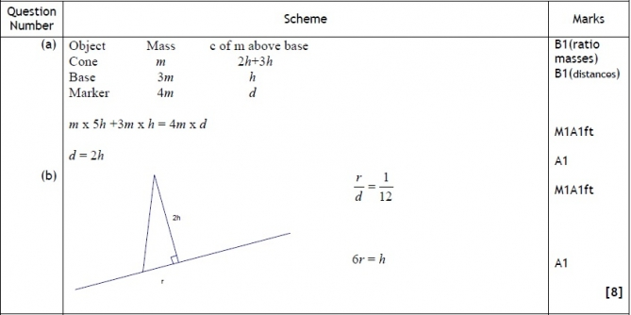

Q3.
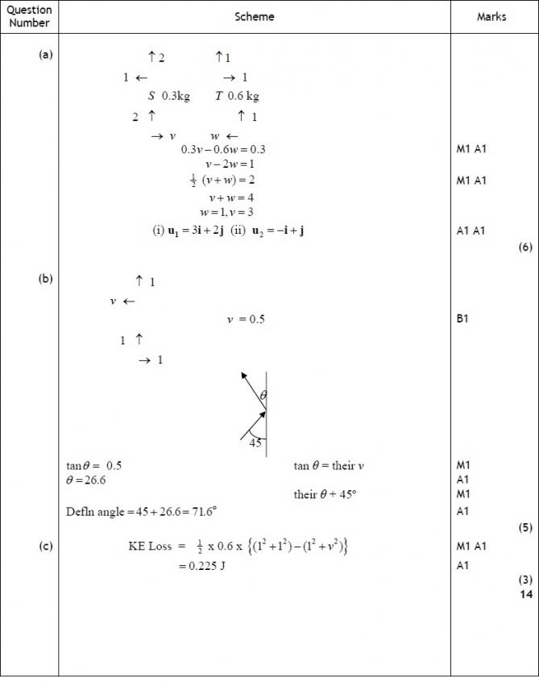

Q4.
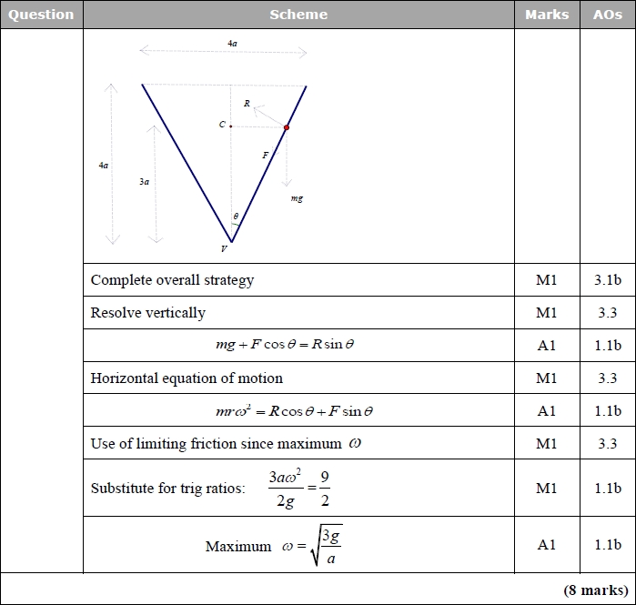
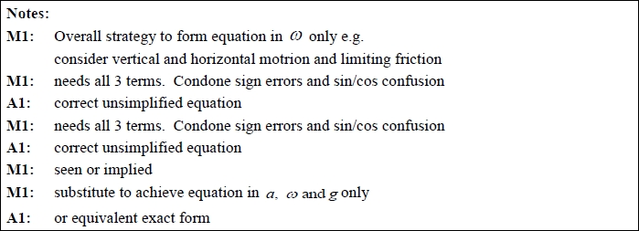

Q5.
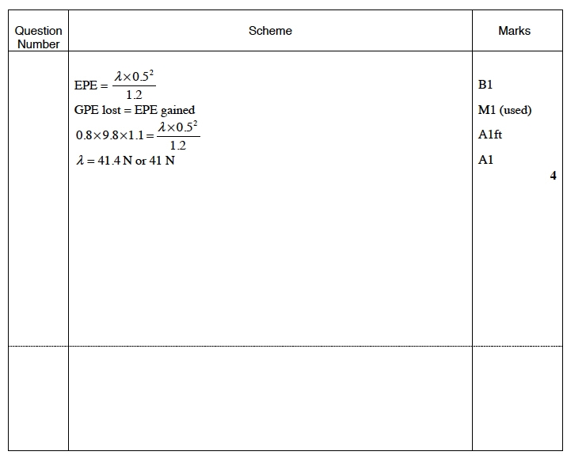

Q6.
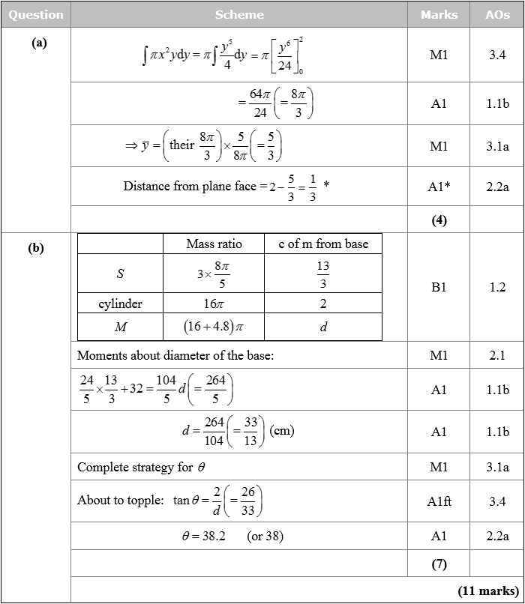
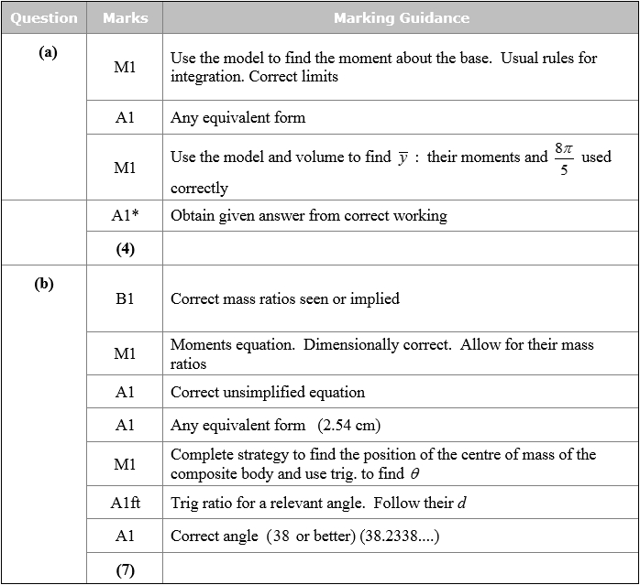

Q7.
