Questions
Q1.
A car of mass 800kg is moving on a straight road which is inclined at an angle θ to the horizontal, where sin θ = . The resistance to the motion of the car from non-gravitational forces is modelled as a constant force of magnitude R newtons. When the car is moving up the road at a constant speed of 12.5ms^{–1}, the engine of the car is working at a constant rate of 3P watts. When the car is moving down the road at a constant speed of 12.5ms^{–1}, the engine of the car is working at a constant rate of P watts.
(a) Find
(i) the value of P,
(ii) the value of R.
When the car is moving up the road at 12.5ms^{–1} the engine is switched off and the car comes to rest, without braking, in a distance d metres. The resistance to the motion of the car from non-gravitational forces is still modelled as a constant force of magnitude R newtons.
(b) Use the work-energy principle to find the value of d.
(4)

(Total for question = 4 marks)

Q2.
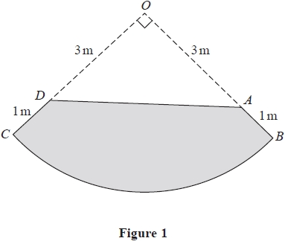
The uniform lamina OBC is one quarter of a circular disc with centre O and radius 4m. The points A and D, on OB and OC respectively, are 3 m from O. The uniform lamina ABCD, shown shaded in Figure 1, is formed by removing the triangle OAD from OBC.
Given that the centre of mass of one quarter of a uniform circular disc of radius r is at a distance 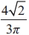r from the centre of the disc,
(a) find the distance of the centre of mass of the lamina ABCD from AD.
(5)
The lamina is freely suspended from D and hangs in equilibrium.
(b) Find, to the nearest degree, the angle between DC and the downward vertical.
(4)

(Total for question = 9 marks)

Q3.
A particle of mass 4 kg is moving along the horizontal x-axis under the action of a single force which acts in the positive x-direction. At time t seconds the force has magnitude 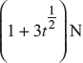.
When t = 0 the particle has speed 2 m s⁻¹ in the positive x-direction. Find the work done by the force in the interval 0 ≤ t ≤ 4
(7)
(Total 7 marks)

Q4.
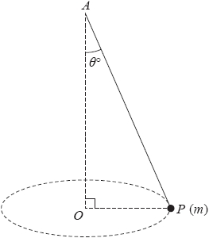
Figure 2
A particle P of mass m is attached to one end of a light inextensible string. The other end of the string is attached to a fixed point A. The particle moves in a horizontal circle with constant angular speed rad s⁻¹. The centre O of the circle is vertically below A and the string makes a constant angle θ° with the downward vertical, as shown in Figure 2.
Given that the tension in the string is 1.2mg, find
(i) the value of θ
(ii) the length of the string.
(8)

(Total for question = 8 marks)

Q5.
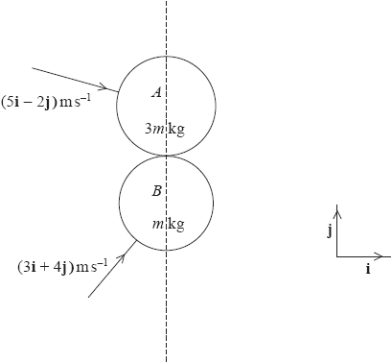
Figure 1
Two smooth uniform spheres A and B have masses 3mkg and mkg respectively and equal radii. The spheres are moving on a smooth horizontal surface. Initially, sphere A has velocity (5i − 2j)ms⁻¹ and sphere B has velocity (3i + 4j)ms⁻¹. When the spheres collide, the line joining their centres is parallel to j, as shown in Figure 1.
The coefficient of restitution between the two spheres is e.
The kinetic energy of sphere B immediately after the collision is 85% of its kinetic energy immediately before the collision.
Find
(a) the velocity of each sphere immediately after the collision,
(9)
(b) the value of e.
(3)

(Total for question = 12 marks)

Q6.
A particle P of mass 0.5 kg is attached to one end of a light elastic spring, of natural length
1.2 m and modulus of elasticity λ newtons. The other end of the spring is attached to a
fixed point A on a ceiling. The particle is hanging freely in equilibrium at a distance 1.5 m
vertically below A.
(a) Find the value of λ.
(3)
The particle is now raised to the point B, where B is vertically below A and AB = 0.8 m.
The spring remains straight. The particle is released from rest and first comes to
instantaneous rest at the point C.
(b) Find the distance AC.
(4)

(Total for question = 7 marks)

Q7.
A particle P is free to move on the smooth inner surface of a fixed thin hollow sphere of internal radius a and centre O. The particle passes through the lowest point of the spherical surface with speed U. The particle loses contact with the surface when OP is inclined at an angle α to the upward vertical.
(a) Show that
U² = ag(2 + 3cos α).
(7)
The particle has speed W as it passes through the level of O. Given that cos α = ,
(b) show that
W² = ag √3.
(5)

(Total 12 marks)

Mark Scheme
Q1.
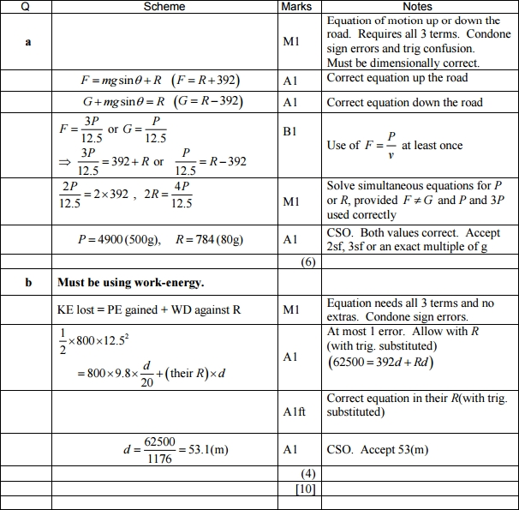

Q2.
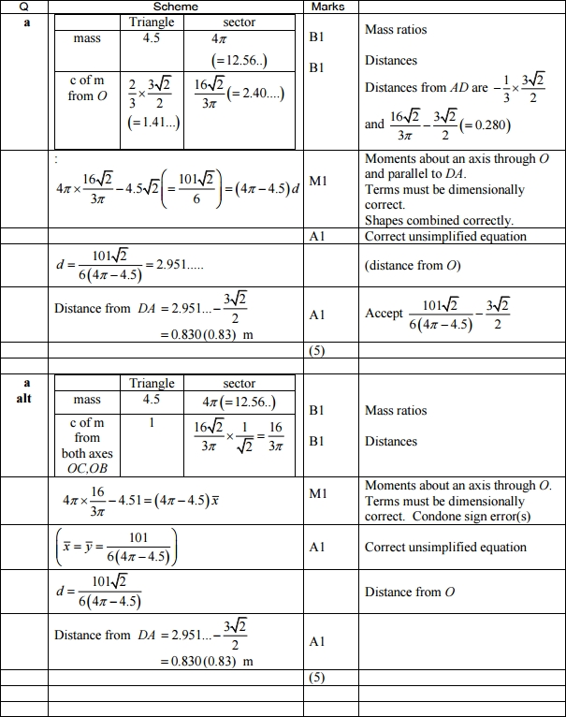
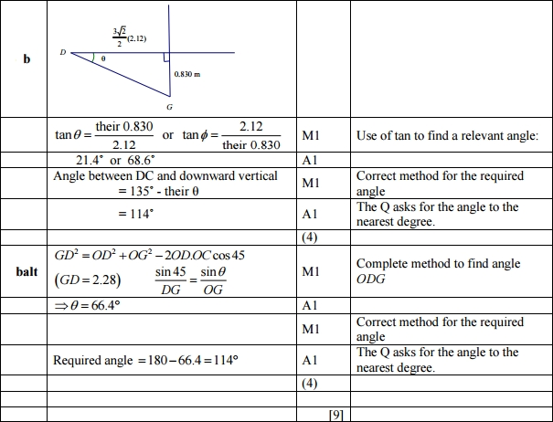

Q3.
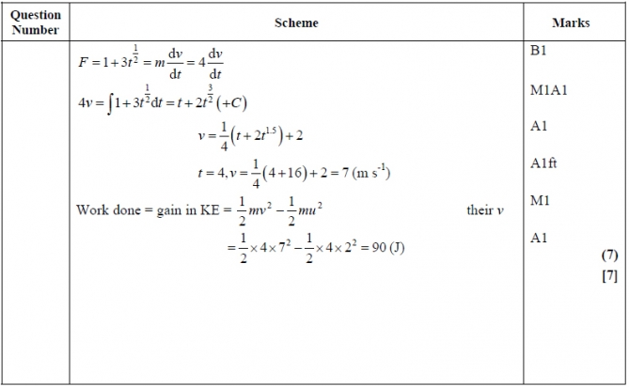

Q4.
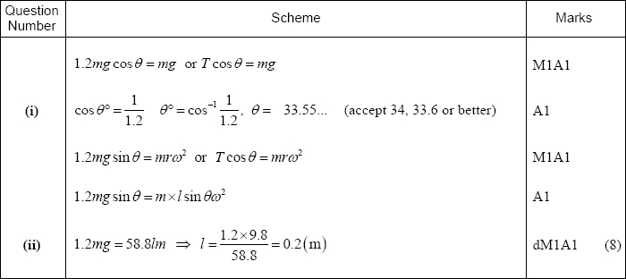

Q5.
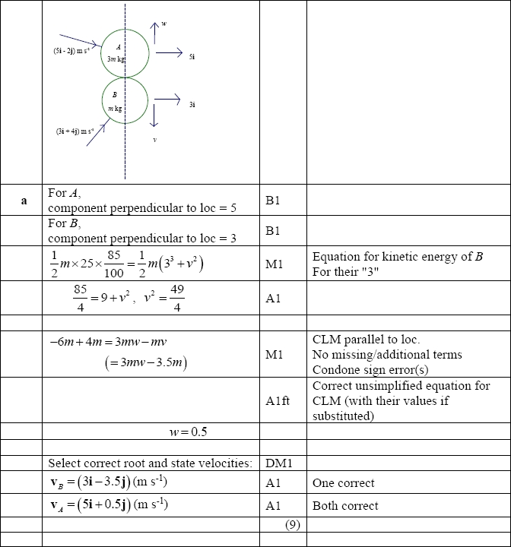
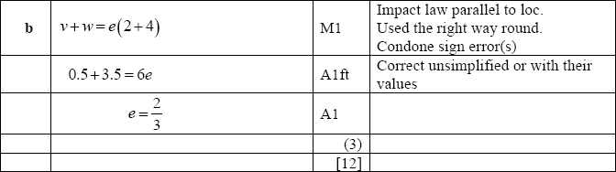

Q6.
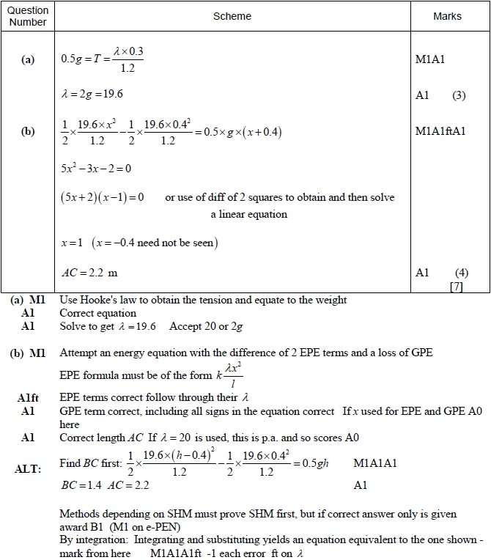

Q7.
