Questions
Q1.
Three particles of masses 3m, 4m and 2m are placed at the points (−2, 2) , (3, 1)
and ( p, p) respectively.
The value of p is such that the distance of the centre of mass of the three particles from
the point (0, 0) is as small as possible.
Find the value of p.

(Total for question = 7 marks)

Q2.
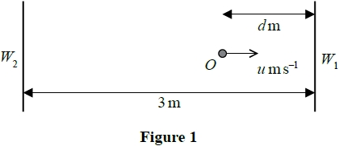
Figure 1 represents the plan of part of a smooth horizontal floor, where W₁ and W₂ are
two fixed parallel vertical walls. The walls are 3 metres apart.
A particle lies at rest at a point O on the floor between the two walls, where the point O
is d metres, 0 < d ≤ 3, from W₁
At time t = 0, the particle is projected from O towards W₁ with speed u m s^{–1} in a direction
perpendicular to the walls.
The coefficient of restitution between the particle and each wall is
The particle returns to O at time t = T seconds, having bounced off each wall once.
(a) Show that T = 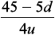
(6)
The value of u is fixed, the particle still hits each wall once but the value of d can now vary.
(b) Find the least possible value of T, giving your answer in terms of u. You must give a reason for your answer.
(2)

(Total for question = 8 marks)

Q3.
A cyclist and her bicycle have a total mass of 70 kg. She cycles along a straight horizontal road with constant speed 3.5 m s⁻¹. She is working at a constant rate of 490 W.
(a) Find the magnitude of the resistance to motion.
(4)
The cyclist now cycles down a straight road which is inclined at an angle θ to the horizontal, where sin θ = , at a constant speed U m s⁻¹. The magnitude of the nongravitational resistance to motion is modelled as 40U newtons. She is now working at a constant rate of 24 W.
(b) Find the value of U.
(7)

(Total 11 marks)

Q4.
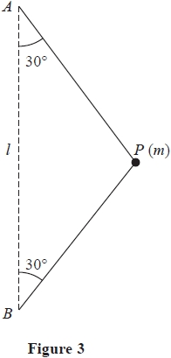
A particle P of mass m is attached to the ends of two light inextensible strings. The other ends of the strings are attached to fixed points A and B, where B is vertically below A and AB = l. The particle is moving with constant angular speed ω in a horizontal circle. Both strings are taut and inclined at 30° to AB, as shown in Figure 3.
(a) (i) Show that the tension in AP is 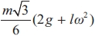
(ii) Find the tension in BP.
(9)
(b) Show that the time taken by P to complete one revolution is less than 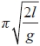
(4)

(Total for question = 13 marks)

Q5.
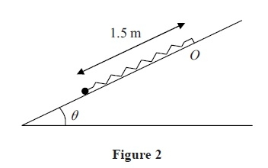
A particle of mass 0.5 kg is attached to one end of a light elastic spring of natural length 0.9 m and modulus of elasticity
λ newtons. The other end of the spring is attached to a fixed point O on a rough plane which is inclined at an angle θ to the horizontal, where sin θ = . The coefficient of friction between the particle and the plane is 0.15. The particle is held on the plane at a point which is 1.5 m down the line of greatest slope from O, as shown in Figure 2. The particle is released from rest and first comes to rest again after moving 0.7 m up the plane.
Find the value of λ.
(9)
(Total 9 marks)

Q6.
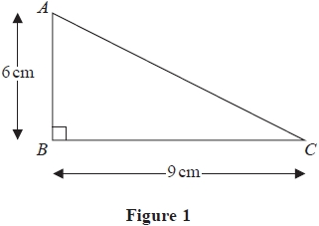
Figure 1 shows a uniform triangular lamina ABC in which AB = 6cm, BC = 9cm and angle ABC = 90°. The centre of mass of the lamina is G. Use algebraic integration to find the distance of G from AB.
(6)

(Total for question = 6 marks)

Q7.
One end of a light inextensible string of length l is attached to a fixed point A. The other end is attached to a particle P of mass m, which is held at a point B with the string taut and AP making an angle arccos with the downward vertical. The particle is released from rest. When AP makes an angle θ with the downward vertical, the string is taut and the tension in the string is T.
(a) Show that
T = 3mg cosθ −
(6)
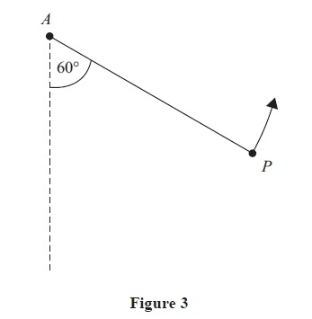
At an instant when AP makes an angle of 60º to the downward vertical, P is moving upwards, as shown in Figure 3. At this instant the string breaks. At the highest point reached in the subsequent motion, P is at a distance d below the horizontal through A.
(b) Find d in terms of l.
(5)
(Total 11 marks)

Mark Scheme
Q1.
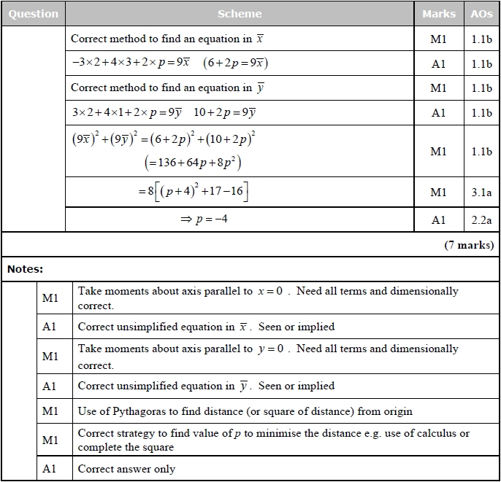

Q2.
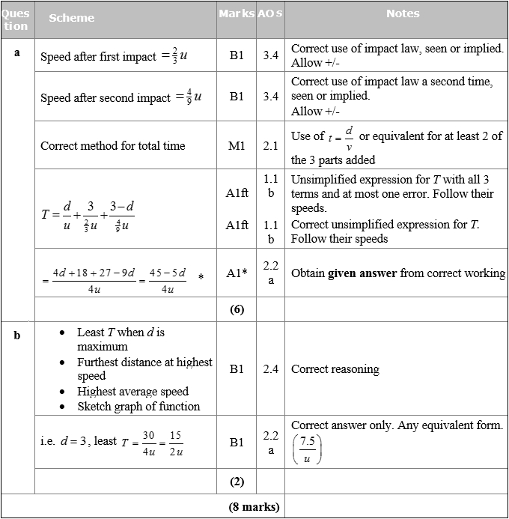

Q3.
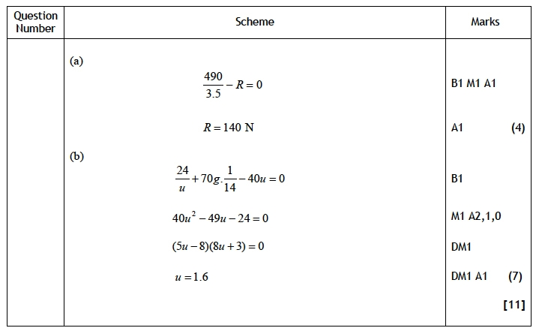

Q4.
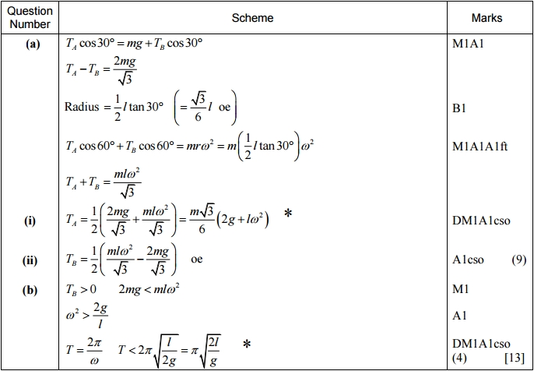
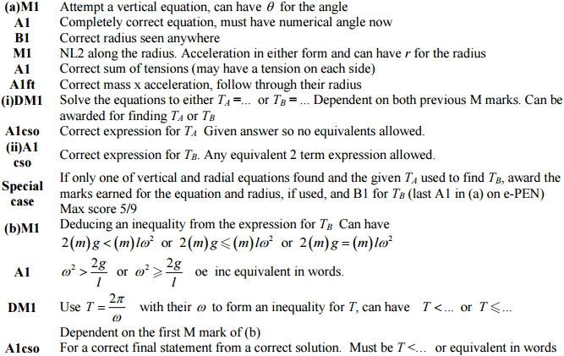

Q5.
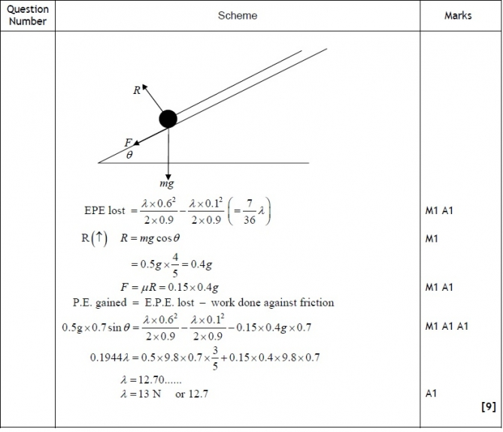

Q6.
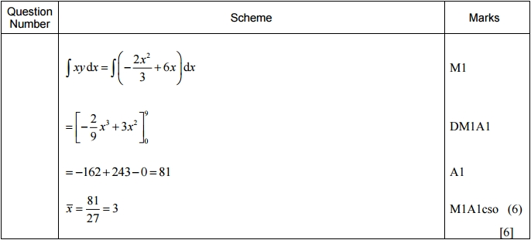
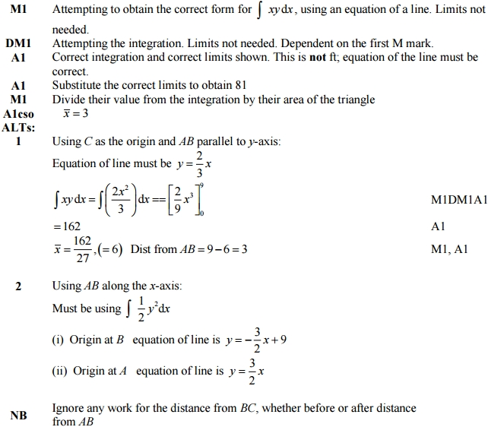

Q7.
