Questions
Q1.
Two uniform rods AB and BC are rigidly joined at B so that ∠ABC = 90º. Rod AB has length 0.5 m and mass 2 kg. Rod BC has length 2 m and mass 3 kg. The centre of mass of the framework of the two rods is at G.
(a) Find the distance of G from BC.
(2)
The distance of G from AB is 0.6 m.
The framework is suspended from A and hangs freely in equilibrium.
(b) Find the angle between AB and the downward vertical at A.
(3)
(Total 5 marks)

Q2.
A caravan of mass 600 kg is towed by a car of mass 900 kg along a straight horizontal road. The towbar joining the car to the caravan is modelled as a light rod parallel to the road. The total resistance to motion of the car is modelled as having magnitude 300 N. The total resistance to motion of the caravan is modelled as having magnitude 150 N. At a given instant the car and the caravan are moving with speed 20 m s⁻¹ and acceleration 0.2 m s⁻².
(a) Find the power being developed by the car's engine at this instant.
(5)
(b) Find the tension in the towbar at this instant.
(2)
(Total 7 marks)

Q3.
Two particles, P, of mass 2m, and Q, of mass m, are moving along the same straight line on a smooth horizontal plane. They are moving in opposite directions towards each other and collide. Immediately before the collision the speed of P is 2u and the speed of Q is u. The coefficient of restitution between the particles is e, where e < 1. Find, in terms of u and e,
(i) the speed of P immediately after the collision,
(ii) the speed of Q immediately after the collision.
(7)

(Total 7 marks)

Q4.
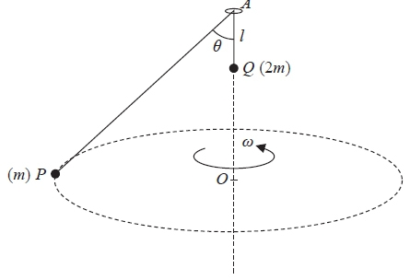
Figure 2
Two particles P and Q, of mass m and 2m respectively, are attached to the ends of a light inextensible string of length 6l. The string passes through a small smooth fixed ring at the point A. The particle Q is hanging freely at a distance l vertically below A. The particle P is moving in a horizontal circle with constant angular speed ω. The centre O of the circle is vertically below A. The particle Q does not move and AP makes a constant angle θ with the downward vertical, as shown in Figure 2.
Show that
(i) θ = 60°
(i) ω = 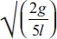
(8)
(Total 8 marks)

Q5.
A small ball is moving on a smooth horizontal plane when it collides obliquely with a smooth plane vertical wall. The coefficient of restitution between the ball and the wall is ¹⁄₃. The speed of the ball immediately after the collision is half the speed of the ball immediately before the collision.
Find the angle through which the path of the ball is deflected by the collision.
(8)
(Total 8 marks)

Q6.
A particle P of mass 2 kg is attached to one end of a light elastic string of natural length 1.2 m. The other end of the string is attached to a fixed point O on a rough horizontal plane. The coefficient of friction between P and the plane is . The particle is held at rest at a point B on the plane, where OB = 1.5 m. When P is at B, the tension in the string is 20 N. The particle is released from rest.
(a) Find the speed of P when OP = 1.2 m.
(7)
The particle comes to rest at the point C.
(b) Find the distance BC.
(2)
(Total 9 marks)

Q7.
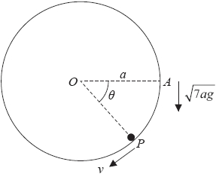
Figure 4
A hollow cylinder is fixed with its axis horizontal. A particle P moves in a vertical circle, with centre O and radius a, on the smooth inner surface of the cylinder. The particle moves in a vertical plane which is perpendicular to the axis of the cylinder. The particle is projected vertically downwards with speed from the point A, where OA is horizontal and OA = a. When angle AOP = θ, the speed of P is v, as shown in Figure 4.
(a) Show that v² = ag(7 + 2sinθ)
(4)
(b) Verify that P will move in a complete circle.
(6)
(c) Find the maximum value of v.
(2)

(Total for question = 12 marks)

Q8.
A spacecraft S of mass m moves in a straight line towards the centre of the earth. The earth is modelled as a fixed sphere of radius R. When S is at a distance x from the centre of the earth, the force exerted by the earth on S is directed towards the centre of the earth and has magnitude , where k is a constant.
(a) Show that k =mgR².
(2)
Given that S starts from rest when its distance from the centre of the earth is 2R, and that air resistance can be ignored,
(b) find the speed of S as it crashes into the surface of the earth.
(7)

(Total 9 marks)

Mark Scheme
Q1.
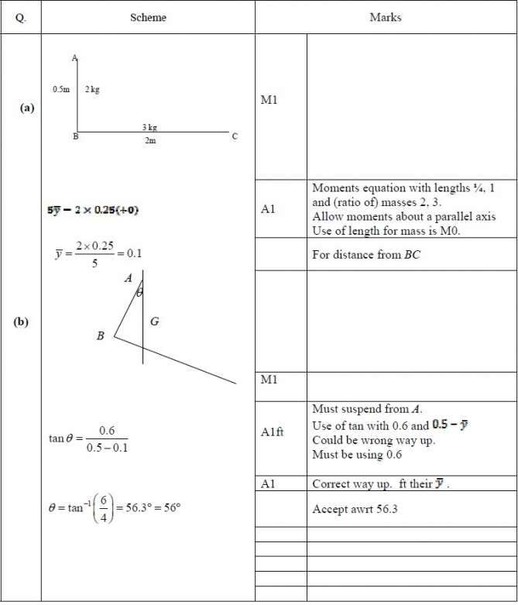

Q2.
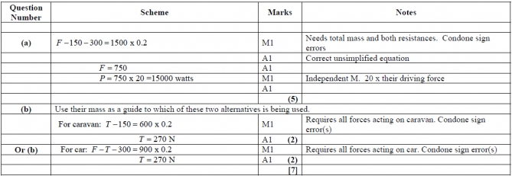

Q3.
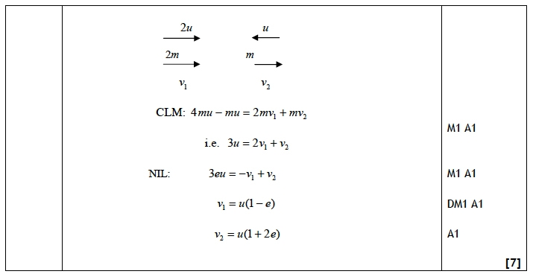

Q4.
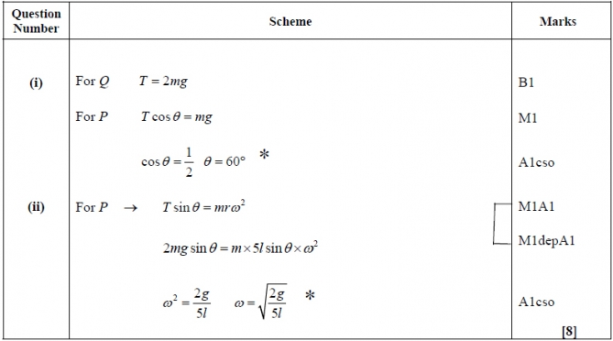
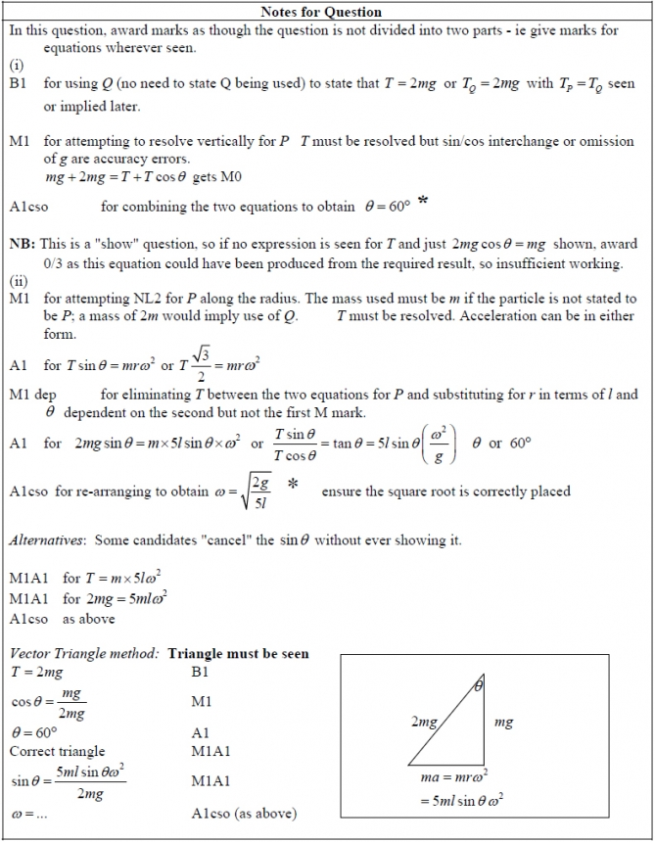

Q5.
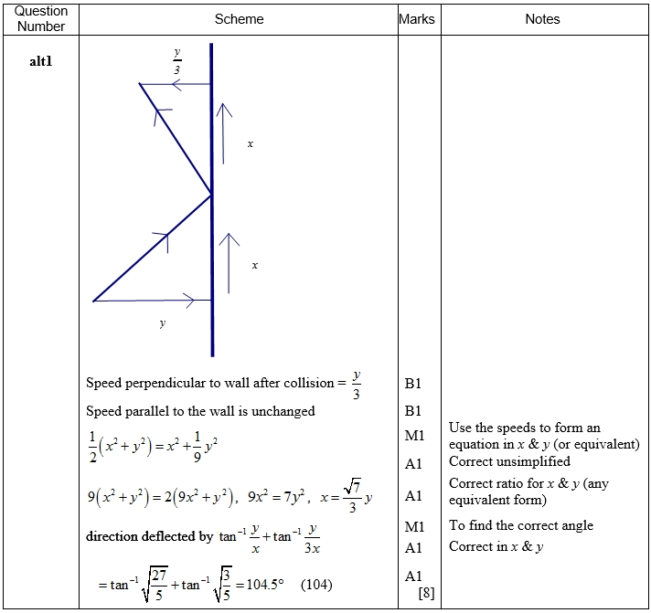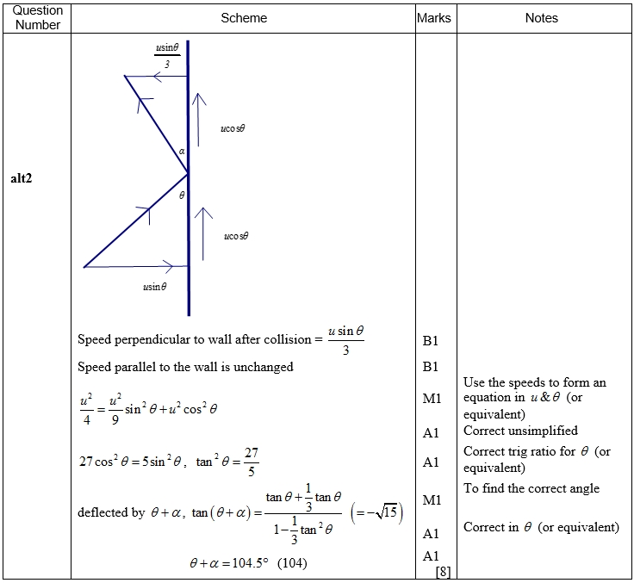

Q6.
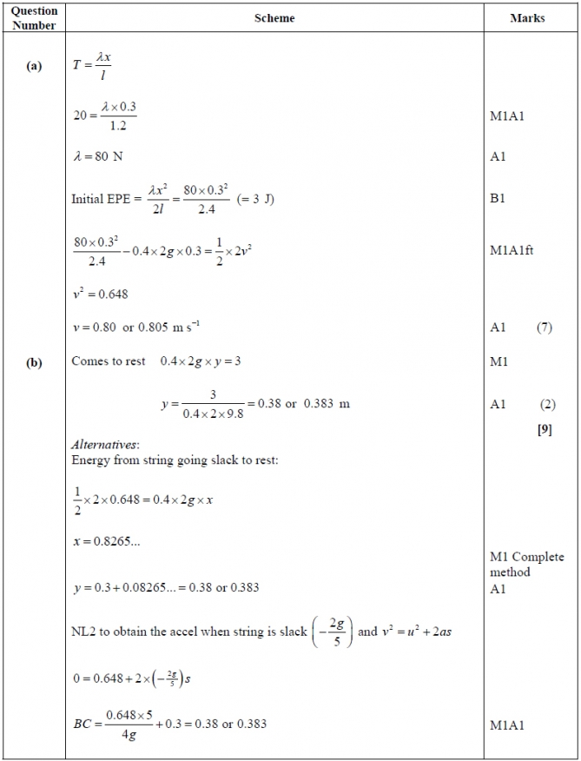
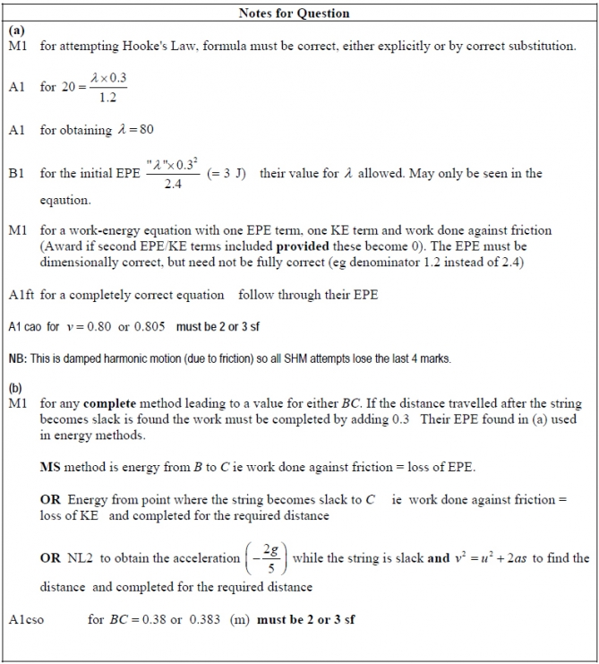

Q7.
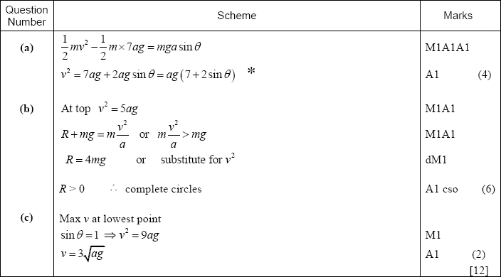
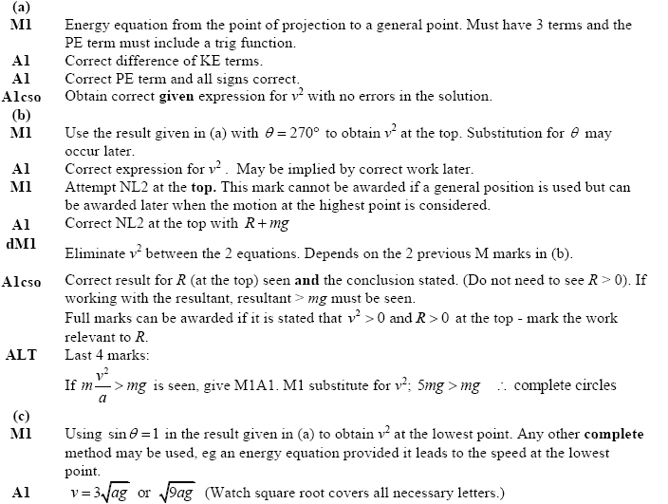

Q8.
