Questions
Q1.
Unless otherwise indicated, whenever a numerical value of g is required, take g = 9.8 m s^{–2} and give your answer to either 2 significant figures or 3 significant figures.
A particle P of mass 3m is moving in a straight line on a smooth horizontal table.
A particle Q of mass m is moving in the opposite direction to P along the same straight line. The particles collide directly. Immediately before the collision the speed of P is u and the speed of Q is 2u. The velocities of P and Q immediately after the collision, measured in the direction of motion of P before the collision, are v and w respectively. The coefficient of restitution between P and Q is e.
(a) Find an expression for v in terms of u and e.
(6)
Given that the direction of motion of P is changed by the collision,
(b) find the range of possible values of e.
(2)
(c) Show that w = (1 + 9e).
(2)
Following the collision with P, the particle Q then collides with and rebounds from a fixed vertical wall which is perpendicular to the direction of motion of Q. The coefficient of restitution between Q and the wall is f.
Given that e = , and that P and Q collide again in the subsequent motion,
(d) find the range of possible values of f.
(6)

(Total for question = 16 marks)

Q2.
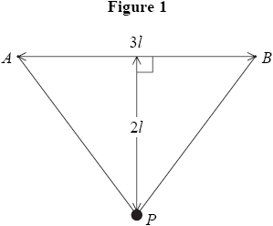
A light elastic string, of natural length 3l and modulus of elasticity λ, has its ends attached to two points A and B, where AB = 3l and AB is horizontal. A particle P of mass m is attached to the mid-point of the string. Given that P rests in equilibrium at a distance 2l below AB, as shown in Figure 1,
(a) show that λ = 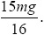
(9)
The particle is pulled vertically downwards from its equilibrium position until the total length of the elastic string is 7.8l. The particle is released from rest.
(b) Show that P comes to instantaneous rest on the line AB.
(6)

(Total 15 marks)

Q3.
A smooth uniform sphere S is moving on a smooth horizontal plane when it collides obliquely with an identical sphere T which is at rest on the plane. Immediately before the collision S is moving with speed U in a direction which makes an angle of 60° with the line joining the centres of the spheres. The coefficient of restitution between the spheres is e.
(a) Find, in terms of e and U where necessary,
(i) the speed and direction of motion of S immediately after the collision,
(ii) the speed and direction of motion of T immediately after the collision.
(12)
The angle through which the direction of motion of S is deflected is δ°.
Find
(i) the value of e for which δ takes the largest possible value,
(ii) the value of δ in this case.
(3)
(Total 15 marks)

Q4.
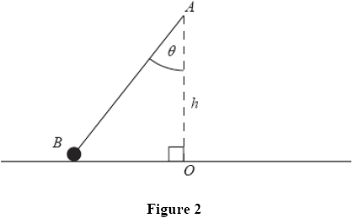
Figure 2 shows a particle B, of mass m, attached to one end of a light elastic string. The other end of the string is attached to a fixed point A, at a distance h vertically above a smooth horizontal table. The particle moves on the table in a horizontal circle with centre O, where O is vertically below A. The string makes a constant angle θ with the downward vertical and B moves with constant angular speed ω about OA.
(a) Show that ω² ≤
(8)
The elastic string has natural length h and modulus of elasticity 2 mg.
Given that tan θ =
(b) find ω in terms of g and h.
(5)

(Total 13 marks)

Q5.
(a) A uniform lamina is in the shape of a quadrant of a circle of radius a. Show, by integration, that the centre of mass of the lamina is at a distance of from each of its straight edges.
(7)
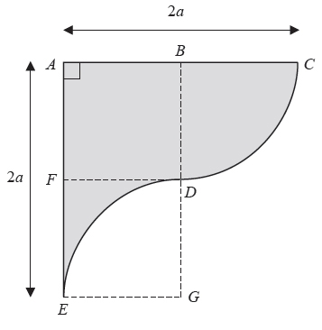
Figure 3
A second uniform lamina ABCDEFA is shown shaded in Figure 3. The straight sides AC and AE are perpendicular and AC = AE = 2a. In the figure, the midpoint of AC is B, the midpoint of AE is F, and ABDF and DGEF are squares of side a. BCD is a quadrant of a circle with centre B. DGE is a quadrant of a circle with centre G.
(b) Find the distance of the centre of mass of the lamina from the side AE.
(5)
The lamina is smoothly hinged to a horizontal axis which passes through E and is perpendicular to the plane of the lamina. The lamina has weight W newtons. The lamina is held in equilibrium in a vertical plane, with A vertically above E, by a horizontal force of magnitude X newtons applied at C.
(c) Find X in terms of W.
(3)
(Total 15 marks)

Q6.
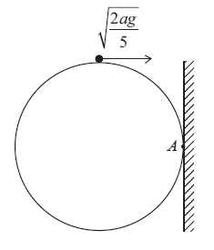
Figure 2
A smooth sphere of radius a is fixed with a point A of its surface in contact with a fixed vertical wall. A particle is placed on the highest point of the sphere and is projected towards the wall and perpendicular to the wall with horizontal speed 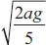, as shown in Figure 2.
The particle leaves the surface of the sphere with speed V.
(a) Show that V = 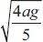
(7)
The particle strikes the wall at the point X.
(b) Find the distance AX.
(9)
(Total 16 marks)

Mark Scheme
Q1.
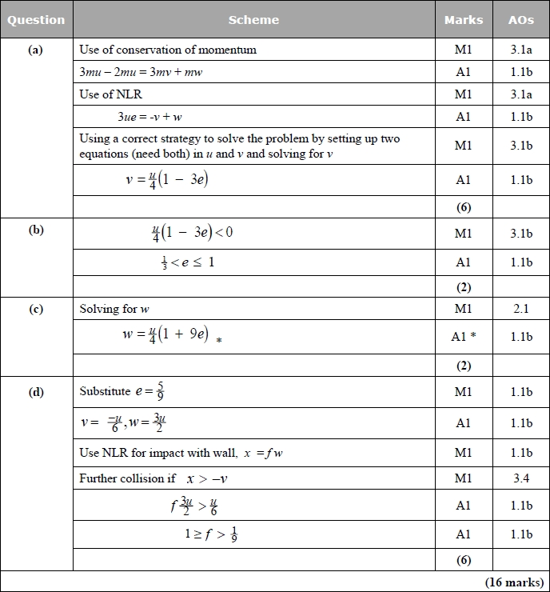
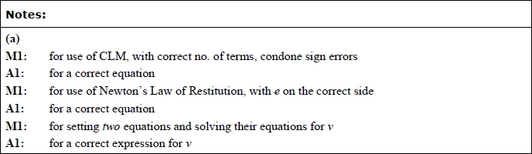
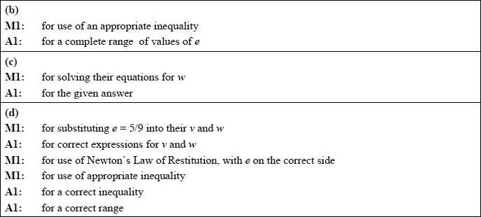

Q2.
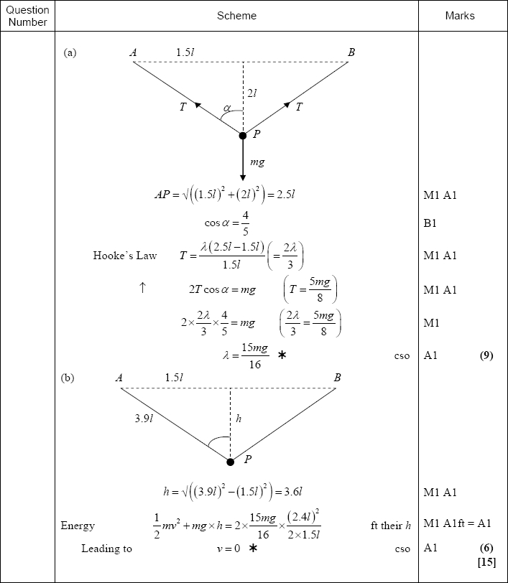

Q3.
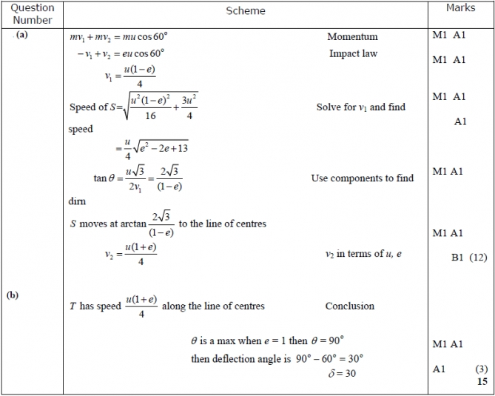

Q4.
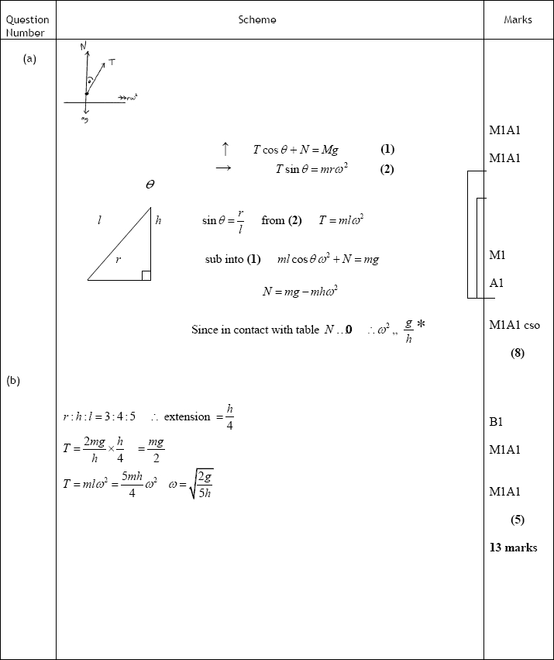

Q5.
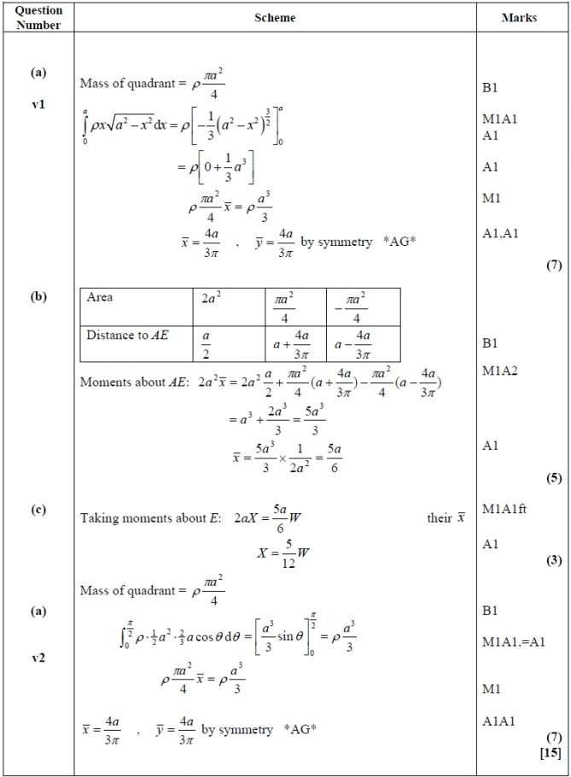

Q6.
