Questions
Q1.
A car of mass 1000 kg moves with constant speed V m s⁻¹ up a straight road inclined at an angle θ to the horizontal,
where sinθ = The engine of the car is working at a rate of 12 kW. The resistance to motion from non-gravitational forces has magnitude 500 N. Find the value of V.
(5)
(Total 5 marks)

Q2.
A cyclist and his bicycle have a combined mass of 90 kg. He rides on a straight road up a hill inclined at an angle α to the horizontal, where sin α = . He works at a constant rate of 444 W and cycles up the hill at a constant speed of 6 m s^{–1}.
Find the magnitude of the resistance to motion from non-gravitational forces as he cycles up the hill.
(4)

(Total for question = 4 marks)

Q3.
Unless otherwise indicated, whenever a numerical value of g is required, take g = 9.8 m s^{–2} and give your answer to either 2 significant figures or 3 significant figures.
A small stone of mass 0.5 kg is thrown vertically upwards from a point A with an initial speed of 25 m s^{–1}. The stone first comes to instantaneous rest at the point B which is 20 m vertically above the point A. As the stone moves it is subject to air resistance. The stone is modelled as a particle.
(a) Find the energy lost due to air resistance by the stone, as it moves from A to B.
(3)
The air resistance is modelled as a constant force of magnitude R newtons.
(b) Find the value of R.
(2)
(c) State how the model for air resistance could be refined to make it more realistic.
(1)

(Total for question = 6 marks)

Q4.
A particle A of mass 4m is moving with speed 3u in a straight line on a smooth horizontal table. The particle A collides directly with a particle B of mass 3m moving with speed 2u in the same direction as A. The coefficient of restitution between A and B is e. Immediately after the collision the speed of B is 4eu.
(a) Show that e = .
(5)
(b) Find the total kinetic energy lost in the collision.
(4)

(Total 9 marks)

Q5.
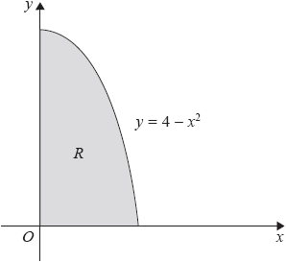
Figure 1
A uniform lamina is in the shape of the region R. Region R is bounded by the curve with equation y = 4 − x², the positive x-axis and the positive y-axis, as shown shaded in Figure 1.
Use algebraic integration to find the x coordinate of the centre of mass of the lamina.
(7)

(Total for question = 7 marks)

Q6.
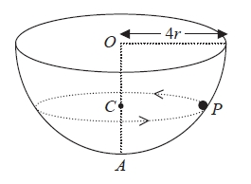
Figure 1
A hemispherical bowl of internal radius 4r is fixed with its circular rim horizontal. The centre of the circular rim is O and the point A on the surface of the bowl is vertically below O. A particle P moves in a horizontal circle, with centre C, on the smooth inner surface of the bowl. The particle moves with constant angular speed 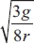
The point C lies on OA, as shown in Figure 1.
Find, in terms of r, the distance OC.
(9)
(Total 9 marks)

Q7.
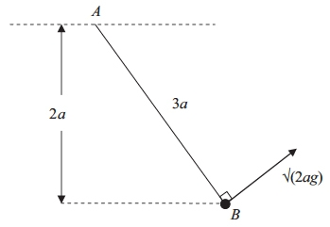
Figure 4
One end A of a light inextensible string of length 3a is attached to a fixed point. A particle of mass m is attached to the other end B of the string. The particle is held in equilibrium at a distance 2a below the horizontal through A, with the string taut. The particle is then projected with speed √(2ag), in the direction perpendicular to AB, in the vertical plane containing A and B, as shown in Figure 4. In the subsequent motion the string remains taut. When AB is at an angle θ below the horizontal, the speed of the particle is v and the tension in the string is T.
(a) Show that v² = 2ag(3 sin θ − 1).
(5)
(b) Find the range of values of T.
(6)

(Total 11 marks)

Q8.
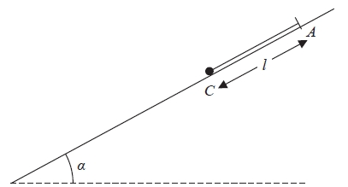
Figure 3
One end of a light elastic string, of natural length l and modulus of elasticity 3mg, is fixed to a point A on a fixed plane inclined at an angle α to the horizontal, where sin α = ³⁄₅
A small ball of mass 2m is attached to the free end of the string. The ball is held at a point C on the plane, where C is below A and AC = l as shown in Figure 3. The string is parallel to a line of greatest slope of the plane. The ball is released from rest. In an initial model the plane is assumed to be smooth.
(a) Find the distance that the ball moves before first coming to instantaneous rest.
(5)
In a refined model the plane is assumed to be rough. The coefficient of friction between the ball and the plane is μ. The ball first comes to instantaneous rest after moving a distance ²⁄₅l.
(b) Find the value of μ.
(6)
(Total 11 marks)

Mark Scheme
Q1.
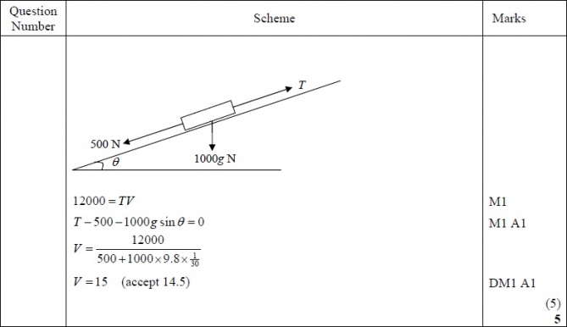

Q2.
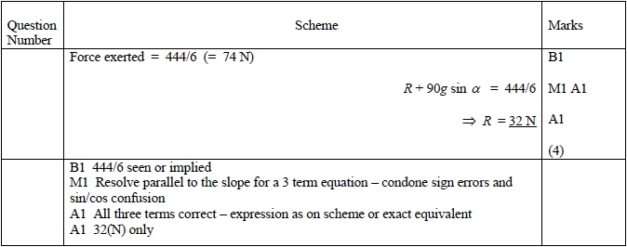

Q3.
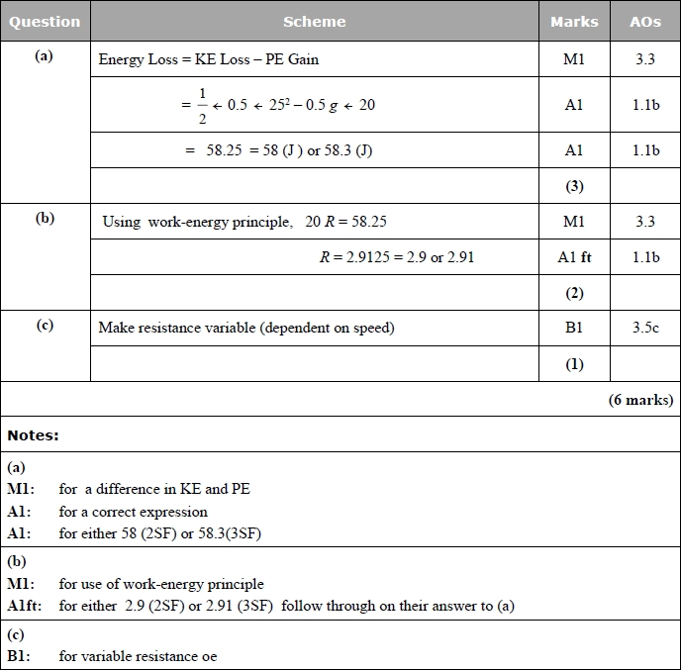

Q4.
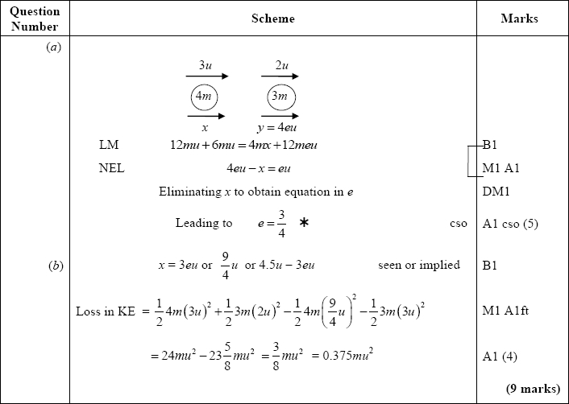

Q5.
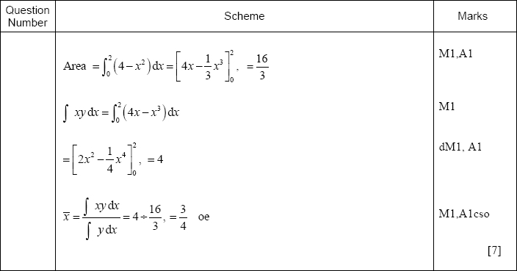
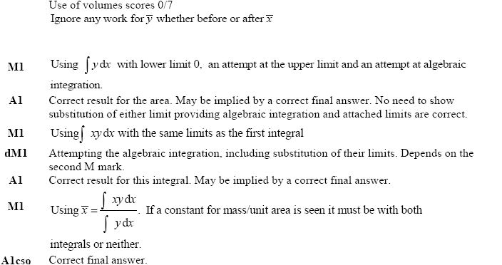

Q6.
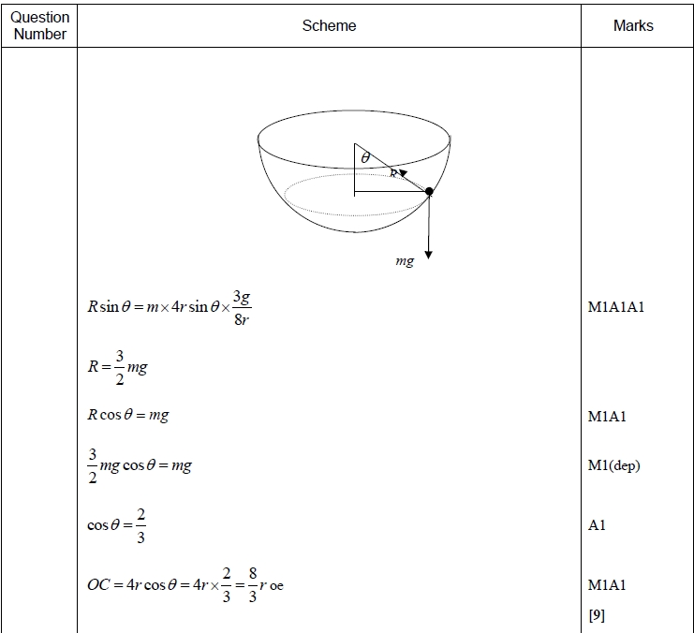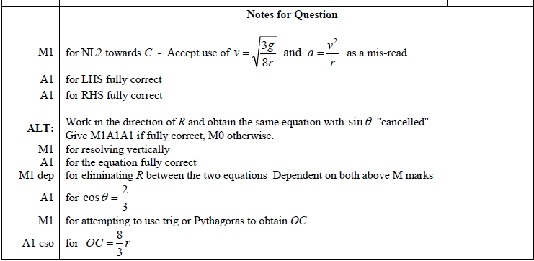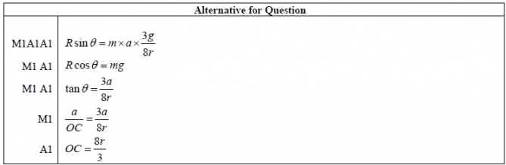

Q7.
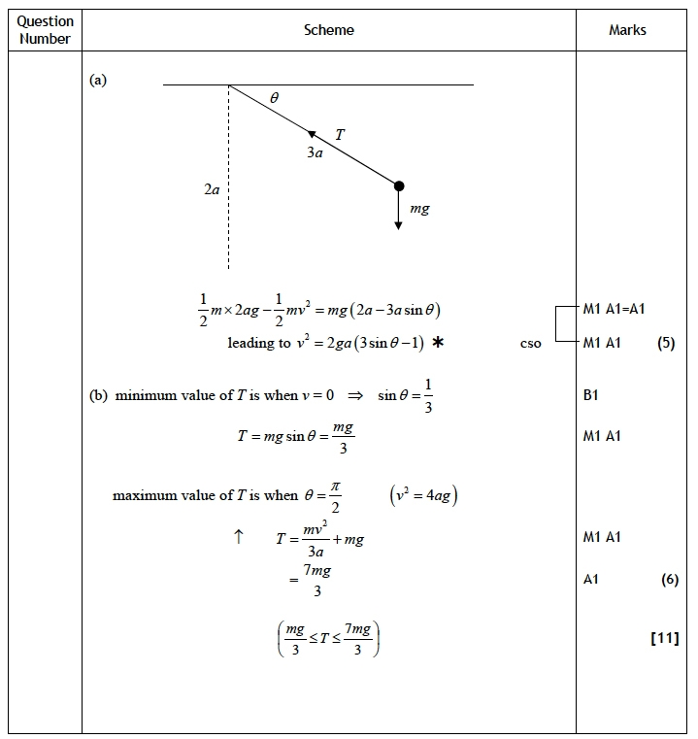

Q8.
